Narrabundah Early Childhood School
Annual School Board Report
2017

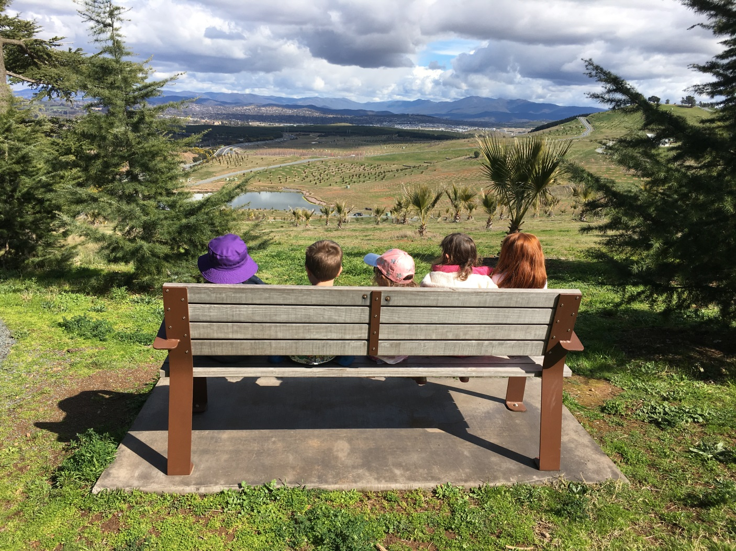
We take our learning outdoors!

This page is intentionally left blank.

This report supports the work being done in the ACT Education Directorate, as outlined in the ‘Education Capital: Leading the Nation Strategic Plan 2014-17’.
Accessibility
The ACT Government is committed to making its information services, events and venues accessible to as many people as possible.
If you have difficulty reading a standard document and would like to receive this publication in an alternate format, such as large print and audio, please telephone (02) 6247 4580.
If English is not your first language and you require the translating and interpreting service, please telephone 13 14 50.
If you are deaf or hearing impaired and require the National Relay Service, please telephone 13 36 77.
© Australian Capital Territory, Canberra, 2017
Material in this publication may be reproduced provided due acknowledgement is made.

Contents
School Board Chair Report 1
Context 1
Student Information 2
Student enrolment 2
Student attendance 2
Staff Information 3
Teacher qualifications 3
Workforce composition 3
School Review and Development 4
School Satisfaction 4
Overall Satisfaction 4
Learning and Assessment 6
Performance in Literacy and Numeracy 6
Early years assessment 6
NAPLAN Error! Bookmark not defined.
Outcomes for College Students Error! Bookmark not defined.
Post School Destination Error! Bookmark not defined.
Performance in Other Areas of the Curriculum 6
Financial Summary 7
Professional Learning 7
Voluntary Contributions 8
Reserves 8
Endorsement Page 9
Members of the School Board 9

School Board Chair Report
The 2017 Narrabundah Early Childhood School Board included three parent representatives, two teachers and a community representative. Due to a posting interstate of one representative the terms of the three parent representatives ended simultaneously. To accommodate the sudden transition and to continue corporate knowledge the Board decided to appoint two additional parent representatives as observers in the second half of 2017. These appointments helped to diversify opinion and assist with transition.
The Board maintains its purpose of guiding the strategic direction of the School. We enjoy a collaborative and friendly relationship with the Executive. This allows the Board to develop the priorities of and policies for the School, suggest changes and request further details as required. Both the Board and the Executive are united in their vision for the School. The 2017 Board wishes the new 2018 Board well.

School Context
The school has a strong focus on relationships, and the integrated service delivery of the Early Childhood Schools Framework encompasses pre-birth to students in year 2, an on-site childcare provider, health services provision, a three-year-old preschool and a Koori preschool.
During the period since opening, the demographics of the school have changed, with a decrease in the number of Indigenous students and an increase in the numbers of students with English as an Additional Language or Dialect. Additionally, while not having a Priority Enrolment Area, most enrolments are from children who live locally. The school is continuing to build their enrolments from preschool into kindergarten, with the proportion of students remaining at the school for kindergarten increasing from 30 percent in 2014 to 48 percent in 2017.

Student Information

Student enrolment
In 2017 there were a total of 142 students from preschool to year 2, of which 76 are male and 66 are female.
Table: 2017 Student enrolment
Student type | Number of students
Male | 76
Female | 66
Aboriginal and Torres Strait Islander | 38
LBOTE* | 37
*Language Background Other Than English
Source: Planning and Analytics, December 2017
Narrabundah Early Childhood School (NECS) does not have a designated Priority Access Area (PPA). This creates considerable complexity and uncertainty for families who are not from the local area and whilst a number of families accessing our childcare continue for preschool and to access our wrap around services they move to the Catholic, Private or local school for kindergarten. The majority of students enrolled at NECS are now from the local areas of Narrabundah, Red Hill, Forrest, Kingston, Manuka, The Causeway and Oaks Estate. Over fifty percent of enrolments continue to be from the preschool programs offered at the school. NECS has a three year old preschool that provides twelve hours of preschool for children who meet strict criteria around access. Koori preschool is offered to eighteen children between three and five years of age. Four year old preschool provides fifteen hours of government preschool to our families. We also offer wrap around care that enables children to be at our school five days a week. The number of children entering kindergarten and remaining untill the end of year two is increasing. We have a very active and strong marketing team who have been supporting continued growth in our kindergarten to year two enrolments with success.

Student attendance
The following table identifies the attendance rate of students by year level during 2017. Student attendance rate is the percentage of school days attended by students in each year level at the school. Student attendance is measured over two school terms; that is from the first day of the school year for students in term 1 to the last day of term 2.
Table: 2017 Attendance rates in percentages
Year level | Attendance rate
K | 92.0
1 | 79.0
2 | 89.0
Source: Planning and Analytics, December 2017
Narrabundah Early Childhood School actively manages non-attendance and late attendance. Families are required to sign their children in at the Front Office when they arrive later than 9:15 am. Teachers are asked to report each week any children who have been away. An initial phone call is made to the family by the classroom teacher. This is then followed up with a phone call from an administrative member of staff. If absences are ongoing for a child, executive staff make contact with the family. Support is provided to families through our Community Development Coordinator and executive staff to ensure systems are in place that enable regular attendance and punctuality. The school has been working closely with a number of families who had been enrolled in other settings and whose children had disengaged and were not attending. We also work closely with ACTION and community groups to ensure all families are able to access transport for children to attend school. NECS has a partnership with Woden Community Services Inc. which sees a family support worker based at the school one day each week. Part of this role supports families around attendance. Unfortunately we continue to see in our data the impact of some families being placed in housing where they do not have access to transport and compounded by health issues impacting on a few children being able to attend school.

Staff Information

Teacher qualifications
All teachers meet the professional requirements for teaching in an ACT public school. The ACT Teacher Quality Institute (TQI) has provided the following data based on teachers registered as at 16 December 2017.
The proportion of teaching staff with certificates/degrees/diplomas and a postgraduate qualification is shown below.
Table: 2017 Qualification of teaching staff in percentages
Qualifications | Proportion of staff
Certificate/ Diploma/ Degree | 100
Postgraduate | 57
Source: Teacher Quality Institute, 16 December 2017

Workforce composition
The 2017 workforce composition of Narrabundah Early Childhood School is highlighted in the following table. The data is taken from the school’s term 4 staff report. For reporting purposes it incorporates all school-based staff. Narrabundah Early Childhood School has one staff member who identifies as Aboriginal.
Table: 2017 Workforce composition numbers
Staff employment category | TOTAL
Teaching Staff: Head Count | 11
Teaching Staff: Full Time Equivalent Permanent | 6.40
Teaching Staff: Full Time Equivalent Temporary | 4.00
Non Teaching Staff: Head Count | 10
Non Teaching Staff: Full Time Equivalent | 8.08

Source: This data is from the school’s term 4 2017 staff report. Data provided in previous years was sourced from the August census date and was calculated using the parameters provided by the ABS. As such, pre-2017 staffing figures may differ significantly from the above.

School Review and Development
In 2017, the ACT Education Directorate’s Strategic Plan 2014-2017 provided the framework and strategic direction for the school’s Strategic Plan. This is supported by the school performance and accountability framework, ‘People, Practice and Performance: School Improvement in Canberra Public Schools, A Framework for Performance and Accountability’. This framework has school improvement at its centre, with the National School Improvement Tool (NSIT) as its core feature, providing support to achieve high standards in student learning, innovation and best practice in ACT public schools.
Prior to 2016 all ACT public schools participated in a four-year cycle of school review and development. In the fourth year schools underwent an external validation process. In 2016 this changed to a five-year cycle with an External School Review at the end.
Narrabundah Early Childhood School was reviewed in 2017. A copy of the Review Report can be found on the school website.

School Satisfaction
Schools use a range of data collection tools to gain an understanding of the satisfaction levels of their parents and carers, staff and students. In August/ September 2017 the school undertook a survey to gain an understanding of school satisfaction at that time. Staff, carers and parents took part in an online survey.

Overall Satisfaction
In 2017, 97% of parents and carers and 100% of staff at this school indicated they were satisfied with the education provided by the school.
Included in the survey were 14 national parent survey items and 12 national student survey items. These items were approved by the then Standing Council on School Education and Early Childhood (SCSEEC) for use from 2015. The following tables show the percentage of parents and carers and students who agreed with each of the national items at this school.
A total of 6 staff responded to the survey. Please note that not all responders answered every question.

Table: Proportion of staff in agreement with each national opinion item
National opinion item | Proportion of staff
Teachers at this school expect students to do their best. | 100
Teachers at this school provide students with useful feedback about their school work. | 100
Teachers at this school treat students fairly. | 67
This school is well maintained. | 67
Students feel safe at this school. | 17
Students at this school can talk to their teachers about their concerns. | 100
Parents at this school can talk to teachers about their concerns. | 100
Student behaviour is well managed at this school. | 17
Students like being at this school. | 100
This school looks for ways to improve. | 83
This school takes staff opinions seriously. | 67
Teachers at this school motivate students to learn. | 100
Students’ learning needs are being met at this school. | 100
This school works with parents to support students' learning. | 83
I receive useful feedback about my work at this school. | 67
Staff are well supported at this school. | 33
Source: 2017 School Satisfaction Surveys, August/September 2017
A total of 34 parents responded to the survey. Please note that not all responders answered every question.
Table: Proportion of parents and carers in agreement with each national opinion item
National opinion item | Proportion of parents and carers
Teachers at this school expect my child to do his or her best. | 97
Teachers at this school provide my child with useful feedback about his/her school work. | 94
Teachers at this school treat students fairly. | 97
This school is well maintained. | 97
My child feels safe at this school. | 94
I can talk to my child’s teachers about my concerns. | 100
Student behaviour is well managed at this school. | 88
My child likes being at this school. | 100
This school looks for ways to improve. | 94
This school takes parents’ opinions seriously. | 91
Teachers at this school motivate my child to learn. | 91
My child is making good progress at this school. | 94
My child's learning needs are being met at this school. | 91
This school works with me to support my child's learning. | 94
Source: 2017 School Satisfaction Surveys, August/September 2017
This information can be considered alongside information available on the My School website (http://www.myschool.edu.au).

These results, as well as the continual review of school performance, contributed to the evaluation of our Strategic Plan and the development of Annual Action Plans. The Strategic Plan is available on the school website.

Learning and Assessment

Performance in Literacy and Numeracy

Early years assessment
Students in kindergarten undertake an on-entry assessment of their early reading and numeracy skills using the Performance Indicators in Primary Schools (PIPS) program. Student results are reported against five performance bands at the end of semester 1 and 2.
Table: Narrabundah Early Childhood School PIPS 2017 mean raw scores
Agency | Reading start | Reading end | Mathematics start | Mathematics end
School | 53 | 120 | 41 | 57
ACT | 51 | 124 | 39 | 55
Source: Planning and Analytics
The children in kindergarten started just above the ACT mean in Reading and finished just below. In mathematics the children started just above the ACT mean and finished just above.

Performance in Other Areas of the Curriculum
The Early Years Learning Framework and Australian Curriculum continue to inform the development of engaging programs that meet the diverse needs of our children from preschool to year two.
Rich units of inquiry are developed across the school that encourage children to develop deep understanding and an ability to develop new understanding. These units of work are related to real life experiences and encourage children to question, investigate, propagate new ideas and challenge bias and inequity. Diversity and cultural understanding are explored in meaningful contexts and allow children to develop their own understandings in authentic and purposeful ways.
Throughout 2017 we have continued to build on our work over the last five years on using the natural world to support learning. Our ‘Bush School’ program continues to include all children from preschool to year two. This has involved the children spending the day exploring and connecting with the natural world. Locations varied to suit the age of the children, interests and needs. This experience was then utilised to support programs across all areas in the learning spaces. All children participated in this program and it was evident that this program supported our priority of improved learning outcomes across all areas of development. Improved learning outcomes were evident for all our children. Strong connections were made to Science, English, Mathematics, Technology and Humanities in the Australian Curriculum and well as social and emotional wellbeing.

Financial Summary
The school has provided the Directorate with an end of year financial statement that was approved by the school board. Further details concerning the statement can be obtained by contacting the school. The following summary covers use of funds for operating costs and does not include expenditure in areas such as permanent salaries, buildings and major maintenance.
Table: Financial Summary
INCOME | January-June | July-December | January-December
Self-management funds | 163807.89 | 124605.82 | 288413.71
Voluntary contributions | 3300.00 | 660.00 | 3960.00
Contributions & donations | 471.05 | 186.35 | 657.40
Subject contributions | 2935.00 | 320.00 | 3255.00
External income (including community use) | 2954.55 | 8863.65 | 11818.20
Proceeds from sale of assets | 840.10 | 0.00 | 840.10
Bank Interest | 4955.90 | 4925.50 | 9881.40
TOTAL INCOME | 179264.49 | 139561.32 | 318825.81
EXPENDITURE
Utilities and general overheads | 39115.37 | 32522.38 | 71637.75
Cleaning | 15568.08 | 9937.59 | 25505.67
Security | 600.80 | 54.62 | 655.42
Maintenance | 54865.01 | 17072.96 | 71937.97
Administration | 10212.90 | 20273.08 | 30485.98
Staffing | 0.00 | 0.00 | 0.00
Communication | 5428.91 | 3668.45 | 9097.36
Assets | 21686.23 | 24487.79 | 46174.02
Leases | 0.00 | 0.00 | 0.00
General office expenditure | 4220.33 | 20580.44 | 24800.77
Educational | 12348.06 | 10494.92 | 22842.98
Subject consumables | 5106.44 | 0.00 | 5106.44
TOTAL EXPENDITURE | 169152.13 | 139092.23 | 308244.36
OPERATING RESULT | 10112.36 | 469.09 | 10581.45
Actual Accumulated Funds | 207998.99 | 207998.99 | 207998.99
Outstanding commitments (minus) | -36.65 | 0.00 | -36.65
BALANCE | 218074.70 | 208468.08 | 218543.79

Professional Learning

The average professional learning expenditure at the school level per full time equivalent teacher was $2,285

Voluntary Contributions
The funds listed were used to support the general operations of the school. The spending of voluntary contributions is in line with the approved budget for 2017.

Reserves
Name and Purpose | Amount | Expected Completion
Staffing – to accommodate any shortfalls in CRS  Landscaping – For possible extra landscaping works in the playground  Photocopier – To cover any cost blowout due to new ricoh contract | $54,000  $65,000  $,3000 | 29/12/2018  29/12/2018  29/12/2018

Endorsement Page

Members of the School Board
Parent Representative(s): | John Norgrove | Felicity Maher | Alon Meltzer
Community Representative(s): | Meg Price
Teacher Representative(s): | Cadeyrn Ollerenshaw
Student Representative(s): | N/A
Board Chair: | John Norgrove
Principal: | Bernadette Hayes

I approve the report, prepared in accordance with the provision of the ACT Education Act 2004, section 52.
Board Chair Signature: | John Norgrove | Date: | 29/05/2018
I certify that to the best of my knowledge and belief the data and information reported in this Annual School Board Report represents an accurate record of the school’s operations in 2017.
Principal Signature: | Bernadette Hayes | Date: | 23/5/2018

