Ngunnawal Primary School

Network: North/Gungahlin

School Improvement Plan 2020-2022



NGUNNAWAL

PRIMARY SCHOOL

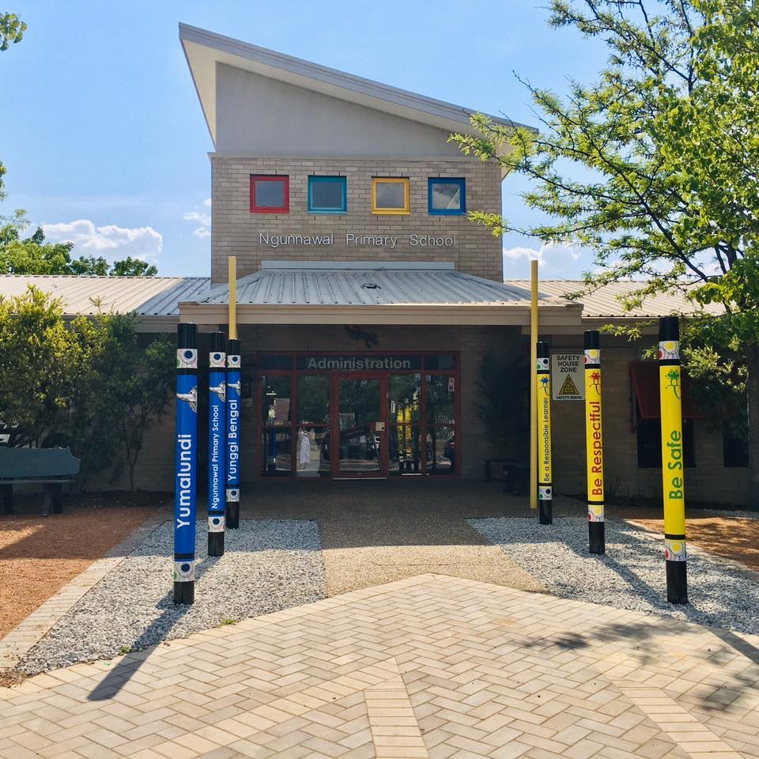

# The purpose of school improvement planning

This plan establishes a strong improvement agenda to be driven by school leaders over the next five years. It was informed by the Directorate’s Strategic Plan and system-level and school-based analysis of multiple sources of evidence. Analysis of these multiple sources of evidence is supported by an annual provision to each school of a data summary as a key enabler of our improvement planning and implementation.

Each school participates in School Review as an integral component of in its five-year improvement planning cycle. Review findings support annual improvement planning (Action Plan) and are an important component of Directorate monitoring and support of school improvement. Reviews provide schools with quality and independent feedback, tailored to the school’s context. Each school is reviewed at least every five years, providing valuable opportunities for self-reflection, planning and improvement. The school improvement planning process is below. This representation is used in the footer of all school-based improvement documents to indicate the stage of planning or implementation.

Analysis ⇨ Priorities ⇨ Strategies ⇨ Actions ⇨ Impact (for student)

Our school improvement planning is grounded in evidence from research and practice and expressed in terms of improvements in measurable student outcomes. Explicit five-year targets for improvement have been set and will give life to monitoring, evaluation and communication of progress to teachers, families and students.

# Our school’s improvement agenda positioned within the Directorate’s Strategic Plan

## Vision

Directorate’s vision: We will be a leading learning organisation where people know they matter.

School’s vision: Ngunnawal Primary School’s fundamental purpose is learning. The school educates students to navigate the social world, develop friendships, demonstrate respect and have fun. Students develop knowledge and skills to enable them to be ready for the future.

## Mission

Directorate’s mission: We develop and deliver educational services to empower each child and young person in the ACT to learn for life.

School’s mission: Ngunnawal Primary School is a safe and supportive learning community where students, staff and the wider community grows. The school is a highly reliable organisation in which all students achieve and develop as productive citizens.

## Values

Directorate’s Values: Respect, Integrity, Collaboration, Innovation.

The Ngunnawal Primary School community has high expectations of its members to demonstrate the **SHARE values** and be inclusive of all. Respect for all underpins this ethos.

S - Show you’re caring

H- Honest

A – Always do your best

R – Respect and Responsibility

E- Everyone knows, what you give comes back to you

**Our Positive Behaviours for Learning (PBL) expectations are:**

Be safe

Be respectful

Be a responsible learner

## Education Directorate’s Strategic Goals for 2018-2021

* Schools where students love to learn
* Investing in early childhood
* Evidence informed decisions
* Learning culture
* United leadership team

## Education Directorate’s Strategic Indicators for 2018-2021

* To promote greater equity in learning outcomes in and across ACT public schools
* To facilitate high quality teaching in ACT public schools and strengthen educational outcomes
* To centre teaching and learning around students as individuals

The Directorate annually publishes progress against its Strategic Indicators. Our school’s contributions to these Strategic Indicators are detailed in our annual Impact Reports.

## Multiple sources of evidence

Evidence informing this School Improvement Plan includes:

* analysis of system-level data
* analysis of school-based evidence over time (past 4/5 years)
* for schools with a preschool setting, Quality Ratings from assessment against the National Quality Framework.*

*\*For schools with a preschool setting their Quality Improvement Plan (QIP) is revised each year as part of the annual planning process.*

# Our improvement priorities

Priority 1: All students learn at a high level within a safe and supportive learning culture. The school equips students with the capabilities and dispositions to live and learn in the future world.

*The statement below details our vision for how this priority will change the experience of school for our students.*

|  |
| --- |
| All children and young people receive universal support and instruction. If students need more support, their instructional program becomes more intensive and individualised to target their specific learning needs.  Students at this school are being equipped with the capabilities to learn and live successfully. Students demonstrate a culture of respect through respectful communication and behaviour in their interactions with others. |

Targets/Measures to be achieved by 2022

Student learning data

### Perception data

**Target or measure:** To improve the consistency in perceptions of the key stakeholders at this school and ensure the school result is not more than 10% below the school type result.

**Source: Satisfaction Survey (Parent, Staff and Students) 2016-2019**

**Starting point:** For the three key stakeholders, the responses to the 2 questions: *student behaviour is well managed at this school and I am satisfied this school has high expectations in all that it does*, are 10% more below those of schools of the same type.

|  |  |  |  |  |
| --- | --- | --- | --- | --- |
|  | 2016 | 2017 | 2018 | 2019 |
| Staff: Student behaviour is well managed at this school | 65.3 | 46.8 | 54.5 | 58.2 |
| Parent: Student behaviour is well managed at this school | 70.3 | 50.4 | 63.0 | 62.9 |
| Student: Student behaviour is well managed at my school | 36.0 | 28.7 | 29.0 | 27.9 |
| Staff: Students like being at this school | 93.9 | 87.2 | 84.8 | 83.6 |
| Parent: My child likes being at this school | 89.6 | 80.3 | 85.8 | 87.7 |
| Student: I like being at my school | 68.1 | 61.9 | 64.9 | 63.1 |
| Staff: Students at this school are being equipped with the capabilities to learn and live successfully | n.a. | n.a. | n.a. | 78.2 |
| Parent: Students at this school are being equipped with the capabilities to learn and live successfully | n.a. | n.a. | n.a. | 73.6 |
| Students: Students at this school are being equipped with the capabilities to learn and live successfully | n.a. | n.a. | n.a. | 67.6 |

**Target or measure:** To be demonstrating the attributes articulated at high in the NSIT to Systematic curriculum delivery

**Source: National School Improvement Tool (Staff reflection Term 4, 2019)**

2019 Self Assessment of the National School Improvement Tool (NSIT)

|  |  |
| --- | --- |
| **Some attributes at this level** | **All attributes at this level** |

|  |  |  |  |  |
| --- | --- | --- | --- | --- |
| 2019 Self Reflection | Low | Medium | High | Outstanding |
| 1 An explicit improvement agenda |  |  |  |  |
| 2 Analysis and discussion of data |  |  |  |  |
| 3 A culture that promotes learning |  |  |  |  |
| 4 Targeted use of school resources |  |  |  |  |
| 5 An expert teaching team |  |  |  |  |
| 6 Systematic curriculum delivery |  |  |  |  |
| 7 Differentiated teaching and learning |  |  |  |  |
| 8 Effective pedagogical practices |  |  |  |  |
| 9 School-community partnerships |  |  |  |  |

### School program and process data

**Target or measure**: Decrease suspensions, major and minor incidents. Increase positive acknowledgment.

**Source: Student Incident Data Student Administration System (Sentral)**

**Starting point:** NB: consistent entry of data commenced in 2019. Entry of positive incident commenced semester 2 2019. 2020 will be the first year of whole school data across a full year which will form the baseline.

|  |  |  |  |  |  |  |  |  |  |  |  |  |  |  |  |  |
| --- | --- | --- | --- | --- | --- | --- | --- | --- | --- | --- | --- | --- | --- | --- | --- | --- |
|  | **2019** | | | | **2020** | | | | **2021** | | | | **2022** | | | |
| **Suspensions**  **(per term)** | **20** | **7** | **6** | **2** |  |  |  |  |  |  |  |  |  |  |  |  |
| **Major** | **569** | | | |  | | | |  | | | |  | | | |
| **Minor** | **881** | | | |  | | | |  | | | |  | | | |
| **Positive** | **1175** | | | |  | | | |  | | | |  | | | |

*Data correct as at 6/11/19*

Priority 2: To improve reading outcomes for students through a whole school, evidence-based approach to reading. This is reflected in high levels of ongoing reading growth and achievement across the school.

*The statement below details our vision for how this priority will change the experience of school for our students.*

|  |
| --- |
| * Students know what good readers do and are capable, confident and competent readers. Students experience a systematic approach to reading including targeted instruction and flexible grouping. Students have access to abundant and diverse reading material to enrich their learning experiences. |

Targets/Measures to be achieved by 2022

Student learning data

**Target or measure:** The school will track cohorts over the three years and set targets to ensure an increasing number of students are achieving at expected levels. Priority will be given to the early years.

**Source: School based data: PM Reading Benchmarks**

**Starting point:** Leading up to the commencement of this plan, there has been considerable year-to-year variation.See table below. Colours indicate the same cohort of students.

|  |  |  |  |  |  |  |  |  |  |  |
| --- | --- | --- | --- | --- | --- | --- | --- | --- | --- | --- |
|  | **2018** | | **2019** | | **2020** | | **2021** | | **2022** | |
|  | **Mid year range** | **End of year range** | **Mid year range** | **End of year range** | **Mid year range** | **End of year range** | **Mid year range** | **End of year range** | **Mid year range** | **End of year range** |
| **Kindy** |  |  | 44% |  |  |  |  |  |  |  |
| **Year 1** | 56% | 75% | 70% |  |  |  |  |  |  |  |
| **Year 2** | 77% | 82% | 91% |  |  |  |  |  |  |  |
| **Year 3** | 75% | 74% | 85% |  |  |  |  |  |  |  |
| **Year 4** | 88% | 88% | 74% |  |  |  |  |  |  |  |
| **Year 5** | 70% | 74% | 84% |  |  |  |  |  |  |  |
| **Year 6** | 65% | 40% | 89% |  |  |  |  |  |  |  |

**Target or measure: Kindergarten** gain performance with be consistently comparable to ACT schools.

**Source: PIPS percentage of students achieving expected growth in reading**

**Starting point:**

|  |  |  |  |  |
| --- | --- | --- | --- | --- |
| PIPS Reading | **Less than expected growth** | **Expected growth** | **Better than expected growth** | **Expected or better** |
| 2017 | 28% | 55% | 17% | 72% |
| 2018 | 16% | 63% | 21% | 84% |
| 2020 |  |  |  |  |
| 2021 |  |  |  |  |
| 2022 |  |  |  |  |

**Target or measure:** Year 3 to year 5 gain performance with be consistently comparable to both ACARA similar schools and schools with the same year 3 starting point. The target was set by considering the gain performance of a sample of ACARA “similar schools”.

**Source:** NAPLAN Growth from Year 3 to Year 5

**Starting point:** Leading up to the commencement of this plan, there has been considerable year-to-year variation.

|  |  |  |  |  |  |
| --- | --- | --- | --- | --- | --- |
|  | **2018** | **2019** | **2020** | **2021** | **2022** |
| **Reading** | **52%** | **76%** |  |  |  |

***Percentage of students achieving expected or greater growth in NAPLAN from Year 3 to Year 5.***

### Perception data

**Target or measure:** To improve the consistency in perceptions of the key stakeholders at this school and ensure the school result is not more than 10% below the school type result.

**Source: Satisfaction Survey (Parent, Staff and Students)**

**Starting point:** Leading up to the commencement of this plan, there has been considerable year-to-year variation.

|  |  |  |  |  |
| --- | --- | --- | --- | --- |
|  | 2016 | 2017 | 2018 | 2019 |
| Staff: Staff get quality feedback on their performance | 63.3 | 57.4 | 56.3 | 66.7 |
| Parent: My child is making good progress at this school | 81.4 | 69.7 | 77.6 | 82.0 |
| Parent: My child's learning needs are being met at this school | 80.7 | 69.7 | 74.6 | 78.0 |
| Parent: This school works with me to support my child's learning | 79.3 | 71.1 | 77.6 | 80.3 |
| Staff: Teachers at this school use results from system testing and system processes to inform planning | 83.3 | 71.1 | 78.1 | 67.3 |

### School program and process data

**Target or measure: P-6 Staff Self Reflection: Embedding Phase:** PLCs are at the heart of the improvement across all levels: vertical, horizontal and leadership. There is a commitment to, and trust in, the value of a wide range of collaborative activities. Resources and time are allocated for continual ‘deep’ learning for improvement.

**Source: Professional Learning Community Matrix (scale used emerging, evolving, excelling)**

**Starting point: P-6 Staff Self Reflection: Evolving Phase:** PLCs formally meet and use a range of data to jointly diagnose strengths and weaknesses in teaching and student’s learning. They agree priority areas of focus for investigation; however, there is variation between classrooms and this impacts on students’ progress and achievement.

