Gordon Primary School
  - Network: Tuggeranong

Impact Report 2020

The purpose of this document
This document flows directly from our Action Plan for 2020 which translated our school priorities into actions for the current year of our five-year improvement cycle. These actions were responsive to identified challenges, changes or risks to delivery of improvement for student learning.

Our school’s contribution to whole-of-system Strategic Indicators

Education Directorate Strategic Indicator 2018-2021
To promote greater equity in learning outcomes in and across ACT public schools
In 2020 our school supported this Strategic Indicator through –

Priority 1: Improve Learning Outcomes in Literacy and Numeracy

Priority 2: Improve students’ sense of satisfaction, enjoyment of learning and sense of wellbeing
Priority 3: Develop collaborative learners who are curious and self-directed problem solvers

- Refinement of Tier 2 and 3 implementation of the Response to Intervention plan and processes.
- Introduction of Pedagogy meetings to focus, in more depth, on the individualisation of learning.
- Refinement of release time (Duties Other Than Teaching) to allow for teachers to better assess the impact of teaching and adjust instruction, both at a class and individual level
- Ongoing use of the Friendship Hub to provide a range of avenues of support for students not engaging in school to an appropriate level.

Education Directorate Strategic Indicator 2018-2021
To facilitate high quality teaching in ACT public schools and strengthen educational outcomes.
In 2020 our school supported this Strategic Indicator through –

Priority 1: Improve Learning Outcomes in Literacy and Numeracy

Priority 2: Improve students’ sense of satisfaction, enjoyment of learning and sense of wellbeing
Priority 3: Develop collaborative learners who are curious and self-directed problem solvers

- Further development of Pedagogy meetings to focus, in more depth, on consistent and targeted analysis of data and application of data analysis to improve the impact of teaching on student learning
- Further refinement of release time (Duties Other Than Teaching) to allow for teachers to better assess the impact of teaching and adjust instruction, both at a class and individual level
- Successful implementation of the Writing Project and Writers Camp

Education Directorate Strategic Indicator 2018-2021
To centre teaching and learning around students as individuals
In 2020 our school supported this Strategic Indicator through –
Priority 1: Improve Learning Outcomes in Literacy and Numeracy
Priority 2: Improve students’ sense of satisfaction, enjoyment of learning and sense of wellbeing
Priority 3: Develop collaborative learners who are curious and self-directed problem solvers

- Continued implementation of Positive Behaviours for learning (PBL)
- Implementation of Digital Technologies in the classroom to develop teachers’ skills in teaching digital technology and problem solving
- Continue exploring Play based and Project based learning
- Refinement of Tier 2 and 3 implementations of the Response to Intervention plan and processes.
- Ongoing use of the Friendship Hub to provide a range of avenues of support for students not engaging in school to an appropriate level.

Reporting against our priorities

Priority 1: Improve Learning Outcomes in Literacy and Numeracy

Targets or measures
- By the end of 2021 the school will achieve:
  - 70% of within school matched students demonstrate expected growth, or better, in Year 3 to Year 5 NAPLAN Numeracy (improved from 55% in 2016)
  - Of all within school matched students, 80% achieve 60% of expected growth or better in NAPLAN Numeracy
  - 85% of Kindergarten students achieve expected growth or better in PIPS Numeracy (improved from 82% mean 2013-16)
  - 75% of Kindergarten students achieve expected growth or better in PIPS Reading (improved from 70% mean 2013-16)
  - 65% of students demonstrate expected growth in Writing in the Gordon Primary School Writing Assessment (K-Y6)
  - 80% of student achieve at least 60% of the expected growth in the Gordon Primary School Writing Assessment (K-Y6)

In 2020 we implemented this priority through the following strategies.
- Refine and Expand the Response to Instruction (RTI) approach in Numeracy including instructional strategies for Tier 2 and Tier 3
- Develop and Implement a Response to Instruction (RTI) approach for Writing (Tier 1, 2 and 3),
- Develop and Implement a Response to Instruction (RTI) approach for Reading (Tier 1, 2 and 3),
Below is our progress towards our five-year targets achieved with an emphasis on the accumulation and analysis of evidence over the term of our plan.

Student learning data
Targets or Measures: | Base  2016 | Year 1  2017 | Year 2  2018 | Year 3  2019 | Year 4  2020 | Year 5
70% of within school matched students demonstrate expected growth, or better, in Year 3 to Year 5 NAPLAN Numeracy | 55% | 47% | 59% | 44.7% | NA
Of all within school matched students, 80% achieve 60% of expected growth or better in NAPLAN Numeracy | 71% | 70% | 87% | 83% * | NA
85% of Kindergarten students achieve expected growth or better in PIPS Numeracy | 82% mean  2013-16 | 88% | 65% | 75% | 95.7 ** over 85 in BASE
75% of Kindergarten students achieve expected growth or better in PIPS Reading | 70% mean 2013-16 | 75% | 84 % | 72% | 92.2 **  Over 85 in BASE
(* This percentage is calculated without the inclusion of students who did not sit the assessment in year 3
** With the transition to BASE there is no point of comparison from year 3 to 4 of the plan. This is purely measuring students performing at or above expected level.)

School program and process data
Targets or Measures  By the end of 2021 the school will have achieved: | Base  2016 | Year 1  2017 | Year 2  2018 | Year 3  2019 | Year 4  2020 | Year 5
65% of students demonstrate expected growth in Writing in the Gordon Primary School Writing Assessment (K-Y6) (NAPLAN) | No Data | 55% | 57% | 55% * | 0.52 **
80% of student achieve at least 60% of the expected growth in the Gordon Primary School Writing Assessment (K-Y6) NAPLAN | No Data | 70% | 73% | 84% * | NA
(* This percentage is calculated without the inclusion of students who did not sit the assessment in year 3
** this is the effect size for writing for grades 1-6. See associated graphs that break down the data from the writing tool)

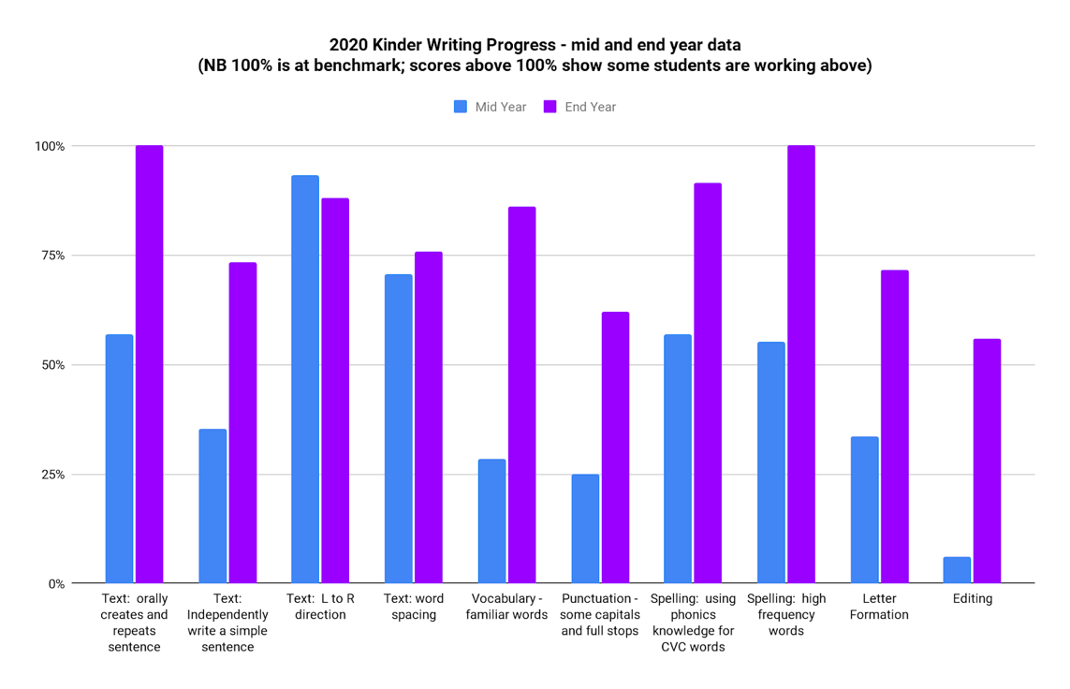
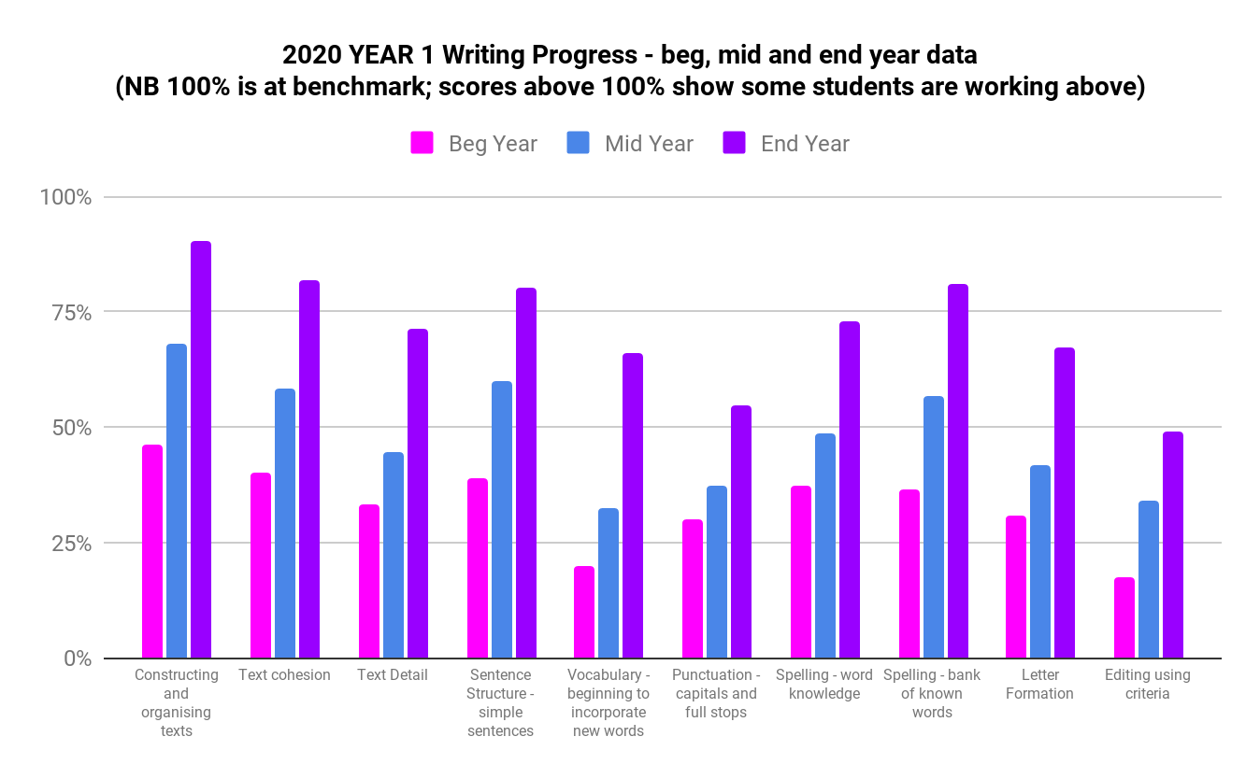

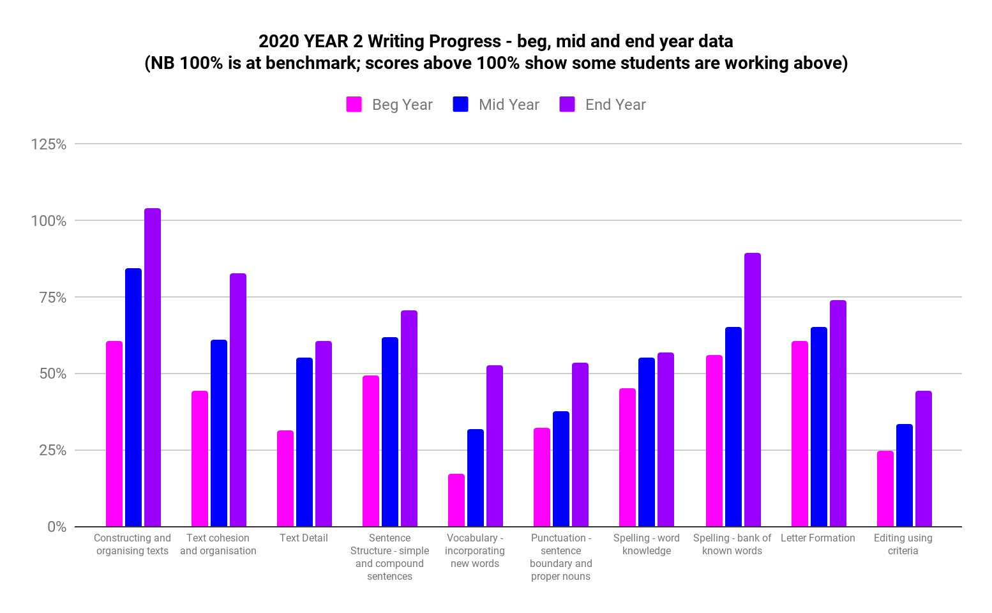
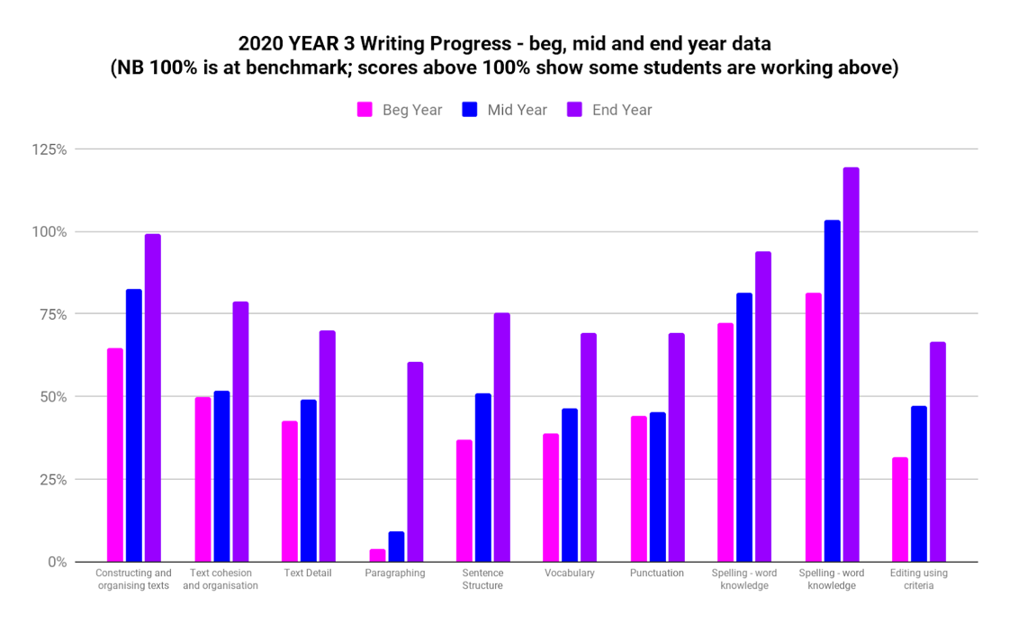
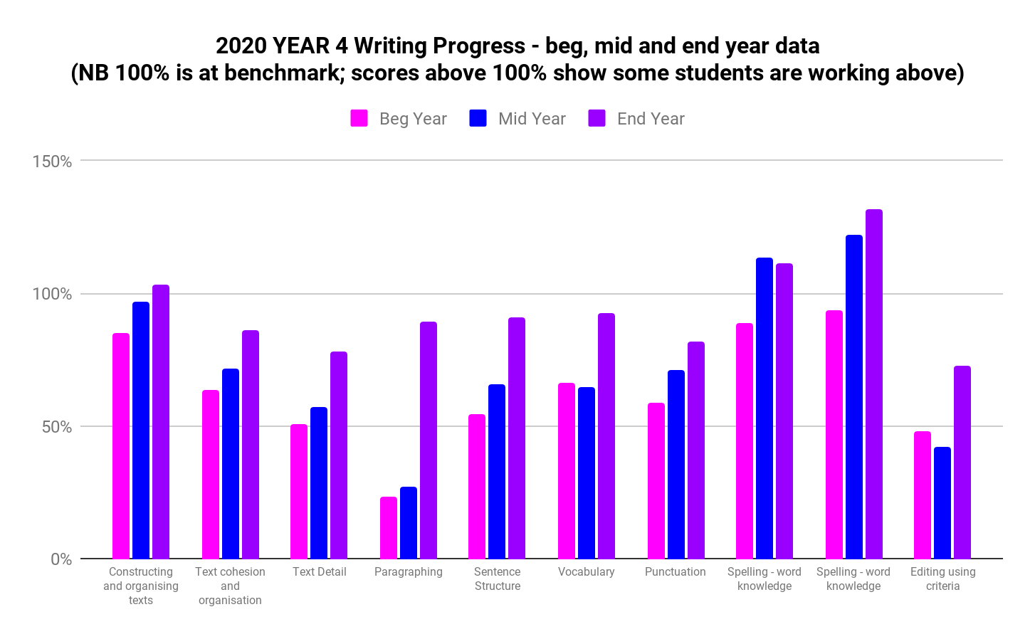
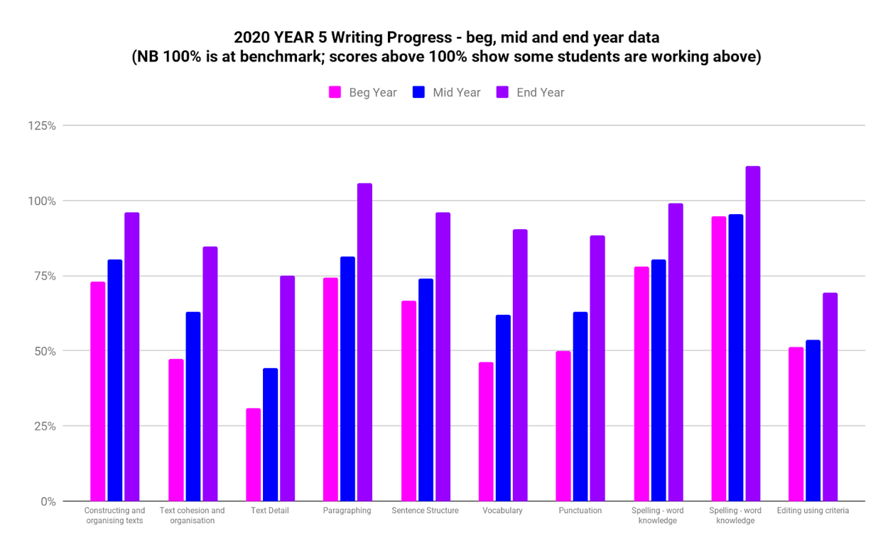
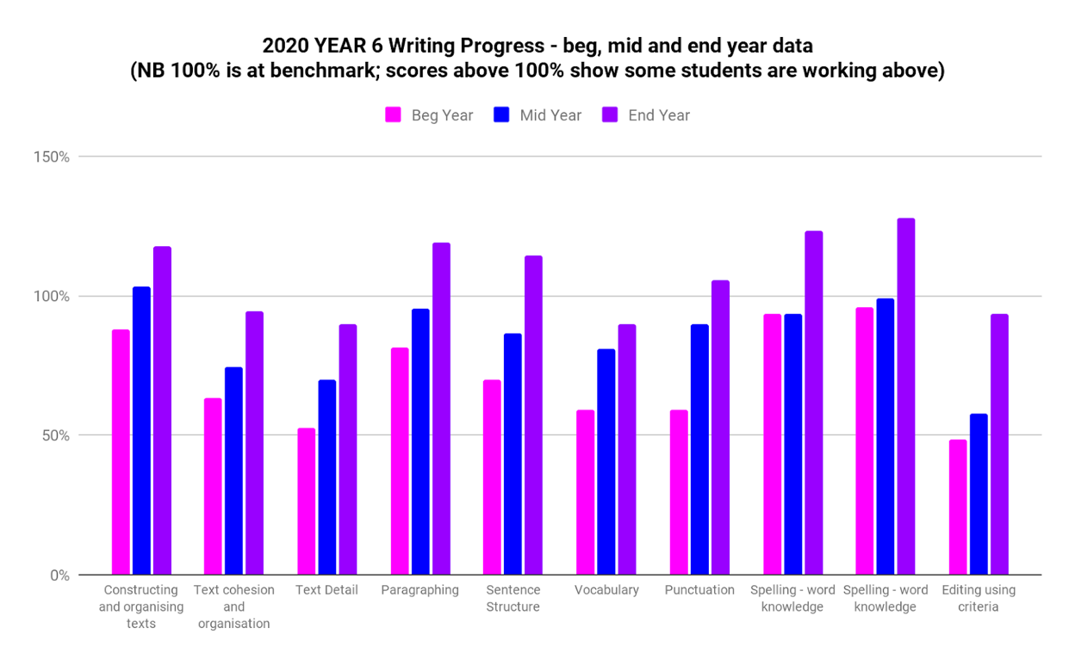

What this evidence tells us
There is no NAPLAN data for 2020. The data previously indicated that Gordon Primary School has made some progress towards the targets set for 2021. In general, in NAPLAN and PIPS there has been an inconsistent narrative of growth, dipping in 2019, after some gains in 2018.

There was a rise in the PIPs Numeracy data in 2018, following a dip in 2019. However, the system has moved to the BASE assessment tool instead of PIPs. This is not growth data but the percentage of children performing at or above expected level (85) is well over 90%. The school had planned on using a school-based Writing Assessment tool to measure student growth. Issues around the use of this tool as a way for statistically measuring growth saw the school continue to use NAPLAN data in 2019. In 2019 a more explicit and refined Gordon Writing Ruler was implemented and used with all students and that this gives teachers a more detailed and effective set of data with which to analyse student performance and plan learning. The use of this tool is continuing to be refined and it is giving teachers important formative data with which to improve pedagogy in writing. As indicated in the charts above, there has been consistent and significant growth in student’s mastery of relevant writing skills, as measured using the Gordon Primary Writing Tool. While a direct correlation can’t be drawn to NAPLAN data it is still a significant piece of school-based data that tracks growth and provides valuable formative data for teachers.

The 2020 data entry on Writing progress is ‘effect size.’ According to John Hattie’s work average growth is demonstrated by an effect size of 0.4. At Gordon, in 2020 the effect size for Writing, grades 1 to 6, is calculated to be 0.52, clearly showing better than average growth.

Our achievements for this priority
- The continued growth and success of Pedagogy meetings with a strong focus on:
  - Consistent, focussed and collaboratively conducted in-depth analysis of data and its application to improve the impact of teaching on student learning
  - Greater individualisation of learning
- Improved consistency and efficacy in pedagogy and data use across the school
- Successful and consistent implementation of the Gordon Primary Writing Tool, providing a:
  - Relevant measure for growth,
  - Valuable formative assessment tool and
  - quality data for assessing ongoing growth
- Coaching and mentoring of all teachers and executive staff

Challenges we will address in our next Action Plan
- Continue to enhance the work of the Pedagogy meetings with a view to improving outcomes in Reading, Writing and Mathematics
- Build the meta language of maths through explicit exposure to concepts in the early years

Priority 2: Improve students’ sense of satisfaction, enjoyment of learning and sense of wellbeing

Targets or measures
By the end of 2021 the school will have sustained for 2 years:
- 82 % positive responses to the statement ‘Teachers at my school treat students fairly’ within the Gordon Primary Yr 3-6 Student Satisfaction Survey having improved from a 76% positive response in 2016
- 80 % positive responses to the statement ‘I feel safe at School’ within the Gordon Primary Yr 3-6 Student Satisfaction Survey having improved from a 70% positive response in 2016
- 80 % positive responses to the statement ‘I can talk to teachers about my concerns’ within the Gordon Primary Yr 3-6 Student Satisfaction Survey having improved from a 67% positive response in 2016
- 65% positive responses to the statement ‘Student behaviour is well managed’ within the Gordon Primary Yr 3-6 Student Satisfaction Survey having improved from a 31% positive response in 2016
- 85 % positive responses to the statement ‘I like being at school’ within the Gordon Primary Yr 3-6 Student Satisfaction Survey having improved from a 72% positive response in 2016
- 85 % positive responses to the statement ‘The school celebrates the achievements of students’ within the Gordon Primary Yr 3-6 Student Satisfaction Survey having improved from a 70% positive response in 2016

In 2020 we implemented this priority through the following strategies.
- Plan for the explicit teaching and learning of Social Skills, values and Choice Theory concepts for all students. Including PBL lessons
- Empower Staff to support an optimal learning environment for every student all of the time (including social skilling, application of Choice Theory, Reality Therapy, restorative practices, etc.
- Establish an ongoing system to monitor students’ satisfaction and other student well-being information, including PBL systems for recognising positive behaviours
- Refine systems for student management processes.
- The ongoing celebration of student demonstration of Gordon Values including awards and recognition at Principal’s Lunches.

Perception Data
Targets or Measures  By the end of 2021 the school will have sustained for 2 years a/an: | Base  2016 | Year 1  2017 | Year 2  2018 | Year 3  2019 | Year 4  2020 | Year 5
82 % positive responses to the statement ‘Teachers at my school treat students fairly’ within the Gordon Primary Yr 3-6 Student Satisfaction Survey having improved from a 76% positive response in 2016 | 76% | 86% | 84% | 77% | 75%  13% were negative
80 % positive responses to the statement ‘I feel safe at School’ within the Gordon Primary Yr 3-6 Student Satisfaction Survey having improved from a 70% positive response in 2016 | 70% | 80% | 80% | 76% | 68%  13% were negative
80 % positive responses to the statement ‘I can talk to teachers about my concerns’ within the Gordon Primary Yr 3-6 Student Satisfaction Survey having improved from a 67% positive response in 2016 | 67% | 83% | 87% | 83% | 75%  11% were negative
65% positive responses to the statement ‘Student behaviour is well managed’ within the Gordon Primary Yr 3-6 Student Satisfaction Survey having improved from a 31% positive response in 2016 | 31% | 54% | 62% | 63% | 66%  18% were negative
85 % positive responses to the statement ‘I like being at school’ within the Gordon Primary Yr 3-6 Student Satisfaction Survey having improved from a 72% positive response in 2016 | 72% | 89% | 89% | 86% | 84%  5% were negative
85 % positive responses to the statement ‘The school celebrates the achievements of students’ within the Gordon Primary Yr 3-6 Student Satisfaction Survey having improved from a 70% positive response in 2016 | 70% | 95% | 91% | 93% | 85%  0% were negative

What this evidence tells us
In two of the items the school has met or exceeded the targets set for the completion of the plan in 2021. In the item ‘I like being at my school’ the positive response was at 84%, one percentage point below target. Interestingly only 5% of students responded negatively to this item. The negative responses in all of the items are relatively low with a bigger percentage being neutral or unsure. In many of these items the positive responses are close to or above the 2016 base. In the one item that had until 2020 been unable to see success, ‘Student behaviour is well managed’, the school has consistently improved from year to year and has now achieved this target, having risen from 31% in 2016, more than doubling that year’s response. There were 66% of responses that were positive, 3% up from last year and above the target by 1%. It is important to note that, with the exception of one item, these results are all above the system average for ACT primary schools.

Our achievements for this priority
- The embedding of a culture and learning environment where students are happy, seek and enjoy learning and feel safe and well.
- The excellent work of teachers and the wellbeing team,
- The ongoing consolidation of the Positive Behaviours for Learning program and other well-being initiatives (eg Lift Off),
- The Friendship Hub continues to be an important part of the wellbeing culture at Gordon
- Improved use of staff resources to support student exhibiting highly challenging needs and complex behaviours.

Challenges we will address in our next Action Plan
- Enhanced implementation of consistent, quality teaching of Positive Behaviours for Learning, focussing on ‘in classroom behaviour’, across the school.
- Implementation of the Be You program, aligned with PBL and Bounce Back
- Identify and address 2019 and 2020 decline in positive responses regarding safety
- Continue to build teacher’s skills in being able to have challenging conversations.

Priority 3: Develop collaborative learners who are curious and self-directed problem solvers

Targets or measures
- By the end of 2021 the school will achieve:
  - 90 % positive responses to the statement ‘At this school digital technologies help me to learn’ within the Gordon Primary Year 3-6 Student Satisfaction Survey, having improved from a 78% positive response in 2016
  - 90 % positive responses to the statement ‘Digital technologies help me to manage my schoolwork’ within the Gordon Primary Year 3-6 Student Satisfaction Survey
  - 90 % positive responses to the statement ‘I know how to be a good digital citizen’’ within the Gordon Primary Year 3-6 Student Satisfaction Survey
  - 90 % positive responses to the statement ‘My school gives me opportunities to do interesting things’ within the Gordon Primary Year 3-6 Student Satisfaction Survey, having improved from a 72% positive response in 2016

In 2020 we implemented this priority through the following strategies.
- Develop and implement a structured approach to student directed play-based and project-based learning.
- Beginning to equip students with the digital literacies and problem-solving skills that will enable 21 Century capabilities.

Below is our progress towards our five-year targets with an emphasis on the accumulation and analysis of evidence over the term of our plan.

Student learning data
Targets or Measures:  By the end of 2021 the school will have sustained for 2 years a/an: | Base  2016 | Year 1  2017 | Year 2  2018 | Year 3  2019 | Year 4 | Year 5
90 % positive responses to the statement ‘At this school digital technologies help me to learn’ within the Gordon Primary Year 3-6 Student Satisfaction Survey, having improved from a 78% positive response in 2016 | 78% | 96% | na | 95.1% | 90%  2% were negative
90 % positive responses to the statement ‘Digital technologies help me to manage my schoolwork’ within the Gordon Primary Year 3-6 Student Satisfaction Survey | na | na | na | 92% | 86%  2% were negative
90 % positive responses to the statement ‘I know how to be a good digital citizen’’ within the Gordon Primary Year 3-6 Student Satisfaction Survey | na | na | na | 95% | 91%  0% were negative
90 % positive responses to the statement ‘My school gives me opportunities to do interesting things’ within the Gordon Primary Year 3-6 Student Satisfaction Survey, having improved from a 72% positive response in 2016 | 72% | 94% | 93 % | 92% | 90%  5% were negative

What this evidence tells us
The data indicate that Gordon Primary School has made significant gains since 2016, even though this is a new priority for the school. In 2020 90 percent of students rated the school positively in three of the four target areas. In the three questions relating to digital technologies data have not been consistently collected so trends are difficult to determine. However, a 2020 positive response rate over 90 percent is very pleasing, noting that the objective was to achieve these outcomes over a two-year period. While the four years of positive responses in the nineties is rewarding the school is looking to maintain that high base. A significant point to note is that where data have been collected the school has improved, since 2016 by more than 15 percent in positive responses to two of the questions. There has been a slight drop in all items with positive responses for the item ‘Digital technologies help me to manage my schoolwork’ dropping to 86%. Interestingly, the negative response in all of these items is extremely low, ranging between 0 and 5 percent. Another fact of note is that all these results are well in excess (8 to 13 percent above) of the ACT average against these items.

Our achievements for this priority
- All teaching staff participated in Digital Technologies Professional Learning and have received classroom support.
- Exposure and upskilling in understanding of Digital Technology curriculum.
- There has been notable improvement in staff confidence regarding teaching Digital Technologies.
- The establishment of a “Creator Space”
- Systems are in place to meet project-based learning – including ensuring that students continue to undergo transformative learning by working through the ‘Learning by Design’ knowledge processes.

Challenges we will address in our next Action Plan
- Maintaining the momentum from the Digital Technologies in Focus (TGiF) Project
- Effectively supporting teachers to implement the Digital Technologies curriculum in their classrooms.
- Improving integration of Digital Technologies with other curriculum areas
- Finding ways to measure success in developing curious and creative learners.
- Documentation of learning outcomes in the Digital Technology Curriculum, Play-based learning and Project-based learning.
- Refined teaching of Australian Curriculum Capabilities

Reporting on preschool improvement
All schools with a preschool setting are required to annually review and update their Quality Improvement Plan*. Schools have a choice to either report against their QIP using the Directorate template or to report progress here.
The report on the Gordon Preschool Quality Improvement Plan is provided on a separate document. The report on the QIP is available on request.
*A copy of the QIP is available for viewing at the school.

