

Macquarie Primary School

Annual School Board Report

2018

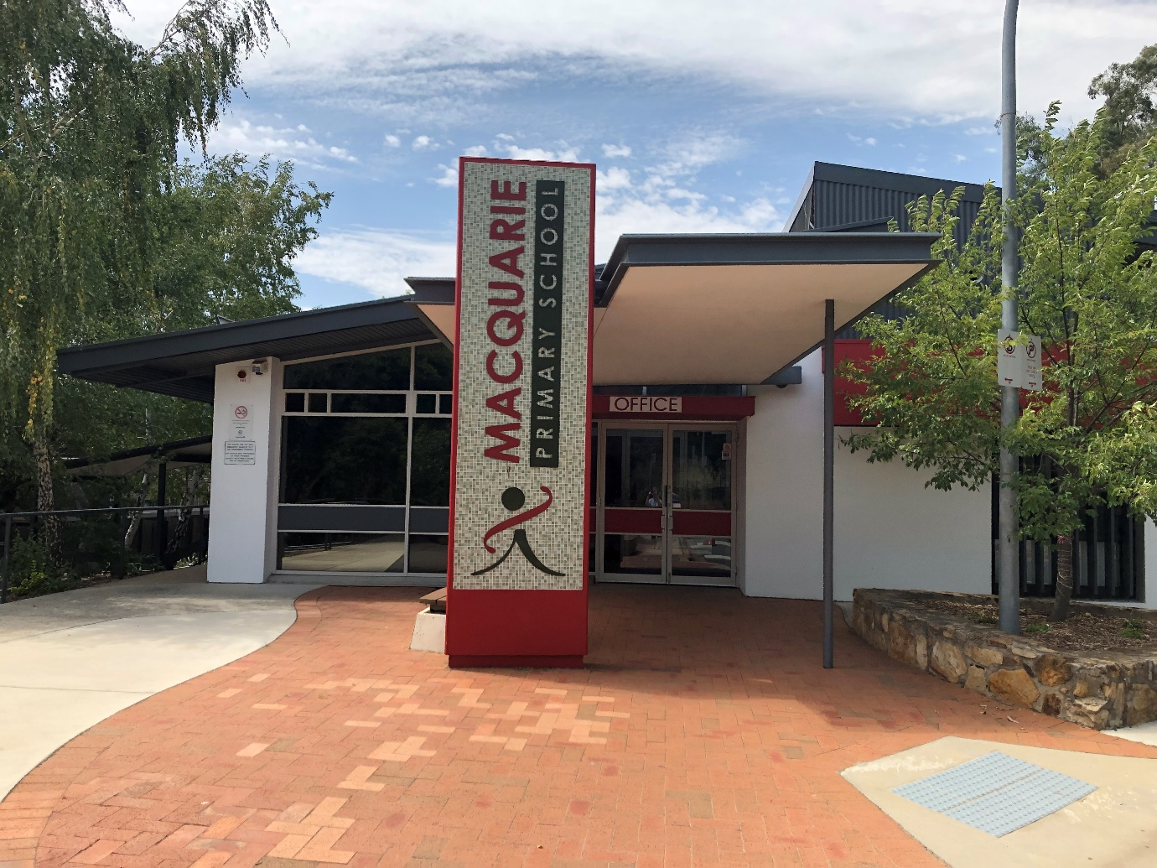

This page is intentionally left blank.



This report supports the work being done in the ACT Education Directorate, as outlined in *Strategic Plan 2018-21: A Leading Learning Organisation*.

Accessibility

The ACT Government is committed to making its information services, events and venues accessible to as many people as possible.

If you have difficulty reading a standard document and would like to receive this publication in an alternate format, such as large print and audio, please telephone (02) 6247 4580.

If English is not your first language and you require the translating and interpreting service, please telephone 13 14 50.

If you are deaf or hearing impaired and require the National Relay Service, please telephone 13 36 77.

© Australian Capital Territory, Canberra, 2018

Material in this publication may be reproduced provided due acknowledgement is made.

Contents

Reporting to the community 1

Summary of School Board activity 1

School Context 1

Student Information 1

Student enrolment 1

Student attendance 2

Supporting attendance and managing non-attendance 2

Staff Information 3

Teacher qualifications 3

Workforce composition 3

School Review and Development 3

School Satisfaction 4

Overall Satisfaction 4

Learning and Assessment 6

Performance in Literacy and Numeracy 6

Early years assessment 6

NAPLAN 6

Outcomes for College Students 7

Post School Destination 7

Financial Summary 9

Voluntary Contributions 10

Reserves 10

Endorsement Page 11

Members of the School Board 11

# Reporting to the community

School report to communities in range of ways, including through:

* Annual School Board Reports
* a (5-year) School Improvement Plan (formerly School Strategic Plan)
* annual Impact Reports/ Annual Action Plan Reports
* newsletters
* other sources such as My School.

# Summary of School Board activity

2018 was a monumental year for Macquarie Primary School as we celebrated our 50th anniversary. As one of the oldest schools in the Belconnen area, Macquarie Primary continues to be an inclusive, multicultural school that supports our children to learn and grow. We celebrated our anniversary through a number of special events including a birthday celebration at the school in November. This included the launch of a book commemorating the anniversary and an Australian Rules Football match between the former Macquarie Demons team and a team made up of staff and parents (as a member of the staff and parents team we won’t talk about the result…). We look forward to the next 50 years.

As stated in the Board Chair’s introduction to last year’s annual report, at the end of 2017 we farewelled our former Principal Wendy Cave as she moved to continue her career at Ainslie Primary School. Danielle Porter commenced as our new Principal in Term 2 of 2018. I would like to thank Sophie Bissell for doing a great job acting as Principal between Wendy’s departure and Danielle’s arrival. Danielle is off to a great start as our Principal as she, along with staff and the Board, implements the recommendations of the recently completed External School Review (see below). I particularly recognise Danielle’s commitment to working with the school community, including the P&C, through holding open days and evenings on specific topics of interest and seeking feedback from the community.

The change in Principal coincided with a change in senior staffing arrangements. In 2018, we farewelled Sophie Bissell, Amanda Hawkins and Jim Gray and welcomed Jodie Rowell as Deputy Principal and Stacey Naden to the Executive team. Thank you to Sophie, Amanda and Jim for their service and commitment to Macquarie Primary.

As noted above, Macquarie Primary underwent its four-yearly External School Review during 2018. I would encourage everyone to have a read of the summary of the report which is available on the school’s website. The commendations, affirmations and recommendations provide a clear way forward for continually improving our school. I would like to thank the reviewers for the extensive consultation they undertook with the Board, students, the school community and staff.

2018 also saw the finalisation of the school’s Strategic Plan for 2018-23 - the next five-year planning cycle. The plan was the result of extensive consultation and data analysis. The Strategic Plan focuses on growth in learning for each student in literacy and numeracy and the development of whole school practices and process in managing behaviour and the curriculum. Again, I would encourage everyone to read the Plan and how the school plans to achieve the objectives.

The Board would like to particularly thank the volunteers from our community who do so much to support the school, particularly in supporting our 50th birthday celebrations. The commitment and dedication of parents and carers volunteering in committee positions, the uniform shop, book club, and in so many activities such as and Mothers’ and Fathers’ Day stalls, discos and the quiz night.

The school board has membership from executive and teaching staff, parents and the community. In 2018, the School Board comprised: Mark Roddam (Chair), Sarah Hollis-Bennetts (Deputy Chair), Janet Hope, Danielle Porter, Justine Fuller, Ami Grover and Karen Tozer.

I have greatly enjoyed my time as Board Chair and I wish the Board well in 2019.

Mark Roddam

Macquarie Primary School Board Chair

# School Context

Macquarie Primary School offers quality education for students from preschool to year 6. Situated in Belconnen in the north west of Canberra it has a current enrolment of 370 students. Macquarie has a reputation as a community school where students parents and the broader community work together with a dedicated professional team to ensure every child achieves success. With families from around the world the school is proudly multicultural. The core values of acceptance, cooperation, honesty, kindness, respect and responsibility place a strong focus on quality relationships throughout the inclusive learning community. While respecting the many traditions established over Macquarie’s 50 year history the school continues to embrace change through improvement focused innovation. As part of the ongoing commitment to achieving the highest standards students, staff and the community regularly review our progress and future directions. In addition to a targeted focus on literacy and numeracy students have access a variety of authentic learning experiences enabling real world application of school based experiences. Macquarie Primary School nurtures creativity and curiosity and inquiry is embedded in the learning philosophy. Teachers at Macquarie focus on the whole child developing each student as a learner, community member and contributor to our society. The school places a strong emphasis on personal and physical health and wellbeing through community initiatives and building strong social and learning skills. Students benefit from a high level of volunteer engagement through many community members supporting a range of literacy, technology and wellbeing initiatives. Specialist music programs have been a longstanding feature of the school and students at Macquarie enjoy access to the Education Directorate’s Instrumental Music Program. Macquarie Primary School enjoys close rapport with neighbouring schools and is supported by cross age literacy, physical education and science initiatives at Canberra High School and University of Canberra Senior Secondary College Lake Ginninderra.

## Student Information

### Student enrolment

In 2018 there were a total of 353 students enrolled at this school.

Table: 2018 Student enrolment

|  |  |
| --- | --- |
| **Student type** | **Number of students** |
| Male | 183 |
| Female | 170 |
| Aboriginal and Torres Strait Islander | 16 |
| LBOTE* | 138 |

*Language Background Other Than English

Source: Analytics and Evaluation, December 2018

### Student attendance

The following table identifies the attendance rate of students by year level during 2018. Student attendance rate is the percentage of school days attended by students in each year level at the school. Student attendance is measured over two school terms; that is from the first day of the school year for students in term 1 to the last day of term 2.

Table: 2018 Attendance rates in percentages*

|  |  |
| --- | --- |
| **Year level** | **Attendance rate** |
| 1 | 92.0 |
| 2 | 90.0 |
| 3 | 91.0 |
| 4 | 92.0 |
| 5 | 87.0 |
| 6 | 90.0 |

Source: Analytics and Evaluation, December 2018

* Attendance data for 2018 have been derived from a school administration system in the process of implementation. Care should be taken when comparing these data with data from previous years and from other jurisdictions.

## Supporting attendance and managing non-attendance

All ACT public schools put into effect the education participation requirements in the *Education Act 2004* and the responsibilities of schools in relation to compulsory education. The Education Directorate’s *Education Participation (Enrolment and Attendance) Policy* describes its position with regard to supporting attendance and managing non-attendance. A suite of procedures supports the implementation of the policy. Please refer to <https://www.education.act.gov.au/> for further details.

## Staff Information

### Teacher qualifications

All teachers at this school meet the professional requirements for teaching in an ACT public school. The ACT Teacher Quality Institute (TQI) specifies two main types of provision for teachers at different stages of their career, these are detailed below.

* ***Full registration*** is for teachers with experience working in a registered school in Australia or New Zealand who have been assessed as meeting the Proficient level of the Australian Professional Standards for Teachers.
* ***Provisional registration*** is for newly qualified teachers or teachers who do not have recent experience teaching in a school in Australia and New Zealand. Many teachers moving to Australia from another country apply for Provisional registration.

### Workforce composition

Workforce composition for the year of reporting is highlighted in the following table. The data is taken from the school’s verified August staffing report. For reporting purposes it incorporates all school staff including preschools, staff absent for a period of less than four consecutive weeks and staff replacing staff absent for more than four consecutive weeks. It does not include casuals and staff absent for a period of four consecutive weeks or longer.

The Education Directorate is required to report Aboriginal and Torres Strait Islander staff figures. As of June 2018, 101 Aboriginal and Torres Strait Islander staff members were employed across the Directorate.

Table: 2018 Workforce composition numbers

|  |  |
| --- | --- |
| **Staff employment category** | **TOTAL** |
| Teaching Staff: Full Time Equivalent Permanent | 17.70 |
| Teaching Staff: Full Time Equivalent Temporary | 2.60 |
| Non Teaching Staff: Full Time Equivalent | 9.87 |

Source: This data is from the 2018 August census date and is calculated using the parameters provided by the ABS.

# School Review and Development

The ACT Education Directorate’s Strategic Plan 2018-2021 provides the framework and strategic direction for School Improvement Plans (formerly School Strategic Plans). This is supported by the school performance and accountability framework, ‘*People, Practice and Performance: School Improvement in Canberra Public Schools, A Framework for Performance and Accountability’*. This framework has school improvement at its centre, with the National School Improvement Tool (NSIT) as its core feature, providing support to achieve high standards in student learning, innovation and best practice in ACT public schools.

Prior to 2016 all ACT public schools participated in a four-year cycle of school review and development. In the fourth year schools underwent an external validation process. In 2016 this changed to a five-year cycle with an External School Review at the end.

Our school was reviewed in 2018. A copy of the Review Report Summary can be found on our school website.

## School Satisfaction

Schools use a range evidence to gain an understanding of the satisfaction levels of their parents and carers, staff and students. In August/ September of this reporting period ACT schools undertook a survey to gain an understanding of school satisfaction at that time. This information was collected from Staff, parents and students from year 5 and above (with the exception of students in special schools) through an online survey.

## Overall Satisfaction

In 2018, 85% of parents and carers, 56% of staff, and 72% of students at this school indicated they were satisfied with the education provided by the school.

Included in the survey were 16 staff, 14 parent, and 12 student items which are described as the national opinion items. These items were approved by the then Standing Council on School Education and Early Childhood (SCSEEC) for use from 2015. The following tables show the percentage of parents and carers, students and staff who agreed with each of the national opinion items at this school.

A total of 26 staff responded to the survey. Please note that not all responders answered every question.

Table: Proportion of staff in agreement with each national opinion item

|  |  |  |
| --- | --- | --- |
| **National opinion item** | |  | | --- | | Proportion of staff | |
| Teachers at this school expect students to do their best. | 96 |
| Teachers give useful feedback. | 73 |
| Teachers at this school treat students fairly. | 88 |
| This school is well maintained. | 27 |
| Students feel safe at this school. | 52 |
| Students at this school can talk to their teachers about their concerns. | 96 |
| Parents at this school can talk to teachers about their concerns. | 92 |
| Student behaviour is well managed at this school. | 23 |
| Students like being at this school. | 88 |
| This school looks for ways to improve. | 69 |
| This school takes staff opinions seriously. | 72 |
| Teachers at this school motivate students to learn. | 84 |
| Students’ learning needs are being met at this school. | 63 |
| This school works with parents to support students' learning. | 88 |
| Staff get quality feedback on their performance | 33 |
| Staff are well supported at this school. | 48 |

Source: 2018 School Satisfaction Surveys, August/September 2018

*Prior to 2018, the item wording and placement was slightly different.

A total of 190 parents responded to the survey. Please note that not all responders answered every question.

Table: Proportion of parents and carers in agreement with each national opinion item

|  |  |  |
| --- | --- | --- |
| **National opinion item** | |  | | --- | | Proportion of parents and carers | |
| Teachers at this school expect my child to do his or her best. | 92 |
| Teachers give useful feedback. | 85 |
| Teachers at this school treat students fairly. | 87 |
| This school is well maintained. | 76 |
| My child feels safe at this school. | 88 |
| I can talk to my child’s teachers about my concerns. | 95 |
| Student behaviour is well managed at this school. | 70 |
| My child likes being at this school. | 92 |
| This school looks for ways to improve. | 82 |
| This school takes parents’ opinions seriously. | 74 |
| Teachers at this school motivate my child to learn. | 90 |
| My child is making good progress at this school. | 80 |
| My child's learning needs are being met at this school. | 76 |
| This school works with me to support my child's learning. | 75 |

Source: 2018 School Satisfaction Surveys, August/September 2018

*Prior to 2018, the item wording and placement was slightly different.

A total of 98 students responded to the survey. Please note that not all responders answered every question.

Table: Proportion of students in years 5 to 6 in agreement with each national opinion item

|  |  |  |
| --- | --- | --- |
| **National opinion item** | |  | | --- | | Proportion of students | |
| My teachers expect me to do my best. | 95 |
| Teachers give useful feedback. | 69 |
| Teachers at my school treat students fairly. | 53 |
| My school is well maintained. | 47 |
| I feel safe at this school. | 51 |
| I can talk to my teachers about my concerns. | 75 |
| Student behaviour is well managed at my school. | 22 |
| I like being at my school. | 70 |
| My school looks for ways to improve. | 68 |
| Staff take students’ opinions seriously. | 70 |
| My teachers motivate me to learn. | 82 |
| My school gives me opportunities to do interesting things. | 77 |

Source: 2018 School Satisfaction Surveys, August/September 2018

*Prior to 2018, the item wording and placement was slightly different.

These results, as well as the continual review of school performance, contributed to the evaluation of our Strategic Plan and the development of Annual Action Plans. The Strategic Plan (or School Improvement Plan) is available on the school website.

# Learning and Assessment

## Performance in Literacy and Numeracy

### Early years assessment

Students in kindergarten undertake an on-entry assessment of their early reading and numeracy skills using the Performance Indicators in Primary Schools (PIPS) program. Student results are reported against five performance bands at the end of semester 1 and 2. Below are the results for this school.

***Table: Macquarie Primary School PIPS 2018 mean raw scores***

|  |  |  |  |  |
| --- | --- | --- | --- | --- |
| **Agency** | **Reading start** | **Reading end** | **Mathematics start** | **Mathematics end** |
| **School** | 45 | 114 | 39 | 53 |
| **ACT** | 49 | 124 | 39 | 54 |

Source: Analytics and Evaluation

Results are not reported when there are fewer than five students with results. This rule is applied for reasons of statistical reliability, as well as to protect the privacy of students in small schools.

The following table shows the mean scores achieved by students at this school compared to the ACT for this reporting period.

***Table: Macquarie Primary School 2018 NAPLAN Mean Scores***

|  |  |  |  |  |
| --- | --- | --- | --- | --- |
| **Test Domain** | **Year 3 School** | **Year 3 ACT** | **Year 5 School** | **Year 5 ACT** |
| **Reading** | 421 | 441 | 487 | 518 |
| **Writing** | 395 | 411 | 423 | 460 |
| **Spelling** | 392 | 410 | 454 | 494 |
| **Grammar & Punctuation** | 421 | 438 | 477 | 510 |
| **Numeracy** | 400 | 416 | 481 | 494 |

Source: Analytics and Evaluation

# Financial Summary

The school has provided the Directorate with an end of year financial statement that was approved by the school board. Further details concerning the statement can be obtained by contacting the school. The following summary covers use of funds for operating costs and does not include expenditure in areas such as permanent salaries, buildings and major maintenance.

Table: Financial Summary

|  |  |  |  |
| --- | --- | --- | --- |
| **INCOME** | **January-June** | **July-December** | **January-December** |
| Self-management funds | 189,651.61 | 162,743.91 | 352,395.52 |
| Voluntary contributions | 9,110.00 | 350.00 | 9,460.00 |
| Contributions & donations | 2,746.90 | 3,820.00 | 6,566.90 |
| External income (including community use) | 12,011.30 | 5,478.55 | 17,489.85 |
| Proceeds from sale of assets | 0.00 | 0.00 | 0.00 |
| Bank Interest | 2,577.78 | 2,831.07 | 5,408.85 |
| **TOTAL INCOME** | 216,097.59 | 175,223.53 | 391,321.12 |
| **EXPENDITURE** |  |  |  |
| Utilities and general overheads | 32,673.29 | 38,165.67 | 70,838.96 |
| Cleaning | 41,417.71 | 43,097.04 | 84,514.75 |
| Security | 873.24 | 0.00 | 873.24 |
| Maintenance | 15,833.87 | 20,672.73 | 36,506.60 |
| Administration | 18,259.73 | 18,476.46 | 36,736.19 |
| Staffing | 0.00 | 0.00 | 0.00 |
| Communication | 718.08 | 653.23 | 1,371.31 |
| Assets | 8,712.78 | 4,902.62 | 13,615.40 |
| Leases | 0.00 | 0.00 | 0.00 |
| General office expenditure | 27,746.66 | 21,416.91 | 49,163.57 |
| Educational | 17,668.30 | 11,726.20 | 29,394.50 |
| **TOTAL EXPENDITURE** | 163,903.66 | 159,110.86 | 323,014.52 |
| **OPERATING RESULT** | 52,193.93 | 16,112.67 | 68,306.60 |
| **Actual** Accumulated Funds | 4,280.81 | 12,393.08 | 9,393.08 |
| Outstanding commitments (minus) | -34,116.99 | 0.00 | -34,116.99 |
| **BALANCE** | 22,357.75 | 28,505.75 | 43,582.69 |

## Voluntary Contributions

The funds listed were used to support the general operations of the school. The spending of voluntary contributions is in line with the approved budget for 2018.

## Reserves

|  |  |  |
| --- | --- | --- |
| Name and Purpose | Amount | Expected Completion |
| **Painting 2019**  This reserve was created to fund the painting of classrooms to improve the aesthetics of the school. | $20,000 | January 2019 |
| **VOIP Phone system**  This reserve was intended to fund the upgrade of the phone system within the school. This work has since been completed and was funded by the Directorate. This reserve will be transferred to accumulated funds in 2019. | $3,000 | January 2019 |
| **Outdoor Learning Environment 2020**  This reserve is to fund improvements to the landscape of the school grounds to enhance the functionality and the aesthetics of the school playground. The project is also enhancing community involvement through working groups formed to design and construct the landscape. | $47,000 | Ongoing throughout 2019-2020 |
| **Bike Ed program shed 2019**  This reserve is to fund a purpose-built bike storage and workshop shed. Riding skills and bike safety are taught as part of the school program, improving health and safety outcomes for our students. | $10,000 | September 2019 |
| **Additional Staffing Allocation**  This reserve is created to fund any possible shortfall in staffing allocation during 2019. | $40,000 | December 2019 |

# Endorsement Page

## Members of the School Board

|  |  |  |  |
| --- | --- | --- | --- |
| Parent Representative(s): | Janet Hope, | Sarah Hollis-Bennets, | Mark Roddam |
| Teacher Representative(s): | Justine Fuller, | Ami Grover. |  |
| Board Chair: | Mark Roddam |  |  |
| Principal: | Danielle Porter |  |  |

I approve the report, prepared in accordance with the provision of the ACT *Education Act* *2004*, section 52.

|  |  |  |  |
| --- | --- | --- | --- |
| Board Chair Signature: | Mark Roddam | Date: | 20/05/2019 |

I certify that to the best of my knowledge and belief the evidence and information reported in this Annual School Board Report represents an accurate record of the Board’s operations during this reporting period.

|  |  |  |  |
| --- | --- | --- | --- |
| Principal Signature: | Danielle Porter | Date: | 20/05/2019 |