Narrabundah College
Annual School Board Report
2019

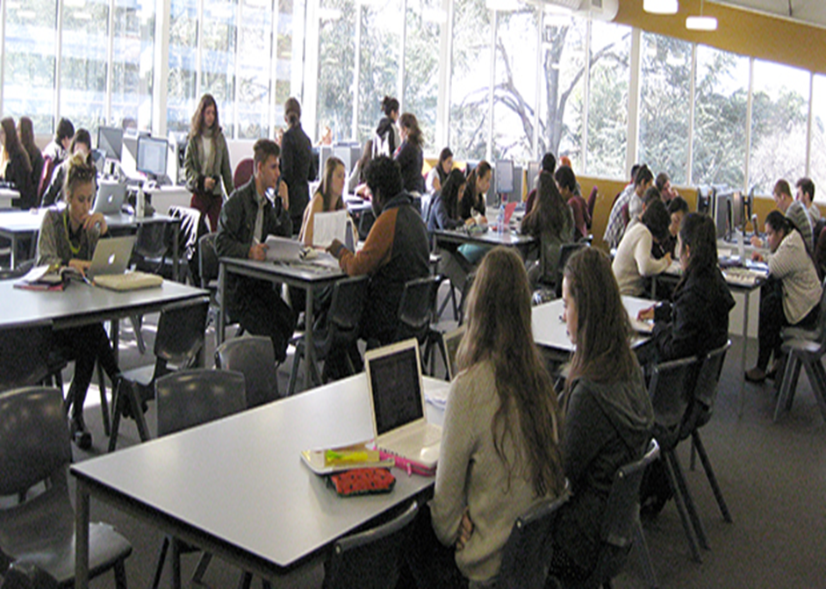

This page is intentionally left blank.

This report supports the work being done in the ACT Education Directorate, as outlined in Strategic Plan 2018-21: A Leading Learning Organisation.

Accessibility
The ACT Government is committed to making its information services, events and venues accessible to as many people as possible.
If you have difficulty reading a standard document and would like to receive this publication in an alternate format, such as large print and audio, please telephone (02) 6247 4580.
If English is not your first language and you require the translating and interpreting service, please telephone 13 14 50.
If you are deaf or hearing impaired and require the National Relay Service, please telephone 13 36 77.
© Australian Capital Territory, Canberra, 2020

Material in this publication may be reproduced provided due acknowledgement is made.

Contents
Reporting to the community 1
Summary of School Board activity 1
School Context 1
Student Information 2
Student enrolment 2
Supporting attendance and managing non-attendance 3
Staff Information 3
Teacher qualifications 3
Workforce composition 3
School Review and Development 4
School Satisfaction 4
Overall Satisfaction 4
Learning and Assessment 6
Outcomes for College Students 6
Post School Destination 6
Financial Summary 8
Voluntary Contributions 9
Reserves 9
Endorsement Page 10
Members of the School Board 10

Reporting to the community
Schools report to communities in range of ways, including through:
- Annual School Board Reports
- a (5-year) School Improvement Plan (formerly School Strategic Plan)
- annual Impact Reports
- newsletters
- other sources such as My School.

Summary of School Board activity
- Education Directorate Strategic Plan 2018-2021 discussed.
- College’s Annual Action Plan presented: staff to focus on quality teaching and learning; feedback now embedded and continues to be an ongoing focus in all classes.
- All staff undertook an Action Research Project to focus on improving student outcomes through quality teaching and learning.
- Professional Learning Communities (PLCs) expanded further to maintain focus on teacher practice to improve teaching and student learning.
- The College Modernisation Program continued into 2019. Communication Link was employed by the Education Directorate to consult our community about what is important to this college to maintain its culture, academic reputation and strong community support.

School Context

Narrabundah College is a large and vibrant government co-educational college nestled in beautiful grounds located near the parliamentary triangle. The college has over 945 students in years 11 and 12 and offers a challenging curriculum in a caring environment to meet the needs of students in a globalised world. Narrabundah College has an international atmosphere with over 30% of our students born overseas.
The college’s diverse curriculum includes nine languages offered at Beginning, Continuing and Advanced levels. In 2019 the languages offered were: Chinese, French, German, Hindi, Indonesian, Italian, Japanese, Korean and Spanish with over 500 students studying a second language.
In addition to the ACT Year 12 Certificate, the college offers the International Baccalaureate (IB) Diploma and the French Baccalauréat. Narrabundah College was the first school in Australasia to deliver the IB program and it has been delivering this curriculum successfully for over 30 years.
The college has maintained a tradition of success and offers a broad and academically rigorous curriculum that is carefully designed to enhance students’ skills in research, critical thinking, communication and self-management in a focused and supportive environment. Study Hub was introduced in 2013: this resource continues to be accessed by large numbers of students to improve their study skills and support their learning.
Narrabundah College challenges national trends in Maths, Science and Languages in that we have significant numbers of students studying these subjects. In 2019, 221 year 11 students and 139 year 12 students studied Specialist Options and/or Core Maths (the highest levels in Maths); 141 students studied Physics and 286 students studied Chemistry over the 2 years and a further 505 students studied Biology, Human Biology, Forestry and the Exercise Sciences. Over 500 students studied a second language.
In 2019, 50 year 11 students were offered places at ANU Extension and 51 year 12 students completed their chosen course.
Further, in our environment, students are also encouraged to become significant contributors to society and take up challenges in areas such as: leadership, supporting charities, managing and improving the environment, debating, value adding to the local community, participating in sports and much more.
Narrabundah College recognises the special needs of students in the challenging senior secondary years and we continue to provide a safe, supportive and caring environment that fosters each student’s personal growth. Our well-resourced Student Services Team advises students on course and careers counselling as well as monitoring and supporting students in their welfare, academic progress and student pathways planning during their two years at this college.
In 2019, the college continued to strengthen and promote the strong partnerships with our parents/carers and the community. For example: The Parent/Student/Teacher year 11 interviews are now embedded in our calendar to take place in December each year.
The college has an active P & C who ran another very successful fund-raising Sausage Sizzle at Bunnings which was well supported by our community.

Student Information

Student enrolment
In this reporting period there were a total of 931 students enrolled at this school.
Table: Student enrolment
Student type | Number of students
Male | 424
Female | 507
Aboriginal and Torres Strait Islander | 8
LBOTE* | 520
Source: ACT Education Directorate, Analytics and Evaluation Branch
*Language Background Other Than English

Supporting attendance and managing non-attendance
ACT public schools support parents and carers to meet their legal responsibilities in relation to the compulsory education requirements of the Education Act 2004. The Education Directorate’s Education Participation (Enrolment and Attendance) Policy describes its position with regard to supporting attendance and managing non-attendance. A suite of procedures supports the implementation of the policy. Please refer to https://www.education.act.gov.au/ for further details.

Staff Information

Teacher qualifications
All teachers at this school meet the professional requirements for teaching in an ACT public school. The ACT Teacher Quality Institute (TQI) specifies two main types of provision for teachers at different stages of their career, these are detailed below.
- Full registration is for teachers with experience working in a registered school in Australia or New Zealand who have been assessed as meeting the Proficient level of the Australian Professional Standards for Teachers.
- Provisional registration is for newly qualified teachers or teachers who do not have recent experience teaching in a school in Australia and New Zealand. Many teachers moving to Australia from another country apply for Provisional registration.

Workforce composition
Workforce composition for the current reporting period is provided in the following table. The data is taken from the school’s verified August staffing report. For reporting purposes, it incorporates all school staff including preschools, staff absent for a period of less than four consecutive weeks and staff replacing staff absent for more than four consecutive weeks. It does not include casuals and staff absent for a period of four consecutive weeks or longer.
The Education Directorate is required to report Aboriginal and Torres Strait Islander staff figures. As of June of the reporting period, 119 Aboriginal and/or Torres Strait Islander staff members were employed across the Directorate.
Table: Workforce composition numbers
Staff employment category | TOTAL
Teaching Staff: Full Time Equivalent Permanent | 53.35
Teaching Staff: Full Time Equivalent Temporary | 5.85
Non Teaching Staff: Full Time Equivalent | 16.05
Source: ACT Education Directorate, People and Performance Branch

School Review and Development
The ACT Education Directorate’s Strategic Plan 2018-2021 provides the framework and strategic direction for School Improvement Plans (formerly School Strategic Plans). This is supported by the school performance and accountability framework ‘People, Practice and Performance: School Improvement in Canberra Public Schools, A Framework for Performance and Accountability’. Annually, system and school level data are used alongside the National School Improvement Tool to support targeted school improvement, high standards in student learning, innovation and best practice in ACT public schools.
Prior to 2016 all ACT public schools participated in a four-year improvement cycle. In the fourth year schools underwent an external Validation process. In 2016 this changed to a five-year cycle with a School Review at the end.
Our school will be reviewed in October 2020. A copy of the most recent Validation Report can be found on our school website.

School Satisfaction
Schools use a range evidence to gain an understanding of the satisfaction levels of their parents and carers, staff and students. Annually in August/ September ACT schools undertake a survey to gain an understanding of school satisfaction at that time. This information is collected from staff, parents and students from year 5 and above through an online survey.

Overall Satisfaction
In this period of reporting, 82% of parents and carers, 96% of staff, and 85% of students at this school indicated they were satisfied with the education provided by the school.
Included in the survey were 16 staff, 14 parent, and 12 student items which are described as the national opinion items. These items were approved by the then Standing Council on School Education and Early Childhood (SCSEEC) for use from 2015. The following tables show the percentage of parents and carers, students and staff who agreed with each of the national opinion items at this school.
A total of 52 staff responded to the survey. Please note that not all responders answered every question.
Table: Proportion of staff in agreement with each national opinion item
National opinion item | Proportion of staff
Parents at this school can talk to teachers about their concerns. | 91
Staff are well supported at this school. | 81
Staff get quality feedback on their performance. | 79
Student behaviour is well managed at this school. | 89
Students at this school can talk to their teachers about their concerns. | 94
Students feel safe at this school. | 93
Students like being at this school. | 96
Students’ learning needs are being met at this school. | 85
Teachers at this school expect students to do their best. | 98
Teachers at this school motivate students to learn. | 93
Teachers at this school treat students fairly. | 94
Teachers give useful feedback. | 89
This school is well maintained. | 57
This school looks for ways to improve. | 89
This school takes staff opinions seriously. | 70
This school works with parents to support students' learning. | 76
Teachers give useful feedback. | 89
Source: ACT Education Directorate, Analytics and Evaluation Branch
*Data derived from annual School Satisfaction Survey

A total of 254 parents responded to the survey. Please note that not all responders answered every question.
Table: Proportion of parents and carers in agreement with each national opinion item
National opinion item | Proportion of parents and carers
I can talk to my child’s teachers about my concerns. | 80
My child feels safe at this school. | 90
My child is making good progress at this school. | 76
My child likes being at this school. | 87
My child's learning needs are being met at this school. | 77
Student behaviour is well managed at this school. | 76
Teachers at this school expect my child to do his or her best. | 88
Teachers at this school give useful feedback. | 75
Teachers at this school motivate my child to learn. | 75
Teachers at this school treat students fairly. | 81
This school is well maintained. | 81
This school looks for ways to improve. | 80
This school takes parents’ opinions seriously. | 67
This school works with me to support my child's learning. | 69
Source: ACT Education Directorate, Analytics and Evaluation Branch
*Data derived from annual School Satisfaction Survey

A total of 665 students responded to the survey. Please note that not all responders answered every question.
Table: Proportion of students in agreement with each national opinion item
National opinion item | Proportion of students
I can talk to my teachers about my concerns. | 63
I feel safe at this school. | 77
I like being at my school. | 70
My school gives me opportunities to do interesting things. | 71
My school is well maintained. | 74
My school looks for ways to improve. | 77
My teachers expect me to do my best. | 87
My teachers motivate me to learn. | 69
Staff take students’ concerns seriously. | 68
Student behaviour is well managed at my school. | 66
Teachers at my school treat students fairly. | 76
Teachers give useful feedback. | 63
Source: ACT Education Directorate, Analytics and Evaluation Branch
*Data derived from annual School Satisfaction Survey

Learning and Assessment

Outcomes for College Students
Year 12 outcomes are shown in the following table. The Board of Senior Secondary Studies has provided this data as it relates to the percentage of students receiving an ACT Senior Secondary Certificate (ACT SSC) and the Australian Tertiary Admission Rank (ATAR). It will not include data for those students who were successful in an equivalent pathway organised by the school. The proportion of students is based on the college’s February census enrolment data.
Table: Year 12 outcomes for students by percentage
Outcome | Proportion of students
Receiving a year 12 or equivalent VET Certificate (without duplicates) within the school setting | 98.22
Receiving an ACT Senior Secondary Certificate | 98.22
Receiving an ATAR | 81.96
Source: Board of Senior Secondary Studies

Post School Destination
The following graph shows the post school destination of college students who were awarded an ACT Senior Secondary Certificate in this reporting period. As many of the respondents were engaged in both study and employment, the percentage total is greater than one hundred percent.
Table: Comparison of post school destinations for students by percentage
Outcome | College | ACT
University | 62.9 | 43.3
CIT/TAFE | 2.7 | 11.6
Other training provider | 2.2 | 4.6
Deferred Studies | 28.3 | 29.5
Employed | 64.0 | 75.2
Not studying or employed | 5.4 | 7.2
Source: ACT Education Directorate, Analytics and Evaluation Branch

Financial Summary
The school has provided the Directorate with an end of year financial statement that was approved by the school board. Further details concerning the statement can be obtained by contacting the school. The following summary covers use of funds for operating costs and does not include expenditure in areas such as permanent salaries, buildings and major maintenance.
Table: Financial Summary
INCOME | January-June | July-December | January-December
Self-management funds | 718036.63 | 492993.94 | 1211030.57
Voluntary contributions | 14040.00 | 51770.00 | 65810.00
Contributions & donations | 1632.73 | 30745.63 | 32378.36
Subject contributions | 33149.70 | 160956.34 | 194106.04
External income (including community use) | 50124.94 | 21706.15 | 71831.09
Proceeds from sale of assets | 0.00 | 0.00 | 0.00
Bank Interest | 19955.33 | 14502.41 | 34457.74
TOTAL INCOME | 836939.33 | 772674.47 | 1609613.80
EXPENDITURE
Utilities and general overheads | 108382.39 | 163853.34 | 272235.73
Cleaning | 105263.51 | 27451.64 | 132715.15
Security | 6799.78 | 8847.29 | 15647.07
Maintenance | 71100.57 | 123510.57 | 194611.14
Administration | 49737.42 | 63623.83 | 113361.25
Staffing | 314171.00 | 3759.90 | 317930.90
Communication | 16701.72 | 6037.34 | 22739.06
Assets | 35411.80 | 146797.99 | 182209.79
Leases | 2305.74 | 3381.72 | 5687.46
General office expenditure | 42526.42 | 45660.71 | 88187.13
Educational | 126060.39 | 81745.00 | 207805.39
Subject consumables | 8867.39 | 15171.48 | 24038.87
TOTAL EXPENDITURE | 887328.13 | 689840.81 | 1577168.94
OPERATING RESULT | -50388.80 | 82833.66 | 32444.86
Actual Accumulated Funds | 760649.00 | 1457737.03 | 910649.00
Outstanding commitments (minus) | -67871.56 | 0.00 | -67871.56
BALANCE | 642388.64 | 1540570.69 | 875222.30

Voluntary Contributions
The funds listed were used to support the general operations of the school. The spending of voluntary contributions is in line with the approved budget for this reporting period.
$65,810.00

Reserves
Name and Purpose | Amount | Expected Completion
French Baccalaureat 2021 – Staffing for French Bac program to be paid to Telopea Park School. | $150,000.00 | 2021
French Baccalaureat 2022 - Staffing for French Bac program to be paid to Telopea Park School. | $150,000.00 | 2022
Computers 2021 – end of warranty computers. | $25,000.00 | 2021
Computers 2022 – end of warranty computers. | $25,000.00 | 2022
Computers 2023 – end of warranty computers. | $30,000.00 | 2023

Endorsement Page

Members of the School Board
Parent Representative(s): | Cissy Lu | Ashish Ahuja | Jennifer Marston
Community Representative(s): | Not filled
Teacher Representative(s): | Glen Stretton | Assunta Corrado-Nitz
Student Representative(s): | Sarah Parker | Ha To
Board Chair: | Cissy Lu
Principal: | Kerrie Grindy
I approve the report, prepared in accordance with the provision of the ACT Education Act 2004, section 52.
Board Chair Signature: | Cissy Lu | Date: | 28 / 06 / 2020
I certify that to the best of my knowledge and belief the evidence and information reported in this Annual School Board Report represents an accurate record of the Board’s operations during this reporting period.

Principal Signature: | Kerrie Grundy | Date: | 25/06/2020

