Fadden Primary School
  - Network: Tuggeranong

Impact Report 2020

The purpose of this document
This document flows directly from our Action Plan for 2020 which translated our school priorities into actions for the current year of our five-year improvement cycle. These actions were responsive to identified challenges, changes or risks to delivery of improvement for student learning.
Please note, due to the events of 2020 the data collection cycles of some measures were interrupted. Where this has occurred an N/A or 0 (zero) entry has been used.

Our school’s contribution to whole-of-system Strategic Indicators

Education Directorate Strategic Indicator 2018-2021
To promote greater equity in learning outcomes in and across ACT public schools
To facilitate high quality teaching in ACT public schools and strengthen educational outcomes.
To centre teaching and learning around students as individuals
In 2020 our school supported this Strategic Indicator through – Priority 1,2 and 3 (see reporting for detail):
  - Improvement in student writing
  - Improvement in student outcomes in mathematics
  - Improvement in student wellbeing.

Reporting against our priorities

Priority 1: Improvement in student writing

Targets or measures
By the end of 2021 we will achieve:
  - An increase of 20 % or greater in the percentage of Year 3 and Year 5 students in the upper two bands of NAPLAN in Writing.
  - Year 3: Band 5 and Band 6 – 67.5 % in 2016 with a 20% increase in 2021 equal to 81% or greater
  - Year 5: Band 7 and Band 8 – 10.8 % in 2016 with a 20% increase in 2021 equal to 12.96% or greater
  - A decrease of 20 % or greater in the percentage of Year 3 and Year 5 students in the bottom two bands of NAPLAN in Writing.
  - Year 3: Band 1 and Band 2 – 5 % in 2016 with a 20% decrease in 2021 equal to 4% or less
  - Year 5: Band 3 and Band 4 – 8.1 % in 2016 with a 20% decrease in 2021 equal to 6.48% or less
  - Student growth in Year 5 (within school match) is at or above the ACT scaled growth score and 85% of students have greater than or expected growth compared to 65.7% in 2016 for NAPLAN Reading
  - Year 5 2016 average scaled growth score is 70.1 compared to the ACT average scaled growth score of 74.9.
  - 90 % of 2017 Kindergarten and Year 1 students show improvement of at least five points on the Fadden PS Criterion Referenced Assessment Tool for writing by the time they are in Years 4 and 5 in 2021.
In 2020 we implemented this priority through the following strategies:
- A whole school scope and sequence (curriculum map) developed and implemented
- Consistent visible learning strategies embedded across the school
- Assessment and feedback tools are used in classrooms according to an agreed annual schedule
Below is our progress towards our five-year targets with an emphasis on the accumulation and analysis of evidence over the term of our plan.

Student learning data
Targets or Measures | Base  2016 | Year 1  2017 | Year 2  2018 | Year 3  2019 | Year 4  2020 | Year 5  2021
An increase of 20 % or greater in the percentage of Year 3 and Year 5 students in the upper two bands of NAPLAN in Writing. | Year 3 67.5 % | 53.5% | 35.1% | 44.1% | N/A
 | Year 5 10.8 % | 24% | 9.8% | 22.2% | N/A
A decrease of 20 % or greater in the percentage of Year 3 and Year 5 students in the bottom two bands of NAPLAN in Writing. | Year 3  5 % | 4.7% | 10.8% | 14.7% | N/A
 | Year 5: 8.1% | 4% | 19.5% | 13.3% | N/A
Student growth in Year 5 (within school match) is at or above the ACT scaled growth score in Reading. | School:  71.4%  ACT:  80% | School:  81.5%  ACT:  78.3% | School:  77.8%  ACT:  82.7% | School:  67.5%  ACT:  72.9% | N/A
85% of Year 5 students have greater than or expected growth for Reading | 66.7% | 68.2% | 80% | 48.6% | N/A

Student learning data (school data set)
As NAPLAN was not administered in 2020, we cannot therefore look to that measure to track student growth. Below is a graph which demonstrates the average score for students at each year level in December 2020 on the school-based writing assessment tool which was implemented in Term 4, 2020.
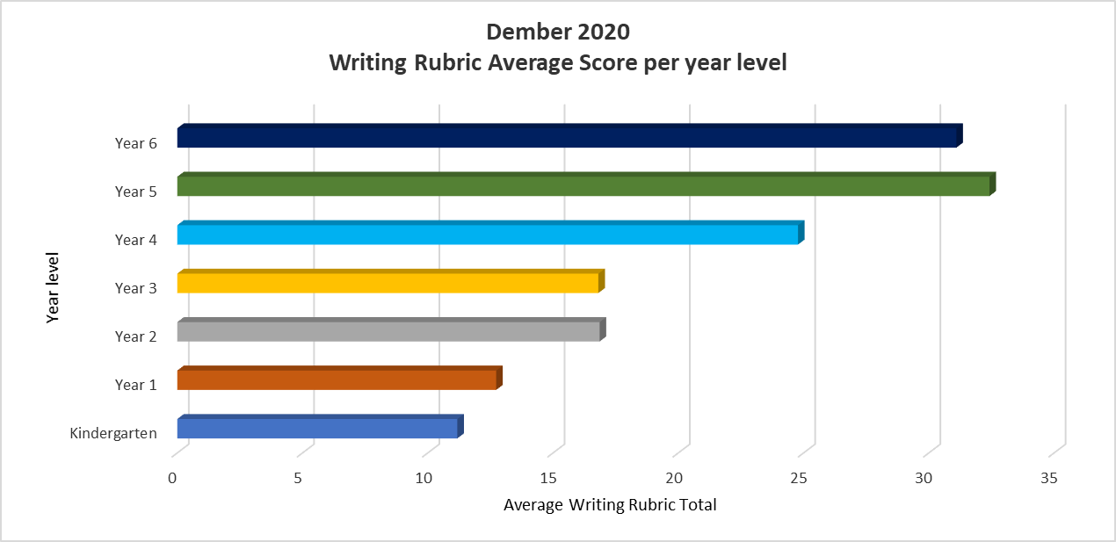

What this evidence tells us
- The Year 5 cohort average is the highest across the school in 2020
- The Year 3 cohort average is at the same level of the Year 2 cohort average.
- The Year 1 cohort average is similar to the average for Kindergarten
- The Fadden PS Criterion Referenced Assessment Tool was not conducted in 2020 and can therefore not be compared in this report.
- The school will continue to focus on writing and developing whole school consistency in the teaching of literacy across the school, ensuring that students skills and knowledge are scaffolded and developed as part of their learning journey from Preschool to Year 6.

Our achievements for this priority
A whole school scope and sequence (curriculum map) developed and implemented
- Australian Curriculum student achievement standards mapped for reporting.
- Participation in professional learning, as part of Early Years Literacy Initiative, was postponed to 2021 due to disruptions with COVID-19.

Consistent visible learning strategies embedded across the school
- Goal setting introduced with students and reflected in Semester 1 2020 reports.

Assessment and feedback tools used in classrooms according to an agreed annual schedule
- Implementation of writing assessment tool for whole school data collection.
- Provided professional learning (PL) to teachers on writing assessment tool.
- Reviewed collected data with staff at whole school and class level.

Challenges we will address in our next Action Plan
- Develop consistent moderation of writing samples throughout the school to confirm valid data sets
- Provide targeted, evidence-based support for students below average and way above in English.
- Professional learning in writing.
  - Ensure all staff access PL offered around the 10 Essentials of Literacy
  - Develop consistency document on expectations for a literacy program, including writing at Fadden PS
- Empower students to take ownership of their learning and become confident writers.

Priority 2: Improvement in student outcomes in mathematics

Targets or measures
- By the end of 2021 the school will achieve:
  - An increase of 20 % or greater in the percentage of Year 3 and Year 5 students in the upper two bands of NAPLAN in Numeracy.
    - Year 3: Band 5 and Band 6 – 48.8 % in 2016 with a 20% increase in 2021 equal to 58.56% or greater
    - Year 5: Band 7 and Band 8 – 23.7 % in 2016 with a 20% increase in 2021 equal to 28.44% or greater.
  - A decrease of 20 % or greater in the percentage of Year 3 and Year 5 students in the bottom two bands of NAPLAN in Numeracy.
    - Year 3: Band 1 and Band 2 – 4.9 % in 2016 with a 20% decrease in 2021 equal to 3.92% or less
    - Year 5: Band 3 and Band 4 – 7.9 % in 2016 with a 20% decrease in 2021 equal to 6.32% or less
  - Student growth in Year 5 (within school match) continues to be at or above the ACT scaled growth score and 85% of students have greater than or expected growth compared to 62.9% in 2016 for NAPLAN Numeracy.
    - Year 5 2016 average scaled growth score is 93.7 compared to the ACT average scaled growth score of 83.8.
  - PAT maths data will demonstrate an increase in the number of students performing at or above the normed range for their year level.

In 2020 we implemented this priority through the following strategies.
- Developing and implementing Fadden PS mathematics agreed practices document.
- Developing whole school additive strategy assessment tool.
Below is our progress towards our five-year targets with an emphasis on the accumulation and analysis of evidence over the term of our plan.

Student learning data
Targets or Measures | Base  2016 | Year 1  2017 | Year 2  2018 | Year 3  2019 | Year 4  2020 | Year 5  2021
An increase of 20 % or greater in the percentage of Year 3 and Year 5 students in the upper two bands of NAPLAN in numeracy | Year 3: 48.8 % | 46.7% | 54.1% | 39.4% | N/A
 | Year 5 : 23.7 % | 34% | 31% | 20.5% | N/A
A decrease of 20 % or greater in the number of Year 3 and Year 5 students in the bottom two bands of NAPLAN in numeracy. | Year 3: 4.9 % | 6.7% | 2.7% | 3% | N/A
 | Year 5: 7.9 % | 6.4% | 4.8% | 11.4% | N/A
Student growth in Year 5 (within school match) continues to be at or above the ACT scaled growth score for Numeracy. | School  91.5%  ACT  91.6% | School  94.1%  ACT  96.4% | School  72.6%  ACT  93.1% | School  73%  ACT  85.6% | N/A
85% of students have greater than or expected growth compared to 61.1% in 2016 for NAPLAN Numeracy. | 61.1% | 73.8% | 60% | 40.5% | N/A

Student learning data (school data set)

As NAPLAN was not administered in 2020, we cannot therefore look to that measure to track student growth. Below is a graph which demonstrates students Additive Strategies Sub-Element as at December 2020 using a school-based additive strategy assessment tool which was implemented in 2020.
Additive Strategy elements are identified in the National Numeracy Learning Progression within the Australian Curriculum. They describe how a student becomes increasingly able to choose and use additive computational strategies for different purposes.

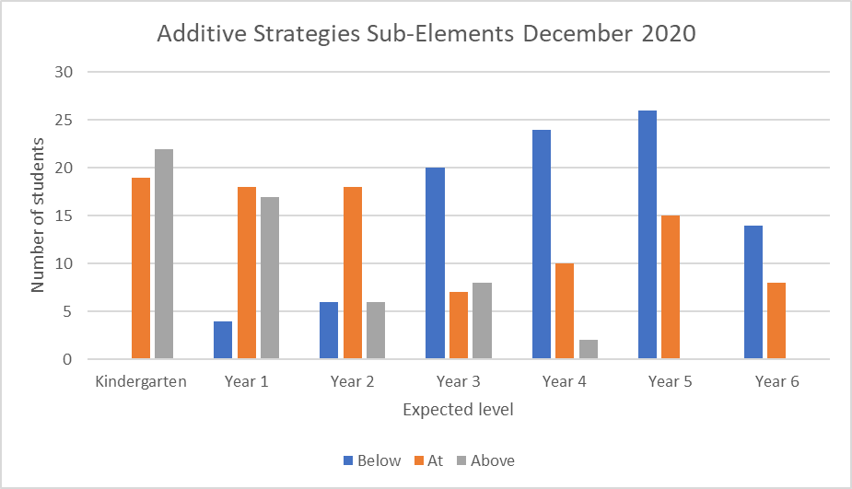

What this evidence tells us
- Early Childhood classes (Kindergarten to Year 2) demonstrates students are at or above expectations for their additive strategies.
- There are more students below expectation in years 3-6
- This school-based evidence demonstrates that more needs to be done for our students to move into the at and above expected level.

Our achievements for this priority
- Established whole school beliefs and values for teaching mathematics
  - Developed during professional learning opportunities
  - Included agreed lesson structure
  - Included development of assessment tool
- Collected and began to use assessment data to guide planning and pedagogical decision for all learners

Challenges we will address in our next Action Plan
- Develop consistent moderation of Fadden Number Assessment tool to confirm valid data sets.
- Empower students to take ownership of their learning and become confident mathematicians.
- Provide targeted, evidence-based support for students below average and way above in Mathematics.

Priority 3: Improvement in student wellbeing

Targets or measures
- By the end of 2021 the school will achieve:
  - 95 percent of parents agree or strongly agree that their children feel safe at this school in the School Satisfaction Survey. This would be a 22% increase from 2016 results.
  - 95 percent of staff rate the school as achieving the nine areas of the National Safe Schools Framework.
  - 95 percent of staff respond positively to feeling a sense of belonging at the school in the School Climate and Identification Measurement Tool.
  - 95 percent of Year 4, 5 and 6 students agree that their teacher listens to them and values their opinion in the KidsMatter survey.
In 2020 we implemented this priority through the following strategies.
- Implement a school-wide evidenced-based approach to early intervention to improve student wellbeing
- Implement and embed Positive Behaviours for Learning (PBL) across the school to establish consistency in responding to student behaviour
Below is our progress towards our five-year targets with an emphasis on the accumulation and analysis of evidence over the term of our plan.

Perception Data
Targets or Measures | Base  2016 | Year 1  2017 | Year 2  2018 | Year 3  2019 | Year 4  2020 | Year 5  2021
95 percent of parents agree or strongly agree that their children feel safe at this school in the School Satisfaction Survey | 87.3% | 86% | 91.6% | 90.6% | 81.1%
95 percent of staff respond positively to feeling a sense of belonging at the school in the School Climate and Identification Measurement Tool  *Average % of responses that agree or strongly agree to School Identification questions. | 90% | 95% | 95% | 98% | 94%

School program and process data
Targets or Measures | Base  2016 | Year 1  2017 | Year 2  2018 | Year 3  2019 | Year 4  2020 | Year 5  2021
95 percent of staff rate the school as achieving the nine areas of the National Safe Schools Framework | Not completed | 66% | 100% | Not completed | Not completed

Positive Behaviours for Learning (PBL) School Evaluation Tool (SET)
The SET is conducted by the external PBL Coach and is designed to evaluate the critical features of school-wide effective behaviour supports and is reviewed after the initial training and then every 12 months to enable comparison of progress made within each feature.

Fadden Primary School participated in the SET at the end of 2019 and 2020.

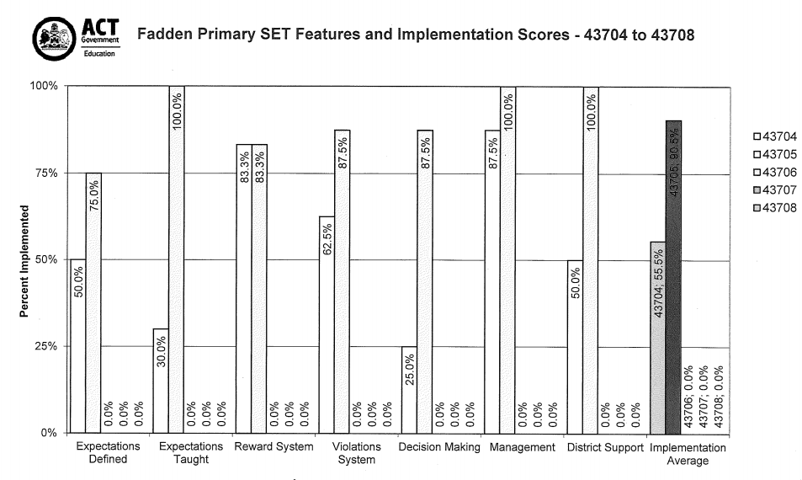

What this evidence tells us
- Parent perception survey data declined in 2020 with 81.1% of parents agreeing or strongly agreeing that their children feel safe as this school.
- Staff perception survey data slightly declined in 2020 by 4% when tracking staff sense of belonging at the school.
- Improvement in staff rating the school as achieving in the nine areas of the National Safe Schools Framework from 2017 to 2018. This data was not collected in 2019 or 2020.
- Implementation of PBL was successful with the school’s implementation moving from 55.5% in 2019 to 90.5% in 2020.

Our achievements for this priority
- Tier 1 of Positive Behaviours for Learning implemented and assessed
  - Professional learning provided for PBL team and teaching staff
  - Students engaged in explicit lesson about behaviour expectations for all settings
  - School acknowledgement system trialled
- Response to intervention data developed and analysed
  - PBL Wellbeing Procedures approved by Board after consultation with students, staff and parents

Challenges we will address in our next Action Plan
- Implement Positive Behaviours for Learning into the classroom
- Implement Friendly Schools Plus as the school’s social and emotional learning program.
- Document whole school procedures for promoting student voice.
- Increase community engagement opportunities with a focus on student learning eg. SeeSaw implementation.

Reporting on preschool improvement
All schools with a preschool setting are required to annually review and update their Quality Improvement Plan*. Schools have a choice to either report against their QIP using the Directorate template or to report progress here.
- We have updated all records to comply with changes to the National Quality Standards and regulations
- QIP reflected upon, updated and new actions identified
- Reflected upon and updated Preschool Philosophy to align with staff, student and family voice

