Ainslie School
  - Network: North/Gungahlin

School Plan 2019-2023
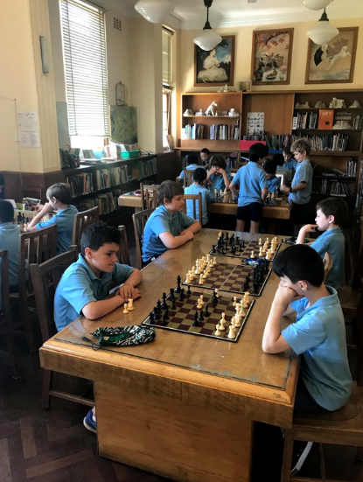

The purpose of school improvement planning
This plan establishes a strong improvement agenda to be driven by school leaders over the next five years. It was informed by the Directorate’s Strategic Plan and system-level and school-based analysis of multiple sources of evidence including our School Review findings. Analysis of these multiple sources of evidence is supported by an annual provision to each school of a data summary as a key enabler of our improvement planning and implementation.
Each school undertakes a school review as an integral component of in its five-year improvement planning cycle. The reviews are an important part of how the Directorate supports and monitors school improvement. Reviews provide schools with quality and independent feedback, tailored to the school’s context. Each school is reviewed at least every five years, providing valuable opportunities for self-reflection, planning and improvement. The school improvement planning process is below. This representation is used in the footer of all school-based improvement documents to indicate the stage of planning or implementation.
Analysis Priorities Strategies Actions Impact (for student)
Our school planning is grounded in evidence from research and practice and expressed in terms of improvements in measurable student outcomes. Explicit five-year targets for improvement have been set and will give life to monitoring, evaluation and communication of progress to teachers, families and students.

Our school’s improvement agenda positioned within the Directorate’s Strategic Plan

Vision
Education Directorate vision: We will be a leading learning organisation where people know they matter.
How will the Education Directorate’s vision gain life within your school’s context?
School vision:

Enabling students to be active, informed and creative citizens.

Mission
Education Directorate’s mission: We develop and deliver educational services to empower each child and young person in the ACT to learn for life.
How will the Education Directorate’s mission gain life within your school’s context?
School mission:

Delivering playful and sophisticated education services.

Values
Education Directorate’s Values: Respect, Integrity, Collaboration, Innovation.
How will the Education Directorate’s values gain life within your school’s context?
School values:

Excellence, Community, Respect, Kindness and Responsibility

Education Directorate’s Strategic goals for 2018-2021
- Schools where students love to learn
- investing in early childhood
- Evidence informed decisions
- Learning culture
- United leadership team

Education Directorate’s Strategic indicators for 2018-2021
- To promote greater equity in learning outcomes in and across ACT public schools
- To facilitate high quality teaching in ACT public schools and strengthen educational outcomes
- To centre teaching and learning around students as individuals

The Directorate will annually publish progress against its strategic indicators. Each school’s contributions to these strategic indicators will be provided to our school for inclusion in our Impact Report.

Multiple sources of evidence
Evidence informing this School Plan includes:
- analysis of system-level data
- analysis of school-based evidence over time (past 4/5 years)
- recommendations from School Review
- for schools with a preschool setting, Quality Ratings from assessment against the National Quality Framework.*
*For schools with a preschool setting their Quality Improvement Plan (QIP) is revised each year as part of the annual planning process.

Having completed the sections ‘Identifying key themes’ and ‘The school’s challenges’ in your data summary, commence the process of identifying priorities.

Our improvement priorities
Priority 1: Improve growth in writing
- Students compose texts with agency and impact

Targets/Measures to be achieved by 2023.

Student learning data
Target or measure: Proportion of students in top two bands equal to or above like schools in writing.
Source: NAPLAN Scout Data
Starting point:
On average approximately 17.5% below 2015-2018 (Year 3)
On average approximately 12% below 2015-2018 (Year 5)
Target or measure: By 2023 80% of our Year 5 students will be achieving at/or above expected growth from Year 3 to Year 5 in writing.
Source: NAPLAN Scout Data
Starting point: On average approximately 50% achieving at/or above expected growth from Year 3 to Year 5 (2015-2018).
Target or measure: Increase the proportion of students achieving at standard or above in their report in writing.
Source: Student Reports
Starting point: 87% achieving at standard or above in writing on Semester 2 Reports 2019.

Perception Data
Target or measure: To increase the proportion of students who agree or strongly agree with the statement:
The texts I compose have impact.
Source: Satisfaction Survey and/or alternative tool, to be developed during 2019 - Students
Starting point: Baseline to be determined in 2019
Target or measure: To increase the proportion of staff who agree or strongly agree with the statement:
I feel confident and capable to enable students to compose texts with impact.
Source: Satisfaction Survey and/or alternative tool to be developed during 2019 - Teachers
Starting point: Baseline to be determined in 2019

School program and process data
Target or measure By 2023, a whole school approach to planning and monitoring will be articulated.
Source: Policy implementation guidelines and planning documents
Starting point: There is philosophical misalignment and inconsistency of practice across the school.

PRIORITY 2: Improve growth in mathematics
- Students will use mathematics with agency and impact

Targets/Measures to be achieved by 2023.

Student learning data
Target or measure: Proportion of students in top two bands equal to or above like schools in mathematics.
Source: NAPLAN Scout Data
Starting point:
On average approximately 12% below 2015-2018 (Year 3)
On average approximately 20% below 2015-2018 (Year 5)
Target or measure: By 2023 80% of our Year 5 students will be achieving at/or above expected growth from Year 3 to Year 5 in Numeracy.
Source: NAPLAN Scout Data
Starting point:
On average approximately 49% students achieved at or above expected growth Year 3 to Year 5 (2015-2018).

Perception Data
Target or measure: To increase the proportion of students who agree or strongly agree with the statements:
I use mathematics effectively
The mathematics I have learnt about is relevant to me
Source: Satisfaction Survey and/or alternative tool to be developed during 2019 - Students
Starting point: Baseline to be determined in 2019
Target or measure: To increase the proportion of staff who agree or strongly agree with the statement:
I feel confident and capable to enable students to use mathematics effectively

Source: Satisfaction Survey and/or alternative tool, to be developed during 2019 - Teachers
Starting point: Baseline to be determined in 2019

School program and process data
Target or measure By 2023, a whole school approach to planning and monitoring will be articulated.
Source: Policy implementation guidelines and planning documents
Starting point: There is philosophical misalignment and inconsistency of practice across the school.
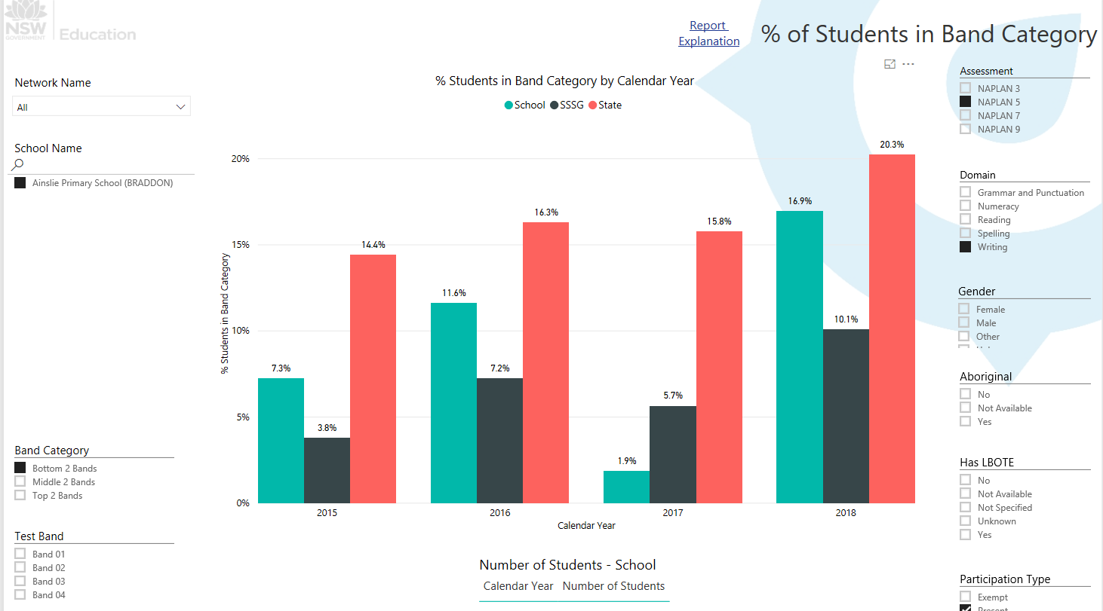

Endorsement
This School Plan has been endorsed electronically by our Principal, Director School Improvement and Board Chair.

Principal
Name:
Date:

Director School Improvement
Name:
Date:

Board Chair
Name:
Date:

