Malkara School
Annual School Board Report 2019

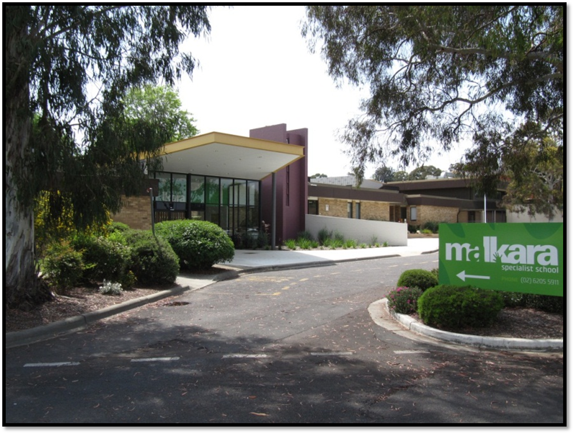

This page is intentionally left blank.

This report supports the work being done in the ACT Education Directorate, as outlined in Strategic Plan 2018-21: A Leading Learning Organisation.

Accessibility
The ACT Government is committed to making its information services, events and venues accessible to as many people as possible.
If you have difficulty reading a standard document and would like to receive this publication in an alternate format, such as large print and audio, please telephone (02) 6247 4580.
If English is not your first language and you require the translating and interpreting service, please telephone 13 14 50.
If you are deaf or hearing impaired and require the National Relay Service, please telephone 13 36 77.
© Australian Capital Territory, Canberra, 2020

Material in this publication may be reproduced provided due acknowledgement is made.

Contents
Reporting to the community 1
School Context 1
Student Information 1
Student enrolment 1
Student attendance 1
Supporting attendance and managing non-attendance 2
Staff Information 2
Teacher qualifications 2
Workforce composition 2
School Review and Development 3
School Satisfaction 3
Overall Satisfaction 3
Learning and Assessment 5
NAPLAN 5
Financial Summary 6
Voluntary Contributions 7
Reserves 7
Endorsement Page 8
Members of the School Board 8

Reporting to the community
Schools report to communities in range of ways, including through:
- Annual School Board Reports
- a (5-year) School Improvement Plan (formerly School Strategic Plan)
- annual Impact Reports
- newsletters
- other sources such as My School.

School Context
Malkara School provides a program for students who have moderate to severe intellectual disabilities and autism. Many students also have associated sensory or communication impairments, or a physical disability. Students come from the south of Canberra and nearby NSW, and many are transported to school on special needs transport buses. In addition to the 67 primary-aged students there were 6 preschool aged students at the school in 2019.

Student Information

Student enrolment
In this reporting period there were a total of 67 students enrolled at this school.
Table: Student enrolment
Student type | Number of students
Male | 48
Female | 19
Aboriginal and Torres Strait Islander | 6
LBOTE* | 15
Source: ACT Education Directorate, Analytics and Evaluation Branch
*Language Background Other Than English

Student attendance
The following table identifies the attendance rate of students by year level during this reporting period. Student attendance rate is the percentage of school days attended by students in each year level at the school. Student attendance is measured over two school terms; that is from the first day of the school year for students in term 1 to the last day of term 2.
Table: Attendance rates in percentages
Year level | Attendance rate
1 | 89.0
2 | 86.0
3 | 83.0
4 | 85.0
5 | 92.0
6 | 92.0
Source: ACT Education Directorate, Analytics and Evaluation Branch

Supporting attendance and managing non-attendance
ACT public schools support parents and careers to meet their legal responsibilities in relation to the compulsory education requirements of the Education Act 2004. The Education Directorate’s Education Participation (Enrolment and Attendance) Policy describes its position with regard to supporting attendance and managing non-attendance. A suite of procedures supports the implementation of the policy. Please refer to https://www.education.act.gov.au/ for further details.

Staff Information

Teacher qualifications
All teachers at this school meet the professional requirements for teaching in an ACT public school. The ACT Teacher Quality Institute (TQI) specifies two main types of provision for teachers at different stages of their career, these are detailed below.
- Full registration is for teachers with experience working in a registered school in Australia or New Zealand who have been assessed as meeting the Proficient level of the Australian Professional Standards for Teachers.
- Provisional registration is for newly qualified teachers or teachers who do not have recent experience teaching in a school in Australia and New Zealand. Many teachers moving to Australia from another country apply for Provisional registration.

Workforce composition
Workforce composition for the current reporting period is provided in the following table. The data is taken from the school’s verified August staffing report. For reporting purposes, it incorporates all school staff including preschools, staff absent for a period of less than four consecutive weeks and staff replacing staff absent for more than four consecutive weeks. It does not include casuals and staff absent for a period of four consecutive weeks or longer.
The Education Directorate is required to report Aboriginal and Torres Strait Islander staff figures. As of June of the reporting period, 119 Aboriginal and/or Torres Strait Islander staff members were employed across the Directorate.
Table: Workforce composition numbers
Staff employment category | TOTAL
Teaching Staff: Full Time Equivalent Permanent | 13.20
Teaching Staff: Full Time Equivalent Temporary | 2.80
Non Teaching Staff: Full Time Equivalent | 29.64
Source: ACT Education Directorate, People and Performance Branch

School Review and Development
The ACT Education Directorate’s Strategic Plan 2018-2021 provides the framework and strategic direction for School Improvement Plans (formerly School Strategic Plans). This is supported by the school performance and accountability framework ‘People, Practice and Performance: School Improvement in Canberra Public Schools, A Framework for Performance and Accountability’. Annually, system and school level data are used alongside the National School Improvement Tool to support targeted school improvement, high standards in student learning, innovation and best practice in ACT public schools.
Prior to 2016 all ACT public schools participated in a four-year improvement cycle. In the fourth year schools underwent an external Validation process. In 2016 this changed to a five-year cycle with a School Review at the end.
Our school will be reviewed in 2021. A copy of the most recent Validation Report can be found on our school website.

School Satisfaction
Schools use a range evidence to gain an understanding of the satisfaction levels of their parents and carers, staff and students. Annually in August/ September ACT schools undertake a survey to gain an understanding of school satisfaction at that time. This information is collected from staff, parents and students from year 5 and above through an online survey.

Overall Satisfaction
In this period of reporting, 100% of parents and carers and 92% of staff at this school indicated they were satisfied with the education provided by the school.
Included in the survey were 16 staff, 14 parent, and 12 student items which are described as the national opinion items. These items were approved by the then Standing Council on School Education and Early Childhood (SCSEEC) for use from 2015. The following tables show the percentage of parents and carers and staff who agreed with each of the national opinion items at this school.
A total of 24 staff responded to the survey. Please note that not all responders answered every question.
Table: Proportion of staff in agreement with each national opinion item
National opinion item | Proportion of staff
Parents at this school can talk to teachers about their concerns. | 92
Staff get quality feedback on their performance. | 78
Student behaviour is well managed at this school. | 79
Students like being at this school. | 92
Students’ learning needs are being met at this school. | 96
Teachers at this school expect students to do their best. | 100
Teachers at this school motivate students to learn. | 96
Teachers at this school treat students fairly. | 88
Teachers give useful feedback. | 83
This school looks for ways to improve. | 96
This school takes staff opinions seriously. | 88
This school works with parents to support students' learning. | 92
Teachers give useful feedback. | 83
Source: ACT Education Directorate, Analytics and Evaluation Branch
*Data derived from annual School Satisfaction Survey

A total of 13 parents responded to the survey. Please note that not all responders answered every question.
Table: Proportion of parents and carers in agreement with each national opinion item
National opinion item | Proportion of parents and carers
I can talk to my child’s teachers about my concerns. | 100
My child feels safe at this school. | 92
My child is making good progress at this school. | 100
My child likes being at this school. | 100
My child's learning needs are being met at this school. | 100
Student behaviour is well managed at this school. | 92
Teachers at this school expect my child to do his or her best. | 92
Teachers at this school give useful feedback. | 100
Teachers at this school motivate my child to learn. | 100
Teachers at this school treat students fairly. | 100
This school is well maintained. | 100
This school looks for ways to improve. | 92
This school takes parents’ opinions seriously. | 100
This school works with me to support my child's learning. | 100
Source: ACT Education Directorate, Analytics and Evaluation Branch
*Data derived from annual School Satisfaction Survey

Learning and Assessment

NAPLAN
Students in years 3, 5, 7 and 9 in all ACT schools participate in the National Assessment Program-Literacy and Numeracy (NAPLAN). This program assesses skills in reading, writing, spelling, grammar and punctuation, and numeracy.
In this reporting period, 100.00 % of year 3 students and 100.00 % of year 5 students were exempt from testing based on nationally agreed criteria.

Financial Summary
The school has provided the Directorate with an end of year financial statement that was approved by the school board. Further details concerning the statement can be obtained by contacting the school. The following summary covers use of funds for operating costs and does not include expenditure in areas such as permanent salaries, buildings and major maintenance.
Table: Financial Summary
INCOME | January-June | July-December | January-December
Self-management funds | 277625.95 | 115170.06 | 392796.01
Voluntary contributions | 2050.00 | 100.00 | 2150.00
Contributions & donations | 5000.00 | 100.00 | 5100.00
Subject contributions | 525.00 | 25.00 | 550.00
External income (including community use) | 15924.67 | 12183.92 | 28108.59
Proceeds from sale of assets | 0.00 | 0.00 | 0.00
Bank Interest | 6424.84 | 4255.08 | 10679.92
TOTAL INCOME | 307550.46 | 131834.06 | 439384.52
EXPENDITURE
Utilities and general overheads | 52020.37 | 68569.43 | 120589.80
Cleaning | 40270.81 | 30670.13 | 70940.94
Security | 0.00 | 0.00 | 0.00
Maintenance | 48215.48 | 126629.34 | 174844.82
Administration | 457.88 | 833.51 | 1291.39
Staffing | 0.00 | 265.00 | 265.00
Communication | 7747.69 | 5166.80 | 12914.49
Assets | 25947.09 | 16532.42 | 42479.51
General office expenditure | 6996.29 | 10145.27 | 17141.56
Educational | 11387.70 | 10552.20 | 21939.90
Subject consumables | 385.95 | 453.33 | 839.28
TOTAL EXPENDITURE | 193429.26 | 269817.43 | 463246.69
OPERATING RESULT | 114121.20 | -137983.37 | -23862.17
Actual Accumulated Funds | 266701.77 | 319067.76 | 319067.76
Outstanding commitments (minus) | -3015.36 | 0.00 | -3015.36
BALANCE | 377807.61 | 181084.39 | 292190.23

Voluntary Contributions
The funds listed were used to support the general operations of the school. The spending of voluntary contributions is in line with the approved budget for this reporting period.

Reserves

Name and Purpose | Amount | Expected Completion
Staffing Reserve  Funds additional staffing requirements | $20 000 | 12/2020
ICT Reserve  Ongoing upgrade of IWBs and IT infrastructure | $20 000 | 12/2020
Toilet upgrade  Further upgrade inadequate toilet facilities | $23 000 | 12/2020

Endorsement Page

Members of the School Board
Parent Representative(s): | Nick Evans | Louise King | Snezana Stekovic
Community Representative(s):
Teacher Representative(s): | Sarah Kavanagh | Clare Reid
Student Representative(s):
Board Chair: | Nick Evans
Principal: | Allison Chapman
I approve the report, prepared in accordance with the provision of the ACT Education Act 2004, section 52.

Board Chair Signature: | Nick Evans | Date: | 29 / 06 / 2020

I certify that to the best of my knowledge and belief the evidence and information reported in this Annual School Board Report represents an accurate record of the Board’s operations during this reporting period.

Principal Signature: | Allison Chapman | Date: | 29 / 06 / 2020

