Chapman Primary School
Network: South Weston

Impact Report 2020

The purpose of this document
This document flows directly from our Action Plan for 2020 which translated our school priorities into actions for the current year of our five-year improvement cycle. These actions were responsive to identified challenges, changes or risks to delivery of improvement for student learning.
Please note, due to the events of 2020 the data collection cycles of some measures were interrupted. Where this has occurred an N/A or 0 (zero) entry has been used.

Our school’s contribution to whole-of-system Strategic Indicators

Education Directorate Strategic Indicator 2018-2021
To promote greater equity in learning outcomes in and across ACT public schools

In 2020 our school supported this Strategic Indicator through – Priority 3 (see reporting for detail):
- Ensuring that the school environment facilitates safety, wellbeing and inclusion for students and families
- Through equity of access enabled all students to engage with technology in new and innovative ways

Education Directorate Strategic Indicator 2018-2021
To facilitate high quality teaching in ACT public schools and strengthen educational outcomes.

In 2020 our school supported this Strategic Indicator through – Priority 1,2 and 3 (see reporting for detail):
- Creating Professional Learning Communities (Focus groups) who utilised the Spiral of Inquiry (Timperley, Kaser and Halbert) to progress the priorities of the Strategic Plan.
- Establishing a data team to develop protocols and oversee the collection and lead the analysis and interpretation of data

Education Directorate Strategic Indicator 2018-2021
To centre teaching and learning around students as individuals

In 2020 our school supported this Strategic Indicator through – Priority 3 (see reporting for detail):
- Commenced the implementation of Positive Behaviours for Learning
- Every student developed in collaboration with the teacher, a meaningful learning goal which focused on writing, mathematics and/or wellbeing

Reporting against our priorities
Priority 1: Increase growth in student performance in numeracy across all year levels.

Targets or measures
By the end of 2024 we will achieve:
- 64% or more of our year 5 students will be achieving at or above expected growth in NAPLAN numeracy
- 85% or more students agree or strongly agree that “Teachers give useful feedback” in the Annual Student Satisfaction Survey
- Increased confidence and proficiency of staff to use and analyse a range of school-based mathematics data sets to differentiate instruction to meet student learning needs.

In 2020 we implemented this priority through the following strategies:
- Built leadership and staff data literacy skills to analyse, interpret and use mathematics data to ensure that there is consistent mapping of school progress over time
- Planned and implemented quality professional learning program to deepen teacher mathematical knowledge and pedagogical practices.

Below is our progress towards our five-year targets with an emphasis on the accumulation and analysis of evidence over the term of our plan.

Targets or Measures | Base | Year 1 | Year 2 | Year 3 | Year 4 | Year 5
- 64% or more of our year 5 students will be achieving at or above expected growth in numeracy. | 59% | N/A

Perception Data
Targets or Measures | Base | Year 1 | Year 2 | Year 3 | Year 4 | Year 5
85% or more students agree or strongly agree that ‘Teachers give useful feedback’. | 79% | 77%

School program and process data
Targets or Measures | Base | Year 1 | Year 2 | Year 3 | Year 4 | Year 5
Increase the confidence and proficiency of staff to use and analyse a range of school-based maths data sets including SENA, MYMC and PAT Maths to differentiate instruction to meet student learning needs. | N/A | SENA 54%  MYMC  36%  PAT  31%

2020 Mathematics Staff Survey
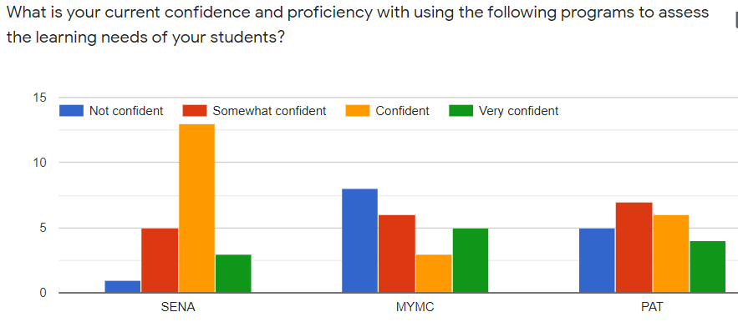
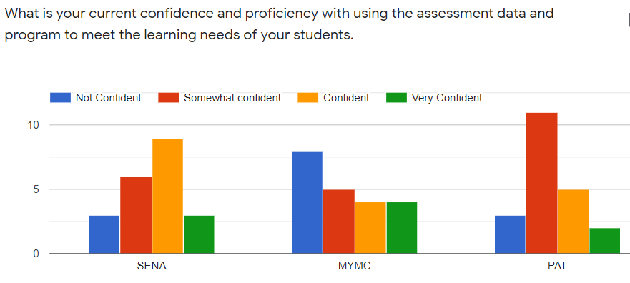
What this evidence tells us
- NAPLAN data has not been available for 2020 to measure year 5 ‘growth data’ in numeracy.
- Student perception of ‘teacher feedback’ has slightly decreased with this cohort.
- Our 2020 teacher mathematics survey has provided our baseline data to measure teacher confidence and proficiency to use the school endorsed SENA, MYMC and PAT Maths programs.

This year has highlighted the need for teachers to have and use multiple sources of evidence to monitor student progress and achievement. Relying on NAPLAN as the only measure of growth and student/school success may lead to this measure not being available across time. Likewise, the response to one question in the Student Satisfaction Survey may not be a reliable measure. The period of ‘learning from home’ has most probably impacted on the student’s perception of teacher feedback this year due to extended time away from face to face teaching in the classroom.
The implications for our 2021 Action Plan may
- suggest additional data sources to complement the existing measures.
- The teacher survey data supports our plan for a range of differentiated mathematics professional learning to be planned and offered to build teachers skills, understanding and confidence in using the three school endorsed assessment programs SENA, MYMC and PAT Maths.
- The survey also highlighted teachers desire to increase their capability to develop rich tasks and improve differentiation to support improved student outcomes.

Our achievements for this priority

- The leadership team and a team of identified teachers attended PAT Maths training and professional learning with ACER to build our skills and knowledge of the assessment tool prior to implementing at CPS in term 4.
- This professional learning supported us to build our data literacy skills to analyse, interpret and use PAT Maths reports to guide teachers use of this assessment data to inform teaching and to ensure that there is consistent mapping of school progress over time.
- A team of teachers consulted with another ACT school to learn about their journey implementing PAT Maths and school wide use of the reports and data sets to inform teaching.
- PAT Maths program was purchased and all staff were trained in how to administer the first assessment for their year level and all assessments have been completed in term 4 for all students K-6 to provide our whole school baseline data.
- The PAT Maths data sets and reports were available and accessed immediately by teachers and a follow up professional learning session supported the teachers in knowing how to generate reports and begin early analysis of class and year level data.
- A teacher survey was developed to gather baseline data from staff about the teaching and learning of Mathematics. In particular the maths assessments they administer, the variety of programs and assessments used to inform differentiation and their confidence levels using programs such as CMIT, MYMC and PAT Maths.
- The data from this survey was analysed to guide the planning of professional learning for 2021 based on the identified needs of teachers.
- A draft document has been created with useful resources and suitable links for parents to support their child’s mathematics learning at home.

Our school’s contribution to the whole of system Strategic Indicator “to facilitate high quality teaching in ACT public schools and strengthen educational outcomes”
- We implemented a whole school mathematics assessment and data tool to efficiently monitor student achievement growth over time to inform whole school planning, teaching and improve capacity for differentiated instruction.

Challenges we will address in our next Action Plan
- Review and define whole school beliefs, assessment and data tracking practices in Mathematics to establish consistent teaching pedagogy and delivery of the Mathematics curriculum across the school aligned to these beliefs and evidenced based ‘best practice’ in Mathematics.
- Plan a ‘long term’ Mathematics PL agenda to support teachers’ pedagogical needs, to develop greater confidence in using SENA, MYMC and PAT Maths and continue learning about interpreting and using PAT maths data sets.
- Provide quality professional learning with a focus on differentiation and open-ended tasks as an area of high interest and budget for possible guest/expert presenters to support this PL.
- Review and streamline assessment data sets and tracking tools, in light of PAT Maths data.
- Embed quality differentiated mathematics teaching and learning programs which enable students to apply mathematical skills and thinking to solve problems.
- Leadership team to work with ACT ED personnel to develop our data literacy skills and strategic analysis of whole school data sets.

Priority 2: Increase growth in student performance in writing across all year levels.

Targets or measures
By the end of 2024 we will achieve:
- An increase in the percentage of year 5 students in the top bands of writing to 28% or more.
- An increase in the scaled score growth of year 5 students in writing to 59 scaled score points or more.
- 62% of our year 5 students will be achieving at or above expected growth in spelling.
- 77% or more of our staff agree or strongly agree that ‘Staff get quality feedback on their performance.
- Increased teacher confidence to effectively use researched based instructional practices in writing.

In 2020 we implemented this priority through the following strategies.
- Utilised the PLC model to engage in the Early Years Literacy Initiative with a focus on the 10 Essential Literacy Skills.
- Engaged with Catherine Nash to improve teacher capacity in the teaching of writing and improve students’ writing capabilities.
- Improved consistent collection, collation and analysis of Bee Spelling data to track student growth.
- Increased teacher confidence to effectively use researched based instructional practices in writing.

Below is our progress towards our five-year targets with an emphasis on the accumulation and analysis of evidence over the term of our plan.

Student learning data
Targets or Measures | Base | Year 1 | Year 2 | Year 3 | Year 4 | Year 5
To increase the percentage of year 5 students in the top bands of writing to 28% or more. | 19% | N/A
To increase the scaled score growth of year 5 students in writing to 59 scaled score points or more. | 55 scaled scores | N/A
62% of our year 5 students will be achieving at or above expected growth in spelling. | 53% | N/A

Perception Data
Targets or Measures | Base | Year 1 | Year 2 | Year 3 | Year 4 | Year 5
Our staff agree or strongly agree that staff get quality feedback on their performance. | 71% | 62%

School program and process data
K-6 Literacy Audit on Essential Literacy Practices results.
2019 Term 4 baseline | 2020 Term 4
Practice 1. below 3%, 30% confident, 67% above  Practice 2. 6% below, 36% confident, 58% above  Practice 3. 8 % below, 25% confident 67% above  Practice 4. 17% below, 25% confident, 58% above  Practice 5. 8% below, 25% confident 67% above  Practice 6. 17% below, 50% confident, 33% above  Practice 7. 7% below, 36% confident 57% above  Practice 8. 0% below, 42% confident, 58% above  Practice 9. 5% below, 53% confident, 42% above  Practice 10. 13% below, 45% confident, 42% above | Practice 1. below 5%, 40% confident, 55% above  Practice 2. 7.5% below, 45% confident, 45.5% above  Practice 3. 10 % below, 35% confident 55% above  Practice 4. 20% below, 50% confident, 30% above  Practice 5. 12% below, 30% confident 58% above  Practice 6. 17% below, 50% confident, 33% above  Practice 7. 2% below, 37% confident 60% above  Practice 8. 7% below, 28% confident, 65% above  Practice 9. 7% below, 43% confident, 50% above  Practice 10. 25% below, 40% confident, 35% above
Blue and red indicate increased % confidence levels for 2020

School program and process data -
Targets or Measures | Base | Year 1 | Year 2 | Year 3 | Year 4 | Year 5
Increase teacher confidence to effectively use researched based instructional practices in writing. | see above | see above

What this evidence tells us
- NAPLAN data has not been available for 2020 to measure student learning data in writing or spelling.
- 62% of our staff agree or strongly agree that staff get quality feedback on their performance. There has been a 9% decrease in relation to staff perception of quality feedback in 2020. Due to COVID, our intention to focus on staff perception on feedback was inhibited and did not progress as planned.
- In the K-6 Literacy Audit on Essential Literacy Practices- Comparison between 2019-2020, indicated that we had increased numbers in the below range for most practices. This may be due to a number of new staff joining us in 2020 and a disrupted school year due to COVID -19. Percentages in the confident range remained similar or were slightly improved.
- It is pleasing to see that there were increased percentages for practices 7, 8 & 9.
7 - intentional and ambitious efforts to build vocabulary and content knowledge
8 - abundant and diverse reading material
9 - ongoing observation and assessment of students’ language and literacy development that informs their education
These improvements reflect the work completed in 2019:
- Classrooms were resourced with quality texts.
- Staff have participated in ongoing professional learning around the writing process, this approach is becoming embedded across the school.
- Our survey indicated that teachers are more confident to implement Instruction Practices 7, 8 and 9.
- On closer analysis of this survey data we concluded that the increased % in the below range may be due to a number of new staff joining us in 2020 and not participating in the 2019 survey and a disrupted school year due to COVID -19. Whilst looking at the above range the biggest decrease was in the “support others” category. Next year we need to clarify that ‘support others’ does not necessarily mean classroom teachers need to formally coach a colleague to be supportive.

Our achievements for this priority
- In January the whole staff attended professional learning with a focus on writing through the ‘10 Essential Literacy Practices’, Catherine Nash ‘All About Writers’ and Harry Laing ‘Inspiring Writers’.
- All classes had a focus on ‘Writers’ notebook’ and there was visual evidence of the writing process on display and being used by teachers and students.
- Each professional learning team conferenced with Catherine Nash to create a team writing goal to aspire to achieve and reflect on after using Catherine’s suggested strategies in their teaching.
- In term 4 staff completed a ‘Beliefs about Writing’ grid to explain their understanding and implementation in the classroom to create a common and agreed understanding of the writing process from Kindergarten to Year 6.
- Students were provided with opportunities to showcase their writing through a range of ways e.g. author’s chair, newsletter items, oral presentations at assembly and class celebration books that were published for the school library.
- The Writing focus group examined the Interim Assessments (IA) (Catherine Nash) rubrics in comparison to the ACARA Literacy Progressions and also completed the ‘Building the Field’ professional learning to develop future directions for 2021.

‘Our school’s contribution to whole-of-system Strategic Indicators’
- To facilitate high quality teaching in ACT public schools and strengthen educational outcomes
Using a range of quality professional learning opportunities, we built teacher capacity and understanding of the writing process and enhanced pedagogy.
- To centre teaching and learning around students as individuals
Through high quality teaching we supported our students to view themselves as competent, creative and capable writers.

Challenges we will address in our next Action Plan
- To develop teacher skills in using the Interim Assessment (Catherine Nash) rubrics to capture students writing growth and to identify the next learning needs of students in their writing by using the Interim Assessment rubrics.
- Continue to plan for all staff to participate in professional learning in the ‘10 Essential Literacy Practices’ and collaboratively plan with our critical friend Catherine Nash.
- Whole school approach to teaching spelling as an inquiry approach by using Christine Topfer’s ‘Effective Spelling Teaching Guides’ as a framework.
- To develop staff skill, capability, and confidence in teaching phonological awareness in the early years.
- Review CPS meeting schedule and the implementation of the QT model to ensure they closely align with the school priorities through observation of ‘expert’ teachers and enable more professional discussion and sharing of quality practices.
- Modify the K-6 Literacy Audit on Essential Literacy Practices so that it is clear what each level means.

Priority 3: Improve student engagement and connectedness across the school

Targets or measures
By the end of 2024 we will achieve:
- 82% or above of students agree or strongly agree that ‘I like being at my school’.
- 86% or above of students agree or strongly agree that ‘Students at this school are being equipped with the capabilities to learn and live successfully’

In 2020 we implemented this priority through the following strategies.
- Implemented and embedded Positive Behaviours for Learning (PBL) across the school.
- Continued to implement a whole school social and emotional wellbeing program that assisted in reducing the negative incidents recorded.
- Utilised the SAS Wellbeing module to document social and emotional wellbeing incidents and procedures.

Below is our progress towards our five-year targets with an emphasis on the accumulation and analysis of evidence over the term of our plan.

Student learning data

SAS Behaviour incident records | Minor incidents | Major incidents
Term 1 2020 Feb- March | 34 | 85
Term 2 and 3  March- July | 31 | 96
Term 3 and 4  August- December | 60 | 100

Perception Data
Targets or Measures | Base | Year 1 | Year 2 | Year 3 | Year 4 | Year 5
‘I like being at my school’ | 78% | 73%
‘Students at this school are being equipped with the capabilities to learn and live successfully.’ | 84% | 78%

School program and process data
Kidsmatter/ PBL Friendship cards - this data has not been collected in the 2020 school year. Positive incidents will be recorded in SAS in 2021.
Targets or Measures | Base | Year 1 | Year 2 | Year 3 | Year 4 | Year 5
Kidsmatter/ PBL Friendship cards | N/A | N/A
Positive Incidents recorded in SAS | N/A | N/A

What this evidence tells us
- School based data above shows no decrease in the number of major incidents occurring over the 12-month period. It is possible that this is due to students completing home learning for a period of time and COVID-19 occurring.
- PBL was not fully rolled out across the school as originally planned due to COVID-19 and limited focus group time to complete set actions.
- The satisfaction survey was completed not long after students returned to school from Home Learning and this may have impacted the results. Teachers may not have explained the questions fully to students and broken down the questions like we have done in previous years.
- Teachers began entering minor incidents into SAS which has led to an increase in the number of minor incidents recorded in SAS over the 12-month period. This data did not exist prior to 2020.
- Targets for 2021 may need to be reduced to demonstrate growth as we may have made them too unattainable.
- The 2021 satisfaction survey may need to be completed by a designated staff member trained in how to deliver the questions to students rather than the classroom teachers.
- PBL wellbeing data needs to focus on the positive achievements of students in 2021.

Our achievements for this priority
- Established a PBL leadership team with representatives from across the school.
- PBL team attending Tier 1 training with NSET team.
- Friendship cards were updated to include School Houses
- Chapman Primary rules and expectations were established with the whole school staff and Matrix completed for all outside areas within the school.
- Baseline data was taken from SAS regarding major and minor behaviour for the last two years.
- Professional learning was provided to staff regarding PBL. Discussions were regarding establishing a consistent language across the school and clear expectations and rules for school areas.
- Review of major and minor behaviours regarding white and yellow playground slips.
- Changes made to the playground slips with teachers entering minor incidents into SAS.
- Chapman behaviour flow chart modified to incorporate PBL language.

‘Our school’s contribution to whole-of-system Strategic Indicator’
To promote greater equity in learning outcomes in and across ACT public schools
- Our school has commenced the implementation of Tier 1 of Positive Behaviours for Learning.
- We have provided a safe learning environment with a focus on wellbeing through our Social and Emotional learning program.
- We maintained connection and engagement of all students during the home learning period and supported families with the return to face to face teaching.

Challenges we will address in our next Action Plan
- Lesson plans to be implemented as part of weekly SEL lessons
- Targeted areas identified through SAS wellbeing data; fortnightly focus announced at whole school assemblies
- Posters to be developed for other areas within the school.
- Positive incidents to be entered into SAS using the house point system
- School satisfaction survey- changes to the way it is conducted at the school with students.
- PBL board to be created in staff room for updates etc.

Reporting on preschool improvement
All schools with a preschool setting are required to annually review and update their Quality Improvement Plan*. Schools have a choice to report progress and achievements either within their QIP or in the section below.
Priority: To identify service strengths and areas for improvement at Chapman Preschool 2020.

In 2020 we implemented this priority through the following strategies:
- Completion of the Self - Assessment Tool to reflect upon, update and implement the 2020 QIP.
- Development and implementation of consistent planning documents.
- Embedded digital platforms (Seesaw) for documenting learning and communicating with families.
- Development of consistent, purposeful ways to document and reflect on student learning.

Next steps for meeting Preschool improvement in 2021:
- Continue to focus on embedding the QIP to drive continuous improvement.
- Improved reflection and analysis of student observations through Professional Learning Teams.
- Incorporating oral language data into school improvement processes.
- Improved positive collaboration and working as a professional learning community.
*A copy of the QIP is available for viewing at the school.

