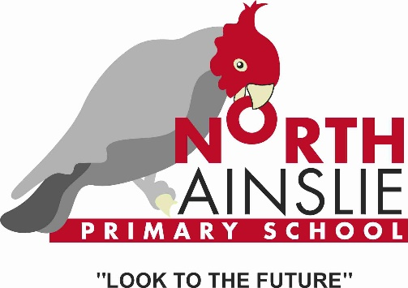

North Ainslie Primary School
  - Network: North/Gungahlin

School Plan 2019-2023

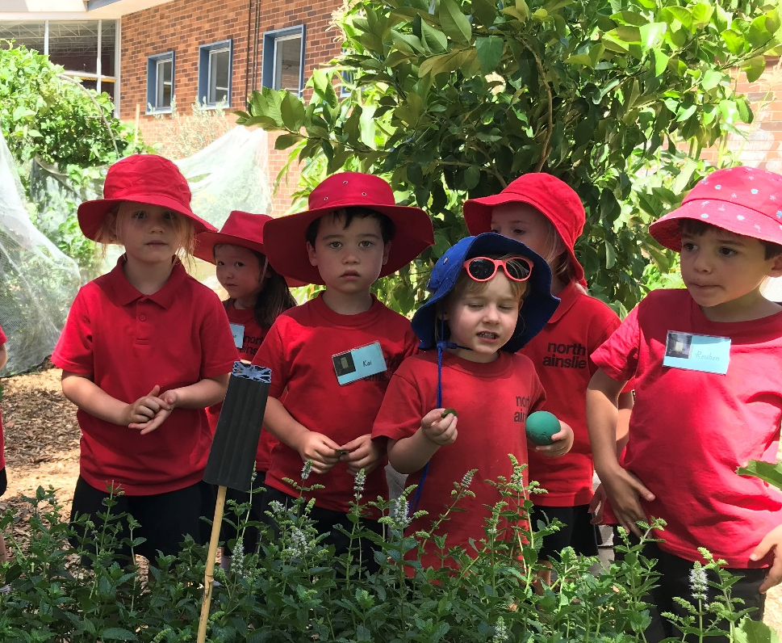

The purpose of school improvement planning
This plan establishes a strong improvement agenda to be driven by school leaders over the next five years. It was informed by the Directorate’s Strategic Plan and system-level and school-based analysis of multiple sources of evidence including our School Review findings. Analysis of these multiple sources of evidence is supported by an annual provision to each school of a data summary as a key enabler of our improvement planning and implementation.
Each school undertakes a school review as an integral component of in its five-year improvement planning cycle. The reviews are an important part of how the Directorate supports and monitors school improvement. Reviews provide schools with quality and independent feedback, tailored to the school’s context. Each school is reviewed at least every five years, providing valuable opportunities for self-reflection, planning and improvement. The school improvement planning process is below. This representation is used in the footer of all school-based improvement documents to indicate the stage of planning or implementation.
Analysis Priorities Strategies Actions Impact (for student)
Our school planning is grounded in evidence from research and practice and expressed in terms of improvements in measurable student outcomes. Explicit five-year targets for improvement have been set and will give life to monitoring, evaluation and communication of progress to teachers, families and students.

Our school’s improvement agenda positioned within the Directorate’s Strategic Plan

Vision
Education Directorate vision: We will be a leading learning organisation where people know they matter.
How will the Education Directorate’s vision gain life within your school’s context?
School vision:
The School Board and Leadership Team continue to consult on the school’s vision, mission and values as part of our response to the recommendations from School Review and our work with Positive Behaviour for Learning. They will be finalised later this year.

Mission
Education Directorate’s mission: We develop and deliver educational services to empower each child and young person in the ACT to learn for life.
How will the Education Directorate’s mission gain life within your school’s context?
School mission:
The School Board and Leadership Team continue to consult on the school’s vision, mission and values as part of our response to the recommendations from School Review and our work with Positive Behaviour for Learning. They will be finalised later this year.

Values
Education Directorate’s Values: Respect, Integrity, Collaboration, Innovation.
How will the Education Directorate’s values gain life within your school’s context?
School values:
We are:
SAFE, RESPONSIBLE, RESPECTFUL AND THOUGHTFUL

The Learner Profile Attributes sit within these values.

Risk-taker, Reflective, Communicator, Balanced, Thinker, Principled, Open-minded, Inquirer, Knowledgeable, Caring

Education Directorate’s Strategic goals for 2018-2021
- Schools where students love to learn
- Investing in early childhood
- Evidence informed decisions
- Learning culture
- United leadership team

Education Directorate’s Strategic indicators for 2018-2021
- To promote greater equity in learning outcomes in and across ACT public schools
- To facilitate high quality teaching in ACT public schools and strengthen educational outcomes
- To centre teaching and learning around students as individuals

The Directorate will annually publish progress against its strategic indicators. Each school’s contributions to these strategic indicators will be provided to our school for inclusion in our Impact Report.

Multiple sources of evidence
Evidence informing this School Plan includes:
- analysis of system-level data
- analysis of school-based evidence over time (past 4/5 years)
- recommendations from School Review
- for schools with a preschool setting, Quality Ratings from assessment against the National Quality Framework.*

*For schools with a preschool setting their Quality Improvement Plan (QIP) is revised each year as part of the annual planning process.

Our improvement priorities
Priority 1: Improve writing for all students with an emphasis on expected growth.
What will the experience of students be like through implementation of this priority at the completion of our five-year school improvement cycle?

At North Ainslie Primary School, we teach writing because it is an essential life skill which enables us to communicate effectively, express ourselves and successfully contribute to society in a meaningful way.

Our students experience a consistent approach in the development of their writing from preschool to year 6. They are aware of their writing strengths and how to improve whilst writing for a range of purposes. Students at North Ainslie understand the links between the oral and written language. They can articulate and apply the authorial and secretarial roles of writing and see themselves as authors.

What measurable targets will support progress and monitoring of the impact of this priority?

Targets/Measures to be achieved by 2023.

Student learning data
Target or measure: Percentage of students achieving at or above expected growth from year 3 to year 5 in writing will be equal to, or above, like schools (SSSG) averaged over the last three years of the plan.
Source: NAPLAN growth data as available through SCOUT.
Starting point: 52.8% (2016-2018 at expected growth). On average the school is 12% points below SSSG (62%) for years 3 and 5 over the last three years.

Student learning data
Target or measure: Percentage of students in the top two bands will be equal to, or above, like schools (SSSG) averaged over the last three years of the plan.
Source: SSSG as available through SCOUT.
Starting point: On average the school is 12% points below SSSG for years 3 and 5 over the last three years.

Student Learning Data
Target or measure: From the commencement of 2020, use A to E data in writing to establish base line data and set targets.
Source: A to E data from SENTRAL, data tracker, moderation
Starting point: To be established in 2019 and 2020.

School program and process data
Target or measure: 100% of teachers (K-6) use consistent rubrics and work samples to make effective judgements regarding student progress.
Source: Rubrics, moderation processes, observation, walkthroughs, immersion visits, planning and assessment documents.
Starting point: To be established in 2019

Perception Data
Target or measure: From 2019 collect perception data from students about the teaching and learning of writing, including receiving appropriate feedback from teachers.
Source: School based surveys
Starting point: To be established in 2019

Perception Data
Target or measure: From 2019 perception data collected from teachers about the teaching and learning of writing, including receiving feedback on their practice.
Source: School based survey
Starting point: To be established in 2019
PRIORITY 2: Improve maths for all students with an emphasis on expected growth.
What will the experience of students be like through implementation of this priority at the completion of our five-year school improvement cycle?

At North Ainslie, we teach maths to empower our students to understand concepts, think critically and problem solve in order to confidently participate in life.

Our students experience a consistent approach in the development of their maths understanding and skills from preschool to year 6. They are aware of their strengths and how to improve whilst engaging in a range of mathematical opportunities, including deep inquiries and hands on problem solving. Students at North Ainslie understand the links between maths and other areas of the curriculum and see themselves as mathematicians.

What measurable targets will support progress and monitoring of the impact of this priority?

Targets/Measures to be achieved by 2023.

Student learning data
Target or measure: Percentage of students achieving at or above expected growth from year 3 to year 5 in numeracy will be equal to, or above, like schools (SSSG) averaged over the last three years of the plan.
Source: NAPLAN growth data as available through SCOUT.
Starting point: 44.9% (2016-2018 at expected growth). On average the school is 12% points below SSSG (57%) for years 3 and 5 over the last three years.

Student learning data
Target or measure: Percentage of students in the top two bands will be equal to, or above, like schools (SSSG) averaged over the last three years of the plan (school will disaggregate for EALD and gender).
Source: SSSG as available through SCOUT.
Starting point: On average the school is 13% points below SSSG for years 3 and 5 over the last three years.

Student Learning Data
Target or measure: From the commencement of 2020, use A to E data in maths to establish base line data and set targets.
Source: A to E data from SENTRAL, data tracker, moderation
Starting point: To be established in 2019 and 2020.

Student Learning Data
Target or measure: Number of students achieving expected growth as evidenced in PAT Maths data at the end of each year.
Source: PAT Maths
Starting point: To be established in 2019

Student Learning Data
Target or measure: Percentage of students achieving expected or above expected growth in maths in PIPS is comparable with the growth in PIPS reading.
Source: PIPS
Starting point: To be established in 2019 using an average over the previous three years

Perception Data
Target or measure: From 2019 collect perception data from students about the teaching and learning of maths.
Source: School based surveys
Starting point: To be established in 2019

Perception Data
Target or measure: From 2019 perception data collected from teachers about the teaching and learning of maths.
Source: School based survey
Starting point: To be established in 2019

Endorsement
This School Plan has been endorsed electronically by our Principal, Director School Improvement and Board Chair.

Principal
Name:
Date:

Director School Improvement
Name:
Date:

Board Chair
Name:
Date:

