Charles Conder Primary School
  - Network: Tuggeranong

Strategic Plan 2018-2022

This page is intentionally left blank.

School Profile

Vision
This school’s vision enables our community to work towards common goals ensuring children are our focus. The manifesto is embodied by ‘Know the Child – Grow the Child’. Charles Conder Primary School has a strong commitment to providing a safe and harmonious school environment where successful relationships thrive. The strength lies in the close partnership between students, staff, parents and the wider community which is highly valued to us all. We promote and develop positive and respectful relationships. The school motto is: Commitment to Excellence – in a caring, cooperative, purposeful and success-oriented environment.

Values and Beliefs

At Charles Conder Primary School our community believes in the manifesto of ‘Know the child, Grow the child’. We incorporate a holistic and collaborative approach to teaching and learning where students belong, feel safe and supported and have high expectations for success.
Learning is student centred, differentiated, authentic and inquiry driven. Teachers analyse data to identify purposeful, personal learning goals allowing for targeted teaching and learning. Feedback and reflection facilitates ongoing learning, ensuring students feel empowered to take risks, extend their thinking and develop a growth mindset.
At Charles Conder Primary school every student is learning and achieving as part of a shared partnership between school and home. As a community we build healthy relationships through trust, respect, support and encouragement.
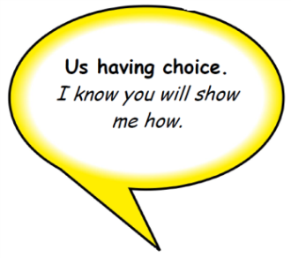
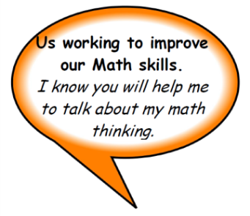
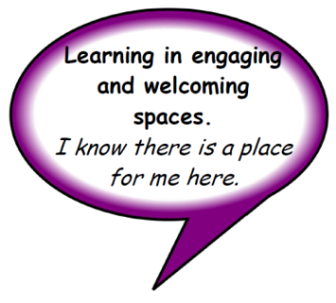
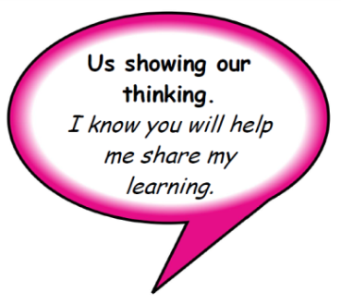
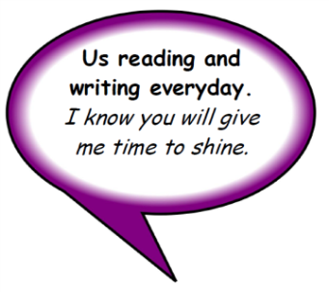
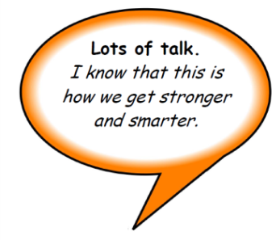
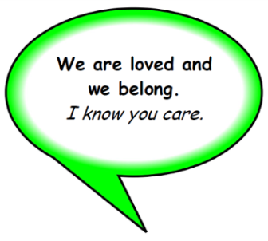
Know the Child, Grow the Child, at Charles Conder Primary School, you will see:

School Improvement Planning

Priority One: Improvement in academic achievement
Student outcomes to be achieved through this priority include:
- Improved Mathematics outcomes P – 6
- Improved English outcomes P - 6

Targets by the end of 2022 we will achieve:
90% K - 6 at reading benchmark
Reading 90% Student growth in year 5 (within school match) is at or above the ACT scaled growth score
NAPLAN Reading 80% of students have greater than or expected growth
Writing 80% Student growth in year 5 (within school match) is at or above the ACT scaled growth score

NAPLAN writing 80% of students have greater than or expected growth
Numeracy 90% Student growth in year 5 (within school match) is at or above the ACT scaled growth score
NAPLAN Numeracy 80% of students have greater than or expected growth
PAT MATHS 75% of students Y 1 - 6 at Stanine 5 or above
PAT SPELLING 75 % of students in Y3 - 6 at Stanine 5 or above
PAT reading Comprehension 75% of students in yrs 1-6 at stanine 5 or above

National School Improvement Tool – Domain focus: Domain 1 - An explicit improvement agenda
National Quality Standard – Quality Area focus: Quality Area 1 - Educational program and practice
Education Directorate Priorities:
Key Improvement Strategies | Timeline(s) | Responsibility | Targeted Resources | Key Performance Indicators
- Embed a culture of analysis of reliable data in English and Mathematics to inform teaching and learning | 2018 | Leadership team | ACER pre and post testing term 1 and 4  Professional learning team agenda | - 100% of teachers at this school use results from system testing and key diagnostic assessments to inform teaching and learning  - 100% of teachers participate in PLT’s reviewing and analysing reading, writing and numeracy data each fortnight, implementing strategies to improve student outcomes  - 80% of each year level Cohort reach reading benchmark
- Embed a coaching culture in order to build capacity and empower teacher efficacy | 2018 - 2022 | Leadership team | SLC and SLB resourcing/ SES loading | - 10% point increase in the proportion of teachers feedback indicate that there are processes in place to support their practice on satisfaction survey  - 10% point increase in the proportion of teachers who indicate satisfaction that they receive useful feedback about their work at this school on satisfaction surveys  - 100% of teachers develop coaching and mentoring agreements which are aligned to whole school and teacher performance goals
- Strengthen differentiated teaching and learning with high expectations from P - 6 | 2018 - 2019 | All staff | PLC | - 100% of teachers use the Conder Framework for Learning aligned with Australian Curriculum achievement standards through K-6  - 100% of teachers utilise ILP goals to differentiate learning and review each term  - 100% of teachers utilise data informed planning templates for English and Mathematics shared with leadership term each term
- Strengthen the goal setting model to cater for all students academic needs | 2018 | All staff | PLC | - 100% of students have visible reading, writing and numeracy goals that are reviewed and changed each term
- Strengthen formative assessment practices to provide feedback mechanisms | 2018 | Pedagogy coach and teachers | Coaching and PLC | - 10% point increase in the proportion of students that indicate teachers provide me with useful feedback about my schoolwork  - 100% of teachers use the T.A.G feedback mechanism in classrooms  - 100% of teachers use formative assessment tools to inform teaching

Priority Two: Improvement in student wellbeing
Student outcomes to be achieved through this priority include:
- Students feel safe
- Students feel connected to school and peers
- Improving student resilience and self esteem
- Improving student persistence and respect

Targets by the end of 2022 we will achieve:
- School Satisfaction data indicates that 95% of parents surveyed believe student behaviour is well managed at this school.
- School Satisfaction data indicates that 95% of parents surveyed believe their child feels safe at this school.
- School Satisfaction data indicates that 100% of parents surveyed believe they are overall satisfied with this school

- School Satisfaction data indicates that 95% of students surveyed believe student behaviour is well managed at this school.
- School Satisfaction data indicates that 95% of students surveyed believe they feel safe at this school.
- School Satisfaction data indicates that 100% of students surveyed believe they are overall satisfied with this school

National School Improvement Tool – Domain focus: Domain 3 - A culture that promotes learning

National Quality Standard – Quality Area focus: Quality Area 5 - Relationships with children
Education Directorate Priorities:
Key Improvement Strategies | Timeline(s) | Responsibility | Targeted Resources | Key Performance Indicators
- Embed the PBL framework as a whole school approach to wellbeing | 2018 - 2019 | PBL team and all staff | PLC and external funding | - Pre and post data on Whole School processes and non-classroom settings (SAS)  - 10% Increase in the proportion of parents who indicate satisfaction related to student behaviour being well managed and that their child feels safe at school  - The student safety mean for each year group from years 3-6 be 3.8 or higher in the Feelings About Yourself and School Survey.  - The student Self Esteem mean for each year group from years 3-6 be 4.0 or higher in the Feelings About Yourself and School Survey.
- Embed a culture of analysis of reliable data in Social and Emotional wellbeing to inform teaching and learning | 2018- 2020 | Student engagement team and teachers | Online surveys and PLC | - 10% increase in the proportion of students who agree/strongly agree with the satisfaction survey item I feel safe at my school.  - 10% increase in the proportion of students who agree/strongly agree with the satisfaction survey item Teachers treat me fairly.  - 10% increase in the proportion of students strongly agree with the satisfaction survey item Student’s behavior is well managed.
- Build highly effective teams to strengthen collegial culture of mutual trust and support among staff | 2018 - 2022 | Principal | PL Steve Francis and PLC | - increase in the proportion of staff who agree/strongly agree that Staff/ Staff Relations are excellent in the ASCSIMT  - 10% point increase in the proportion of staff that agree their professional achievements are celebrated at this school  - 10% point increase in the proportion of staff that agree there is effective communication amongst all staff.
- Strengthen the engagement of parents as partners in learning | 2018 - 2022 | All staff | Seesaw | - 95% parents and students indicate their learning needs are met and communicated through Seesaw  - 10% point increase in the proportion of parents who indicate satisfaction related to community partnerships are valued and maintained and the school takes parents’ opinions seriously compared

Priority Three: Embed a culture of Inquiry to foster lifelong learners in school and beyond
Student outcomes to be achieved through this priority include:
- Students develop skills and dispositions from assets of life
- Students integrate digital technologies to enhance their learning
- Students be inquiry thinkers to investigate the world they live in
- Students to develop knowledge and skills to solve conflict
- Students have a growth mindset in all facets of learning and socialisation
- Students develop a healthy living mindset and learn practical ways to facilitate
- Students develop key general capabilities and curriculum perspectives to be informed citizens

National School Improvement Tool – Domain focus: Domain 6 - Systematic curriculum delivery
National Quality Standard – Quality Area focus: Quality Area 6 - Collaborative partnerships with families and communities
Education Directorate Priorities:
Key Improvement Strategies | Timeline(s) | Responsibility | Targeted Resources | Key Performance Indicators
- Embed the assets for life to facilitate learning | 2018 - 2021 | Leadership team |  | - 100% of teacher show evidence of and use Kath Murdoch’s ‘Assets for Life’
- Strengthen the inquiry model across all key learning areas | 2018 - 2021 | Leadership team |  | - 10 % point increase in proportion of parents who indicate satisfaction that computer technology is an integral part of learning and teaching at my child’s school  - 10% point increase in proportion of students who indicate that teachers provide opportunities to do interesting things  - 100% of teachers can provide evidence to show ways they have made improvements to their inquiry teaching based on their individual and team goals set in term 1  - 100% teachers indicate through evaluations progress in their planning and teaching of Inquiry
- Facilitate the General Capabilities and cross curriculum perspectives to contextualise real life connections | 2019 - 2021 | All staff |  | To be developed

Endorsements

School Principal
Name: Jason Walmsley | SIGNATURE  ___________________________________

Board Chair
Name: Michael Sutton | SIGNATURE  ___________________________________

Director School Improvement
Name: Kate Smith | SIGNATURE  ___________________________________

