Florey Primary School
Annual School Board Report
2018

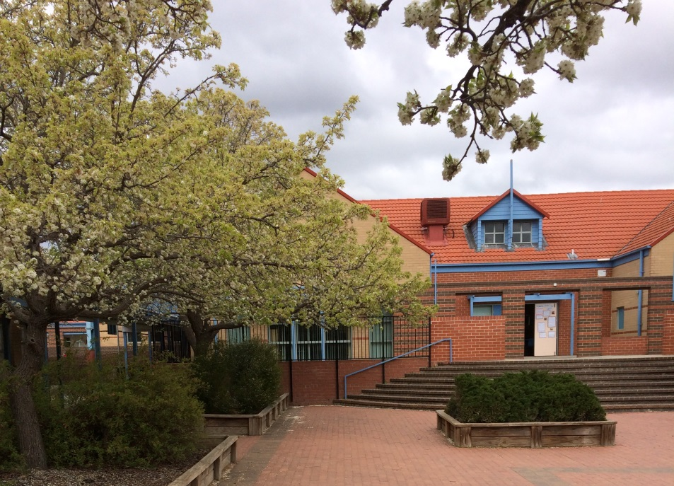

This page is intentionally left blank.

This report supports the work being done in the ACT Education Directorate, as outlined in Strategic Plan 2018-21: A Leading Learning Organisation.

Accessibility
The ACT Government is committed to making its information services, events and venues accessible to as many people as possible.
If you have difficulty reading a standard document and would like to receive this publication in an alternate format, such as large print and audio, please telephone (02) 6247 4580.
If English is not your first language and you require the translating and interpreting service, please telephone 13 14 50.
If you are deaf or hearing impaired and require the National Relay Service, please telephone 13 36 77.
© Australian Capital Territory, Canberra, 2018
Material in this publication may be reproduced provided due acknowledgement is made.

Contents
Reporting to the community 1
Summary of School Board activity 1
School Context 1
Student Information 1
Student enrolment 1
Student attendance 2
Supporting attendance and managing non-attendance 2
Staff Information 3
Teacher qualifications 3
Workforce composition 3
School Review and Development 3
School Satisfaction 4
Overall Satisfaction 4
Learning and Assessment 6
Performance in Literacy and Numeracy 6
Early years assessment 6
NAPLAN 6
Outcomes for College Students 7
Post School Destination 7
Financial Summary 9
Voluntary Contributions 10
Reserves 10
Endorsement Page 11
Members of the School Board 11

Reporting to the community
School report to communities in range of ways, including through:
- Annual School Board Reports
- a (5-year) School Improvement Plan (formerly School Strategic Plan)
- annual Impact Reports/ Annual Action Plan Reports
- newsletters
- other sources such as My School.

Summary of School Board activity
The Board congratulates the students, staff and parents of Florey Primary School for a successful 2018, and for creating an open and caring environment that we can all enjoy.
This year, Board members focussed on:
- Further successes with the Positive Behaviours for Learning
- Implementation and revision of school guidelines and policies
Florey Primary School’s vision is helping our children reach their educational potential through a supportive and individual teaching program and learning environment. Our educators continually are using assessment data to respond to the individual needs of the child, whilst involving the community to assist in our children’s learning.
I congratulate our Principal, Felicity Bruce on her continued outstanding leadership of her wonderful team of educators - time and again they demonstrated a willingness to go above and beyond the call of duty in the service of their profession. To all our teachers and support staff, a heartfelt thank you.
I also wish to thank the P and C and Board Members for their efforts in providing improvements within the school community throughout 2018.
It has been my pleasure to chair the Florey Primary School Board this year and work with our dedicated staff and parents.

School Context
Over the past seven years the demographics of Florey Primary School have shown a gradual increase in total numbers of students until 2017 when the numbers have started to decline. While the percentage of language background other than English (LBOT) students has remained relatively consistent. The number of students in the bottom quarter of the Index of Community Socio-Educational Advantage (ICSEA) has remained relatively consistent over the past four years, while the number in the top quarter ICSEA has continued to drop over the seven years. The number of boys at the school has been greater than the number of girls for the last two years. There is a variation in student enrolment from the two data sources. This is due to the time of the year when data is collected as the number of students attending the school fluctuates throughout the year.
Table: Student population changes in the primary school sector from 2012 to 2018
Group | 2012 | 2013 | 2014 | 2015 | 2016 | 2017 | 2018
ICSEA value | 1064 | 1065 | 1053 | 1054 | 1051 | 1053 | 1047
Female | 190 | 212 | 212 | 222 | 223 | 212 | 205
Male | 167 | 171 | 200 | 222 | 223 | 226 | 209
Indigenous | 3% | 2% | 3% | 3% | 3% | 2% | 4%
LBOT | 38% | 42% | 43% | 39% | 39% | 40% | 40%
Total | 356 | 383 | 412 | 443 | 446 | 438 | 414
Source: myschool.edu.au May 2019
Table: Distribution of students by ICSEA
Quarter | 2012 | 2013 | 2014 | 2015 | 2016 | 2017 | 2018
Bottom | 9 | 14 | 16 | 17 | 18 | 17 | 17
Middle | 17 | 22 | 21 | 22 | 21 | 22 | 23
Middle | 29 | 27 | 26 | 27 | 29 | 30 | 31
Top | 46 | 37 | 36 | 35 | 32 | 31 | 29
Source: myschool.edu.au May 2019

Student Information

Student enrolment
In 2018 there were a total of 427 students enrolled at this school.
Table: 2018 Student enrolment
Student type | Number of students
Male | 217
Female | 210
Aboriginal and Torres Strait Islander | 14
LBOTE* | 176
*Language Background Other Than English
Source: Analytics and Evaluation, December 2018

Student attendance
The following table identifies the attendance rate of students by year level during 2018. Student attendance rate is the percentage of school days attended by students in each year level at the school. Student attendance is measured over two school terms; that is from the first day of the school year for students in term 1 to the last day of term 2.
Table: 2018 Attendance rates in percentages*
Year level | Attendance rate
1 | 92.0
2 | 88.0
3 | 92.0
4 | 90.0
5 | 91.0
6 | 89.0
Source: Analytics and Evaluation, December 2018
* Attendance data for 2018 have been derived from a school administration system in the process of implementation. Care should be taken when comparing these data with data from previous years and from other jurisdictions.

Supporting attendance and managing non-attendance
All ACT public schools put into effect the education participation requirements in the Education Act 2004 and the responsibilities of schools in relation to compulsory education. The Education Directorate’s Education Participation (Enrolment and Attendance) Policy describes its position with regard to supporting attendance and managing non-attendance. A suite of procedures supports the implementation of the policy. Please refer to https://www.education.act.gov.au/ for further details.

Staff Information

Teacher qualifications
All teachers at this school meet the professional requirements for teaching in an ACT public school. The ACT Teacher Quality Institute (TQI) specifies two main types of provision for teachers at different stages of their career, these are detailed below.
- Full registration is for teachers with experience working in a registered school in Australia or New Zealand who have been assessed as meeting the Proficient level of the Australian Professional Standards for Teachers.
- Provisional registration is for newly qualified teachers or teachers who do not have recent experience teaching in a school in Australia and New Zealand. Many teachers moving to Australia from another country apply for Provisional registration.

Workforce composition
Workforce composition for the year of reporting is highlighted in the following table. The data is taken from the school’s verified August staffing report. For reporting purposes it incorporates all school staff including preschools, staff absent for a period of less than four consecutive weeks and staff replacing staff absent for more than four consecutive weeks. It does not include casuals and staff absent for a period of four consecutive weeks or longer.
The Education Directorate is required to report Aboriginal and Torres Strait Islander staff figures. As of June 2018, 101 Aboriginal and Torres Strait Islander staff members were employed across the Directorate.
Table: 2018 Workforce composition numbers
Staff employment category | TOTAL
Teaching Staff: Full Time Equivalent Permanent | 23.30
Teaching Staff: Full Time Equivalent Temporary | 5.20
Non Teaching Staff: Full Time Equivalent | 13.69
Source: This data is from the 2018 August census date and is calculated using the parameters provided by the ABS.

School Review and Development
The ACT Education Directorate’s Strategic Plan 2018-2021 provides the framework and strategic direction for School Improvement Plans (formerly School Strategic Plans). This is supported by the school performance and accountability framework, ‘People, Practice and Performance: School Improvement in Canberra Public Schools, A Framework for Performance and Accountability’. This framework has school improvement at its centre, with the National School Improvement Tool (NSIT) as its core feature, providing support to achieve high standards in student learning, innovation and best practice in ACT public schools.
Prior to 2016 all ACT public schools participated in a four-year cycle of school review and development. In the fourth year schools underwent an external validation process. In 2016 this changed to a five-year cycle with an External School Review at the end.
Our school will be reviewed in 2020. A copy of the most recent validation report can be found on our school website.

School Satisfaction
Schools use a range evidence to gain an understanding of the satisfaction levels of their parents and carers, staff and students. In August/ September of this reporting period ACT schools undertook a survey to gain an understanding of school satisfaction at that time. This information was collected from Staff, parents and students from year 5 and above (with the exception of students in special schools) through an online survey.

Overall Satisfaction
In 2018, 81% of parents and carers, 95% of staff, and 75% of students at this school indicated they were satisfied with the education provided by the school.
Included in the survey were 16 staff, 14 parent, and 12 student items which are described as the national opinion items. These items were approved by the then Standing Council on School Education and Early Childhood (SCSEEC) for use from 2015. The following tables show the percentage of parents and carers, students and staff who agreed with each of the national opinion items at this school.
A total of 39 staff responded to the survey. Please note that not all responders answered every question.
Table: Proportion of staff in agreement with each national opinion item
National opinion item | Proportion of staff
Teachers at this school expect students to do their best. | 100
Teachers give useful feedback. | 95
Teachers at this school treat students fairly. | 97
This school is well maintained. | 97
Students feel safe at this school. | 64
Students at this school can talk to their teachers about their concerns. | 92
Parents at this school can talk to teachers about their concerns. | 97
Student behaviour is well managed at this school. | 59
Students like being at this school. | 84
This school looks for ways to improve. | 97
This school takes staff opinions seriously. | 85
Teachers at this school motivate students to learn. | 97
Students’ learning needs are being met at this school. | 79
This school works with parents to support students' learning. | 87
Staff get quality feedback on their performance | 82
Staff are well supported at this school. | 79
Source: 2018 School Satisfaction Surveys, August/September 2018
*Prior to 2018, the item wording and placement was slightly different.
A total of 168 parents responded to the survey. Please note that not all responders answered every question.
Table: Proportion of parents and carers in agreement with each national opinion item
National opinion item | Proportion of parents and carers
Teachers at this school expect my child to do his or her best. | 90
Teachers give useful feedback. | 83
Teachers at this school treat students fairly. | 87
This school is well maintained. | 88
My child feels safe at this school. | 85
I can talk to my child’s teachers about my concerns. | 89
Student behaviour is well managed at this school. | 62
My child likes being at this school. | 87
This school looks for ways to improve. | 79
This school takes parents’ opinions seriously. | 66
Teachers at this school motivate my child to learn. | 86
My child is making good progress at this school. | 78
My child's learning needs are being met at this school. | 77
This school works with me to support my child's learning. | 81
Source: 2018 School Satisfaction Surveys, August/September 2018
*Prior to 2018, the item wording and placement was slightly different.
A total of 102 students responded to the survey. Please note that not all responders answered every question.

Table: Proportion of students in years 5 to 6 in agreement with each national opinion item
National opinion item | Proportion of students
My teachers expect me to do my best. | 100
Teachers give useful feedback. | 71
Teachers at my school treat students fairly. | 68
My school is well maintained. | 60
I feel safe at this school. | 51
I can talk to my teachers about my concerns. | 71
Student behaviour is well managed at my school. | 23
I like being at my school. | 72
My school looks for ways to improve. | 82
Staff take students’ opinions seriously. | 63
My teachers motivate me to learn. | 87
My school gives me opportunities to do interesting things. | 67
Source: 2018 School Satisfaction Surveys, August/September 2018
*Prior to 2018, the item wording and placement was slightly different.
These results, as well as the continual review of school performance, contributed to the evaluation of our Strategic Plan and the development of Annual Action Plans. The Strategic Plan (or School Improvement Plan) is available on the school website.

Learning and Assessment

Performance in Literacy and Numeracy

Early years assessment
Students in kindergarten undertake an on-entry assessment of their early reading and numeracy skills using the Performance Indicators in Primary Schools (PIPS) program. Student results are reported against five performance bands at the end of semester 1 and 2. Below are the results for this school.
Table: Florey Primary School PIPS 2018 mean raw scores
Agency | Reading start | Reading end | Mathematics start | Mathematics end
School | 41 | 110 | 37 | 55
ACT | 49 | 124 | 39 | 54
Source: Analytics and Evaluation

Results are not reported when there are fewer than five students with results. This rule is applied for reasons of statistical reliability, as well as to protect the privacy of students in small schools.
The following table shows the mean scores achieved by students at this school compared to the ACT for this reporting period.
Table: Florey Primary School 2018 NAPLAN Mean Scores
Test Domain | Year 3 School | Year 3 ACT | Year 5 School | Year 5 ACT
Reading | 415 | 441 | 486 | 518
Writing | 410 | 411 | 450 | 460
Spelling | 404 | 410 | 470 | 494
Grammar & Punctuation | 426 | 438 | 487 | 510
Numeracy | 416 | 416 | 485 | 494
Source: Analytics and Evaluation

Financial Summary
The school has provided the Directorate with an end of year financial statement that was approved by the school board. Further details concerning the statement can be obtained by contacting the school. The following summary covers use of funds for operating costs and does not include expenditure in areas such as permanent salaries, buildings and major maintenance.
Table: Financial Summary
INCOME | January-June | July-December | January-December
Self-management funds | 171410.55 | 356421.59 | 527832.14
Voluntary contributions | 12265.00 | 3448.75 | 15713.75
Contributions & donations | 1217.35 | 350.00 | 1567.35
Subject contributions | 4000.00 | 1770.00 | 5770.00
External income (including community use) | 10357.27 | 6403.64 | 16760.91
Proceeds from sale of assets | 1454.55 | 0.00 | 1454.55
Bank Interest | 7445.17 | 7508.06 | 14953.23
TOTAL INCOME | 208149.89 | 375902.04 | 584051.93
EXPENDITURE
Utilities and general overheads | 36156.86 | 54655.05 | 90811.91
Cleaning | 45300.89 | 51202.72 | 96503.61
Security | 4350.68 | 180.00 | 4530.68
Maintenance | 45358.03 | 86319.78 | 131677.81
Administration | 7992.27 | 8319.62 | 16311.89
Staffing | 0.00 | 0.00 | 0.00
Communication | 3480.87 | 2582.55 | 6063.42
Assets | 37500.20 | 25295.14 | 62795.34
Leases | 0.00 | 0.00 | 0.00
General office expenditure | 24780.07 | 17139.89 | 41919.96
Educational | 26865.38 | 10469.77 | 37335.15
Subject consumables | 6298.64 | 835.92 | 7134.56
TOTAL EXPENDITURE | 238083.89 | 257000.44 | 495084.33
OPERATING RESULT | -29934.00 | 118901.60 | 88967.60
Actual Accumulated Funds | 226111.57 | 208111.57 | 178111.57
Outstanding commitments (minus) | -33752.18 | 0.00 | -33752.18
BALANCE | 162425.39 | 327013.17 | 233326.99

Voluntary Contributions
The funds listed were used to support the general operations of the school. The spending of voluntary contributions is in line with the approved budget for 2018.

Reserves
Name and Purpose | Amount | Expected Completion
Painting Interior 2018  - Painting is an ongoing maintenance requirement of the school.  - Reserves are set each year to ensure any upgrades can be completed.  - A clean and cared for environment ensures the school remains welcoming and encourages students to care for the school. | $30,000.00 | 04/2019, with remaining funds rolled over for use during 2019.
Staffing 2018  - This reserve is set to cover any unanticipated staffing expenses that may occur. For example: increase student numbers causing the need to open another class; staff injury that may not be covered by workers compensation.  - This enhances the school’s ability to keep staffing at appropriate levels. | $20,000.00 | Rolled over to 2019
Staff Room Upgrade 18/19  - The staff room has not been upgraded or refurbished in over 10 years. This reserve has been set to enable improvements. The possibility of extension is also being considered as the staff room currently does not fit the total number of staff at any given time.  - Having a pleasant place to meet enhances staff wellbeing. | $30,000.00 | 12/2020
Furniture 2018  - The Year 1/2 area needed an upgrade in furniture as chairs were old, scratched and marked.  - The new furniture provides greater comfort for students and greater workspace. It also enhances student sense of being valued and valuing their work. | $20,000.00 | 11/2018

Endorsement Page

Members of the School Board
Parent Representative(s): | Nicole Inveen | Stephen Watt | Shobhana Sharma
Community Representative(s):
Teacher Representative(s): | Adam Volmari | David Kemp
Student Representative(s):
Board Chair: | Nicole Inveen
Principal: | Felicity Bruce
I approve the report, prepared in accordance with the provision of the ACT Education Act 2004, section 52.

Board Chair Signature: | Nicole Inveen | Date: | 14/05/2019

I certify that to the best of my knowledge and belief the evidence and information reported in this Annual School Board Report represents an accurate record of the Board’s operations during this reporting period.

Principal Signature: | Felicity Bruce | Date: | 14/05/2019

