Turner School

Annual Action Plan Report 2017
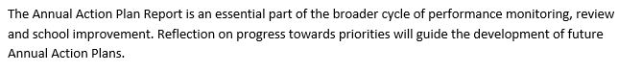

Context
2017 was the first year of the new School Plan 2017 to 2021 and followed the highly successful external School Review that took place in 2016. In the Review the school was commended on its school improvement processes that involved staff, students and the community and the inquiry stance the school took towards continually improving. Thus the systematic approach to planning, reflecting and collaborating as a staff and school community was carried into 2017. The recognition across the ACT and beyond as a highly effective school has meant that Turner has hosted many visiting school leaders and teachers across 2017. This has enabled the school to share practices, which was a 2016 Review recommendation and at the same time build capacity of our own teachers, coaches and school leaders as they hosted visiting educators.
Some of our 2016 school leadership team have moved on to lead in other ACT schools in 2017 which has provided further leadership opportunities for Turner aspiring leaders and the opportunity for other ACT school leaders to move into Turner during 2017. While this could have had an unsettling influence on the school, the strongly embedded practices at the school have meant the school has not weakened its improvement agenda with leadership movement. The end of 2017 saw the announcement of the principal ending her time in the principalship and moving in 2018 to a part time leadership coaching role for the Directorate.

Methodology
In 2017 Turner School had an active School Improvement Committee that met twice a term to drive the implementation of the School Plan initiatives, to reflect on the impact of actions and to plan ongoing improvement with the staff, students, community and School Board. The School Improvement Committee consisted of the 7 executive team members, the 2 staff Board representatives and 3 other teachers who volunteered to be on the committee making it a group of 12 for 2017.
To ensure school improvement is seen as a normal part of the school’s ongoing learning and work, the meeting schedule for each term in 2017 saw 2 School Improvement Committee meetings and 2 staff meetings scheduled. Every Board meeting had a standing item on school improvement where the progress against each of the school’s priorities was discussed. Every P&C meeting the principal presented a written and verbal report that included a standing item on school improvement. Each term a number of newsletters had a featured column on school improvement, providing families the details of the actions within each of the two priorities and the impact of our work. Throughout the year we held student forums to discuss particular aspects of our school to provide our students with the opportunity to give feedback and ideas.
The School Improvement Committee developed Theories of Action for each of the priorities on A2 coloured posters to present them in a bold and simple format for staff, students and parents to engage with. The posters are across the school and on the school website.
The data drawn upon for this report includes a mix of both qualitative and quantitative data generated from the system and the school.
Quantitative data sets:
System Satisfaction Survey results, School Climate Survey results, NAPLAN results, PIPS results, Turner School Reading Benchmark results, Turner School Place Value Interview results.
Qualitative data sets:
Annual audit against the National Safe Schools Framework, annual audit against the National School Improvement Tool, coaching feedback, Coffee Chat forums, student forums, P&C and Board feedback and initial feedback on the efficacy of tracking student learning assets, skills and dispositions. In addition feedback data from the Artists’ and Writers’ Festival, the staff performance development tools and discussions and a range of team and staff meeting forums have contributed to school improvement reflection and planning.
The annual audit by staff teams against the National Safe Schools Framework found the school to have maintained the rating from the 2016 School Review of ‘Doing Well’ in all 9 domains. The team ratings provide useful snapshots of how each team perceives elements of the school’s practices and enables reflection and discussion of ways to further strengthen elements.
The annual audit by staff against the National School Improvement Tool found the school to have maintained the ratings from the 2016 School Review of Outstanding in 8 of the domains and High in 1 domain, Community Partnerships. Evidence cited by the staff in 2017 actually indicates strengthening of evidence in many of the 9 domains and of potentially moving the Community Partnerships to the Outstanding rating given partnerships now have been documented.

Evaluation of Performance

Priority 1

Maximise the growth in learning for every student

Targets
  - Increase in the percentage of mainstream K-3 students achieving at or above the ACT ED Benchmark Reading range from end 2016 data by 2 percentage points
  - Increase in the percentage of mainstream students achieving the expected achievement level or above on the Turner School Place Value assessment from end 2016 data by 2 percentage points for each year level K-6
  - Increase in the percentage of students who demonstrate growth over a school year using the ABLES English: Reading and Writing assessment tool (2016 78% demonstrated growth)
  - Increase in the percentage of students achieving at or above the expected growth in PIPS reading and number by 2 percentage points from the 2016 figures of Reading 81% and Number 92%
  - Increase in the percentage of students in year 5 making equal to or greater than expected growth in NAPLAN reading, writing and numeracy by 5 percentage points from the 2016 growth data
  - Increase in the percentage of mainstream students achieving in the top two bands for year 3 NAPLAN reading, writing, numeracy by 3 percentage points from 2016 NAPLAN data
  - Increase in parent agreement to 85% of the System Satisfaction Survey question “ This school works with me to support my child’s learning” from 2016 parent figures of 81%
  - Increase in student agreement to 90% in the System Satisfaction Survey question “Teachers at the school provide students with useful feedback about their schoolwork” from 2016 student figures of 87%

Progress
The following tables indicate the 2017 percentage for each target against the 2016 baseline.
Percentage of mainstream K-3 students achieving at or above the ACT ED Benchmark Reading range |  |  |  |  |  |  | Target  Achievement
Year level | 2016 | 2017 | 2018 | 2019 | 2020 | 2021
K | 77% | 75.5% |  |  |  |  | In progress
1 | 82% | 74% |  |  |  |  | In progress
2 | 90% | 84% |  |  |  |  | In progress
3 | 93% | 91% |  |  |  |  | In progress

Percentage of mainstream students achieving the expected achievement level or above on the Turner School Place Value assessment |  |  |  |  |  |  | Target  Achievement
Year level | 2016 | 2017 | 2018 | 2019 | 2020 | 2021
K | 92% | 75% |  |  |  |  | In progress
1 | 92% | 83% |  |  |  |  | In progress
2 | 89% | 87% |  |  |  |  | In progress
3 | 89% | 86% |  |  |  |  | In progress
4 | 81% | 89% |  |  |  |  | In progress
5 | 93% | 82% |  |  |  |  | In progress
6 | 90% | 78% |  |  |  |  | In progress

Percentage of students who demonstrate growth over a school year using the ABLES English: Reading and Writing assessment tool |  |  |  |  |  |  | Target  Achievement
K-6 | 2016 | 2017 | 2018 | 2019 | 2020 | 2021
% | 78% | 95% |  |  |  |  | In progress

Percentage of students achieving at or above the expected growth in PIPS reading and number |  |  |  |  |  |  | Target  Achievement
 | 2016 | 2017 | 2018 | 2019 | 2020 | 2021
Reading | 81% | 83% |  |  |  |  | In progress
Number | 92% | 84% |  |  |  |  | In progress

Percentage of students in year 5 making equal to or greater than expected growth in NAPLAN reading, writing and numeracy |  |  |  |  |  |  | Target  Achievement
Yr 5 | 2016 | 2017 | 2018 | 2019 | 2020 | 2021
Reading | 61.9% | 76.7% |  |  |  |  | In progress
Writing | n/a | 64.3% |  |  |  |  | In progress
Numeracy | 54.4% | 73.8% |  |  |  |  | In progress

Percentage of mainstream students achieving in the top two bands for year 3 NAPLAN reading, writing, numeracy |  |  |  |  |  |  | Target  Achievement
Yr 3 | 2016 | 2017 | 2018 | 2019 | 2020 | 2021
Reading | 72% | 67.7% |  |  |  |  | In progress
Writing | 52.6% | 56.3% |  |  |  |  | In progress
Numeracy | 59.7% | 50.8% |  |  |  |  | In progress

Percentage of mainstream students achieving in the top two bands for year 5 NAPLAN reading, writing, numeracy |  |  |  |  |  |  | Target  Achievement
Yr 5 | 2016 | 2017 | 2018 | 2019 | 2020 | 2021
Reading | 58.8% | 77.2% |  |  |  |  | In progress
Writing | 23.5% | 27.3% |  |  |  |  | In progress
Numeracy | 40.8% | 50.9% |  |  |  |  | In progress

System Satisfaction Survey question  “ This school works with me to support my child’s learning” |  |  |  |  |  |  | Target  Achievement
 | 2016 | 2017 | 2018 | 2019 | 2020 | 2021
Percentage of parent agreement | 81% | 87.5% |  |  |  |  | In progress

System Satisfaction Survey question  “Teachers at the school provide students with useful feedback about their schoolwork” |  |  |  |  |  |  | Target  Achievement
 | 2016 | 2017 | 2018 | 2019 | 2020 | 2021
Percentage of student agreement | 87% | 83.49% |  |  |  |  | In progress

Key Improvement Strategies and Key Performance Indicators from School Plan
- Extend teacher knowledge of curriculum (EYLF, Victorian Curriculum A-D, and Australian Curriculum) aligning pedagogy and practice
- KPI: Performance Development Plans and conversations with mentors indicate Turner teachers are confident and knowledgeable implementing the Australian Curriculum
Building teacher knowledge of curriculum and aligning pedagogy and practice has been a main focus of 2017. Embedded coaches in each team and layered professional learning focusing on the Australian Curriculum Achievement Standards and the Content Descriptors has been highly effective in building teachers’ capacity. In addition the teachers on small group classes have become much more confident with their knowledge of the A-D stages of curriculum pre Foundation and the associated ABLES assessment tool. This is reinforced through coaching feedback and the team leaders and school leadership have seen depth of understanding through their learning walks, discussions with teachers at team planning days and performance development conversations and through the presentations teachers give to visiting teachers and school leaders and at conferences. The annual staff audit of the NSIT undertaken in term 3 showed the separate teaching teams all citing evidence of curriculum knowledge that lead to the overall ‘Outstanding’ rating in that domain. Visiting school leaders also comment on the teaching staff and coaches’ depth of knowledge of curriculum and their effectiveness in aligning pedagogy and practice. The Turner School Beliefs and Practices documents are an ongoing touchstone to reflect on beliefs and practices and were used as coaching focus areas in 2017.
- Continue to strengthen the effectiveness and consistency of teaching practice to meet student need
- KPI: Teacher capacity building and checking mechanisms indicate a reduction in variance in teaching
The annual staff audit of the NSIT undertaken in term 3 showed the separate teaching teams all citing evidence of high levels of expertise within the teaching teams that lead to the overall ‘Outstanding’ rating in the ‘Expert teaching team’ domain. The professional learning model and strong culture of reflective and collaborative practice underpins the strong approach to continually improving practice. The practices of coaching, setting of team goals and checking in on them through Learning Walks and Talks have been essential to the success of this key improvement strategy in 2017. Twice a year audits to check in on writing and maths have also been effective. The start of the year saw a number of early career teachers on staff and through thorough induction processes and close support from team leaders, coaches and highly experienced teachers on each team, initial variance between teachers has been greatly reduced. Again the frequent revisiting of the Turner Beliefs and Practices document has been a key strategy used at the coaching, team and whole staff level to ensure consistency and coherence of practices. Three Directors of School Improvement have been on Turner Learning Walks and Talks over 2017 and all have commented on the low levels of variance between classes and celebrated the high levels of consistency within and across teams.

- Strengthen the alignment of assessment and feedback for all students
- KPI: Turner Assessment and Monitoring schedule and associated tools ensures every child’s growth in reading, writing, numeracy is tracked and Learning Walk feedback indicates student feedback is aligned to assessment.
2017 has seen a focus on developing teacher knowledge of the Australian Curriculum requirements related to Writing and teacher capacity to effectively analyse student writing to plan for next learning. This has led to refinements in the Writing analysis tools and a Turner Class Writing Map. Teachers now effectively track student growth in reading, writing and maths place value and for younger students, oral language development. The writing maps are kept with each class teacher and shared at the team level and with the school leadership. The reading, place value and oral language growth is displayed on a series of large data walls in the staff learning room where the team leaders and coaches facilitate team level discussion about individual and cohort growth. The cohort growth is also documented as a percentage in the tables in this report as measures for targets for this priority.
Every K-6 student has had reading, writing, maths and social or learning asset goals every term this year. Through regular conferencing and peer and teacher feedback matched to their goals the school leadership is confident students are receiving feedback that takes their learning further. 83.49% of year 5/6 students agreed with the statement “Teachers at the school provide students with useful feedback about their schoolwork”. A student feedback Beliefs and Practices statement has been drafted to take into the 2018 school year to further strengthen this area.
- Continue the implementation of the Turner professional learning model
- KPI: Satisfaction data shows high levels of staff satisfaction for professional learning, support and feedback
Data for 2017 shows high levels of staff satisfaction for professional achievements, support and feedback including an improvement from the 2016 data in all 3 areas.
84.6% of combined teacher and administrative staff noted agreement with the question “I receive useful feedback about my work at this school”. (85.3% teaching staff noted agreement)
The School Climate survey results for staff indicate very high levels of satisfaction with the professional learning model in place. The professional learning includes embedded coaching, additional time for every teacher to be a part of a professional learning community meeting during the school day and support to collaboratively inquire into their practice using an Action Learning model. The 9 coaches supported teachers throughout the year with new and experienced teachers receiving coaching, demonstrating it as a strength-based rather than a deficit approach to building capacity. Coaching feedback is highly positive with every teacher being coached rating their teaching after coaching 1 or 2 intervals higher on a 5 point scale. In addition a strong focus on sharing practice within the school, across the network and at the national level has built the Turner staff as a strong professional learning culture. This professional learning model has been documented into a Theory of Action to take the staff from the 2017 year into the 2018 school year.
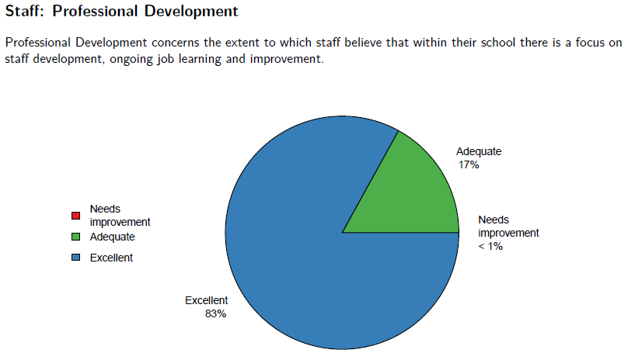
Strengthen strategic partnerships with families and the wider community to engage in children’s learning and development
Figure 1: ASCSIMT 2017 Turner School Report - Staff: Professional Development, page 59
- KPI: Tracking of parental involvement in school activities indicates high levels of involvement; Satisfaction data shows high levels of parental satisfaction and Documentation indicates formalised agreements with community groups
Our School Satisfaction data and School Climate data indicates strong levels of parental engagement.
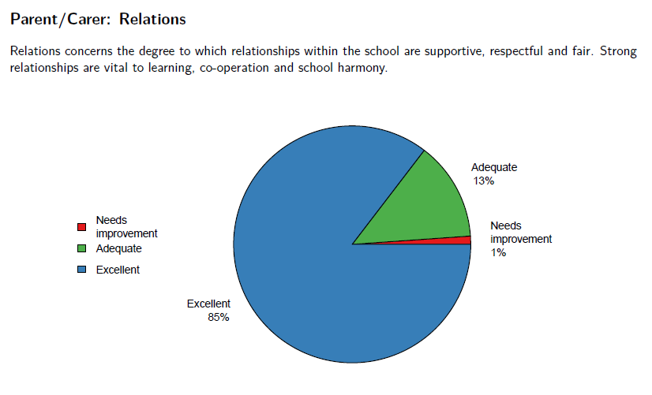
87.5% of parents noted high levels of agreement for the question “This school works with me to support my child’s learning” which is the highest agreement in 4 years and 90.36% noted high levels of agreement for the question “Community partnerships are valued and maintained”, again the highest rating in 4 years. In 2017 attendance at information sessions, parent teacher interviews, learning journeys and parent workshops was documented. Represented as percentages some levels of parental engagement captured in 2017 were:
Figure 2: ASCSIMT 2017 Turner School Report - Parent/Carer: Relations, page 68
- 92% of parents and carers met with teachers to develop their child’s Individual Learning Plan (ILP)
- Between 90% and 100% of parents and carers from each class P-6 participated in their child’s Learning Journey
- Between 30% and 50% of parents and carers from each year group P-6 attended the team start of year information and meet the teacher session. While low in comparison to the percentages above, those who attended the information sessions commented on the usefulness of these sessions for them.
It is evident from all our data that high numbers of parents and carers engage at school when their child is present and/or if the activity is 1:1 with a teacher. The greater use in 2017 of the school website to share information, the SMS messaging and whole of parent emails has supported communication channels.
In addition in 2017:
- Monthly Coffee Chats and special EALD Coffee Chats attracted groups of parents and carers where they could meet other parents and exchange viewpoints and information with school leadership. Numbers varied between 5 and 15 at each Chat.
- Each term a set of parent carer workshops were held for Reading, Writing, Numeracy, Setting up for Success in Kindergarten as well as the Sexual Health and Family Planning Personal Development workshop. All had numbers in attendance of between 10 and 20 parents and carers.
- Working Bees in the preschool and also in the main school grounds attracted small but dedicated groups of parents.
- The school fete once again attracted a very large number of parent carer volunteers to set up stalls and work together for the school community.
- The Volunteer folders set up in every classroom and office document a huge number of volunteer hours in the school (over 1000) and events such as the Artists’ and Writers’ Festival in 2017, particularly the Imagin-athon and the team launch events at the end of the festival saw record numbers of parents and carers involved in the school.
We have ended 2017 with letters documenting the ongoing support of our year 4 students’ participation in the Pegasus Horse-Riding for the Disabled by the Canberra City Lions Club and the ongoing scholarship for a rider arranged by the Pegasus CEO.
The end of year school improvement staff workshop documented the following as high impact strategies and actions that have contributed to the progress of this priority:
- The targeted professional learning that includes whole staff and team meetings, coaching and action learning set/PLC time that collectively enabled teachers to deepen their curriculum understandings
- The focus from all staff on their lesson learning intentions and individual student goals and matching feedback to these
- The layered professional learning and resultant refinements to the Writing analysis tools
- The team moderation focus across a range of learning areas including the ABLES tool
- The structure of the PLC and ALS times in 2017 and deepening of analysis of student learning in PLC meetings with PLC mentors
- An increased focus on analysis of student learning data
- The embedded coaching model
- The whole school take-up of the 1/3:2/3 workshop model that supports greater differentiation and conferencing
- The targeted support students receive in literacy and numeracy and through the integration support program
- The team collaborative planning, teaching and implementation along with team goals and sharing and checking of practice through team learning walks and talks
- The development of more website resources for parents and carers to support their child.
Through reflection on the various data sources and the particular targets for this priority, we are pleased that our data is indicating we are working effectively to achieve the outcome for this priority of Every student is making substantial growth in their learning each year.

Priority 2
Equip students with the capabilities and dispositions to learn and live successfully in the 21st Century

Targets
By the end of 2021 the school will achieve:
  - The establishment of a set of reliable measures to track student growth in a range of learning dispositions (for example we may track growth in a student’s ability to coordinate these learning dispositions). Once established, these tools will be used to track growth for the rest of the strategic plan
  - An increase in agreement in the System Survey question “The use of learning technologies is an integral part of learning and teaching” from 2016 figures
    - students (2016-93%) by 1 percentage point
    - staff (2016-61%) by 5 percentage points
    - parents (2016- 67%) by 5 percentage points

  - An increase in agreement in the new school question in the System Survey “Students at Turner School are being equipped with the capabilities and dispositions to learn and live successfully in the 21st Century.”(This question added in 2017 to form the baseline percentage)

Progress
Key Improvement Strategies and Key Performance Indicators from School Plan
- Embed contemporary learning and teaching pedagogies
- KPI: Checking mechanisms indicate that GAFE is implemented across all year levels and inquiry learning is implemented across multiple curriculum areas in classrooms
In 2017 the 3/4 classes received a rollout of Chromebooks and as a result all 3-6 classrooms are implementing GAFE (Google Apps For Education). Additional iPads were distributed to all P-2 classrooms enabling greater student use of technology and all specialist teachers received iPads to support their teaching. The higher levels of agreement in the System Satisfaction Survey from students, parents and staff indicates our efforts to improve access to and use of devices is improving.
Kath Murdoch, international expert on Inquiry education, made two visits to Turner School in 2017 taking our learning deeper. Lee Crockett, another international presenter in the 21st century learning field also made two visits to Turner. The work of Murdoch and Crockett, along with the learning from the research project that Turner is leading with 5 other Canberra schools working with 5 researchers from Griffith, Sydney and Wollongong universities provided our 5/6 teachers the confidence to explore Project Based Learning (PBL) pedagogies in 2017. PBL maximises multi-disciplinary learning as students select and inquire into real world community issues. Teachers have been recognized for their leadership in this area and presented on PBL at the Directorate’s 2017 Student Engagement conference, the 2017 national Maths conference and the 2017 national Australian Association of Research in Education conference.
System Satisfaction Survey question  “The use of learning technologies is an integral part of learning and teaching” |  |  |  |  |  |  | Target  Achievement
 | 2016 | 2017 | 2018 | 2019 | 2020 | 2021
Students | 93% | 99.09% |  |  |  |  | In progress
Staff | 61% | 81.13% |  |  |  |  | In progress
Parents | 67% | 77.91% |  |  |  |  | In progress

- Continue to improve learning environments
- KPI: Flexible learning spaces are evident in every classroom and annual program of upgrades is implemented
Every preschool to year 5/6 classroom learning space is set up as a flexible learning space and new furniture in all 1/2 classrooms at the start of this year supported this. Teachers continue to be guided by the research reading by Kath Murdoch ‘Classroom as the second teacher’ and in 2017 the focus on aesthetic learning spaces was a feature. Some classrooms set up Maker Project spaces and through team goals and team learning walks, classrooms across the school have regularly demonstrated consistency in high quality flexible learning spaces. The staff worked through a process of designing a Makerspace in the back library workroom and a design has been agreed upon with funding from a successful federal grant application for Maker projects to be further developed in 2018. The school purchased more display cabinets to enable teams to use them for display of student learning and/or as cabinets of curiosity to spark wondering with students at different points in their inquiries.

In 2017 upgrades included:
- Improvements to the grounds and play areas; specifically adding additional equipment to the playground (musical, balance and seating), installation of a watering system for the grassed area in front of the outdoor stage and development of a special garden in memory of a year 4 student who died in 2017
- Internal painting of all classrooms, corridors and the hall in the Condamine St building
- Expansion of the David St Carpark and associated paths
- Installation of a sail to shade a hot 1/2 courtyard
- New Indonesian language signage across the whole school
- A range of heat mitigation strategies undertaken by the Directorate.

- Develop effective monitoring and evaluation of learning dispositions and skills
- KPI: Tracking of student learning dispositions and skills is implemented
During 2017 all teaching teams have worked collaboratively, researching possible models internationally that could be adapted; developing these into tracking tools and trialling them. The results of this learning was shared to all staff mid-term 4 in a forum and it was agreed that as this work in education is new and our teachers are leading the way with this work, further refinements will occur in 2018 as teachers continue to track and monitor the development of student’s learning assets, skills and dispositions. Work with the research partners in our Data and Digital Literacy project will support this. The sharing forum was videoed as a record of the learning to date. The percentages of agreement for the Turner individual question in the system satisfaction survey indicate high levels of satisfaction already from students, staff and parents in the work we are doing as a school to equip students with the capabilities and dispositions to learn and live successfully in the 21st century.

System Satisfaction Survey question – Turner question:  “Students at Turner School are being equipped with the capabilities and dispositions to learn and live successfully in the 21st Century.” |  |  |  |  |  | Target  Achievement
 | 2017 | 2018 | 2019 | 2020 | 2021
Students | 88% |  |  |  |  | In progress
Staff | 98% |  |  |  |  | In progress
Parents | 93% |  |  |  |  | In progress

The end of year school improvement staff workshop documented the following as high impact strategies and actions that have contributed to the progress of this priority:
- A consistent whole school and whole team approach and shared language
- A shared focus on the benefits of flexible furniture and use of indoor and outdoor spaces and learning walks to highlight their effectiveness
- The focus on the 5 learner assets and their associated dispositions and skills, with personalised learning and project based learning through an inquiry approach highlighted by Kath Murdoch in the January and July professional learning and regularly revisited over the course of the year as well as linking assets across the curriculum
- The addition of more student devices P-6 including the 3-6 chromebooks and the associated focus on pedagogies for their effective use
- The introduction of a digital literacies coach
- The enrichment activities for students across the teams including the Artists’ and Writers’ Festival and many performing arts and creative and entrepreneurial opportunities
- The layered and focused professional learning over the year including the work of the Action Learning Sets.

Through reflection on the various data sources and the particular targets for this priority, we are confident that we are working effectively towards achieving our outcome for this priority of Students are confident and creative learners, equipped for a rapidly changing world.

