Macgregor Primary School
  - Network: Belconnen

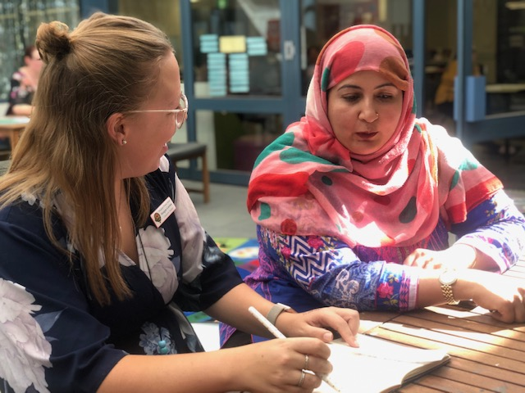
School Plan 2019-2023
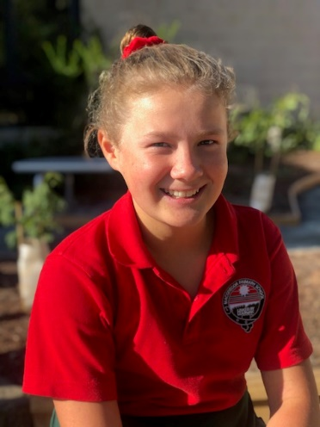

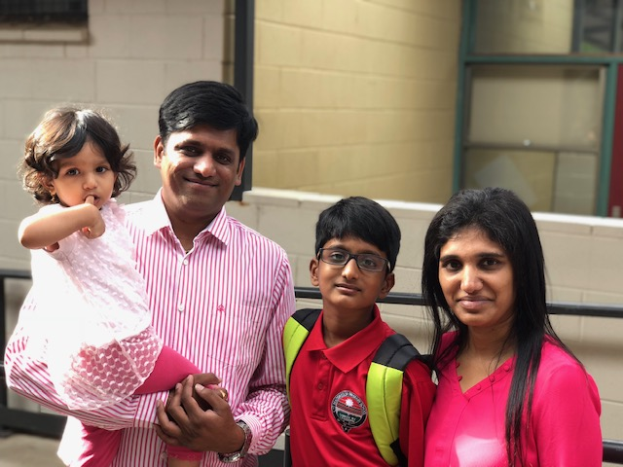
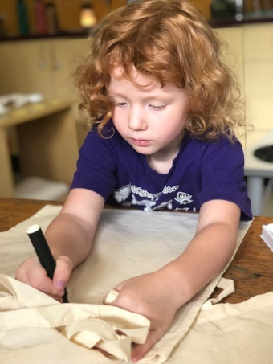
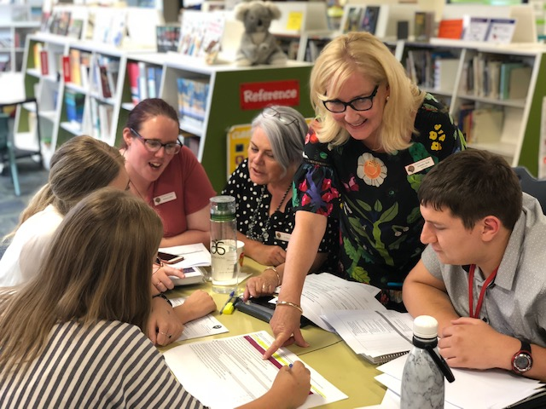

The purpose of school improvement planning
This plan establishes a strong improvement agenda to be driven by school leaders over the next five years. It was informed by the Directorate’s Strategic Plan and system-level and school-based analysis of multiple sources of evidence including our School Review findings. Analysis of these multiple sources of evidence is supported by an annual provision to each school of a data summary as a key enabler of our improvement planning and implementation.
Each school undertakes a school review as an integral component of in its five-year improvement planning cycle. The reviews are an important part of how the Directorate supports and monitors school improvement. Reviews provide schools with quality and independent feedback, tailored to the school’s context. Each school is reviewed at least every five years, providing valuable opportunities for self-reflection, planning and improvement. The school improvement planning process is below. This representation is used in the footer of all school-based improvement documents to indicate the stage of planning or implementation.
Analysis Priorities Strategies Actions Impact (for student)
Our school planning is grounded in evidence from research and practice and expressed in terms of improvements in measurable student outcomes. Explicit five-year targets for improvement have been set and will give life to monitoring, evaluation and communication of progress to teachers, families and students.

Our school’s improvement agenda positioned within the Directorate’s Strategic Plan

Vision
Education Directorate vision: We will be a leading a learning organisation where people know they matter.
How will the Education Directorate’s vision gain life within your school’s context?
School vision:
'Linked by Learning ... Experience, Expression and Excellence', students striving to develop to their full potential, learn respect for self, for others and the environment, whilst striving in harmony to prepare for a challenging future.

Mission
Education Directorate’s mission: We develop and deliver educational services to empower each child and young person in the ACT to learn for life.
How will the Education Directorate’s mission gain life within your school’s context?
School mission:
At Macgregor, we will function as a professional learning community, collaborating to ensure that all students achieve success.
"We will do whatever it takes, to ensure all students achieve success in their schooling”.

Values
Education Directorate’s Values: Respect, Integrity, Collaboration, Innovation.
How will the Education Directorate’s values gain life within your school’s context?
School values:
At Macgregor, our school values are most easily encompassed in one acronym: BRICK.
Our BRICK values are:
- Belonging
- Respect
- Individuality
- Cooperation
- Kindness
These values provide the foundation upon which all relationships at Macgregor Primary School are based. Through the explicit teaching of these values students develop skills that enable them to take increased responsibility for their own learning and their relationships with others.
Our W@M (Wellbeing at Macgregor) expectations were collaboratively created by the school community - Respect, Responsibility, Learner and Safe.

Education Directorate’s Strategic goals for 2018-2021
- Schools where students love to learn
- Investing in early childhood
- Evidence informed decisions
- Learning culture
- United leadership team

Education Directorate’s Strategic indicators for 2018-2021
- To promote greater equity in learning outcomes in and across ACT public schools
- To facilitate high quality teaching in ACT public schools and strengthen educational outcomes
- To centre teaching and learning around students as individuals

The Directorate will annually publish progress against its strategic indicators. Each school’s contributions to these strategic indicators will be provided to our school for inclusion in our Impact Report.

Multiple sources of evidence
Evidence informing this School Plan includes:
- analysis of system-level data
- analysis of school-based evidence over time (past 4/5 years)
- recommendations from School Review
- for schools with a preschool setting, Quality Ratings from assessment against the National Quality Framework.*

*For schools with a preschool setting their Quality Improvement Plan (QIP) is revised each year as part of the annual planning process.

Our improvement priorities
Priority 1: Build on the writing capabilities of all students
What will the experience of students be like through implementation of this priority at the completion of our five-year school improvement cycle?

- Students experience consistent and systematic high quality pedagogical, assessment and curriculum practices throughout their primary school years
- Students enjoy writing and have some choice
- Students know what good writing is
- Students understand how they can make their writing better
- Students have personalised and meaningful learning experiences

What measurable targets will support progress and monitoring of the impact of this priority?

Targets/Measures to be achieved by 2023

Student learning data
- Target or measure: Reduce the proportion of students in the bottom two bands to be less than 5% of the year 3 cohort and less than 10% of the year 5 by the last two years of the plan
Source: NAPLAN
Starting point (Baseline): Leading up to the commencement of this plan, there has been considerable year to year variation. The bottom two bands mean over three years for year 3 is 9.7% and for year 5 is 22.2%

- Target or measure: Increase the proportion of students in the top two bands for both year 3 and year 5 to be a mean of 36% by the last two years of the plan
Source: NAPLAN
Starting point (Baseline): Leading up to the commencement of this plan, there has been considerable year to year variation. The mean in the top two bands over three years for year 3 is 30.9% and for year 5 is 11.4%

- Target or measure: 85% of Macgregor Primary School’s year 5 student cohort will achieve at or above expected growth from year 3 to year 5 in writing (in school match) by the last two years of the plan
Source: NAPLAN
Starting point (Baseline): 58% students at or above expected growth (represented as a mean
over three years). Leading up to the commencement of this plan, there has been
considerable year to year variation

- Target or measure: An increase of 15% of year 3 and year 5 students at or above year level expectation for writing by the last two years of the plan
Source: School developed Writing Analysis Tool (WAT)
Starting point (Baseline): To be collected and analysed term 1, 2019

Perception Data
- Target or measure: All class teachers report clear knowledge of the school’s preferred writing pedagogy, with clarity about how to support individual student growth by the last two years of the plan
Source: In-school termly survey focussing on each teacher’s confidence to utilise the agreed pedagogy and analyse each student’s writing skills in order to support students to progress their writing by the last two years of the plan
Starting point (baseline): Results of teacher self-reflection during annual Teacher Professional Development Plan discussions and implementation of a standardised writing assessment. To be collected Term 1, 2019

School program and process data
- Target or measure: Every teacher (100%) has a personal-professional goal to build their own capacity in an identified area of writing that aligns with the school’s ‘agreed practices’ document
Source: Teacher Professional Development Plans (TPDP)
Starting point (baseline): TPDPs currently articulate a range of needs, some of which do not appear to align with classroom/pedagogical improvement

PRIORITY 2: Build on the numeracy capabilities of all students
What will the experience of students be like through implementation of this priority at the completion of our five-year school improvement cycle?

- Students experience consistent and systematic high quality pedagogical, assessment and curriculum practices throughout their primary school years
- Students enjoy numeracy and have some choice
- Students know and understand what it means to be proficient in numeracy
- Students experience personalised and meaningful learning
- Students demonstrate increased and consistent longitudinal growth

What measurable targets will support progress and monitoring of the impact of this priority?

Targets/Measures to be achieved by 2023

Student learning data
- Target or measure: Reduce the proportion of students in the bottom two bands to be less than 5% of the year 3 cohort and 10% of the year 5 cohort by the last two years of the plan
Source: NAPLAN
Starting point (Baseline): Leading up to the commencement of this plan, there has been considerable year to year variation. The mean over three years for year 3 is 13.1% and for year 5 is 20.7%
- Target or measure: Increase the proportion of students in the top two bands to be at least 40% of the cohort by the last two years of the plan
Source: NAPLAN
Starting point (Baseline): Leading up to the commencement of this plan, there has been considerable year to year variation. The mean over three years for year 3 is 25.9% and for year 5 is 17.3%
- Target or measure: 70% of Macgregor Primary School’s year 5 student cohort will achieve at or above expected growth from year 3 to year 5 in numeracy (in school match) by the last two years of the plan
Source: NAPLAN
Starting point (Baseline): Leading up to the commencement of this plan, there has been
considerable year to year variation. The mean over three years for year 5 is 44% students at
or above expected growth

- Target or measure: An increase of 15% (to achieve 62%) of students at or above Stanine 5 (40th percentile) by the last two years of the plan
Source: PAT Maths results years 2 to 6
Starting point (Baseline): end of 2018 current average across years 2 to 6 is 54%

Perception Data
- Target or measure: All class teachers report clear knowledge of the school’s preferred numeracy pedagogy, with clarity about how to support individual student growth by the last two years of the plan
Source: In-school termly survey focussing on each teacher’s confidence to utilise the agreed pedagogy and analyse each student’s mathematical skills in order to support students to progress their numeracy capabilities
Starting point (baseline): Results of teacher self-reflection during annual Teacher Professional Development Plan discussions and implementation of a standardised numeracy assessment. To be collected Term 1, 2019

School program and process data
- Target or measure: Every teacher (100%) has a personal-professional goal to build their own capacity in an identified area of numeracy
Source: Teacher Professional Development Plans (TPDPs)
Starting point (baseline): TPDPs currently articulate a range of needs, some of which do not appear to align with classroom/pedagogical improvement

PRIORITY 3: Build on the positive and safe learning culture for all students
What will the experience of students be like through implementation of this priority at the completion of our five-year school improvement cycle?

- Students learn in a positive and safe learning environment
- Students feel happy at school and have access to support
- Students are empowered to learn in an environment with high expectations
- Students feel connected to school and their individual successes are acknowledged
- Students have agency and voice
- Students understand and demonstrate positive behaviours for learning
- Families are connected to the student’s learning in meaningful ways

What measurable targets will support progress and monitoring of the impact of this priority?

Targets/Measures to be achieved by 2023

Student learning data
- Target or measure: 90% of parents, 80% of students and 90% of staff agree or strongly agree that ‘Behaviour is well managed at this school’ by the last two years of the plan
Source: School Satisfaction Survey data
Starting point (baseline): 2018 School Satisfaction Survey results shows 64% of staff, 58%
of parents and 32% of students

Perception Data
- Target or measure: 100% of staff and students understand our Positive Behaviour for Learning (PBL) systems
Source: PBL School Evaluation Tool data
Starting point (baseline): November 2018 School Evaluation Tool implementation data
indicates that 96.3% of staff and students understand our PBL systems

School program and process data
- Target or measure: Formal strategies for informing families regarding expected behaviours will be an area of strength in the PBL School Evaluation Tool by the last two years of the plan
Source: PBL School Assessment Survey and PBL School Evaluation Tool data
Starting point: The 2018 School Assessment Survey feedback identified that, formal
strategies for informing families regarding expected behaviours, is an area for development

- Target or measure: Every teacher (100%) has a personal-professional goal to build their own capacity in an identified area of building and maintain a positive and safe learning environment
Source: Teacher Professional Development Plans (TPDPs)
Starting point (baseline): Survey through Teacher Professional Development Plan
discussions to be collected Term 1, 2019

Endorsement
This School Plan has been endorsed electronically by our Principal, Director School Improvement and Board Chair.

Principal
Name: Jennifer Hall
Date: 24/05/2019

Director School Improvement
Name: Kris Willis
Date: 24/05/2019

Board Chair
Name: Duncan Beard
Date: 24/05/2019

