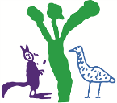

O'Connor Cooperative School
  - Network: North/Gungahlin

School Plan 2019 – 2023

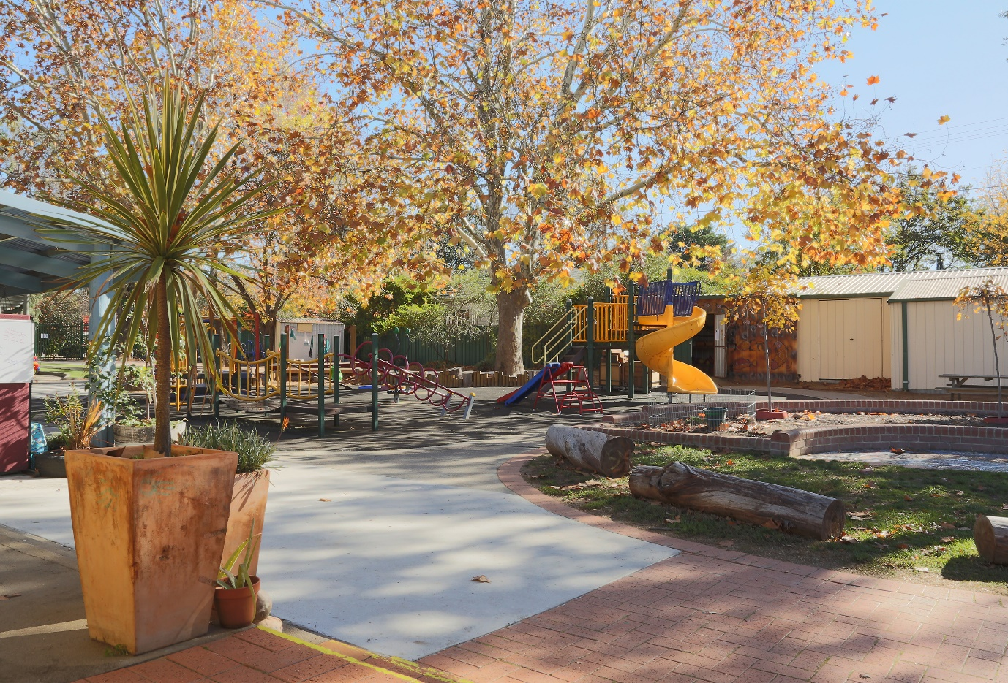

The purpose of school improvement planning
This plan establishes a strong improvement agenda to be driven by school leaders over the next five years. It was informed by the Directorate’s Strategic Plan and system-level and school-based analysis of multiple sources of evidence including our School Review findings. Analysis of these multiple sources of evidence is supported by an annual provision to each school of a data summary as a key enabler of our improvement planning and implementation.
Each school undertakes a school review as an integral component of in its five-year improvement planning cycle. The reviews are an important part of how the Directorate supports and monitors school improvement. Reviews provide schools with quality and independent feedback, tailored to the school’s context. Each school is reviewed at least every five years, providing valuable opportunities for self-reflection, planning and improvement. The school improvement planning process is below. This representation is used in the footer of all school-based improvement documents to indicate the stage of planning or implementation.
Analysis Priorities Strategies Actions Impact (for student)
Our school planning is grounded in evidence from research and practice and expressed in terms of improvements in measurable student outcomes. Explicit five-year targets for improvement have been set and will give life to monitoring, evaluation and communication of progress to teachers, families and students.

Our school’s improvement agenda positioned within the Directorate’s Strategic Plan

Vision
Education Directorate vision: We will be a leading learning organisation where people know they matter
How will the Education Directorate’s vision gain life within your school’s context?
School vision:
O’Connor Cooperative School is committed to excellence in early childhood education. As a community of learners, we work together to create sustainable connections between each other and within our environment, developing intellectual, personal, social and environmental responsibility.

PBL Vision
At O’Connor Cooperative School, we are committed to excellence in early childhood education. As a community of learners, we work together respectfully and safely. We show responsibility for ourselves, each other and our environment.
Together we Learn: Together we grow as
Safe Respectful Responsible Learners

Mission
Education Directorate’s mission: We develop and deliver educational services to empower each child and young person in the ACT to learn for life.
School How will the Education Directorate’s vision gain life within your school’s context?
School mission:
O’Connor Cooperative School is committed to growing relationships with Aboriginal peoples and Torres Strait Islander peoples. Together we learn and Together we grow as safe, responsible, respectful, learners.

We understand that children arrive at our school with a wealth of prior knowledge and experience and use this as a foundation for their learning and development.
We have secure, respectful and reciprocal relationships with all members of the community.
At our school the educators:
- ensure that the interests, abilities and culture of every child and their family are understood, valued and respected;
- encourage children to be active participants for sustainability, influencing the quality of life now, and for future generations;
- respect the views and feelings of each child;
- initiate warm, trusting and reciprocal relationships with children;
- provide safe and stimulating environments for children;

Values
Education Directorate’s Values: Respect, Integrity, Collaboration, Innovation
How will the Education Directorate’s vision gain life within your school’s context?
School values:
We value: (No rank order of importance)
- A thriving school community where staff and families openly work as willing partners
- A safe, inclusive setting where the strengths and needs of all members of our school community are recognised, respected and valued
- A family-friendly environment where privacy of personal information is respected and safeguarded
- The professionalism of staff as educational leaders committed to play-based best practice in early learning
- A strong focus on a balanced literacy and numeracy program which is embedded in all aspects of learning and teaching in our school
- The importance of social, emotional, physical and cognitive development - all the developmental domains.

We value cooperation, community, learning, respect and our environment.

Education Directorate’s Strategic goals for 2018-2021
- Schools where students love to learn
- investing in early childhood
- Evidence informed decisions
- Learning culture
- United leadership team

Education Directorate’s Strategic indicators for 2018-2021
- To promote greater equity in learning outcomes in and across ACT public schools
- To facilitate high quality teaching in ACT public schools and strengthen educational outcomes
- To centre teaching and learning around students as individuals.

The Directorate will annually publish progress against its strategic indicators. Each school’s contributions to these strategic indicators will be provided to our school for inclusion in our Impact Report.

Multiple sources of evidence
Evidence informing this School Plan includes:
- analysis of system-level data
- analysis of school-based evidence over time (past 4/5 years)
- recommendations from School Review
- Quality Ratings from assessment against the National Quality Framework.

Our improvement priorities
Priority 1: Improve learning outcomes in numeracy
What will the experience of students be like through implementation of this priority at the completion of our five-year school improvement cycle?

Students at O’Connor Cooperative school will experience a range of learning in mathematics to develop essential skills and knowledge in number and algebra, measurement and geometry, statistics and probability through
- Supported learning in a range of ways including information and communication technology
- Access to manipulatives
- Aligned pedagogical practice including common language
- Understanding of purpose and connection to real life
- Feedback about their learning- where to next
Students will be
- Familiar with a range of assessment tools
- Engaged and enjoy mathematical learning
- Successful and demonstrate growth
- Equipped to continue their education in mathematics

What measurable targets will support progress and monitoring of the impact of this priority?
Using the multiple sources of evidence approach as a guide, what measures will inform and demonstrate impact for students and staff through implementation of this improvement priority?

Targets/Measures to be achieved by 2023

Student learning data
Target: PIPS data
Increase to 80% the proportion of students in kindergarten achieving at or above expected growth in mathematics in PIPS (Number)
Source: EDU PIPS data
Starting point: Establish baseline in 2019

Target: A-E grades in number (Based on Australian Curriculum Achievement Standards)
Increase the number of students above standard in the number strand as evidenced in Yr 1 &2 Semester 2 student reports.
Source: School based achievement data
Starting point: Establish baseline in 2019

Perception Data
Measure: Parents
By 2023 90% of parent stakeholders are satisfied with the quality of education in mathematics
Source: School Satisfaction Surveys and additional school based surveys
Starting point: Establish baseline in 2019 survey.

School program and process data
Measure: Staff
Increase the level of staff confidence to “know the content and teaching strategies (pedagogies) of the teaching of numeracy”.
Source: School Based survey (Inquiring to Leading)
Starting point: Baseline data collected in 2019
Measure: Increase the level of staff confidence in using a whole of school approach for curriculum planning and delivery of mathematics including adequately resourced classrooms
Source: School Based data: Survey, Class Programs and observations
Starting point: Baseline data collected in 2019
Priority 2: Improve learning outcomes for students in writing and spelling
What will the experience of students be like through implementation of this priority at the completion of our five-year school improvement cycle?

Students at O’Connor Cooperative school will experience a range of learning in English to develop essential skills and knowledge in writing and spelling to create confident communicators, imaginative thinkers and informed citizens.
Students will experience
- A range of opportunities for daily meaningful writing
- Writing linked to variety of curriculum areas
- Regular feedback on their writing
Students will demonstrate
- Writing in a variety of genres
- Well-developed editing skills
- A variety of strategies to spell a range of words accurately

What measurable targets will support progress and monitoring of the impact of this priority?
Using the multiple sources of evidence approach as a guide, what measures will inform and demonstrate impact for students and staff through implementation of this improvement priority?

Targets/Measures to be achieved by 2023.

Student learning data
Target: A-E: Writing and Spelling based on the Australian Curriculum Achievement standards – at least 70% of students achieve at or above C grade in writing as evidenced in Yr 1 &2 Semester 2 student reports.
Source: A-E School based data
Starting point: Baseline established in 2019

Perception Data
Measure: 100% of students receiving descriptive and informative feedback about their writing and spelling
Source: Rubric (Student/peer/teacher) (based on Qld Achievement Standard Elaborations)
Starting point: Baseline established in 2019
Measure: By 2023 maintain or better than a 90% average of parent stakeholders are satisfied with the question Teachers at this school provide my child with useful feedback at this school
Source: School Satisfaction Survey
Starting point: Baseline established in 2018 (89%)

School program and process data
Measure: Increase the level of staff confidence to effectively know and use the 10 essential literacy strategies to improve student outcomes in writing and spelling
Source: School Based survey
Starting point: Baseline data collected in 2019

In addition to these priorities students at O’Connor Cooperative school will continue to experience a range of learning experiences to broaden their connection with families and the wider school community.

Across the school, all stakeholders will deepen the culture of inclusion and diversity through implementation of strategies that raise visibility and awareness of diverse cultures and ways of being.

Students will experience
- A range of learning experiences creating meaningful connections within our community
- Genuine opportunities to share learning with families
- Growth in their understandings of cultural inclusion
- Positive Behaviours for Learning
- Quality transition events

Endorsement This School Plan has been endorsed electronically by our Board Chair, Principal and Director School Improvement.

Principal
Name: Jenny Loudon
Date: 12 April 2019

Director School Improvement
Name: Judith Hamilton
Date: 12 April 2019

Board Chair
Name: Angela Corin
Date: 12 April 2019

