Amaroo School
Annual School Board Report 2019

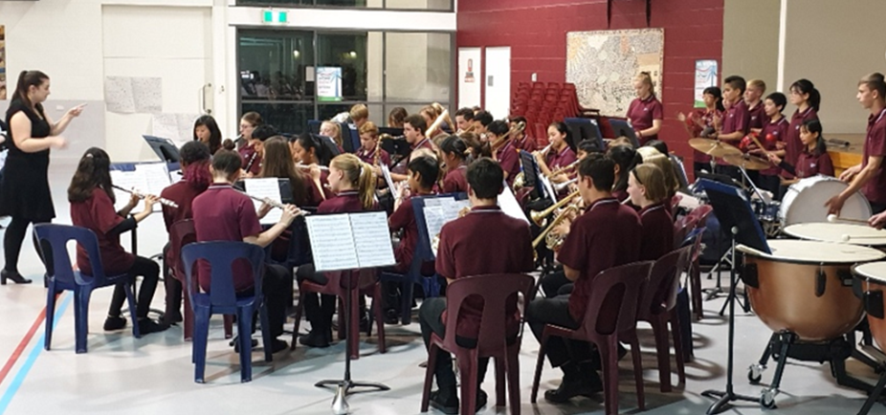
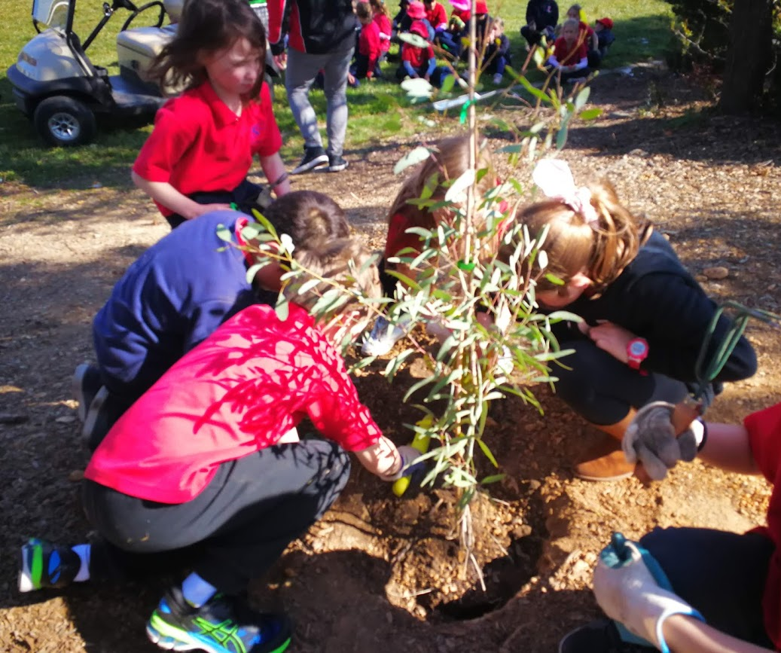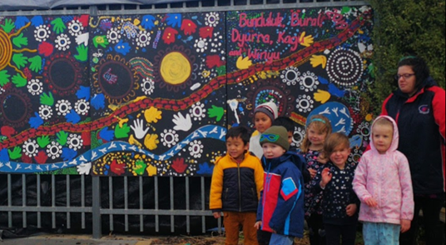

This page is intentionally left blank.

This report supports the work being done in the ACT Education Directorate, as outlined in Strategic Plan 2018-21: A Leading Learning Organisation.

Accessibility
The ACT Government is committed to making its information services, events and venues accessible to as many people as possible.
If you have difficulty reading a standard document and would like to receive this publication in an alternate format, such as large print and audio, please telephone (02) 6247 4580.
If English is not your first language and you require the translating and interpreting service, please telephone 13 14 50.
If you are deaf or hearing impaired and require the National Relay Service, please telephone 13 36 77.
© Australian Capital Territory, Canberra, 2020

Material in this publication may be reproduced provided due acknowledgement is made.

Contents
Reporting to the community 1
Summary of School Board activity 1
School Context 1
Student Information 2
Student enrolment 2
Student attendance 2
Supporting attendance and managing non-attendance 2
Staff Information 3
Teacher qualifications 3
Workforce composition 3
School Review and Development 3
School Satisfaction 4
Overall Satisfaction 4
Learning and Assessment 6
Performance in Literacy and Numeracy 6
Early years assessment 6
NAPLAN 6
Financial Summary 7
Voluntary Contributions 8
Reserves 8
Endorsement Page 9
Members of the School Board 9

Reporting to the community
Schools report to communities in a range of ways, including through:
- Annual School Board Reports
- a (5-year) School Improvement Plan (formerly School Strategic Plan)
- annual Impact Reports
- newsletters
- other sources such as My School.

Summary of School Board activity
Amaroo School is well positioned to continue to meet the needs of its growing community and remain as not just the largest school in the ACT, but also the best. Our focus on excellence, inclusion and helping students reach their potential will see our school community continue to thrive.
Amaroo School has experienced another wonderful year:

- Our new Hill playground was ready for the start of the 2019 school year. Thank you to the support of the Amaroo P and C and a successful 2018 Fete that raised the funds.
- Order of Australia Award, ACT Branch Student Award for voluntary community service and good citizenship amongst ACT school students, was awarded to year 9/10 LEADAS and PEARLS programs.
- The primary sector and SRC focus on sustainability brought changes to the school canteen as well as new tree plantings and sustainable gardens across the school
- Preschool underwent assessment against the National Quality Standards resulting in standards met or standards exceeded
- Biennial excursion to Japan occurred in October
- Upgrade of the main school carpark to include a “kiss and drop area”
- In December we were successful in obtaining a Federal Government “Local School Community Fund” grant of $20,000 for two shade sails to cover the Hill Playground and Early Childhood promenade.
- Amaroo School began piloting a new leadership structure of three principals; Executive Principal (P-10), Principal (P-6) and Principal (7-10)

School Context
Amaroo School is located in the Gungahlin region and is the largest ACT public school. Our student enrolment in February 2019 was 1,960 in Preschool to Year 10. Our student profile represents a highly diverse and multicultural background. We have 802 students with a language background other than English. There are 43 Aboriginal and Torres Strait Islander students currently enrolled and we provide for over 100 students with diagnosed special needs including four learning support classrooms for students with autism (LSUAs). We also boast a high Defence Force population with 158 students from Australian Defence Force families. We highly value our diversity as it represents the unique nature of the people in our school.
In 2019 we had an increased student population enrol into our Year 7 from Neville Bonner Primary School compared to 2018 and we expect the numbers to steadily increase.

Student Information

Student enrolment
In this reporting period there were a total of 1,859 students enrolled at this school in K-10. An additional 101 students enrolled in preschool.
Table: Student enrolment
Student type | Number of students
Male | 990
Female | 869
Aboriginal and Torres Strait Islander | 43
LBOTE* | 802
Source: ACT Education Directorate, Analytics and Evaluation Branch
*Language Background Other Than English

Student attendance
The following table identifies the attendance rate of students by year level during this reporting period. Student attendance rate is the percentage of school days attended by students in each year level at the school. Student attendance is measured over two school terms; that is from the first day of the school year for students in term 1 to the last day of term 2.
Table: Attendance rates in percentages
Year level | Attendance rate
1 | 90.0
2 | 91.0
3 | 92.0
4 | 92.0
5 | 92.0
6 | 93.0
7 | 90.0
8 | 89.0
9 | 89.0
10 | 86.0
Source: ACT Education Directorate, Analytics and Evaluation Branch

Supporting attendance and managing non-attendance
ACT public schools support parents and careers to meet their legal responsibilities in relation to the compulsory education requirements of the Education Act 2004. The Education Directorate’s Education Participation (Enrolment and Attendance) Policy describes its position with regard to supporting attendance and managing non-attendance. A suite of procedures supports the implementation of the policy. Please refer to https://www.education.act.gov.au/ for further details.

Staff Information

Teacher qualifications
All teachers at this school meet the professional requirements for teaching in an ACT public school. The ACT Teacher Quality Institute (TQI) specifies two main types of provision for teachers at different stages of their career, these are detailed below.
- Full registration is for teachers with experience working in a registered school in Australia or New Zealand who have been assessed as meeting the Proficient level of the Australian Professional Standards for Teachers.
- Provisional registration is for newly qualified teachers or teachers who do not have recent experience teaching in a school in Australia and New Zealand. Many teachers moving to Australia from another country apply for Provisional registration.

Workforce composition
Workforce composition for the current reporting period is provided in the following table. The data is taken from the school’s verified August staffing report. For reporting purposes, it incorporates all school staff including preschools, staff absent for a period of less than four consecutive weeks and staff replacing staff absent for more than four consecutive weeks. It does not include casuals and staff absent for a period of four consecutive weeks or longer.
The Education Directorate is required to report Aboriginal and Torres Strait Islander staff figures. As of June of the reporting period, 119 Aboriginal and/or Torres Strait Islander staff members were employed across the Directorate.
Table: Workforce composition numbers
Staff employment category | TOTAL
Teaching Staff: Full Time Equivalent Permanent | 119.05
Teaching Staff: Full Time Equivalent Temporary | 7.80
Non Teaching Staff: Full Time Equivalent | 53.11
Source: ACT Education Directorate, People and Performance Branch

School Review and Development
The ACT Education Directorate’s Strategic Plan 2018-2021 provides the framework and strategic direction for School Improvement Plans (formerly School Strategic Plans). This is supported by the school performance and accountability framework ‘People, Practice and Performance: School Improvement in Canberra Public Schools, A Framework for Performance and Accountability’. Annually, system and school level data are used alongside the National School Improvement Tool to support targeted school improvement, high standards in student learning, innovation and best practice in ACT public schools.
Prior to 2016 all ACT public schools participated in a four-year improvement cycle. In the fourth year schools underwent an external Validation process. In 2016 this changed to a five-year cycle with a School Review at the end.
Our school was reviewed in 2016. A copy of the Report of Review can be found on our school website.

School Satisfaction
Schools use a range evidence to gain an understanding of the satisfaction levels of their parents and carers, staff and students. Annually in August/ September ACT schools undertake a survey to gain an understanding of school satisfaction at that time. This information is collected from staff, parents and students from year 5 and above through an online survey.

Overall Satisfaction
In this period of reporting, 84% of parents and carers, 92% of staff, and 70% of students at this school indicated they were satisfied with the education provided by the school.
Included in the survey were 16 staff, 14 parent, and 12 student items which are described as the national opinion items. These items were approved by the then Standing Council on School Education and Early Childhood (SCSEEC) for use from 2015. The following tables show the percentage of parents and carers, students and staff who agreed with each of the national opinion items at this school.
A total of 133 staff responded to the survey. Please note that not all responders answered every question.
Table: Proportion of staff in agreement with each national opinion item
National opinion item | Proportion of staff
Parents at this school can talk to teachers about their concerns. | 96
Staff are well supported at this school. | 74
Staff get quality feedback on their performance. | 70
Student behaviour is well managed at this school. | 65
Students at this school can talk to their teachers about their concerns. | 93
Students feel safe at this school. | 90
Students like being at this school. | 90
Students’ learning needs are being met at this school. | 89
Teachers at this school expect students to do their best. | 95
Teachers at this school motivate students to learn. | 95
Teachers at this school treat students fairly. | 93
Teachers give useful feedback. | 91
This school is well maintained. | 87
This school looks for ways to improve. | 91
This school takes staff opinions seriously. | 72
This school works with parents to support students' learning. | 93
Teachers give useful feedback. | 91
Source: ACT Education Directorate, Analytics and Evaluation Branch
*Data derived from annual School Satisfaction Survey

A total of 556 parents responded to the survey. Please note that not all responders answered every question.
Table: Proportion of parents and carers in agreement with each national opinion item
National opinion item | Proportion of parents and carers
Teachers at this school expect my child to do his or her best. | 89
I can talk to my child’s teachers about my concerns. | 91
My child feels safe at this school. | 87
My child is making good progress at this school. | 80
My child likes being at this school. | 88
My child's learning needs are being met at this school. | 79
Student behaviour is well managed at this school. | 72
Teachers at this school give useful feedback. | 78
Teachers at this school motivate my child to learn. | 84
Teachers at this school treat students fairly. | 85
This school is well maintained. | 92
This school looks for ways to improve. | 83
This school takes parents’ opinions seriously. | 72
This school works with me to support my child's learning. | 80
Source: ACT Education Directorate, Analytics and Evaluation Branch
*Data derived from annual School Satisfaction Survey

A total of 1008 students responded to the survey. Please note that not all responders answered every question.
Table: Proportion of students in agreement with each national opinion item
National opinion item | Proportion of students
I can talk to my teachers about my concerns. | 51
I feel safe at this school. | 57
I like being at my school. | 61
My school gives me opportunities to do interesting things. | 70
My school is well maintained. | 46
My school looks for ways to improve. | 64
My teachers expect me to do my best. | 89
My teachers motivate me to learn. | 69
Staff take students’ concerns seriously. | 52
Student behaviour is well managed at my school. | 32
Teachers at my school treat students fairly. | 53
Teachers give useful feedback. | 57
Source: ACT Education Directorate, Analytics and Evaluation Branch
*Data derived from annual School Satisfaction Survey

Learning and Assessment

Performance in Literacy and Numeracy

Early years assessment
Students in kindergarten undertake an on-entry and on-exit assessment of their early reading and numeracy skills using the Performance Indicators in Primary Schools (PIPS) program. Student results are reported against five performance bands at the end of semester 1 and 2. Below are the results for this school for the current reporting period.
Table: Amaroo School PIPS 2019 mean raw scores
Agency | Reading start | Reading end | Mathematics start | Mathematics end
School | 57 | 125 | 40 | 55
ACT | 49 | 123 | 39 | 55
Source: ACT Education Directorate, Analytics and Evaluation Branch

NAPLAN
Students in years 3, 5, 7 and 9 in all ACT schools participate in the National Assessment Program-Literacy and Numeracy (NAPLAN). This program assesses skills in reading, writing, spelling, grammar and punctuation, and numeracy.
In this reporting period, 1.30 % of year 3 students, 0.00 % of year 5 students, 1.40 % of year 7 students and 0.00 % of year 9 students were exempt from testing based on nationally agreed criteria.
For reasons of statistical reliability, as well as to protect the privacy of students, results are not reported when the sample size is less than five.
The following table shows the mean scores achieved by students at this school compared to all other ACT public schools for this reporting period.
Table: NAPLAN Mean Scores
Test Domain | Year 3 School | Year 3 ACT | Year 5 School | Year 5 ACT | Year 7 School | Year 7 ACT | Year 9 School | Year 9 ACT
Reading | 429 | 438 | 518 | 516 | 547 | 550 | 598 | 592
Writing | 408 | 418 | 492 | 474 | 512 | 509 | 555 | 544
Spelling | 417 | 408 | 514 | 497 | 544 | 542 | 583 | 584
Grammar & Punctuation | 432 | 440 | 505 | 500 | 538 | 544 | 577 | 580
Numeracy | 400 | 411 | 503 | 496 | 555 | 552 | 591 | 594
Source: ACT Education Directorate, Analytics and Evaluation Branch

Financial Summary
The school has provided the Directorate with an end of year financial statement that was approved by the school board. Further details concerning the statement can be obtained by contacting the school. The following summary covers use of funds for operating costs and does not include expenditure in areas such as permanent salaries, buildings and major maintenance.
Table: Financial Summary
INCOME | January-June | July-December | January-December
Self-management funds | 764,245.60 | 476,249.11 | 1,240,494.71
Voluntary contributions | 20,470.50 | 25,187.00 | 45,657.50
Contributions & donations | 280.00 | 3,546.00 | 3,826.00
Subject contributions | 6,552.50 | 12,623.00 | 19,175.50
External income (including community use) | 64,943.30 | 71,314.29 | 136,257.59
Proceeds from sale of assets | 1,018.18 | 0.00 | 1,018.18
Bank Interest | 5,663.18 | 5,119.87 | 10,783.05
TOTAL INCOME | 863,173.26 | 594,039.27 | 1,457,212.53
EXPENDITURE
Utilities and general overheads | 189,500.01 | 271,623.06 | 461,123.07
Cleaning | 135,526.01 | 27,444.30 | 162,970.31
Security | 2,679.01 | 7,458.39 | 10,137.40
Maintenance | 141,042.94 | 107,429.85 | 248,472.79
Administration | 21,755.84 | 15,175.86 | 36,931.70
Staffing | 23,405.50 | 0.00 | 23,405.50
Communication | 9,101.80 | 9,361.11 | 18,462.91
Assets | 79,715.43 | 4,203.00 | 83,918.43
Leases | 13,413.71 | 12,327.69 | 25,741.40
General office expenditure | 33,004.46 | 53,536.60 | 86,541.06
Educational | 185,819.13 | 100,676.65 | 286,495.78
Subject consumables | 8,869.45 | 11,866.78 | 20,736.23
TOTAL EXPENDITURE | 843,833.29 | 621,103.29 | 1,464,936.58
OPERATING RESULT | 19,339.97 | -27,064.02 | -7,724.05
Actual Accumulated Funds | 176,504.88 | 238,774.67 | 236,524.57
Outstanding commitments (minus) | -39,306.44 | 0.00 | -39,306.44
BALANCE | 156,538.41 | 211,710.65 | 189,494.08

Voluntary Contributions
The funds listed were used to support the general operations of the school. The spending of voluntary contributions is in line with the approved budget for this reporting period.

Reserves
Name and Purpose | Amount | Expected Completion
Site enhancement Buildings and Grounds  To update or create spaces within the school & grounds to compliment student learning ( replace preschool carpet and vinyl) | $15,000.00 | 01/2020
Gardens  To regenerate the existing garden beds | $ 5,000.00 | 2020
ICT Teachers Devices  To purchase extra devices so all teachers can be allocated a device | $ 20,000.00 | 06/2019
Literacy  This is a goal from school plan to increase Literacy | $ 16,750.00 | 2020
Numeracy  This is a goal from school plan to increase Numeracy | $ 15,555.74 | 2020
Staffing  Required in the event we have a staffing debt in 2019 | $15,000 | 01/2020
Pear Deck  Teacher resource | $ 5,000.00 | 01/2020

Endorsement Page

Members of the School Board
Parent Representative(s): | Helen Cheung | Penny Freestone
Teacher Representative(s): | Garth Jurd | Raye Down
Student Representative(s): | Gemma Steele | Mohid Hussain
Board Chair: | Ian Phillips
Principal: | Gai Beecher
I approve the report, prepared in accordance with the provision of the ACT Education Act 2004, section 52.

Board Chair Signature: | Ian Phillips | Date: | 03 / 06 / 2020

I certify that to the best of my knowledge and belief the evidence and information reported in this Annual School Board Report represents an accurate record of the Board’s operations during this reporting period.

Principal Signature: | Gai Beecher | Date: | 03 / 06 / 2020

