Yarralumla Primary School
  - Network: South/Weston

School Improvement Plan 2020-2024

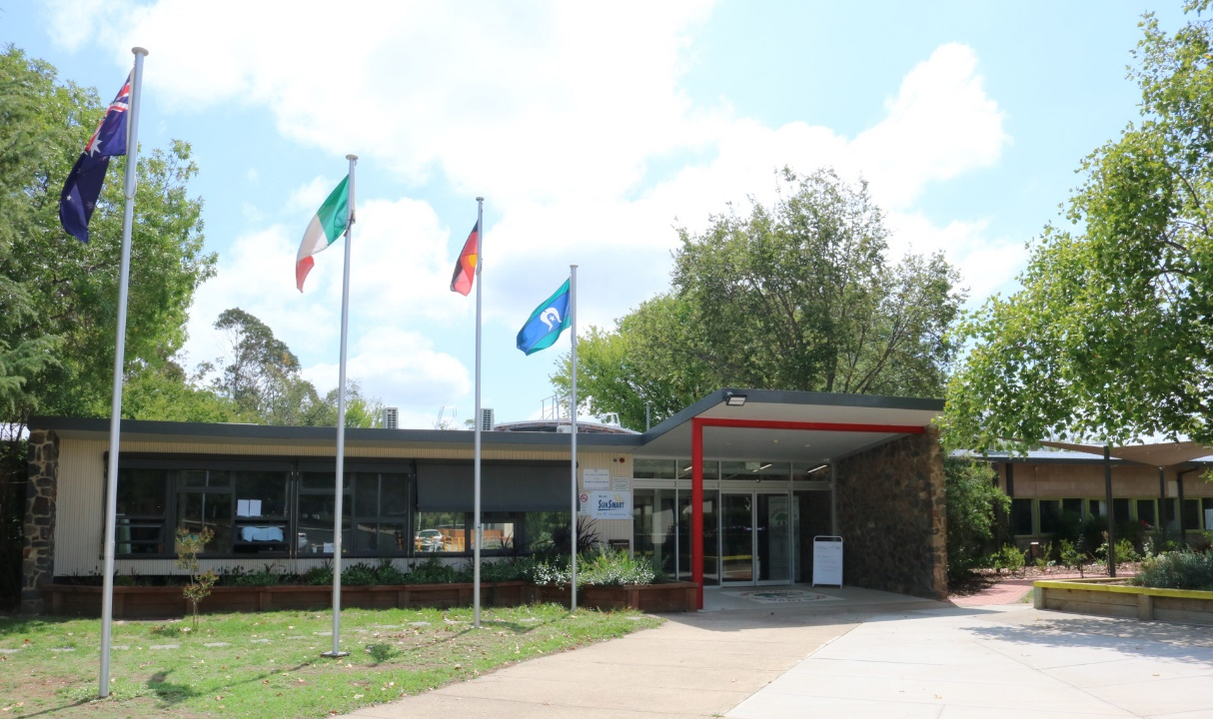

The purpose of school improvement planning
This plan establishes a strong improvement agenda to be driven by school leaders over the next five years. It was informed by the Directorate’s Strategic Plan and system-level and school-based analysis of multiple sources of evidence. Analysis of these multiple sources of evidence is supported by an annual provision to each school of a data summary as a key enabler of our improvement planning and implementation.
Each school participates in School Review as an integral component of in its five-year improvement planning cycle. Review findings support annual improvement planning (Action Plan) and are an important component of Directorate monitoring and support of school improvement. Reviews provide schools with quality and independent feedback, tailored to the school’s context. Each school is reviewed at least every five years, providing valuable opportunities for self-reflection, planning and improvement. The school improvement planning process is below. This representation is used in the footer of all school-based improvement documents to indicate the stage of planning or implementation.
Analysis Priorities Strategies Actions Impact (for student)
Our school improvement planning is grounded in evidence from research and practice and expressed in terms of improvements in measurable student outcomes. Explicit five-year targets for improvement have been set and will give life to monitoring, evaluation and communication of progress to teachers, families and students.

Our school’s improvement agenda positioned within the Directorate’s Strategic Plan

Vision
Directorate’s vision: We will be a leading learning organisation where people know they matter.
School’s vision: Together we create lifelong learners. Insieme, creiamo studenti per tutta la vita.

Mission
Directorate’s mission: We develop and deliver educational services to empower each child and young person in the ACT to learn for life.
School’s mission:
- To develop the whole child as a confident, resilient and engaged young person able to positively contribute as a global citizen.
- To deliver a high-quality curriculum so students experience challenge and success at all ages and developmental levels.
- To foster welcoming and inclusive partnerships with Yarralumla families and the wider Italian community to maximise opportunity and extension for all.

Values
Directorate’s Values: Respect, Integrity, Collaboration, Innovation.
School’s values: STAR: Safe, Team Player, Active Learner, Respect

Education Directorate’s Strategic Goals for 2018-2021
- Schools where students love to learn
- Investing in early childhood
- Evidence informed decisions
- Learning culture
- United leadership team

Education Directorate’s Strategic Indicators for 2018-2021
- To promote greater equity in learning outcomes in and across ACT public schools
- To facilitate high quality teaching in ACT public schools and strengthen educational outcomes
- To centre teaching and learning around students as individuals
The Directorate annually publishes progress against its Strategic Indicators. Our school’s contributions to these Strategic Indicators are detailed in our annual Impact Reports.

Multiple sources of evidence
Evidence informing this School Improvement Plan includes:
- analysis of system-level data
- analysis of school-based evidence over time (past 4/5 years)
- for schools with a preschool setting, Quality Ratings from assessment against the National Quality Framework.*
*For schools with a preschool setting their Quality Improvement Plan (QIP) is revised each year as part of the annual planning process.

Our improvement priorities
Priority 1: Increase growth in student performance in numeracy for all year levels.
The statement below details our vision for how this priority will change the experience of school for our students.

Students articulate the learning intention and success criteria of the numeracy lesson.
Students experience consistency of numeracy practices across all year levels.
Students learning in numeracy is differentiated.
Students receive feedback on their learning.
Students articulate their numeracy goals.
Teachers observe each other’s practice and provide feedback.
Teaching teams use data to inform teaching practices.

Targets/Measures to be achieved by 2024
Student learning data
Target or measure: 62% or more of our year 5 students will be achieving at or above expected growth in numeracy. The target was set by averaging the percentages of students achieving at or above expected growth in similar schools over 2016-2019.
Source: NAPLAN: school level growth data available through SCOUT.
Starting point: Baseline data of 53% was determined by averaging percentages of students achieving at or above expected growth over the previous four years at your school i.e. 2016-2019.

Student learning data
Target or measure: 25% or more of kindergarten students will be achieving high growth in PIPS Mathematics. The target was set by averaging the percentage of ACT students achieving high growth in PIPS mathematics over 2013 to 2018.
Source: PIPS growth data available through the PIPS database administered by the UWA.
Starting point: Baseline data of 22% was determined by averaging percentages of students achieving high growth over 2013 to 2018.

Perception data
Target or measure: 90% or more students agree or strongly agree that ‘My teachers motivate me to learn’. The target was set by averaging the percentages of agree or strongly agree over 2016-2019 for all ACT P-6 schools (85%) plus an additional 5% points.

Source: Annual Student Satisfaction Survey
Starting point: Baseline data was determined by averaging student responses for ‘My teachers motivate me to learn’ over 2016-2019, 86% agree or strongly agree.

School program and process data
Target or measure: Students to achieve growth in median scale score year to year comparable or above the Australian median scale score.
Source: PAT Maths
Starting point: Baseline data yet to be established and will commence in 2020.

Priority 2: Increase growth in student performance in writing across all year levels.
The statement below details our vision for how this priority will change the experience of school for our students.
Students articulate the learning intention and success criteria of the writing lesson.
Students receive feedback on their writing.
Students articulate their writing goals.
Teachers observe each other’s practice and provide feedback.
Teacher capacity is enhanced through involvement in the Early Years Literacy Initiative.
Teaching teams participate in writing moderation tasks.

Targets/Measures to be achieved by 2024
Student learning data
Target or measure: To increase the percentage of year 5 students in the top two bands of writing to 28% or more. The target was set by averaging the percentage of students in the top two bands of writing for similar schools over 2016-2019.
Source: NAPLAN % in bands available through SCOUT
Starting point: Baseline data of 17% was determined by averaging the percentage of students in the top two bands of writing for the school over 2016 -2019.

Student learning data
Target or measure: To increase the percentage of year 3 students in the top bands of writing to 69% or more. The target was set by averaging the percentage of students in the top bands for writing for similar schools over 2016-2019.
Source: NAPLAN % in bands available through SCOUT
Starting point: Baseline data of 48% was determined by averaging percentages of year 3 students in the top two bands of writing for the school over 2016-2019.
Student learning data
Target or measure: To increase the Year 3 to Year 5 growth in mean scale scores in Writing to 61 mean scale scores or more. The target was set by averaging the growth in mean scale scores in similar schools over 2016-2019.
Source: NAPLAN school-level growth data available through SCOUT
Starting point: Baseline data of 58 mean scale scores was determined by averaging the mean scale scores for Writing at the school over 2016-2019.

Perception data
Target or measure: 85% or more of our staff agree or strongly agree that ‘Teachers give useful feedback’. The target was set by averaging the percentages of agree or strongly agree over 2015-2018 for similar schools (79%) plus 6%.
Source: Annual School Satisfaction Survey
Starting point: Baseline data of 79% agree or strongly agree for ‘Teachers give useful feedback’ was determined by averaging the school data for students over 2015-2018.

Endorsement
This School Improvement Plan has been endorsed electronically by our Principal, Director School Improvement and Board Chair.

Principal
Name: Rohan Evans
Date: 19.12.2019

Director School Improvement
Name: Julie Cooper
Date: 19.12.2019

Board Chair
Name: Rachel Smith-Cianchi
Date: 19.12.2019

