CALWELL HIGH SCHOOL
Network: Tuggeranong

School Improvement Plan 2019-2023
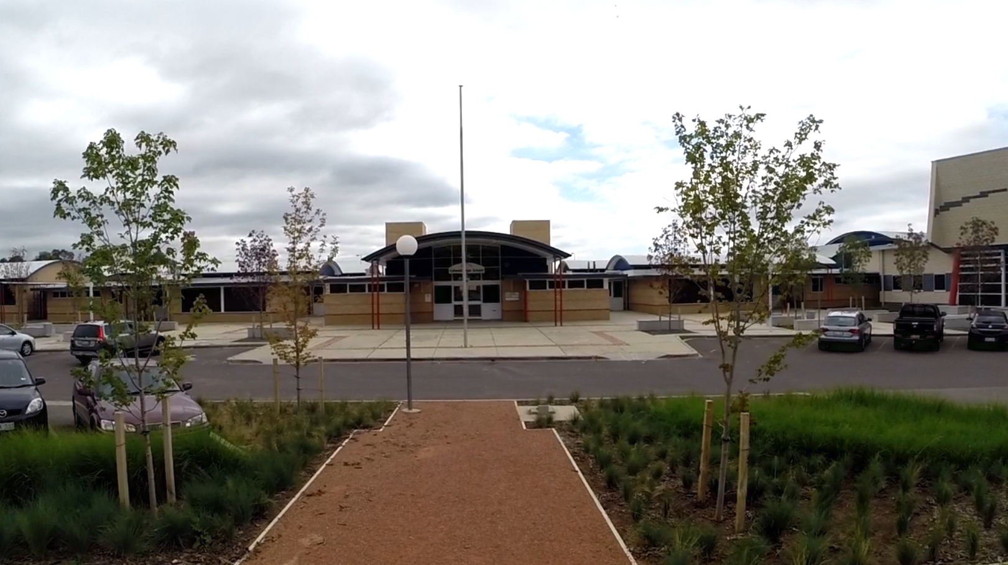

The purpose of school improvement planning
This plan establishes a strong improvement agenda to be driven by school leaders over the next five years. It was informed by the Directorate’s Strategic Plan and system-level and school-based analysis of multiple sources of evidence including our School Review findings. Analysis of these multiple sources of evidence is supported by an annual provision to each school of a data summary as a key enabler of our improvement planning and implementation.
Each school undertakes a school review as an integral component of in its five-year improvement planning cycle. The reviews are an important part of how the Directorate supports and monitors school improvement. Reviews provide schools with quality and independent feedback, tailored to the school’s context. Each school is reviewed at least every five years, providing valuable opportunities for self-reflection, planning and improvement. The school improvement planning process is below. This representation is used in the footer of all school-based improvement documents to indicate the stage of planning or implementation.
Analysis ⇨ Priorities ⇨ Strategies ⇨ Actions ⇨ Impact (for student)
Our school improvement planning is grounded in evidence from research and practice and expressed in terms of improvements in measurable student outcomes. Explicit five-year targets for improvement have been set and will give life to monitoring, evaluation and communication of progress to teachers, families and students.

Our school’s improvement agenda positioned within the Directorate’s Strategic Plan

Vision
Directorate’s vision: We will be a leading learning organisation where people know they matter.
School’s vision:
Our vision at Calwell High School is to empower every student to acquire, demonstrate, articulate
and value knowledge and skills that will support them, as life-long learners.

Mission
Directorate’s mission: We develop and deliver educational services to empower each child and young person in the ACT to learn for life.
School’s mission:
Is to enable all learners to have complete access to learning through the provision of:
- A quality inclusive learning environment that is responsive to student voice and built upon authentic relationships, wellbeing and respect
- Highly effective teachers, focussed on improving student outcomes, through their commitment to ongoing professional development, quality teaching, evidenced-based practices, coaching and mentoring and collaboration
- Opportunities for community and parents to participate in learning and decision-making partnerships.

Values
Directorate’s Values: Respect, Integrity, Collaboration, Innovation.
School’s values: Achievement, Respect, Self-discipline and Courage

Education Directorate’s Strategic Goals for 2018-2021
- Schools where students love to learn
- Investing in early childhood
- Evidence informed decisions
- Learning culture
- United leadership team

Education Directorate’s Strategic Indicators for 2018-2021
- To promote greater equity in learning outcomes in and across ACT public schools
- To facilitate high quality teaching in ACT public schools and strengthen educational outcomes
- To centre teaching and learning around students as individuals
The Directorate annually publishes progress against its strategic indicators. Our school’s contributions to these strategic indicators are detailed in our annual Impact Reports.

Multiple sources of evidence
Evidence informing this School Improvement Plan includes:
- analysis of system-level data
- analysis of school-based evidence over time (the past 4-5 years)
- recommendations from School Review

Our improvement priorities
Priority 1: Improve levels of student engagement and performance in reading and writing.
The statement below details our vision for how this priority will change the experience of school for our students.
Teachers and students are committed to building a strong foundation to develop the necessary understanding and skills to;
- write effectively for a variety of audiences and purposes
- read with high levels of comprehension, fluency and accuracy in each learning area.
Targets/Measures to be achieved by 2023
Student learning data
Target or measure: 58% or more of year 9 students will be making above average progress in reading. The target was set by averaging the two highest percentages of students making above average progress in reading at the school over the last four cohorts i.e. since the 2014-2016 cohort.
Source: NAPLAN data on student progress available on My School.
Starting Point: Baseline data of 53% was determined by averaging the % of year 9 students making above average progress over the previous four cohorts at your school for reading i.e. 2014-2016 cohort to 2017-2019 cohort. Students are being compared to students of a similar background and those with the same starting score on their previous NAPLAN test.

Target or measure: To reduce the percentage of year 9 students in the bottom two bands of writing to 50% or less. The target was set by averaging the percentage of students in the bottom two bands of writing for similar schools over 2016-2019.
Source: NAPLAN data available through SCOUT.
Starting Point: Baseline data of 70% was determined by averaging the percentage of students in the school in the bottom two bands for writing over 2016-2019.

Perception Data
Target or measure: To improve the academic emphasis category of the school climate survey that measures the extent to which students feel supported, encouraged and engaged in their learning and success to the target of 65% which is set from the 2019 average of ACT students that agree or strongly agree with this item.
Source: School Climate Survey data from Qualtrics
Starting point: The baseline data of 49% was set by averaging the percentages of agree or strongly agree for academic emphasis items over 2016 to 2019.

School program and process data
Target or measure: To improve PAT test results in Reading by 10% using median norm referenced result and baseline from Year 7 2016 to 2019 average, and other years 2017 to 2019 average.

Source: Pat test results
Starting point: Baselines, Year 7 = 122, Year 8 = 119, Year 9 = 124, Year 10 = 126

Priority 2: Improve student wellbeing and respectful relationships at school.

The statement below details our vision for how this priority will change the experience of school for our students.

To develop a positive and inclusive school culture where:
- each student feels safe and supported as a valued member of our school community.
- respectful relationships are developed, reinforced and maintained.

Targets/Measures to be achieved by 2023
Perception data
Target or measure: To improve the student relations category of the school climate survey that measures the extent to which students feel valued and respected in their dealings with others leading to better learning achievement and attendance. The target of 35% was set from the 2019 average of ACT students that agree or strongly agree with this item.
Source: School Climate Survey data from Qualtrics
Starting point: The baseline data of 16% was set by averaging the percentages of agree or strongly agree for student relations items over 2016 to 2019.

Target or measure: 53% or more of students agree or strongly agree that ‘I feel safe at this school’. The target is based on the average of all ACT 7-10 schools over 2016-2019 for this item.
Source: Annual Student Satisfaction Survey
Starting Point: Baseline data of 31% for ‘I feel safe at this school’ is based on the average results for the school over 2016-2019 for this item.
Priority 3: Increase student growth and performance in numeracy
Where students develop
- a strong foundation of understanding and skills in numeracy across all learning areas.

Targets/Measures to be achieved by 2024
Student learning data
Target or measure: 57% or more of our year 9 students will be achieving at or above expected growth in numeracy. The target was set by averaging the percentages of students achieving at or above expected growth in numeracy in similar schools over 2016 -2019.
Source: NAPLAN growth data available through SCOUT
Starting Point: Baseline data of 33% was determined by averaging percentages of year 9 students achieving at or above expected growth in numeracy over 2016-2019.

Endorsement
This School Improvement Plan has been endorsed electronically by our Principal, Director School Improvement and Board Chair.

Principal
Name: Megan Altenburg
Date: 16-3-21

Director School Improvement
Name: Sue Norton
Date: 16-3-21

Board Chair
Name: Ann Hartley
Date: 16-3-21

