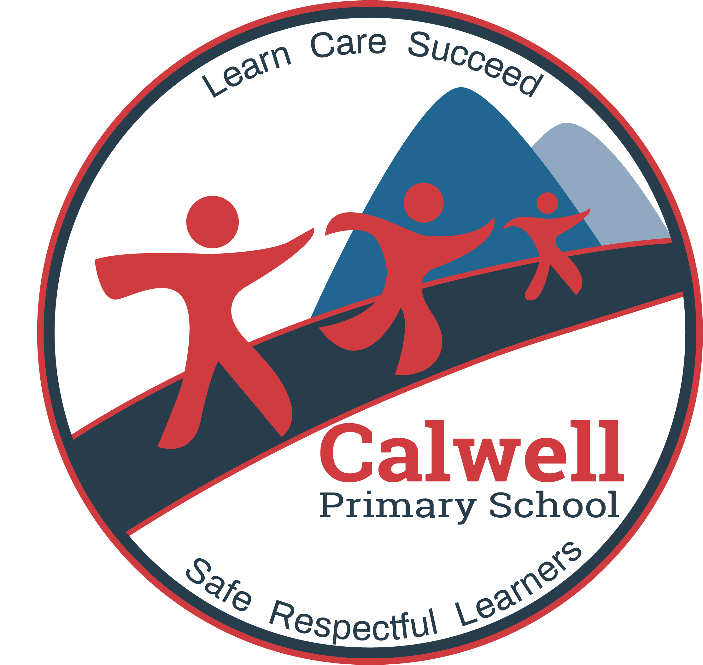

Calwell Primary School
  - Network: Tuggeranong

School Improvement Plan 2019-2023

The purpose of school improvement planning
This plan establishes a strong improvement agenda to be driven by school leaders over the next five years. It was informed by the Directorate’s Strategic Plan and system-level and school-based analysis of multiple sources of evidence including our School Review findings. Analysis of these multiple sources of evidence is supported by an annual provision to each school of a data summary as a key enabler of our improvement planning and implementation.
Each school undertakes a school review as an integral component of in its five-year improvement planning cycle. The reviews are an important part of how the Directorate supports and monitors school improvement. Reviews provide schools with quality and independent feedback, tailored to the school’s context. Each school is reviewed at least every five years, providing valuable opportunities for self-reflection, planning and improvement. The school improvement planning process is below. This representation is used in the footer of all school-based improvement documents to indicate the stage of planning or implementation.
Analysis Priorities Strategies Actions Impact (for student)
Our school improvement planning is grounded in evidence from research and practice and expressed in terms of improvements in measurable student outcomes. Explicit five-year targets for improvement have been set and will give life to monitoring, evaluation and communication of progress to teachers, families and students.

Our school’s improvement agenda positioned within the Directorate’s Strategic Plan

Vision
Directorate’s vision: We will be a leading learning organisation where people know they matter.
School’s vision: We will be a school with a learning culture that supports students and staff to achieve success

Mission
Directorate’s mission: We develop and deliver educational services to empower each child and young person in the ACT to learn for life.
School’s mission: We equip students to be learners for life.

Values
Directorate’s Values: Respect, Integrity, Collaboration, Innovation.
School’s values: We are safe, respectful citizens who Learn, Care, Succeed
and value diversity and integrity.

Education Directorate’s Strategic Goals for 2018-2021
- Schools where students love to learn
- Investing in early childhood
- Evidence informed decisions
- Learning culture
- United leadership team

Education Directorate’s Strategic Indicators for 2018-2021
- To promote greater equity in learning outcomes in and across ACT public schools
- To facilitate high quality teaching in ACT public schools and strengthen educational outcomes
- To centre teaching and learning around students as individuals
The Directorate annually publishes progress against its strategic indicators. Our school’s contributions to these strategic indicators are detailed in our annual Impact Reports.

Multiple sources of evidence
Evidence informing this School Improvement Plan includes:
- analysis of system-level data
- analysis of school-based evidence over time (past 4/5 years)
- recommendations from School Review
- for schools with a preschool setting, Quality Ratings from assessment against the National Quality Framework.*

Our improvement priorities
Priority 1: Students will be engaged, challenged and learn successfully.

The statement below details our vision for how this priority will change the experience of school for our students.

VISION for CHANGE
- Every child will be literate and numerate
- A comprehensive school Data Plan will monitor student growth
- Students will demonstrate growth in reading, writing and mathematics
- Teaching and learning will be differentiated to meet individual student need
- Individual student goals will support student engagement supporting students to be active participants in their learning
- There is a culture of feedback - teacher to student, student to student and teacher to teacher
- A comprehensive Professional Learning Plan will provide a framework to guide observations, mentoring, coaching and professional learning in the school
- Develop a Calwell Curriculum Framework which incorporates the General Capabilities and the Cross Curriculum Perspectives

Strategies

- Embed effective pedagogical practice across the school
- Use multiple sources of data to monitor student growth
- Embed Formative Assessment
- Differentiate teaching and learning to meet individual student need
- Develop Individual student goals to support teaching, learning and student agency
- Develop a culture of feedback
- Deliver an innovative and relevant curriculum

Targets/Measures to be achieved by 2023

Student learning data
Target or measure: 85% or greater of students (K-2) achieve PM reading benchmark
Source: School data base
Starting Point: 85% Average over two years (2017/18)

Target or measure: The percentage of students showing similar or greater growth in PIPS than the two year average 2017/18 will remain at or above the starting points.
Source: PIPS
Starting Points: Reading 82%, Numeracy 81%

Target or measure: 60% of students in Years 3-6 achieve an expected scaled growth score that matches or exceeds ACER scaled projections in PAT testing (Comprehension, Spelling and Mathematics)
Source: School Data Base
Starting point: New in 2019

Target or measure: % of students in the top two proficiency bands in Reading, Writing and Numeracy is equal to the mean of similar schools
Source: My School - SCOUT
Starting point: See table
2yr Average (2017/18) | Calwell Primary | Similar Schools | Difference
Reading | 29.5 | 33.5 | -4
Writing | 11.5 | 11.2 | +.3
Numeracy | 21.1 | 28 | -6.9

Target or measure: Decrease the percentage of students in the lower two bands in Reading, Writing and Numeracy by 5% or greater
Source: My School - SCOUT
Starting point: See table
2yr Average (2017/18) | Calwell Primary
Reading | 17%
Writing | 26.4%
Numeracy | 19.5%

Target or measure: Increase the percentage of ‘in-school matched’ students achieving expected growth or greater in NAPLAN Reading, Writing and Numeracy
Source: NAPLAN (Scout)
Starting point:
2yr Average | Calwell Primary | Target
Reading | 65% | 70%
Writing | 55% | 65%
Numeracy | 62% | 65%

Perception data
Target or measure:
Year average is at or above the ACT average in the following Satisfaction & Climate Survey questions:

'Teacher’s provides give useful feedback’ (11.4% points above ACT average in 2018)
‘Teachers motivate me to learn’ (3.39% points above ACT average in 2018)
‘My teachers expect me to do my best’ (3.80% points above ACT average in 2018)

Source: 2018 Satisfaction & Climate Survey
Starting point: see above

Target or measure: Build teacher capacity to set learning goals with their students.
Source: 2018 Satisfaction & Climate Survey – school specific questions

‘My teacher works with me to set learning goals’
Starting point: 80% 2018

School program and process data
Target or measure: % positive responses to the school Learning Survey
Source: School Learning Survey to Years 1- 6
Starting point: New in 2019 (*target to be generated in 2020 based on 2019 baseline data)

Priority 2: Build a positive and inclusive school culture to support student well-being and social emotional development and learning.

The statement below details our vision for how this priority will change the experience of school for our students.

VISION for CHANGE

- Everyone feels safe at our school
- Relationships are respectful
- There is a culture of inclusion and diversity is embraced
- Student well-being supports and underpins learning
- Individual student social emotional learning needs are identified and met
- Students, Staff and Parents feel valued and connected to the school
- SeeSaw facilitates and supports parental engagement in their child’s learning
- A range of communication tools promotes the home/school partnership (Facebook, Google Communities Newsletter etc)

Strategies
- Implement and embed PBL
- Deliver an explicit SEL program P-6 and embed processes to ensure social emotional needs are identified and met for all students
- Strategically target school resources to meet the needs of students Preschool to Year 6
- Enhance school /community partnerships and refine communication practices to strengthen connection and well-being

Targets/Measures to be achieved by 2023

Perception data
Target or measure: Well Being / School Culture - year average meets or is above average of P-6 same ACT school type in the following student Satisfaction & Climate Survey questions:

‘I feel safe at this school’ (6.66% points above 2018)
‘I like being at my school’ (-5% points below in 2018)
‘I can talk to my teachers about my concerns’ (-5.96% points below in 2018)
‘Student behaviour is well managed at my school’ (-10% below in 2018)
‘Staff take students concerns seriously’ (-0.49% below in 2018)

Source: Satisfaction & Climate Survey
Starting point: see above

Target or measure: Parental Engagement / Home – School partnership. Year average meets or is above average of P-6 same ACT school type in the following Parent Satisfaction & Climate Survey questions:
‘This school takes parent’s opinions seriously (2.14% points above 2018)
‘This school works with me to support my child’s learning’ (0.64% points below in 2018)
‘My child’s learning needs are being met at this school’ ( 1.60% points in 2018)
‘Student behaviour is well managed at this school’ (2.95% points in 2018)
‘Teachers at this school treat students fairly’ (3.92% points below in 2018)

Source: Satisfaction & Climate Survey
Starting points: 2018 see above

School program and process data
Target or measure: PBL Data Sets and School Staff Survey shows positive impact of PBL Framework Source: Sentral / School Survey
Starting point: New in 2019

Target or measure: % positive student responses to a school Well-being Survey
Source: School Well-Being Survey Kinder to Year 6
Starting point: New in 2019 (*target to be generated in 2020 based on 2019 baseline data)

Target or measure: % families engaging with SeeSaw P-Yr6
Source: SeeSaw
Starting point: New in 2019 (*target to be generated in 2020 based on 2019 baseline data)

Endorsement
This School Improvement Plan has been endorsed electronically by our Principal, Director School Improvement and Board Chair.

Principal
Name: Linda Neeson
Date: March 2019

Director School Improvement
Name: Kate Smith / Sue Norton
Date: March 2019 / May 2019

Board Chair
Name: Megan Fox
Date: March 2019

