Lake Tuggeranong College
Annual School Board Report 2020

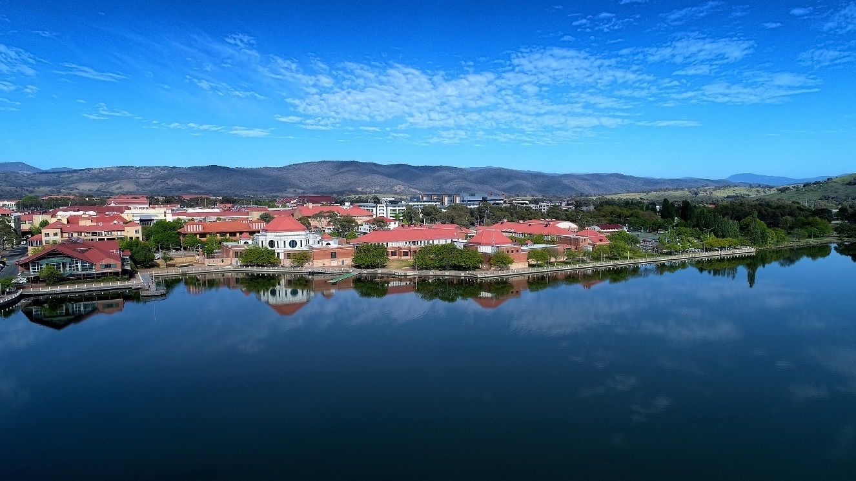

This page is intentionally left blank.

This report supports the work being done in the ACT Education Directorate, as outlined in Strategic Plan 2018-21: A Leading Learning Organisation.

Accessibility
The ACT Government is committed to making its information services, events and venues accessible to as many people as possible.
If you have difficulty reading a standard document and would like to receive this publication in an alternate format, such as large print and audio, please telephone (02) 6247 4580.
If English is not your first language and you require the translating and interpreting service, please telephone 13 14 50.
If you are deaf or hearing impaired and require the National Relay Service, please telephone 13 36 77.
© Australian Capital Territory, Canberra, 2021

Material in this publication may be reproduced provided due acknowledgement is made.

Contents
Reporting to the community 1
Summary of School Board activity 1
School Context 1
Student Information 2
Student enrolment 2
Student attendance 2
Supporting attendance and managing non-attendance 2
Staff Information 2
Teacher qualifications 2
Workforce composition 3
School Review and Development 3
School Satisfaction 3
Overall Satisfaction 4
Learning and Assessment 6
Outcomes for College Students 6
Post School Destination 6
Financial Summary 7
Voluntary Contributions 8
Reserves 8
Endorsement Page 9
Members of the School Board 9

Reporting to the community
Schools report to communities in range of ways, including through:
- Annual School Board Reports
- a (5-year) School Improvement Plan (formerly School Strategic Plan)
- annual Impact Reports
- newsletters
- other sources such as My School.

Summary of School Board activity
In 2020, the LTC Board discussed and pursued several activities in support of the college:
- management of declining enrolments and associated over-staffing challenges
- the rollout of instructional leadership supports
- preparation and consideration of the school’s School Improvement agenda, specifically in relation to involvement in the 2019 School Review process
- discussion and support of the college’s processes and response to the 2020 pandemic, including lockdown in Term 2 2020 and increased online options for students and staff throughout 2020.

School Context
Lake Tuggeranong College caters for Years 11 and 12 students. It also hosts a vocational course in Automotive which is made available to interested Year 10 students from southern Canberra. Specifically, the college draws from suburbs in the southern and eastern areas of the Tuggeranong Valley. The feeder high schools are Calwell High School, Lanyon High School and Namadgi School.
In 2020, the student enrolment profile continued a steady but noticeable decline. The college had 645 students in 2020 (down from 662 in 2019). Changes to the enrolment policies at the system level have again significantly reduced the proportion of enrolled students coming from outside the priority enrolment areas. Demographics of the colleges priority enrolment area (PEA) are also affecting enrolments.
The college continues its hosting of 16 students in our Learning Support Units. The newly refurbished suite of spaces in the heart of the school, The Hub (as the units are referred to locally), were embedded in 2020 and became a highly effective learning space for our students with disabilities. In 2020 the College experienced disruptions to learning and teaching programs due to the coronavirus pandemic. Exceptional efforts were made to reconstruct learning in a remote manner, with many teachers and students developing new skills very quickly. Participation and attendance patterns changed and both students and teachers were supported throughout a remarkably different year.
In 2020, 31 students identified as being of Aboriginal and Torres Strait Islander descent. An engagement strategy which was initiated in 2019 was paused in 2020 due to the disruptions of the pandemic. By the end of 2020, a multi-faceted inquiry into cultural integrity had been planned for 2021, with leaders and classroom teachers taking part in ‘On Country’ action research in partnership with the University of Canberra.
The proportion of students from language backgrounds other than English is 17 percent. The college curriculum continues to reflect this profile with strong English as a Second Language (ESL) programs. The International Private Students (IPS) program adds to the cultural diversity within the college. Many International Private Students were unable to participate in the college programs (in a face-to-face manner) in 2020 due to the pandemic and future IPS enrolments and language programs may be affected. The college will maintain its capacity in this area until the international situation is resolved.

Student Information

Student enrolment
In this reporting period there were a total of 645 students enrolled at this school.
Table: Student enrolment*
Student type | Number of students
Gender - Male | 353
Gender - Female | 292
Gender - Non-binary or other | 0
Aboriginal and Torres Strait Islander | 31
LBOTE** | 111
Source: ACT Education Directorate, Analytics and Evaluation Branch
* To protect personally identifiable information any figures less than six are not reported.
** Language Background Other Than English

Student attendance
Due to the effects of the COVID-19 pandemic, 2020 attendance data has not been published in the Annual School Board Report.

Supporting attendance and managing non-attendance
ACT public schools support parents and careers to meet their legal responsibilities in relation to the compulsory education requirements of the Education Act 2004. The Education Directorate’s Education Participation (Enrolment and Attendance) Policy describes its position with regard to supporting attendance and managing non-attendance. A suite of procedures supports the implementation of the policy. Please refer to https://www.education.act.gov.au/ for further details.

Staff Information

Teacher qualifications
All teachers at this school meet the professional requirements for teaching in an ACT public school. The ACT Teacher Quality Institute (TQI) specifies two main types of provision for teachers at different stages of their career, these are detailed below.
- Full registration is for teachers with experience working in a registered school in Australia or New Zealand who have been assessed as meeting the Proficient level of the Australian Professional Standards for Teachers.
- Provisional registration is for newly qualified teachers or teachers who do not have recent experience teaching in a school in Australia and New Zealand. Many teachers moving to Australia from another country apply for Provisional registration.

Workforce composition
Workforce composition for the current reporting period is provided in the following table. The data is taken from the school’s verified August staffing report. For reporting purposes, it incorporates all school staff including preschools, staff absent for a period of less than four consecutive weeks and staff replacing staff absent for more than four consecutive weeks. It does not include casuals and staff absent for a period of four consecutive weeks or longer.
The Education Directorate is required to report Aboriginal and Torres Strait Islander staff figures. As of June of the reporting period, 135 Aboriginal and Torres Strait Islander staff members were employed across the Directorate.
Table: Workforce composition numbers
Staff employment category | TOTAL
Teaching Staff: Full Time Equivalent Permanent | 35.53
Teaching Staff: Full Time Equivalent Temporary | 11.46
Non Teaching Staff: Full Time Equivalent | 25.48
Source: ACT Education Directorate, People and Performance Branch

School Review and Development
The ACT Education Directorate’s Strategic Plan 2018-2021 provides the framework and strategic direction for School Improvement Plans (formerly School Strategic Plans). This is supported by the school performance and accountability framework ‘People, Practice and Performance: School Improvement in Canberra Public Schools, A Framework for Performance and Accountability’. Annually, system and school level data are used alongside the National School Improvement Tool to support targeted school improvement, high standards in student learning, innovation and best practice in ACT public schools.
Our school was reviewed in 2019. A copy of the Report of Review can be found on our school website.

School Satisfaction
Schools use a range evidence to gain an understanding of the satisfaction levels of their parents and carers, staff and students. Annually in August/ September ACT schools undertake a survey to gain an understanding of school satisfaction at that time. This information is collected from staff, parents and from 2020 students from year 4 and above (previously year 5 and above) through an online survey.

Overall Satisfaction
In this period of reporting, 89% of parents and carers, 94% of staff, and 74% of students at this school indicated they were satisfied with the education provided by the school.
Included in the survey were 16 staff, 14 parent, and 12 student items which are described as the national opinion items. These items were approved by the then Standing Council on School Education and Early Childhood (SCSEEC) for use from 2015. The following tables show the percentage of parents and carers, students and staff who agreed with each of the national opinion items at this school.
Note: The overall response rate for parents and carers in ACT public schools was negatively impacted by COVID-19, dropping from 31% in 2019 to 23% in 2020.
A total of 48 staff responded to the survey. Please note that not all responders answered every question.
Table: Proportion of staff* in agreement with each national opinion item
National opinion item | Proportion of staff
Parents at this school can talk to teachers about their concerns. | 98
Staff are well supported at this school. | 90
Staff get quality feedback on their performance. | 49
Student behaviour is well managed at this school. | 74
Students at this school can talk to their teachers about their concerns. | 100
Students feel safe at this school. | 94
Students like being at this school. | 98
Students’ learning needs are being met at this school. | 96
Teachers at this school expect students to do their best. | 94
Teachers at this school motivate students to learn. | 92
Teachers at this school treat students fairly. | 96
Teachers give useful feedback. | 69
This school is well maintained. | 100
This school looks for ways to improve. | 98
This school takes staff opinions seriously. | 86
This school works with parents to support students' learning. | 92
Source: ACT Education Directorate, Analytics and Evaluation Branch
*Proportion of those who responded to each individual survey question

A total of 65 parents responded to the survey. Please note that not all responders answered every question.
Table: Proportion of parents and carers* in agreement with each national opinion item
National opinion item | Proportion of parents and carers
I can talk to my child’s teachers about my concerns. | 80
My child feels safe at this school. | 92
My child is making good progress at this school. | 69
My child likes being at this school. | 85
My child's learning needs are being met at this school. | 75
Student behaviour is well managed at this school. | 60
Teachers at this school expect my child to do his or her best. | 91
Teachers at this school give useful feedback. | 71
Teachers at this school motivate my child to learn. | 68
Teachers at this school treat students fairly. | 77
This school is well maintained. | 75
This school looks for ways to improve. | 68
This school takes parents’ opinions seriously. | 71
This school works with me to support my child's learning. | 69
Source: ACT Education Directorate, Analytics and Evaluation Branch
*Proportion of those who responded to each individual survey question

A total of 188 students responded to the survey. Please note that not all responders answered every question.
Table: Proportion of students* in agreement with each national opinion item
National opinion item | Proportion of students
I can talk to my teachers about my concerns. | 47
I feel safe at this school. | 71
I like being at my school. | 55
My school gives me opportunities to do interesting things. | 65
My school is well maintained. | 72
My school looks for ways to improve. | 63
My teachers expect me to do my best. | 87
My teachers motivate me to learn. | 68
Staff take students’ concerns seriously. | 73
Student behaviour is well managed at my school. | 50
Teachers at my school treat students fairly. | 71
Teachers give useful feedback. | 65
Source: ACT Education Directorate, Analytics and Evaluation Branch
*Proportion of those who responded to each individual survey question

Learning and Assessment

Outcomes for College Students
Year 12 outcomes are shown in the following table. The Board of Senior Secondary Studies has provided this data as it relates to the percentage of students receiving an ACT Senior Secondary Certificate (ACT SSC) and the Australian Tertiary Admission Rank (ATAR). It will not include data for those students who were successful in an equivalent pathway organised by the school. The proportion of students is based on the college’s February census enrolment data.
Table: Year 12 outcomes for students by percentage
Outcome | Proportion of students
Receiving a year 12 or equivalent VET Certificate (without duplicates) within the school setting | 86.46
Receiving an ACT Senior Secondary Certificate | 86.15
Receiving an ATAR | 35.38
Source: Board of Senior Secondary Studies

Post School Destination
The following table shows the post school destination of college students who were awarded an ACT Senior Secondary Certificate in this reporting period. As many of the respondents were engaged in both study and employment, the percentage total is greater than one hundred percent.
Note: The survey was conducted in May 2020 during COVID-19 lockdown. This has impacted the results, particularly for employment.
Table: Comparison of post school destinations for students by percentage
Outcome | College | ACT
University | 19.4 | 36.0
CIT/TAFE | 19.4 | 10.9
Other training provider | 3.7 | 6.4
Deferred Studies | 34.3 | 30.3
Employed | 65.7 | 62.4
Not studying or employed | 14.8 | 15.1
Source: ACT Education Directorate, Analytics and Evaluation Branch

Financial Summary
The school has provided the Directorate with an end of year financial statement that was approved by the school board. Further details concerning the statement can be obtained by contacting the school. The following summary covers use of funds for operating costs and does not include expenditure in areas such as permanent salaries, buildings and major maintenance.
Table: Financial Summary
INCOME | January-June | July-December | January-December
Self-management funds | 369356.92 | 376705.43 | 746062.35
Voluntary contributions | 6140.00 | 8725.00 | 14865.00
Contributions & donations | 4160.00 | 9600.00 | 13760.00
Subject contributions | 6301.40 | 9394.07 | 15695.47
External income (including community use) | 14555.02 | 4804.74 | 19359.76
Proceeds from sale of assets | 0.00 | 0.00 | 0.00
Bank Interest | 4388.74 | 4524.57 | 8913.31
TOTAL INCOME | 404902.08 | 413753.81 | 818655.89
EXPENDITURE
Utilities and general overheads | 134543.61 | 167678.29 | 302221.90
Cleaning | 0.00 | 0.00 | 0.00
Security | 11641.32 | 5769.94 | 17411.26
Maintenance | 42939.17 | 144530.46 | 187469.63
Administration | 7849.38 | 8016.70 | 15866.08
Staffing | -883.30 | 75657.00 | 74773.70
Communication | 8154.16 | 8462.84 | 16617.00
Assets | 21582.60 | 15193.87 | 36776.47
Leases | 0.00 | 0.00 | 0.00
General office expenditure | 22214.29 | 29860.75 | 52075.04
Educational | 24376.48 | 36952.70 | 61329.18
Subject consumables | 354.76 | 1096.18 | 1450.94
TOTAL EXPENDITURE | 272772.47 | 493218.73 | 765991.20
OPERATING RESULT | 132129.61 | -79464.92 | 52664.69
Actual Accumulated Funds | 308401.52 | 485401.52 | 395401.52
Outstanding commitments (minus) | -50334.12 | 0.00 | -50334.12
BALANCE | 390197.01 | 405936.60 | 397732.09

Voluntary Contributions
The funds listed were used to support the general operations of the school. The spending of voluntary contributions is in line with the approved budget for this reporting period.

Reserves
Name and Purpose | Amount | Expected Completion
- Maths Textbooks 2020  - To purchase maths texts in line with the Australian Curriculum  - Enhances student learning by providing up to date resources | $28,000 | 31 December 2020
- School Initiatives/Upgrades 2020  - To provide a flexible learning space  b) Enhances student learning by providing a flexible space to adapt to different learning styles | $40,000 | 31 December 2020

Endorsement Page

Members of the School Board
Parent Representative(s): | Andrew Windsor | Melissa Martin
Community Representative(s): | Peter Henry
Teacher Representative(s): | Cameron Taylor
Student Representative(s): | Leila Rickman | Shaun Payne
Board Chair: | Tony Page
Principal: | Tom Kobal
I approve the report, prepared in accordance with the provision of the ACT Education Act 2004, section 52.

2020 Board Chair Signature: | Tony Page | Date: | 13/ 07/ 2021

I certify that to the best of my knowledge and belief the evidence and information reported in this Annual School Board Report represents an accurate record of the Board’s operations during this reporting period.

Principal Signature: | Tom Kobal | Date: | 06 / 07 / 2021

