Farrer Primary School
Annual School Board Report 2021

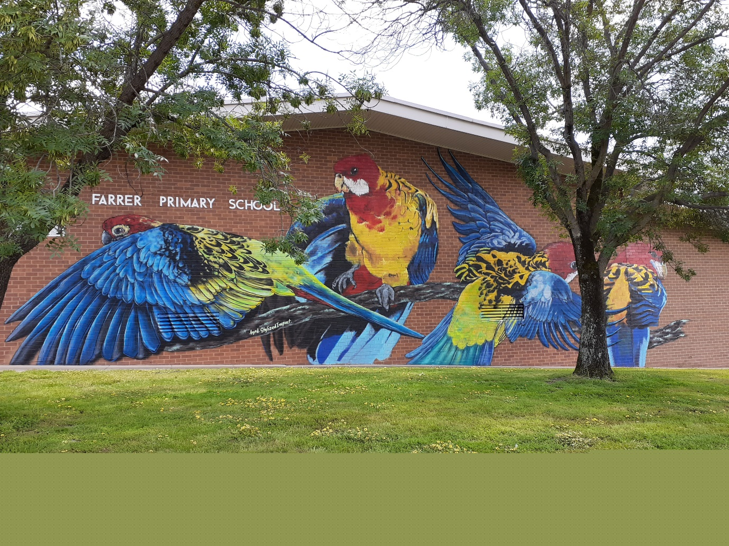

This page is intentionally left blank.

This report supports the work being done in the ACT Education Directorate, as outlined in Strategic Plan 2018-21: A Leading Learning Organisation.

Accessibility
The ACT Government is committed to making its information services, events and venues accessible to as many people as possible.
If you have difficulty reading a standard document and would like to receive this publication in an alternate format, such as large print and audio, please telephone (02) 6247 4580.
If English is not your first language and you require the translating and interpreting service, please telephone 13 14 50.
If you are deaf or hearing impaired and require the National Relay Service, please telephone 13 36 77.
© Australian Capital Territory, Canberra, 2022

Material in this publication may be reproduced provided due acknowledgement is made.

Contents
Reporting to the community 1
Summary of School Board activity 1
School Context 1
Student Information 1
Student enrolment 1
Student attendance 2
Supporting attendance and managing non-attendance 2
Staff Information 3
Teacher qualifications 3
Workforce composition 3
School Review and Development 3
School Satisfaction 4
Overall Satisfaction 4
Learning and Assessment 6
Performance in Literacy and Numeracy 6
Early years assessment 6
NAPLAN 6
Outcomes for College Students 7
Post School Destination 7
Financial Summary 9
Voluntary Contributions 10
Reserves 10
Endorsement Page 11
Members of the School Board 11

Reporting to the community
Schools report to communities in range of ways, including through:
- Annual School Board Reports
- a (5-year) School Improvement Plan (formerly School Strategic Plan)
- annual Impact Reports
- newsletters
- other sources such as My School.

School Context
Farrer Primary School offers preschool to year 6 education in a traditional setting catering for an enrolment of approximately 330 students from kindergarten to year 6 and 42 students in the preschool.
Farrer Primary School is focused on excellence in literacy and numeracy. Students are engaged in learning about technologies, science, history and social sciences, the arts and health through real world inquiry experiences that extend beyond the school environment.
The school's values of excellence, support, innovation, inclusion and sustainability are reflected in resources, specialist teachers and purpose-built classrooms including the preschool and environment centre. The Japanese language program delivers a specialised language approach from kindergarten to year 6 students and offers enrichment through linguistics and the performing arts. Students from preschool to year 6 has access to a specialised Physical Education program as well as carnivals and team sports throughout the year. Science and sustainability are taught to all students through a specialist science program. Students can join the school choir and participate in music and performing arts activities as part of their regular curriculum. Woodwind band is available to year 5 and 6 students.
The school values inclusivity and provides a Learning Support Unit for students on the autism spectrum and successfully integrates students with disabilities. Teachers support students with specific learning and social needs within the classroom by differentiating curriculum, teaching and assessment to meet the needs of all students from high achievers to students with additional needs.
Our school culture fosters authentic partnerships to provide the best educational experiences for every student. We encourage effective partnerships between all members of the school community including teachers, families, students and outside organisations. Our staff and families work together in the education of students. School Board and Farrer School Community Association (Parents and Citizens Association) meetings are held regularly to provide an authentic partnership and open forum for communication.
Farrer Primary School is warm, friendly and caring school and ensures that each child is valued for their unique contributions and strengths. Students know what is expected of them through Positive Behaviours for Learning (PBL) expectations and clear learning intentions. Our teaching staff are committed to catering for every child and providing opportunities for success in each child’s learning and social development. Farrer Primary has high standards for student achievement, behaviour and success and offers a school environment where every child is nurtured and encouraged to achieve their potential.

Student Information

Student enrolment
In this reporting period there were a total of 334 students enrolled at this school.
Table: Student enrolment
Student type | Number of students
Gender - Male | 168
Gender - Female | 166
Aboriginal and Torres Strait Islander | 10
LBOTE* | 99
Source: ACT Education Directorate, Analytics and Evaluation Branch
*Language Background Other Than English

Student attendance
The following table identifies the attendance rate of students by year level during this reporting period. Student attendance rate is the percentage of school days attended by students in each year level at the school. Student attendance is measured over two school terms; that is from the first day of the school year for students in term 1 to the last day of term 2.
*NOTE: Student attendance data for this period should be understood within the context of flexible learning arrangements enacted in response to COVID19. Comparison of attendance figures to previous reporting periods is not valid.
Table: Attendance rates in percentages
Year level | Attendance rate
1 | 94.0
2 | 92.0
3 | 93.0
4 | 94.0
5 | 91.0
6 | 93.0
Source: ACT Education Directorate, Analytics and Evaluation Branch

Supporting attendance and managing non-attendance
ACT public schools support parents and careers to meet their legal responsibilities in relation to the compulsory education requirements of the Education Act 2004. The Education Directorate’s Education Participation (Enrolment and Attendance) Policy describes its position with regard to supporting attendance and managing non-attendance. A suite of procedures supports the implementation of the policy. Please refer to https://www.education.act.gov.au/ for further details.

Staff Information

Teacher qualifications
All teachers at this school meet the professional requirements for teaching in an ACT public school. The ACT Teacher Quality Institute (TQI) specifies two main types of provision for teachers at different stages of their career, these are detailed below.
- Full registration is for teachers with experience working in a registered school in Australia or New Zealand who have been assessed as meeting the Proficient level of the Australian Professional Standards for Teachers.
- Provisional registration is for newly qualified teachers or teachers who do not have recent experience teaching in a school in Australia and New Zealand. Many teachers moving to Australia from another country apply for Provisional registration.

Workforce composition
Workforce composition for the current reporting period is provided in the following table. The data is taken from the school’s verified August staffing report. For reporting purposes, it incorporates all school staff including preschools, staff absent for a period of less than four consecutive weeks and staff replacing staff absent for more than four consecutive weeks. It does not include casuals and staff absent for a period of four consecutive weeks or longer.
The Education Directorate is required to report Aboriginal and Torres Strait Islander staff figures. As of June of the reporting period, 135 Aboriginal and/or Torres Strait Islander staff members were employed across the Directorate.
Table: Workforce composition numbers
Staff employment category | TOTAL
Teaching Staff: Full Time Equivalent Permanent | 19.36
Teaching Staff: Full Time Equivalent Temporary | 0.60
Non Teaching Staff: Full Time Equivalent | 11.01
Source: ACT Education Directorate, People and Performance Branch

School Review and Development
The ACT Education Directorate’s Strategic Plan 2018-2021 provides the framework and strategic direction for School Improvement Plans (formerly School Strategic Plans). This is supported by the school performance and accountability framework ‘People, Practice and Performance: School Improvement in Canberra Public Schools, A Framework for Performance and Accountability’. Annually, system and school level data are used alongside the National School Improvement Tool to support targeted school improvement, high standards in student learning, innovation and best practice in ACT public schools.
Our school was reviewed in 2021. A copy of the Report of Review can be found on our school website.

School Satisfaction
Schools use a range evidence to gain an understanding of the satisfaction levels of their parents and carers, staff and students. Annually in August/ September ACT schools undertake a survey to gain an understanding of school satisfaction at that time. This information is collected from staff, parents and from 2020 students from year 4 and above (previously year 5 and above) through an online survey.

Overall Satisfaction
In this period of reporting, 84.3% of parents and carers, 92.6% of staff, and 72.6% of students at this school indicated they were satisfied with the education provided by the school.
Included in the survey were 8 staff, 9 parent, and 10 student items which are described as the national opinion items. These items were approved by the then Standing Council on School Education and Early Childhood (SCSEEC) for use from 2015. The following tables show the percentage of parents and carers, students and staff who agreed with each of the national opinion items at this school.
Due to the impacts of the COVID-19 pandemic, the survey was taken in November, rather than in August as has been done in previous years. This was just after the majority of students and staff returned to school-based learning after a period of around 3 months of remote learning. A number of questions were removed from previous years’ to shorten the time required by community members to complete the survey.
A total of 27 staff responded to the survey. Please note that not all responders answered every question.
Table: Proportion of staff* in agreement with each national opinion item
National opinion item | Proportion of staff
Parents at this school can talk to teachers about their concerns. | 93
Staff get quality feedback on their performance. | 39
Student behaviour is well managed at this school. | 48
Teachers want every student to do their best. (Replaces 'Teachers at this school expect students to do their best') | 94
Staff at this school treat students with respect. (Replaces 'Teachers at this school treat students fairly') | 100
Teachers give useful feedback. | 67
This school is well maintained. | 63
The way decisions are made in this school are appropriate (Replaces 'This school takes staff opinions seriously') | 82
Source: ACT Education Directorate, Analytics and Evaluation Branch
*Proportion of those who responded to each individual survey question

A total of 70 parents responded to the survey. Please note that not all responders answered every question.
Table: Proportion of parents and carers* in agreement with each national opinion item
National opinion item | Proportion of parents and carers
My child feels safe at this school. | 90
My child is making good progress at this school. | 82
Student behaviour is well managed at this school. | 81
Teachers at this school believe that every student can be a success. (Replaces 'Teachers at this school expect my child to do his or her best') | 77
Teachers give useful feedback. | 74
Staff at this school treat students with respect. (Replaces 'Teachers at this school treat students fairly') | 92
This school is well maintained. | 82
This school is active in seeking parents' opinion and ideas for making important decisions.(Replaces 'This school takes parents’ opinions seriously') | 65
This school works with me to support my child's learning. | 83
Source: ACT Education Directorate, Analytics and Evaluation Branch
*Proportion of those who responded to each individual survey question

A total of 113 students responded to the survey. Please note that not all responders answered every question.
Table: Proportion of students* in agreement with each national opinion item
National opinion item | Proportion of students
I feel I can talk to teachers about problems at school. (Replaces 'I can talk to teachers about my concern') | 49
I feel safe at this school. | 73
I am happy to be part of this school.(Replaces 'I like being at my school') | 82
I am interested in what I learn in school. (Replaces 'My school gives me opportunities to do interesting things') | 53
My school is well maintained. | 67
Teachers want every student to do their best.(Replaces 'My teachers expect me to do my best') | 92
Teachers encourage students to try out new ideas. (Replaces 'My teachers motivate me to learn') | 80
Staff take students’ concerns seriously. | 54
Staff treat students with respect. (Replaces 'Teachers at my school treat students fairly') | 79
Teachers give useful feedback. | 57
Source: ACT Education Directorate, Analytics and Evaluation Branch
*Proportion of those who responded to each individual survey question

Learning and Assessment

Performance in Literacy and Numeracy

Early years assessment
Students in kindergarten undertake an on-entry and on-exit assessment of their early reading and numeracy skills using the BASE program. Student results are reported against five performance bands at the end of semester 1 and 2. Below are the results for this school for the current reporting period.
Table: Farrer Primary School BASE 2021 mean raw scores
Agency | Reading start | Reading end | Numeracy start | Numeracy end
School | 52 | 105 | 37 | 51
ACT | 58 | 125 | 38 | 56
Source: ACT Education Directorate, Analytics and Evaluation Branch

NAPLAN
Students in years 3, 5, 7 and 9 in all ACT schools participate in the National Assessment Program-Literacy and Numeracy (NAPLAN). This program assesses skills in reading, writing, spelling, grammar and punctuation, and numeracy.
In this reporting period, no students were exempt from testing based on nationally agreed criteria.
For reasons of statistical reliability, as well as to protect the privacy of students, results are not reported when the sample size is less than five.
The following table shows the mean scores achieved by students at this school compared to all other ACT public schools for this reporting period.
Table: NAPLAN Mean Scores
Test Domain | Year 3 School | Year 3 ACT | Year 5 School | Year 5 ACT
Reading | 446 | 437 | 514 | 515
Writing | 418 | 418 | 459 | 475
Spelling | 421 | 409 | 477 | 502
Grammar & Punctuation | 444 | 426 | 497 | 497
Numeracy | 418 | 404 | 475 | 492

Financial Summary
The school has provided the Directorate with an end of year financial statement that was approved by the school board. Further details concerning the statement can be obtained by contacting the school. The following summary covers use of funds for operating costs and does not include expenditure in areas such as permanent salaries, buildings and major maintenance.
Table: Financial Summary
INCOME | January-December
Directorate Funding | 299066.66
Contributions and Donations | 28274.28
Subject Contributions | 3554.00
Hire of Facilities | 22646.59
External Revenue | 1789.49
Sale of Assets | 0.00
Interest Received | 3640.25
Other School Revenue | 20497.50
TOTAL INCOME | 379468.77
EXPENDITURE
Utilities and General Overheads | 80394.39
Security and Caretaking | 0.00
Maintenance | 52107.20
Administration | 22952.33
Staffing Expenditure | 2389.96
Communication | 1500.78
Assets & Leases | 65903.16
General Expenses | 29925.72
Educational Resources | 36162.22
Subject Consumables | 6028.00
Directorate Funded Payments | 3536.23
Other Payments | 37137.02
TOTAL EXPENDITURE | 338037.01
OPERATING RESULT | 41431.76
Accumulated Funds | 161399.12
BALANCE | 202830.88

Voluntary Contributions
The funds listed were used to support the general operations of the school. The spending of voluntary contributions is in line with the approved budget for this reporting period.
The amount received for Voluntary Contributions in 2021 was $14,570. The fund received were used across the school to support resourcing of teaching and learning in all learning areas.

Reserves
Name and Purpose | Amount | Expected Completion
Future Projects  Improvement of school facilities where needed e.g. painting, minor building upgrades. | $28,000 | 2021/2022
Staffing  Additional teaching resources to support staff across the school. | $30,000 | 2021/2022
Work Reduction Resources  Additional administrative resources to support staff across the school. | $35,688 | 2021/2022

Endorsement Page

Members of the School Board
Parent Representative(s): | Alex Konrad, | Sian Phillips
Community Representative(s): | Judy Pettiford
Teacher Representative(s): | Tracey Croucher, | Kate Banwell
Board Chair: | Pip Northam
Principal: | Liz Wallace
I approve the report, prepared in accordance with the provision of the ACT Education Act 2004, section 52.

2021 Board Chair Signature: | Pip Northam | Date: | 19 July 2022

I certify that to the best of my knowledge and belief the evidence and information reported in this Annual School Board Report represents an accurate record of the Board’s operations during this reporting period.

Principal Signature: | Liz Wallace | Date: | 19 July 2022

