Torrens Primary School
  - Network: South/Weston

School Improvement Plan 2019-2023
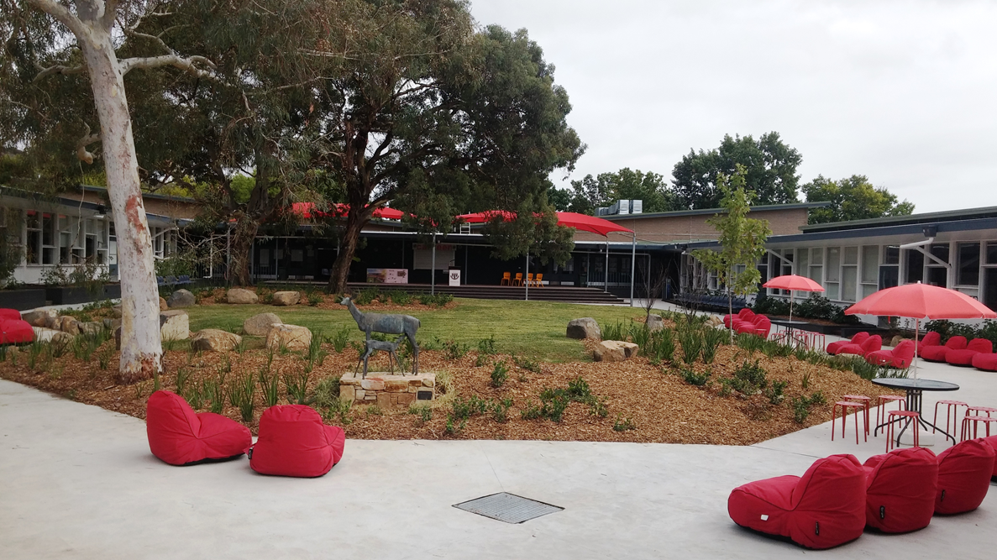

The purpose of school improvement planning
This plan establishes a strong improvement agenda to be driven by school leaders over the next five years. It was informed by the Directorate’s Strategic Plan and system-level and school-based analysis of multiple sources of evidence including our School Review findings. Analysis of these multiple sources of evidence is supported by an annual provision to each school of a data summary as a key enabler of our improvement planning and implementation.
Each school undertakes a school review as an integral component of in its five-year improvement planning cycle. The reviews are an important part of how the Directorate supports and monitors school improvement. Reviews provide schools with quality and independent feedback, tailored to the school’s context. Each school is reviewed at least every five years, providing valuable opportunities for self-reflection, planning and improvement. The school improvement planning process is below. This representation is used in the footer of all school-based improvement documents to indicate the stage of planning or implementation.
Analysis Priorities Strategies Actions Impact (for student)
Our school planning is grounded in evidence from research and practice and expressed in terms of improvements in measurable student outcomes. Explicit five-year targets for improvement have been set and will give life to monitoring, evaluation and communication of progress to teachers, families and students.

Our school’s improvement agenda positioned within the Directorate’s Strategic Plan

Vision
Education Directorate vision: We will be a leading learning organisation where people know they matter.
How will the Education Directorate’s vision gain life within your school’s context?
School vision:
Torrens Primary School, while valuing elements of traditional educational approaches, recognises the need to incorporate current advances in curriculum development, teaching and learning styles and strategies and educational resources in order to develop quality educational programs to meet the needs of our students in a constantly changing world.

Mission
Education Directorate’s mission: We develop and deliver educational services to empower each child and young person in the ACT to learn for life.
How will the Education Directorate’s mission gain life within your school’s context?
School mission:
Torrens Primary School provides a purposeful, productive and comprehensive education of the highest quality, working in partnership with the school community. The school aims to provide quality experiences that empower students to live in, and contribute to, a changing society. Torrens strives to develop in students, the ability to work as members of a team in cooperative learning environments, and to appreciate the worth of individual differences, with the capacity to act as responsible, independent citizens who care about themselves and their environment.

Values
Education Directorate’s Values: Respect, Integrity, Collaboration, Innovation.
How will the Education Directorate’s values gain life within your school’s context?
School values:

Teamwork and tolerance.

Education Directorate’s Strategic goals for 2018-2021
- Schools where students love to learn
- investing in early childhood
- Evidence informed decisions
- Learning culture
- United leadership team

Education Directorate’s Strategic indicators for 2018-2021
- To promote greater equity in learning outcomes in and across ACT public schools
- To facilitate high quality teaching in ACT public schools and strengthen educational outcomes
- To centre teaching and learning around students as individuals

The Directorate will annually publish progress against its strategic indicators. Each school’s contributions to these strategic indicators will be provided to our school for inclusion in our Impact Report.

Multiple sources of evidence
Evidence informing this School Plan includes:
- analysis of system-level data
- analysis of school-based evidence over time (past 4/5 years)
- recommendations from School Review
- for schools with a preschool setting, Quality Ratings from assessment against the National Quality Framework.*
*For schools with a preschool setting their Quality Improvement Plan (QIP) is revised each year as part of the annual planning process.

Our improvement priorities
Priority 1: Improve growth in writing
What will the experience of students be like through implementation of this priority at the completion of our five-year school improvement cycle?

A community of engaged writers.

What measurable targets will support progress and monitoring of the impact of this priority?
Using the multiple sources of evidence approach as a guide, what measures will inform and demonstrate impact for students and staff through implementation of this improvement priority?

Targets/Measures to be achieved by 2023.

Student learning data
Target or measure 60% of Yrs 3-5 students are at or above expected growth
Source: NAPLAN – Scout/Myschool
Starting point: 47% of Yrs 3-5 students are at or above expected growth

Perception Data
Target or measure: 96% of classroom teachers believe they receive effective feedback on the teaching of writing.
Source: School based survey
Starting point: 59% of classroom teachers believe they receive effective feedback on the teaching of writing.

School program and process data
Target or measure: In all classrooms, students know where they are at in their writing and what they need to do to improve.
Source: Classroom walkthroughs
Starting point: One class, out of the 9 K-2 classes, had individual learning goals. Two classes had anchor charts for what good writer’s do. One class had co-constructed anchor charts for what good writer’s do.

PRIORITY 2: Improve Growth in Mathematics
What will the experience of students be like through implementation of this priority at the completion of our five-year school improvement cycle?

A community of engaged mathematicians.

What measurable targets will support progress and monitoring of the impact of this priority?
Using the multiple sources of evidence approach as a guide, what measures will inform and demonstrate impact for students and staff through implementation of this improvement priority?

Targets/Measures to be achieved by 2023.

Student learning data
Target or measure 60% of Yrs 3-5 students are at or above expected growth
Source: NAPLAN and PIPS
Starting point: 49.2% of Yrs 3-5 students are at or above expected growth
Target or measure All teachers feel competent and confident in enriching and extending all students in mathematics.
Source: Teacher survey
Starting point: 50% of teachers feel competent and confident in enriching and extending all students in mathematics.

School program and process data
Target or measure In all classrooms, students are able to apply and transfer their mathematical knowledge.
Source: Class walkthrough/Planning documents
Starting point: 12 out of 22 classroom maths programmes show evidence that students are learning how to apply maths concepts.

Endorsement
This School Plan has been endorsed electronically by our Principal, Director School Improvement and Board Chair.

Principal
Name: Rachel Matthews
Date: 9th April 2019

Director School Improvement
Name: Julie Cooper
Date:

Board Chair
Name: Sally Bower
Date: 9th April 2019

