

Lyneham High School

Annual School Board Report

2018

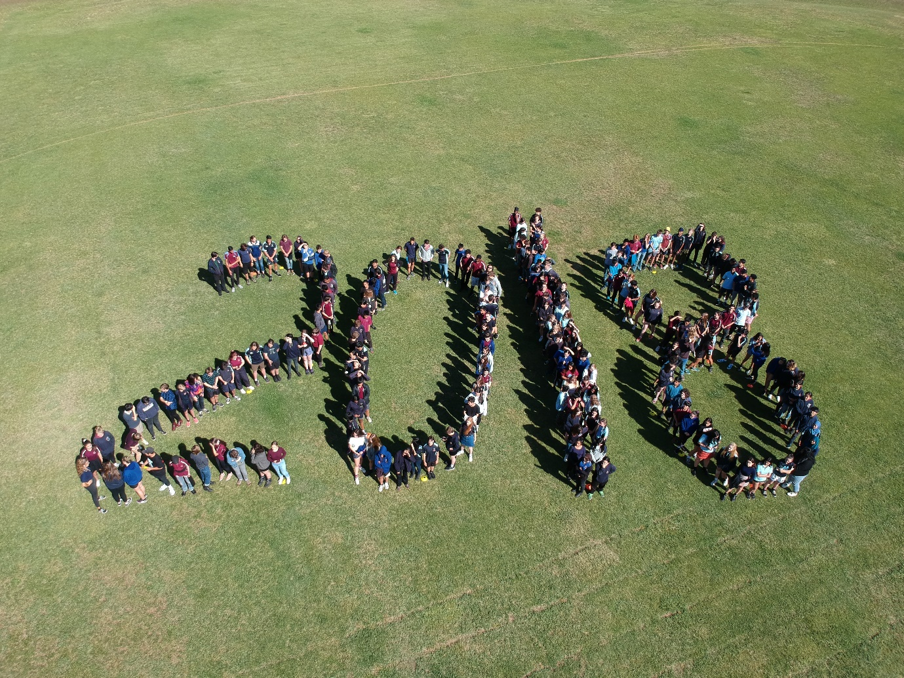

This page is intentionally left blank.



This report supports the work being done in the ACT Education Directorate, as outlined in *Strategic Plan 2018-21: A Leading Learning Organisation*.

Accessibility

The ACT Government is committed to making its information services, events and venues accessible to as many people as possible.

If you have difficulty reading a standard document and would like to receive this publication in an alternate format, such as large print and audio, please telephone (02) 6247 4580.

If English is not your first language and you require the translating and interpreting service, please telephone 13 14 50.

If you are deaf or hearing impaired and require the National Relay Service, please telephone 13 36 77.

© Australian Capital Territory, Canberra, 2018

Material in this publication may be reproduced provided due acknowledgement is made.

Contents

Reporting to the community 1

Summary of School Board activity 1

School Context 1

Student Information 2

Student enrolment 2

Student attendance 2

Supporting attendance and managing non-attendance 2

Staff Information 3

Teacher qualifications 3

Workforce composition 3

School Review and Development 4

School Satisfaction 4

Overall Satisfaction 4

Learning and Assessment 6

Financial Summary 7

Voluntary Contributions 8

Reserves 8

Endorsement Page 9

Members of the School Board 9

# Reporting to the community

School report to communities in range of ways, including through:

* Annual School Board Reports
* a (5-year) School Improvement Plan (formerly School Strategic Plan)
* annual Impact Reports/ Annual Action Plan Reports
* newsletters
* other sources such as My School.

# Summary of School Board activity

2018 was the second year in our school improvement cycle (2017-2021) with a focus on student engagement, success and resilience through differentiation in learning and assessment.

Throughout the year the Board met seven times and received regular reports from the principal, students, parents and staff on the implementation of our strategic priorities and progress towards our key improvement strategies. As well as approving the school budget and overseeing school finances and budgetary policy, the Board heard more about the staged implementation of the Student Resource Allocation (SRA) model. The Board also approved overseas excursions to Vietnam and Cambodia for 2019, Malaysia for 2019, STAR New Zealand for 2019 and France (LHS students to access Telopea Park School trip) for 2019.

During the year the Board discussed a range of topics including the Education Directorate Future of Education consultations, the introduction and use of ACT Government provided Chromebooks, the impacts of streaming and removal of labels/levels against classes, the development of cross curriculum learning options (Seek Program and STEM) and the continuing work to monitor demographic and enrolment trends and their impact on the school and its programs.

The Board noted with thanks the professional work undertaken by school staff throughout the year to provide students with a breadth of engaging opportunities both within and outside the classroom. Recognition was given to ongoing professional learning, the collaborative work in Professional Learning Teams (PLTs) to support strategies that differentiate learning and QTm Workshops that facilitated observations and feedback cycles focussed on effective classroom practices.

The Board noted with appreciation the ongoing joint work of the school Parents and Citizens’ (P&C) Association and school staff to host parent forums on matters of interest. Another highlight of the year for the school community was the annual Trivia Night

# School Context

Lyneham High School has operated at above full capacity throughout 2018 after experiencing a further increase in the total student population. Continued growth in the number of students from within the school’s Priority Enrolment Area (PEA) has resulted in a very limited number of places available for “out-of-area” families. Lyneham High School has been designated a Category A school and will only consider enrolment applications from out of area students against criteria specified in Education Directorate policy and procedures.

While there has been a small decrease in the overall percentage of students who are Aboriginal or Torres Strait Islander students, the actual number of students has remained unchanged. The overall percentage of students who have English as Another Language or Dialect (EAL/D) has also remained steady with approximately one third of all students still identify a language background other than English. The number of students enrolled in Disability Education placements has remained steady. There has been a continuing increase in the number of students receiving Inclusion Support Program (ISP) funding, particularly relating to Mental Health support.

## Student Information

### Student enrolment

In 2018 there were a total of 1,119 students enrolled at this school.

Table: 2018 Student enrolment

|  |  |
| --- | --- |
| **Student type** | **Number of students** |
| Male | 591 |
| Female | 528 |
| Aboriginal and Torres Strait Islander | 25 |
| LBOTE* | 368 |

*Language Background Other Than English

Source: Analytics and Evaluation, December 2018

### Student attendance

The following table identifies the attendance rate of students by year level during 2018. Student attendance rate is the percentage of school days attended by students in each year level at the school. Student attendance is measured over two school terms; that is from the first day of the school year for students in term 1 to the last day of term 2.

Table: 2018 Attendance rates in percentages*

|  |  |
| --- | --- |
| **Year level** | **Attendance rate** |
| 7 | 91.0 |
| 8 | 89.0 |
| 9 | 87.0 |
| 10 | 88.0 |

Source: Analytics and Evaluation, December 2018

* Attendance data for 2018 have been derived from a school administration system in the process of implementation. Care should be taken when comparing these data with data from previous years and from other jurisdictions.

## Supporting attendance and managing non-attendance

All ACT public schools put into effect the education participation requirements in the *Education Act 2004* and the responsibilities of schools in relation to compulsory education. The Education Directorate’s *Education Participation (Enrolment and Attendance) Policy* describes its position with regard to supporting attendance and managing non-attendance. A suite of procedures supports the implementation of the policy. Please refer to <https://www.education.act.gov.au/> for further details.

## Staff Information

### Teacher qualifications

All teachers at this school meet the professional requirements for teaching in an ACT public school. The ACT Teacher Quality Institute (TQI) specifies two main types of provision for teachers at different stages of their career, these are detailed below.

* ***Full registration*** is for teachers with experience working in a registered school in Australia or New Zealand who have been assessed as meeting the Proficient level of the Australian Professional Standards for Teachers.
* ***Provisional registration*** is for newly qualified teachers or teachers who do not have recent experience teaching in a school in Australia and New Zealand. Many teachers moving to Australia from another country apply for Provisional registration.

### Workforce composition

Workforce composition for the year of reporting is highlighted in the following table. The data is taken from the school’s verified August staffing report. For reporting purposes it incorporates all school staff including preschools, staff absent for a period of less than four consecutive weeks and staff replacing staff absent for more than four consecutive weeks. It does not include casuals and staff absent for a period of four consecutive weeks or longer.

The Education Directorate is required to report Aboriginal and Torres Strait Islander staff figures. As of June 2018, 101 Aboriginal and Torres Strait Islander staff members were employed across the Directorate.

Table: 2018 Workforce composition numbers

|  |  |
| --- | --- |
| **Staff employment category** | **TOTAL** |
| Teaching Staff: Full Time Equivalent Permanent | 67.50 |
| Teaching Staff: Full Time Equivalent Temporary | 11.10 |
| Non Teaching Staff: Full Time Equivalent | 17.67 |

Source: This data is from the 2018 August census date and is calculated using the parameters provided by the ABS.

# School Review and Development

The ACT Education Directorate’s Strategic Plan 2018-2021 provides the framework and strategic direction for School Improvement Plans (formerly School Strategic Plans). This is supported by the school performance and accountability framework, ‘*People, Practice and Performance: School Improvement in Canberra Public Schools, A Framework for Performance and Accountability’*. This framework has school improvement at its centre, with the National School Improvement Tool (NSIT) as its core feature, providing support to achieve high standards in student learning, innovation and best practice in ACT public schools.

Prior to 2016 all ACT public schools participated in a four-year cycle of school review and development. In the fourth year schools underwent an external validation process. In 2016 this changed to a five-year cycle with an External School Review at the end.

Our school will be reviewed in [INSERT YEAR OF REVIEW]. A copy of the most recent validation report can be found on our school website.

## School Satisfaction

Schools use a range evidence to gain an understanding of the satisfaction levels of their parents and carers, staff and students. In August/ September of this reporting period ACT schools undertook a survey to gain an understanding of school satisfaction at that time. This information was collected from Staff, parents and students from year 5 and above (with the exception of students in special schools) through an online survey.

## Overall Satisfaction

In 2018, 86% of parents and carers, 96% of staff, and 81% of students at this school indicated they were satisfied with the education provided by the school.

Included in the survey were 16 staff, 14 parent, and 12 student items which are described as the national opinion items. These items were approved by the then Standing Council on School Education and Early Childhood (SCSEEC) for use from 2015. The following tables show the percentage of parents and carers, students and staff who agreed with each of the national opinion items at this school.

A total of 96 staff responded to the survey. Please note that not all responders answered every question.

Table: Proportion of staff in agreement with each national opinion item

|  |  |  |
| --- | --- | --- |
| **National opinion item** | |  | | --- | | Proportion of staff | |
| Teachers at this school expect students to do their best. | 100 |
| Teachers give useful feedback. | 90 |
| Teachers at this school treat students fairly. | 97 |
| This school is well maintained. | 77 |
| Students feel safe at this school. | 97 |
| Students at this school can talk to their teachers about their concerns. | 98 |
| Parents at this school can talk to teachers about their concerns. | 97 |
| Student behaviour is well managed at this school. | 82 |
| Students like being at this school. | 98 |
| This school looks for ways to improve. | 97 |
| This school takes staff opinions seriously. | 73 |
| Teachers at this school motivate students to learn. | 98 |
| Students’ learning needs are being met at this school. | 88 |
| This school works with parents to support students' learning. | 88 |
| Staff get quality feedback on their performance | 77 |
| Staff are well supported at this school. | 80 |

Source: 2018 School Satisfaction Surveys, August/September 2018

*Prior to 2018, the item wording and placement was slightly different.

A total of 362 parents responded to the survey. Please note that not all responders answered every question.

Table: Proportion of parents and carers in agreement with each national opinion item

|  |  |  |
| --- | --- | --- |
| **National opinion item** | |  | | --- | | Proportion of parents and carers | |
| Teachers at this school expect my child to do his or her best. | 88 |
| Teachers give useful feedback. | 79 |
| Teachers at this school treat students fairly. | 84 |
| This school is well maintained. | 86 |
| My child feels safe at this school. | 93 |
| I can talk to my child’s teachers about my concerns. | 86 |
| Student behaviour is well managed at this school. | 75 |
| My child likes being at this school. | 90 |
| This school looks for ways to improve. | 84 |
| This school takes parents’ opinions seriously. | 73 |
| Teachers at this school motivate my child to learn. | 74 |
| My child is making good progress at this school. | 76 |
| My child's learning needs are being met at this school. | 73 |
| This school works with me to support my child's learning. | 65 |

Source: 2018 School Satisfaction Surveys, August/September 2018

*Prior to 2018, the item wording and placement was slightly different.

A total of 875 students responded to the survey. Please note that not all responders answered every question.

Table: Proportion of students in years 7 to 10 in agreement with each national opinion item

|  |  |  |
| --- | --- | --- |
| **National opinion item** | |  | | --- | | Proportion of students | |
| My teachers expect me to do my best. | 89 |
| Teachers give useful feedback. | 55 |
| Teachers at my school treat students fairly. | 61 |
| My school is well maintained. | 66 |
| I feel safe at this school. | 71 |
| I can talk to my teachers about my concerns. | 44 |
| Student behaviour is well managed at my school. | 40 |
| I like being at my school. | 71 |
| My school looks for ways to improve. | 74 |
| Staff take students’ opinions seriously. | 58 |
| My teachers motivate me to learn. | 63 |
| My school gives me opportunities to do interesting things. | 83 |

Source: 2018 School Satisfaction Surveys, August/September 2018

*Prior to 2018, the item wording and placement was slightly different.

These results, as well as the continual review of school performance, contributed to the evaluation of our Strategic Plan and the development of Annual Action Plans. The Strategic Plan (or School Improvement Plan) is available on the school website.

# Learning and Assessment

Results are not reported when there are fewer than five students with results. This rule is applied for reasons of statistical reliability, as well as to protect the privacy of students in small schools.

The following table shows the mean scores achieved by students at this school compared to the ACT for this reporting period.

***Table: Lyneham High School 2018 NAPLAN Mean Scores***

|  |  |  |  |  |
| --- | --- | --- | --- | --- |
| **Test Domain** | **Year 7 School** | **Year 7 ACT** | **Year 9 School** | **Year 9 ACT** |
| **Reading** | 582 | 549 | 626 | 593 |
| **Writing** | 518 | 501 | 570 | 539 |
| **Spelling** | 565 | 540 | 610 | 582 |
| **Grammar & Punctuation** | 587 | 549 | 629 | 592 |
| **Numeracy** | 590 | 554 | 638 | 596 |

Source: Analytics and Evaluation

# Financial Summary

The school has provided the Directorate with an end of year financial statement that was approved by the school board. Further details concerning the statement can be obtained by contacting the school. The following summary covers use of funds for operating costs and does not include expenditure in areas such as permanent salaries, buildings and major maintenance.

Table: Financial Summary

|  |  |  |  |
| --- | --- | --- | --- |
| **INCOME** | **January-June** | **July-December** | **January-December** |
| Self-management funds | 553135.39 | 526016.02 | 1079151.41 |
| Voluntary contributions | 37843.00 | 21197.50 | 59040.50 |
| Contributions & donations | 13650.00 | 7485.00 | 21135.00 |
| Subject contributions | 68394.96 | 38100.36 | 106495.32 |
| External income (including community use) | 22659.69 | 15793.82 | 38453.51 |
| Proceeds from sale of assets | 0.00 | 0.00 | 0.00 |
| Bank Interest | 14515.14 | 15008.43 | 29523.57 |
| **TOTAL INCOME** | 710198.18 | 623601.13 | 1333799.31 |
| **EXPENDITURE** |  |  |  |
| Utilities and general overheads | 119764.37 | 167719.28 | 287483.65 |
| Cleaning | 123713.27 | 132015.61 | 255728.88 |
| Security | 780.00 | 288.00 | 1068.00 |
| Maintenance | 105119.82 | 214025.27 | 319145.09 |
| Administration | 14402.88 | 5298.23 | 19701.11 |
| Staffing | 0.00 | 0.00 | 0.00 |
| Communication | 15890.36 | 5538.42 | 21428.78 |
| Assets | 51700.13 | 60678.55 | 112378.68 |
| General office expenditure | 73961.99 | 43193.01 | 117155.00 |
| Educational | 58190.02 | 55914.08 | 114104.10 |
| Subject consumables | 44058.01 | 66210.57 | 110268.58 |
| **TOTAL EXPENDITURE** | 607580.85 | 750881.02 | 1358461.87 |
| **OPERATING RESULT** | 102617.33 | -127279.89 | -24662.56 |
| **Actual** Accumulated Funds | 414234.47 | 501578.42 | 421578.42 |
| Outstanding commitments (minus) | -31137.28 | 0.00 | -31137.28 |
| **BALANCE** | 485714.52 | 374298.53 | 365778.58 |

## Voluntary Contributions

The funds listed were used to support the general operations of the school. The spending of voluntary contributions is in line with the approved budget for 2018.

## Reserves

|  |  |  |
| --- | --- | --- |
| Name and Purpose | Amount | Expected Completion |
| **Internal Painting**  Ongoing maintenance and improvements to teaching areas and staff rooms. | $100000 | 12/2020 |
| **Staffing**  Contingency to cover additional staffing costs to support learning programs during the year. | $200000 | 12/2020 |

# Endorsement Page

## Members of the School Board

|  |  |  |  |
| --- | --- | --- | --- |
| Parent Representative(s): | Chris Johnston | Greg Terrill | Stephen van Gerwen |
| Community Representative(s): |  |  |  |
| Teacher Representative(s): | Luke Coleman | Robin Morrell |  |
| Student Representative(s): | Reba Nelson | Sara Blakey |  |
| Board Chair: | Stephen van Gerwen |  |  |
| Principal: | Rob Emanuel |  |  |

I approve the report, prepared in accordance with the provision of the ACT *Education Act* *2004*, section 52.

|  |  |  |  |
| --- | --- | --- | --- |
| Board Chair Signature: | Stephen van Gerwen | Date: | 06 / 08 / 2019 |

I certify that to the best of my knowledge and belief the evidence and information reported in this Annual School Board Report represents an accurate record of the Board’s operations during this reporting period.

|  |  |  |  |
| --- | --- | --- | --- |
| Principal Signature: | Rob Emanuel | Date: | 06 / 08 / 2019 |