Harrison School
Annual School Board Report 2019

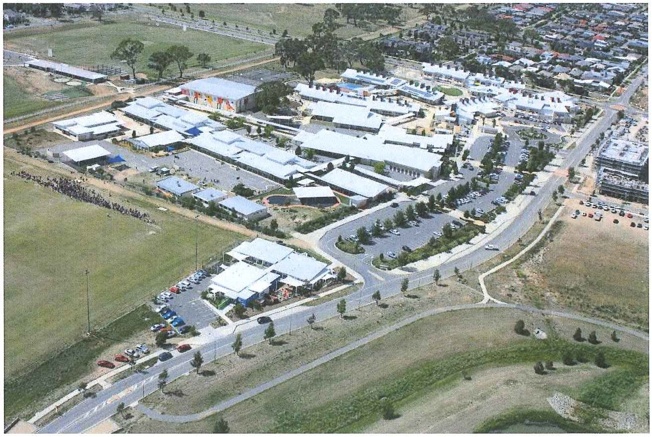

This page is intentionally left blank.

This report supports the work being done in the ACT Education Directorate, as outlined in Strategic Plan 2018-21: A Leading Learning Organisation.

Accessibility
The ACT Government is committed to making its information services, events and venues accessible to as many people as possible.
If you have difficulty reading a standard document and would like to receive this publication in an alternate format, such as large print and audio, please telephone (02) 6247 4580.
If English is not your first language and you require the translating and interpreting service, please telephone 13 14 50.
If you are deaf or hearing impaired and require the National Relay Service, please telephone 13 36 77.
© Australian Capital Territory, Canberra, 2020

Material in this publication may be reproduced provided due acknowledgement is made.

Contents
Reporting to the community 1
Summary of School Board activity 1
School Context 1
Student Information 1
Student enrolment 1
Student attendance 2
Supporting attendance and managing non-attendance 2
Staff Information 2
Teacher qualifications 2
Workforce composition 3
School Review and Development 3
School Satisfaction 4
Overall Satisfaction 4
Learning and Assessment 6
Performance in Literacy and Numeracy 6
Early years assessment 6
NAPLAN 6
Financial Summary 8
Voluntary Contributions 9
Reserves 9
Endorsement Page 10
Members of the School Board 10

Reporting to the community
Schools report to communities in range of ways, including through:
- Annual School Board Reports
- a (5-year) School Improvement Plan (formerly School Strategic Plan)
- annual Impact Reports
- newsletters
- other sources such as My School.

Summary of School Board activity
The Board acknowledges the efforts of the Harrison School teaching, administrative and leadership group in navigating the challenges that occurred at the end of and following the reporting period, including the severe bushfire season and the major disruptions brought by COVID-19. The school's response to these challenges has been commendable.
The Board was pleased that the school received a letter from the chairman of the Australian Curriculum, Assessment and Reporting Authority advising that Harrison School had demonstrated substantially above average gain in reading and numeracy achievement, as measured by NAPLAN. The school realised strong growth in reading for all NAPLAN tested cohorts and in numeracy for both the years 5-7 and years 7-9 cohorts.
The school’s financial position remains healthy, with reserves set aside for a number of projects. Following the commencement of a new enterprise agreement, the Board supported a necessary review of staffing to ensure the school continues to operate within budget.
A change to the configuration of the school, aligning our years 5/6 cohort with the junior area of the school as opposed to the senior area was implemented at the start of this year. This was done following parent, student and staff feedback and reflected the changing nature of the school as it continues to grow. It also aligns with the school’s effort to provide a more fulsome primary school experience for our years 5/6 students.
The Board has commenced a review of policies and procedures and has agreed on the highest priorities. This work will be a major focus of Board activities in 2020-21.

School Context
Harrison School is a large preschool to year 10 (P-10) school in the Gungahlin area of northern Canberra. The school opened in 2008 as a preschool to year 6 (P-6) school with an enrolment of approximately 300 students and expanded to include years 7-10 incrementally from 2011-2014. The school has continued to grow and with an enrolment of almost 1750 it is the second largest public school in the ACT. A strength of the school is its diverse population, with a large number of students coming from language backgrounds other than English and a significant number coming from Australian Defence Force families. Through enacting our Cultural Action Plan we acknowledge and recognise the strong history and culture of Indigenous People and the ongoing richness these contribute to our community.
Harrison School operates with a values focus and a strong sense of community. The Harrison School values of Respect, Inclusion, Teamwork, Integrity, Resilience and Endeavour continue to shape all actions and interactions across the P-10 school. Harrison started our implementation of Positive Behaviours for Learning (PBL) to help clarify how our values look in action across the school. Our PBL expectations, which are:
- We are respectful
- We are responsible
- We are learners
were expanded on during the year through the development of “Everywhere” statements which articulate, in positive language, behaviours expected in all parts of the school.
The school is physically designed to be inclusive for all students through offering a variety of learning spaces and accessible buildings. It supports our student-centred philosophy of learning and our model of inclusion. Classes and other learning groups are multi-aged with a focus on personalising learning through helping students understand themselves as learners and supporting their social development. During 2018-2019 an overt focus on literacy learning across the curriculum was actioned for all year levels from preschool to year 10, promoting greater understanding of the importance of becoming or being literate as an enabler of learning. Our ‘one school’ philosophy enables strong transitions for students as they traverse their learning journey.
Our preschool curriculum aligns with the National Early Years Learning Framework through a collaborative and play-based program. The school was an early implementer of the Australian Curriculum and all learning programs from kindergarten to year 10 are based on this.
Harrison School is engaging with other Gungahlin schools and university researchers in the Contemporary Literacy Project, which has a current focus on the teaching and assessment of the Australian Curriculum General Capabilities.
ICT has featured heavily at the school since 2011, initially through all years 7-10 students using personal electronic devices to enrich their learning. Increased use of ICT for our primary aged students has occurred through the use of Google Apps for Education and a focus on developing student digital portfolios.

Student Information

Student enrolment
In this reporting period there were a total of 1,744 students enrolled at this school.
Table: Student enrolment
Student type | Number of students
Male | 891
Female | 853
Aboriginal and Torres Strait Islander | 50
LBOTE* | 835
Source: ACT Education Directorate, Analytics and Evaluation Branch
*Language Background Other Than English

Student attendance
The following table identifies the attendance rate of students by year level during this reporting period. Student attendance rate is the percentage of school days attended by students in each year level at the school. Student attendance is measured over two school terms; that is from the first day of the school year for students in term 1 to the last day of term 2.
Table: Attendance rates in percentages
Year level | Attendance rate
1 | 90.0
2 | 91.0
3 | 92.0
4 | 92.0
5 | 92.0
6 | 90.0
7 | 91.0
8 | 88.0
9 | 88.0
10 | 87.0
Source: ACT Education Directorate, Analytics and Evaluation Branch

Supporting attendance and managing non-attendance
ACT public schools support parents and careers to meet their legal responsibilities in relation to the compulsory education requirements of the Education Act 2004. The Education Directorate’s Education Participation (Enrolment and Attendance) Policy describes its position with regard to supporting attendance and managing non-attendance. A suite of procedures supports the implementation of the policy. Please refer to https://www.education.act.gov.au/ for further details.

Staff Information

Teacher qualifications
All teachers at this school meet the professional requirements for teaching in an ACT public school. The ACT Teacher Quality Institute (TQI) specifies two main types of provision for teachers at different stages of their career, these are detailed below.
- Full registration is for teachers with experience working in a registered school in Australia or New Zealand who have been assessed as meeting the Proficient level of the Australian Professional Standards for Teachers.
- Provisional registration is for newly qualified teachers or teachers who do not have recent experience teaching in a school in Australia and New Zealand. Many teachers moving to Australia from another country apply for Provisional registration.

Workforce composition
Workforce composition for the current reporting period is provided in the following table. The data is taken from the school’s verified August staffing report. For reporting purposes, it incorporates all school staff including preschools, staff absent for a period of less than four consecutive weeks and staff replacing staff absent for more than four consecutive weeks. It does not include casuals and staff absent for a period of four consecutive weeks or longer.
The Education Directorate is required to report Aboriginal and Torres Strait Islander staff figures. As of June of the reporting period, 119 Aboriginal and/or Torres Strait Islander staff members were employed across the Directorate.
Table: Workforce composition numbers
Staff employment category | TOTAL
Teaching Staff: Full Time Equivalent Permanent | 89.56
Teaching Staff: Full Time Equivalent Temporary | 22.20
Non Teaching Staff: Full Time Equivalent | 49.06
Source: ACT Education Directorate, People and Performance Branch

School Review and Development
The ACT Education Directorate’s Strategic Plan 2018-2021 provides the framework and strategic direction for School Improvement Plans (formerly School Strategic Plans). This is supported by the school performance and accountability framework ‘People, Practice and Performance: School Improvement in Canberra Public Schools, A Framework for Performance and Accountability’. Annually, system and school level data are used alongside the National School Improvement Tool to support targeted school improvement, high standards in student learning, innovation and best practice in ACT public schools.
Prior to 2016 all ACT public schools participated in a four-year improvement cycle. In the fourth year schools underwent an external Validation process. In 2016 this changed to a five-year cycle with a School Review at the end.
Our school was reviewed in 2017. A copy of the Report of Review can be found on our school website.

School Satisfaction
Schools use a range evidence to gain an understanding of the satisfaction levels of their parents and carers, staff and students. Annually in August/ September ACT schools undertake a survey to gain an understanding of school satisfaction at that time. This information is collected from staff, parents and students from year 5 and above through an online survey.

Overall Satisfaction
In this period of reporting, 71% of parents and carers, 84% of staff, and 62% of students at this school indicated they were satisfied with the education provided by the school.
Included in the survey were 16 staff, 14 parent, and 12 student items which are described as the national opinion items. These items were approved by the then Standing Council on School Education and Early Childhood (SCSEEC) for use from 2015. The following tables show the percentage of parents and carers, students and staff who agreed with each of the national opinion items at this school.
A total of 85 staff responded to the survey. Please note that not all responders answered every question.
Table: Proportion of staff in agreement with each national opinion item
National opinion item | %*
Parents at this school can talk to teachers about their concerns. | 94
Staff are well supported at this school. | 63
Staff get quality feedback on their performance. | 60
Student behaviour is well managed at this school. | 48
Students at this school can talk to their teachers about their concerns. | 94
Students feel safe at this school. | 70
Students like being at this school. | 83
Students’ learning needs are being met at this school. | 84
Teachers at this school expect students to do their best. | 98
Teachers at this school motivate students to learn. | 92
Teachers at this school treat students fairly. | 93
Teachers give useful feedback. | 89
This school is well maintained. | 72
This school looks for ways to improve. | 85
This school takes staff opinions seriously. | 71
This school works with parents to support students' learning. | 86
Teachers give useful feedback. | 89
Source: ACT Education Directorate, Analytics and Evaluation Branch
Data derived from annual School Satisfaction Survey
*percentage of parent respondents
A total of 282 parents responded to the survey. Please note that not all responders answered every question.
Table: Proportion of parents and carers in agreement with each national opinion item
National opinion item | %*
My child likes being at this school. | 82
I can talk to my child’s teachers about my concerns. | 83
My child feels safe at this school. | 82
My child is making good progress at this school. | 68
My child's learning needs are being met at this school. | 66
Student behaviour is well managed at this school. | 60
Teachers at this school expect my child to do his or her best. | 80
Teachers at this school give useful feedback. | 65
Teachers at this school motivate my child to learn. | 71
Teachers at this school treat students fairly. | 74
This school is well maintained. | 72
This school looks for ways to improve. | 64
This school takes parents’ opinions seriously. | 60
This school works with me to support my child's learning. | 65
Source: ACT Education Directorate, Analytics and Evaluation Branch
Data derived from annual School Satisfaction Survey
*percentage of parent respondents
A total of 626 students responded to the survey. Please note that not all responders answered every question.
Table: Proportion of students in agreement with each national opinion item
National opinion item | %*
I can talk to my teachers about my concerns. | 51
I feel safe at this school. | 52
I like being at my school. | 62
My school gives me opportunities to do interesting things. | 74
My school is well maintained. | 36
My school looks for ways to improve. | 64
My teachers expect me to do my best. | 85
My teachers motivate me to learn. | 66
Staff take students’ concerns seriously. | 54
Student behaviour is well managed at my school. | 24
Teachers at my school treat students fairly. | 55
Teachers give useful feedback. | 60
Source: ACT Education Directorate, Analytics and Evaluation Branch
Data derived from annual School Satisfaction Survey
*percentage of parent respondents

Learning and Assessment

Performance in Literacy and Numeracy

Early years assessment
Students in kindergarten undertake an on-entry and on-exit assessment of their early reading and numeracy skills using the Performance Indicators in Primary Schools (PIPS) program. Student results are reported against five performance bands at the end of semester 1 and 2. Below are the results for this school for the current reporting period.
Table: Harrison School PIPS 2019 mean raw scores
Agency | Reading start | Reading end | Mathematics start | Mathematics end
School | 56 | 125 | 39 | 52
ACT | 49 | 123 | 39 | 55
Source: ACT Education Directorate, Analytics and Evaluation Branch

NAPLAN
Students in years 3, 5, 7 and 9 in all ACT schools participate in the National Assessment Program-Literacy and Numeracy (NAPLAN). This program assesses skills in reading, writing, spelling, grammar and punctuation, and numeracy.
In this reporting period, 2.00 % of year 3 students, 1.10 % of year 5 students, 0.60 % of year 7 students and 3.30 % of year 9 students were exempt from testing based on nationally agreed criteria.
For reasons of statistical reliability, as well as to protect the privacy of students, results are not reported when the sample size is less than five.
The following table shows the mean scores achieved by students at this school compared to all other ACT public schools for this reporting period.
Table: NAPLAN Mean Scores
Test Domain | Year 3 School | Year 3 ACT | Year 5 School | Year 5 ACT | Year 7 School | Year 7 ACT | Year 9 School | Year 9 ACT
Reading | 411 | 438 | 504 | 516 | 544 | 550 | 580 | 592
Writing | 411 | 418 | 473 | 474 | 512 | 509 | 538 | 544
Spelling | 392 | 408 | 492 | 497 | 551 | 542 | 584 | 584
Grammar & Punctuation | 408 | 440 | 486 | 500 | 539 | 544 | 565 | 580
Numeracy | 390 | 411 | 495 | 496 | 553 | 552 | 583 | 594
Source: ACT Education Directorate, Analytics and Evaluation Branch

Financial Summary
The school has provided the Directorate with an end of year financial statement that was approved by the school board. Further details concerning the statement can be obtained by contacting the school. The following summary covers use of funds for operating costs and does not include expenditure in areas such as permanent salaries, buildings and major maintenance.
Table: Financial Summary
INCOME | January-June | July-December | January-December
Self-management funds | 621633.62 | 506713.42 | 1128347.04
Voluntary contributions | 17754.50 | 9785.00 | 27539.50
Contributions & donations | 10.00 | 3000.00 | 3010.00
Subject contributions | 41026.29 | 15495.42 | 56521.71
External income (including community use) | 81463.17 | 102390.98 | 183854.15
Proceeds from sale of assets | 0.00 | 0.00 | 0.00
Bank Interest | 20369.30 | 14336.17 | 34705.47
TOTAL INCOME | 782256.88 | 651720.99 | 1433977.87
EXPENDITURE
Utilities and general overheads | 127426.35 | 220675.44 | 348101.79
Cleaning | 337000.00 | -168335.20 | 168664.80
Security | 0.00 | 796.85 | 796.85
Maintenance | 250519.98 | 147486.12 | 398006.10
Administration | 20322.94 | 27457.98 | 47780.92
Staffing | 185.00 | 377678.30 | 377863.30
Communication | 15380.94 | 7365.01 | 22745.95
Assets | 70884.03 | 31756.46 | 102640.49
Leases | 8009.79 | 160.39 | 8170.18
General office expenditure | 17316.98 | 14207.32 | 31524.30
Educational | 94605.54 | 151888.65 | 246494.19
Subject consumables | 24251.40 | 15060.61 | 39312.01
TOTAL EXPENDITURE | 965902.95 | 826197.93 | 1792100.88
OPERATING RESULT | -183646.07 | -174476.94 | -358123.01
Actual Accumulated Funds | 517069.48 | 425751.16 | 528086.36
Outstanding commitments (minus) | 65.17 | 0.00 | 65.17
BALANCE | 333488.58 | 251274.22 | 170028.52

Voluntary Contributions
The funds listed were used to support the general operations of the school, including purchasing of learning resources such as books and ICT equipment. The spending of voluntary contributions is in line with the approved budget for this reporting period.

Reserves
Name and Purpose | Amount | Expected Completion
Carpet replacement  Replacement of carpet in the administration and the library area due wear and tear. The school anticipates to replace carpet in other schooling areas, this will be factored in future years. | $75,000 | 2020
LED Lighting  The school has undertaken the LED lighting project which was paid upfront by the carbon loan neutrality scheme operated by ICW, with the agreement to pay the loan over time. | $18,520 | 2021
Painting  Re-painting interior walls of classrooms | $33,740.92 | 2021
Shade Structures  Providing shade to junior areas of the school to provide shaded outdoor areas. | $57,000 | 2021
ICT software subscription  Ongoing renewal of software licences for science subscription, eg. maths space, curriculum based etc | $20,040 | 2020
ICT Smartboards/equipment  Replace aging ICT asset base regarding interactive whiteboards, bulbs etc | $80,000 | 2020
Work shed  The school requires a workshop area for BSO to store gym equipment, desks, chairs and tables etc | $100,000 | 2020
Softfall repairs  The playgrounds require maintenance to ensure it is safe for students. | $70,000 | 2021
Increase storage space  The school requires storage facility for curriculum such as musical instruments, including offering storage to long term hirers. | $50,000 | 2020
Student Wellbeing Program  Supporting implementation of Mind Matters resources | $5,000 | 2020
Teacher Professional Learning  developing workforce capability, inexperienced executive team therefore require specific coaching and learning | $10,000 | 2020
Walkways Covered  Covered walkway between two buildings, dry access between buildings, students can move across safely. | $59,173.46 | 2020
Front Office Renovations  This is to provide additional space for increased staff and functionality. | $80,668 | 2020
Staffing resource - Improve Literacy & Numeracy Outcomes  School’s data along with NAPLAN data, PATS data and PIPs data shows that there is a diverse range of students requiring additional support across all year levels. In addition to this, the school self-funds two additional principals. | $293,000 | 2020

Endorsement Page

Members of the School Board
Parent Representative(s): | Jenny Byron, | Joshua Smith. | Mike Burns.
Community Representative(s):
Teacher Representative(s): | Michelle O’Brien, | Karen Longmuir.
Student Representative(s): | John Elphick, | Talon Cass-Dunbar.
Board Chair: | Mike Burns.
Principal: | Jason Holmes.
I approve the report, prepared in accordance with the provision of the ACT Education Act 2004, section 52.

Board Chair Signature: | Mike Burns | Date: | 27 / 07 / 2020

I certify that to the best of my knowledge and belief the evidence and information reported in this Annual School Board Report represents an accurate record of the Board’s operations during this reporting period.

Principal Signature: | Jason Holmes | Date: | 27 / 07 / 2020

