Charles Weston School
Annual School Board Report 2020

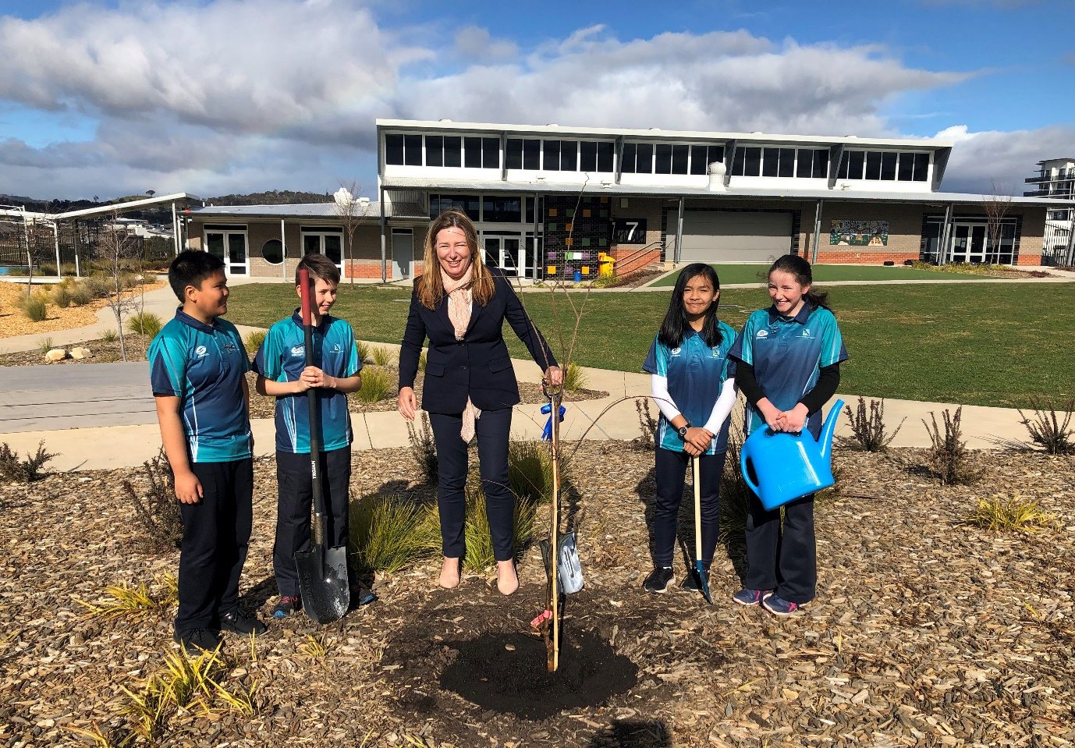
Minister Yvette Berry and our Student Parliament representatives on Tree Day 2020

This page is intentionally left blank.

This report supports the work being done in the ACT Education Directorate, as outlined in Strategic Plan 2018-21: A Leading Learning Organisation.

Accessibility
The ACT Government is committed to making its information services, events and venues accessible to as many people as possible.
If you have difficulty reading a standard document and would like to receive this publication in an alternate format, such as large print and audio, please telephone (02) 6247 4580.
If English is not your first language and you require the translating and interpreting service, please telephone 13 14 50.
If you are deaf or hearing impaired and require the National Relay Service, please telephone 13 36 77.
© Australian Capital Territory, Canberra, 2021

Material in this publication may be reproduced provided due acknowledgement is made.

Contents
Reporting to the community 1
School Context 1
Student Information 1
Student enrolment 1
Student attendance 2
Supporting attendance and managing non-attendance 2
Staff Information 2
Teacher qualifications 2
Workforce composition 2
School Review and Development 3
School Satisfaction 3
Overall Satisfaction 3
Learning and Assessment 5
Performance in Literacy and Numeracy 5
Early years assessment 5
NAPLAN 5
Financial Summary 6
Voluntary Contributions 7
Reserves 7
Endorsement Page 8
Members of the School Board 8

Reporting to the community
Schools report to communities in range of ways, including through:
- Annual School Board Reports
- a (5-year) School Improvement Plan (formerly School Strategic Plan)
- annual Impact Reports
- newsletters
- other sources such as My School.

School Context
Charles Weston School Coombs is an inclusive and culturally diverse P-6 school in the Molonglo Valley. We are a school community rich in diversity, with over 54 different languages spoken by our families. We acknowledge that we are growing our school community on Ngunnawal land and work with our children and families to respect the contributions of the Aboriginal people who we learn from, about and with at CWSC. We also recognise and welcome the opportunities for learning that come through the vast array of cultures that make up our emerging community. As a candidate school for the International Baccalaureate Primary Years Programme (PYP) our staff work collaboratively to provide authentic and purposeful learning opportunities via an inquiry-led, transdisciplinary framework. Students are challenged to take responsibility for their learning as they explore local and global issues. Teachers collaborate to deepen student learning, helping them take action and develop their capacity as self aware and socially responsible citizens of an international community. We actively promote and engage in partnerships with families and members of the wider community to strengthen the education of all students. The staff and students at CWSC are extremely fortunate to have high quality, contemporary and well resourced learning environments that support collaboration and inclusion.

Student Information

Student enrolment
In this reporting period there were a total of 485 students enrolled at this school.
Table: Student enrolment
Student type | Number of students
Gender - Male | 254
Gender - Female | 231
Gender - Non-binary or other* | 0
Aboriginal and Torres Strait Islander | 10
LBOTE** | 286
Source: ACT Education Directorate, Analytics and Evaluation Branch
* If the number of non binary students is less than six, or if gender is unknown, these are randomly assigned 'Male' or 'Female' and included in the counts.
** Language Background Other Than English

Student attendance
Due to the effects of the COVID-19 pandemic, 2020 attendance data has not been published in the Annual School Board Report.

Supporting attendance and managing non-attendance
ACT public schools support parents and careers to meet their legal responsibilities in relation to the compulsory education requirements of the Education Act 2004. The Education Directorate’s Education Participation (Enrolment and Attendance) Policy describes its position with regard to supporting attendance and managing non-attendance. A suite of procedures supports the implementation of the policy. Please refer to https://www.education.act.gov.au/ for further details.

Staff Information

Teacher qualifications
All teachers at this school meet the professional requirements for teaching in an ACT public school. The ACT Teacher Quality Institute (TQI) specifies two main types of provision for teachers at different stages of their career, these are detailed below.
- Full registration is for teachers with experience working in a registered school in Australia or New Zealand who have been assessed as meeting the Proficient level of the Australian Professional Standards for Teachers.
- Provisional registration is for newly qualified teachers or teachers who do not have recent experience teaching in a school in Australia and New Zealand. Many teachers moving to Australia from another country apply for Provisional registration.

Workforce composition
Workforce composition for the current reporting period is provided in the following table. The data is taken from the school’s verified August staffing report. For reporting purposes, it incorporates all school staff including preschools, staff absent for a period of less than four consecutive weeks and staff replacing staff absent for more than four consecutive weeks. It does not include casuals and staff absent for a period of four consecutive weeks or longer.
The Education Directorate is required to report Aboriginal and Torres Strait Islander staff figures. As of June of the reporting period, 135 Aboriginal and Torres Strait Islander staff members were employed across the Directorate.
Table: Workforce composition numbers
Staff employment category | TOTAL
Teaching Staff: Full Time Equivalent Permanent | 33.35
Teaching Staff: Full Time Equivalent Temporary | 3.62
Non Teaching Staff: Full Time Equivalent | 17.03
Source: ACT Education Directorate, People and Performance Branch

School Review and Development
The ACT Education Directorate’s Strategic Plan 2018-2021 provides the framework and strategic direction for School Improvement Plans (formerly School Strategic Plans). This is supported by the school performance and accountability framework ‘People, Practice and Performance: School Improvement in Canberra Public Schools, A Framework for Performance and Accountability’. Annually, system and school level data are used alongside the National School Improvement Tool to support targeted school improvement, high standards in student learning, innovation and best practice in ACT public schools.
Our school was reviewed in 2019. A copy of the Report of Review can be found on our school website.

School Satisfaction
Schools use a range evidence to gain an understanding of the satisfaction levels of their parents and carers, staff and students. Annually in August/ September ACT schools undertake a survey to gain an understanding of school satisfaction at that time. This information is collected from staff, parents and from 2020 students from year 4 and above (previously year 5 and above) through an online survey.

Overall Satisfaction
In this period of reporting, 92% of parents and carers, 100% of staff, and 77% of students at this school indicated they were satisfied with the education provided by the school.
Included in the survey were 16 staff, 14 parent, and 12 student items which are described as the national opinion items. These items were approved by the then Standing Council on School Education and Early Childhood (SCSEEC) for use from 2015. The following tables show the percentage of parents and carers, students and staff who agreed with each of the national opinion items at this school.
Note: The overall response rate for parents and carers in ACT public schools was negatively impacted by COVID-19, dropping from 31% in 2019 to 23% in 2020.
A total of 45 staff responded to the survey. Please note that not all responders answered every question.
Table: Proportion of staff* in agreement with each national opinion item
National opinion item | Proportion of staff
Parents at this school can talk to teachers about their concerns. | 89
Staff are well supported at this school. | 64
Staff get quality feedback on their performance. | 76
Student behaviour is well managed at this school. | 58
Students at this school can talk to their teachers about their concerns. | 98
Students feel safe at this school. | 53
Students like being at this school. | 87
Students’ learning needs are being met at this school. | 84
Teachers at this school expect students to do their best. | 96
Teachers at this school motivate students to learn. | 100
Teachers at this school treat students fairly. | 89
Teachers give useful feedback. | 76
This school is well maintained. | 98
This school looks for ways to improve. | 93
This school takes staff opinions seriously. | 71
This school works with parents to support students' learning. | 96
Source: ACT Education Directorate, Analytics and Evaluation Branch
*Proportion of those who responded to each individual survey question

A total of 92 parents responded to the survey. Please note that not all responders answered every question.
Table: Proportion of parents and carers* in agreement with each national opinion item
National opinion item | Proportion of parents and carers
I can talk to my child’s teachers about my concerns. | 97
My child feels safe at this school. | 87
My child is making good progress at this school. | 90
My child likes being at this school. | 95
My child's learning needs are being met at this school. | 91
Student behaviour is well managed at this school. | 72
Teachers at this school expect my child to do his or her best. | 91
Teachers at this school give useful feedback. | 82
Teachers at this school motivate my child to learn. | 88
Teachers at this school treat students fairly. | 88
This school is well maintained. | 99
This school looks for ways to improve. | 85
This school takes parents’ opinions seriously. | 79
This school works with me to support my child's learning. | 91
Source: ACT Education Directorate, Analytics and Evaluation Branch
*Proportion of those who responded to each individual survey question

A total of 118 students responded to the survey. Please note that not all responders answered every question.
Table: Proportion of students* in agreement with each national opinion item
National opinion item | Proportion of students
I can talk to my teachers about my concerns. | 58
I feel safe at this school. | 55
I like being at my school. | 67
My school gives me opportunities to do interesting things. | 73
My school is well maintained. | 69
My school looks for ways to improve. | 76
My teachers expect me to do my best. | 90
My teachers motivate me to learn. | 77
Staff take students’ concerns seriously. | 58
Student behaviour is well managed at my school. | 39
Teachers at my school treat students fairly. | 67
Teachers give useful feedback. | 70
Source: ACT Education Directorate, Analytics and Evaluation Branch
*Proportion of those who responded to each individual survey question

Learning and Assessment

Performance in Literacy and Numeracy

Early years assessment
Students in kindergarten undertake an on-entry and on-exit assessment of their early reading and numeracy skills using the BASE program. Student results are reported against five performance bands at the end of semester 1 and 2. Below are the results for this school for the current reporting period.
Due to the impact of COVID-19, analysis of BASE data for 2020 has been delayed. Analysis will be provided to schools in 2021. Please speak with the school should you require further information.

NAPLAN
Students in years 3, 5, 7 and 9 in all ACT schools participate in the National Assessment Program-Literacy and Numeracy (NAPLAN). This program assesses skills in reading, writing, spelling, grammar and punctuation, and numeracy.
*Note: There are no NAPLAN results for 2020, with the assessments not being conducted due to the impacts of COVID-19.

Financial Summary
The school has provided the Directorate with an end of year financial statement that was approved by the school board. Further details concerning the statement can be obtained by contacting the school. The following summary covers use of funds for operating costs and does not include expenditure in areas such as permanent salaries, buildings and major maintenance.

INCOME | January-June | July-December | January-December
Self-management funds | 113311.84 | 141414.80 | 254726.64
Voluntary contributions | 12100.00 | 4931.00 | 17031.00
Contributions & donations | 0.00 | 520.65 | 520.65
Subject contributions | 16117.00 | 2882.00 | 18999.00
External income (including community use) | 36947.99 | 31068.31 | 68016.30
Proceeds from sale of assets | 0.00 | 0.00 | 0.00
Bank Interest | 1273.20 | 1114.47 | 2387.67
TOTAL INCOME | 179750.03 | 181931.23 | 361681.26
EXPENDITURE
Utilities and general overheads | 44790.57 | 53336.80 | 98127.37
Cleaning | 2406.04 | 568.80 | 2974.84
Security | 0.00 | 0.00 | 0.00
Maintenance | 13201.87 | 7521.46 | 20723.33
Administration | 27160.85 | 7366.46 | 34527.31
Staffing | 0.00 | 244.17 | 244.17
Communication | 3204.46 | 3616.05 | 6820.51
Assets | -8427.45 | 1319.01 | -7108.44
Leases | 0.00 | 0.00 | 0.00
General office expenditure | 13363.38 | 12619.96 | 25983.34
Educational | 22699.58 | 28535.21 | 51234.79
Subject consumables | 1064.17 | 2939.13 | 4003.30
Other Payments | 0.00 | 13573.48 | 13573.48
Directorate Funded Payments | 0.00 | 24883.81 | 24883.81
TOTAL EXPENDITUIRE | 119463.47 | 156524.34 | 275987.81
OPERATING RESULT | 60286.56 | 25406.89 | 85693.45
Actual Accumulated Funds (31.12.20) | -32429.27 | -32429.27 | -32429.27
Outstanding commitments (minus) | -8152.48 | 0.00 | 0.00
BALANCE | -40581.75 | -32429.27 | -32429.27

Voluntary Contributions
The funds listed were used to support the general operations of the school. The spending of voluntary contributions is in line with the approved budget for this reporting period.

Reserves
Name and Purpose | Amount | Expected Completion
ICT Student devices  Update ageing chromebooks and & ipads for students and expand our collection of devices to support increased opportunity for 1:1 access | $20000 | 2021
Classroom Set Up  To support expansion of student numbers as the school population grows | $20000 | 2022
Painting & Carpeting  General upkeep of school in line with the maintenance plan as the school begins to age | $20000 | 2024

Endorsement Page

Members of the School Board
Parent Representative(s): | Karol Czarnota | Himali Mazmudar | Jo Stratton
Teacher Representative(s): | Hayley Stensholt | Kaitlin van den Engel
Board Chair: | Jo Stratton
Principal: | Nicole Nicholson
I approve the report, prepared in accordance with the provision of the ACT Education Act 2004, section 52.

2020 Board Chair Signature: | Jo Stratton | Date: | 15/07/2021

I certify that to the best of my knowledge and belief the evidence and information reported in this Annual School Board Report represents an accurate record of the Board’s operations during this reporting period.

Principal Signature: | Nicole Nicholson | Date: | 12 / 07 / 2021

