Dickson College

Annual Action Plan Report 2017
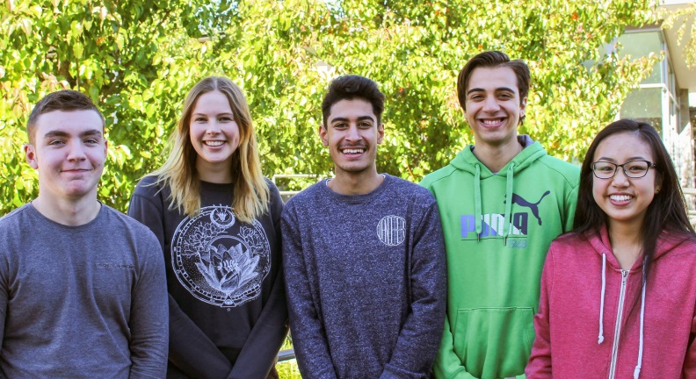

Context
DC is a senior secondary college situated in the inner north of Canberra. In 2017 DC was home to a diverse student community of 851 students engaged in a range of programs. Students are able to choose from tertiary(ATAR) or accredited courses in a broad range of course areas or Vocational Education and Training (VET) qualifications, or a combination of these. In addition, the college has a specialised Refugee Bridging Program for refugees (RBP), a unit for year 10 students (DC High) that have had difficulty engaging in a mainstream high school setting, a secondary introductory English centre (SIEC) for overseas students, and a program for students with disabilities (Support Programs).
IMROVEMENT AND CHANGE
In 2017 teachers continued their Professional Practice focus on effective teaching through their PPT Groups (PLC). A range of differentiated PL workshops were also made available to staff during the year. Teachers began using Google Classroom across the school.
In 2017 the College implemented a new timetable, community communications strategy, and continued to grow student agency through its expanding Student Leadership group. A number of improvements were also made to the school environment, particularly the canteen, for students.

Methodology
In this report Annual Action Plan Targets were evaluated agains outcomes (survey results, students results, and tangible actions). Report and results were discussed with The Dickson College Board. Teachers at Dickson College were involved in identifying several ‘Critical Challenges’ that the colleges faces over several staff meeting late in 2017. These challenges will inform our 2018 Annual Action Plan.

Evaluation of Performance

Priority

Enhance educational outcomes for all students

Targets:
- an ACT Senior Secondary Certificate or Vocational Qualification completion rate of 95% by 2020 (2015 92.5%, 2016 93.4% - ACT BSSS Completion data) – 2017 94%
- an ACT Senior Secondary Certificate or Vocational Qualification completion rate of 75% for Aboriginal and Torres Strait Islander students by 2020(2015 62.5%, 2016 70%) – 2017 73%
- a school-wide system of collecting and analysing evidence that provides greater understanding and visibility of student performance by teachers and students
- a school-wide system for supporting ongoing innovation at the college

Progress
The College continued to refine its Professional Learning Program with teachers over the course of 2017. This included, continued refinement of Professional Practice Team (PPT aka PLC) Model with associated action research and inter college collaboration with Gungahlin College during semester 1. Data collected from Year 9 NAPLAN and previous graduating cohort was analyzed to support school wide processes relating to assessment, moderation and scaling. These improvements resulted in fewer end of Year 12 scaling issues and more accurate Year 12 ATAR estimates than in 2016. Also supported by the college’s Professional Learning Program was the implementation of Google classroom across the school, and the implementation of the new Schools Administration System (SAS) where Dickson was one of two colleges piloting the new system.

Key Improvement Strategy
Develop and implement whole-school processes to support effective teaching and student achievement through evidence informed practice.

Indicators of success
75% of staff on School Satisfaction Survey report that “teachers at this school use results from system testing and system processes to inform planning” – Actual 77.6%
100% of Professional Practice Team goals informed by evidence that supports student outcomes – Actual 75%

Actions completed
Refine Professional Practice Team Model (PLC) with associated Action Research Project with a focus on implementing evidence informed practice
Collect and analyze comparative data in a number of identified key areas (NAPLAN, AST, Year 12 results, and individual course results)

Key Improvement Strategy
Strengthen staff capacity through a differentiated professional learning program which; includes collaborative planning and evaluation, addresses the relevant career stages of teachers, and allows the sharing of effective teaching practice within the school and across networks.

Indicators of success
100% of all early career educators, contract and probationary teachers have a formal mentoring relationship – Actual 100%
70% of staff on School Satisfaction Survey report that “My professional achievements are celebrated at this school” – Actual 61%

Actions Completed
All staff participated in cross College Collaboration and sharing opportunities with Gungahlin College in Semester 1
A variety of targeted Professional Learning workshops for all staff were offered during staff PL time

Key Improvement Strategy
Increase the use and effectiveness of learning technology in pedagogical practice

Indicators of success
80% of parents agree that “Computer technology is an integral part of learning and teaching at my child’s school” on school satisfaction survey– Actual 81%
80% of staff on School Satisfaction Survey report that “The use of learning technology is an integral part of teaching and learning at this school” – Actual 89%

Actions Completed
Implemented Google Classroom as the Learning Management System (LMS) across the college
Provided appropriate professional learning to staff to transition to Google classroom and Google Apps for Education (GAFE)

Key Improvement Strategy
Increase opportunities for students, staff and the community to explore ideas and initiatives that support innovation and personal growth

Indicators of success
80% of students report that “My teachers provide me with useful feedback about my school work” on school satisfaction survey– Actual 72%
85% of students report on School Satisfaction Survey that “My school gives me opportunities to do interesting things” – Actual 74%

Actions Completed
Continue to develop and implement a strategy to support ongoing innovative practice.*
*progress against this strategy was limited. Process for applying to the innovation fund has been identified but will require greater communication to students in 2018.

Key Improvement Strategy
Develop clear and transparent communication with students and parents regarding student progress, attendance, wellbeing and achievement.

Indicators of success
70% of parents report that “This school works with me to support my child’s learning.” on school satisfaction survey– Actual 66%
75% of parents report on School Satisfaction Survey that “My child is making good progress at this school” – Actual 73%
A reduction in V grades to 12% - Actual 13%

Actions Completed
Implement new School Administration System (SAS) as a system pilot school and utilize improved systems for attendance checking and reporting to students and families

Year 12 Certification Summary

342 Senior Secondary Certificates – Representing completion rate of 91.44%
53% Completion rate for Indigenous students
193 Vocational Qualifications
191 Tertiary Entrance Statements (TES) - Representing 56% of Year 12 Cohort
13% of students above an ATAR of 95
25% of students above an ATAR of 90
53% of students above an ATAR of 80
82% of students above an ATAR of 65
Median ATAR of 80.55
Source: ACT BSSS Year 12 data 2017

Priority

A thriving school community

Targets:
- An increase in student retention by 3% between Year 11 and 12 (90% in 2015)
- A systematic approach to collecting and analysing data relating student wellbeing and the most vulnerable young people enrolled at our school

Progress
Over the course of the year in conjunction with the school Board the College began to implement a communication strategy that includes Facebook, website and regular College email and Newsletters. The student leadership group grew significantly over 2017, in terms of size, participation and school events. In 2017 the student leadership group was given a budget to manage in order to support its various events. With teacher assistance the group work together to create various governance structures that helped manage the group’s size during the year.

Key Improvement Strategy
Develop and implement whole school strategy to support community engagement

Indicators of success
80% of parents agree or strongly agree that “Community partnerships are valued and maintained.” on school satisfaction survey– Actual 73%

Actions Completed
Over the course of the year in conjunction the school Board the College began to implement a communication strategy
Introduced regular family and community updates advertising what is coming up in the school community
Refined existing newsletters and social media communication

Key Improvement Strategy
Strengthen and improve existing school-wide practices for supporting student wellbeing.

Indicators of success
Review of Student Wellbeing processes– Actual underway
Improved student attendance in Clubs program – Data currently unavailable

Actions Completed
Implement new Clubs model based on special interests
Conduct a review of Student Wellbeing processes across the College

Key Improvement Strategy
Improve students’ agency through increased opportunities for leadership, individual involvement and voice

Indicators of success

School Climate responses
Increase student response to greater than 3 on School Climate Survey question “I feel a strong connection with this school”. – Actual 2.8
Increase student response to greater than 3 on School Climate Survey question “I feel I can talk to teachers about problems at school”. – Actual 2.6

Actions Completed
Established a Student Agency and Leadership model at the College in 2016, this was further refined and developed in 2017.
Implementation of student handbook ‘DC essentials’ in Clubs program

Retention and Student Wellbeing Summary 2017

92% Retention

897 Students referred to School Psychologist over the year

The two largest categories of referral being Mental Health and Interpersonal Relationships

Students and Staff completed Clubs survey during semester 2 – with some key themes being addressed in the 2018 Clubs program

