Harrison School
Annual School Board Report
2017
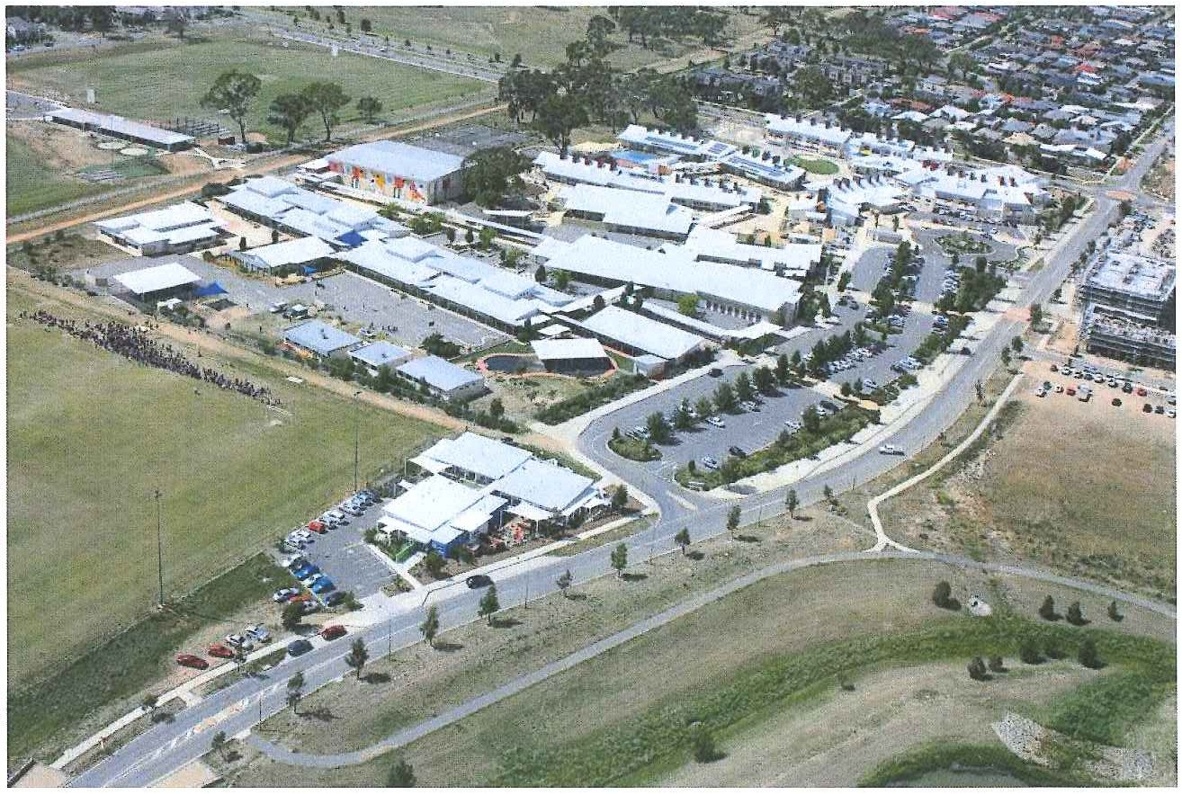
This page is intentionally left blank.

This report supports the work being done in the ACT Education Directorate, as outlined in the ‘Education Capital: Leading the Nation Strategic Plan 2014-17’.
Accessibility
The ACT Government is committed to making its information services, events and venues accessible to as many people as possible.
If you have difficulty reading a standard document and would like to receive this publication in an alternate format, such as large print and audio, please telephone (02) 6247 4580.
If English is not your first language and you require the translating and interpreting service, please telephone 13 14 50.
If you are deaf or hearing impaired and require the National Relay Service, please telephone 13 36 77.
© Australian Capital Territory, Canberra, 2017
Material in this publication may be reproduced provided due acknowledgement is made.

Contents
School Board Chair Report 1
Context 1
Student Information 2
Student enrolment 2
Student attendance 2
Staff Information 3
Teacher qualifications 3
Workforce composition 3
School Review and Development 4
School Satisfaction 4
Overall Satisfaction 4
Learning and Assessment 6
Performance in Literacy and Numeracy 6
Early years assessment 6
NAPLAN 7
Outcomes for College Students Error! Bookmark not defined.
Post School Destination Error! Bookmark not defined.
Performance in Other Areas of the Curriculum 7
Financial Summary 9
Professional Learning 10
Voluntary Contributions 10
Reserves 10
Endorsement Page 11
Members of the School Board 11

School Board Chair Report
No School Board Chair was available for this report.

School Context
Our school population continues to grow, increasing from a total enrolment of 1,572 in 2016. The demographics of the Harrison School student population has not altered dramatically since 2016, as the table below shows.
Table: 2016-2017 Harrison School Student Demographic Percentages
Demographic Category | 2016 Percentage | 2017 Percentage
Male | 51 | 52
Female | 49 | 48
Indigenous | 0.03 | 0.02
LBOTE | 46 | 46
Funded Diverse Needs | 4 | 4
Australian Defence Force | 19 | 20
International | 3 | 3
Source: Harrison School Student Data, 2016 and 2017

Student Information

Student enrolment
In 2017 there were a total of 1,628 students enrolled at this school.
Table: 2017 Student enrolment
Student type | Number of students
Male | 833
Female | 795
Aboriginal and Torres Strait Islander | 38
LBOTE* | 743
*Language Background Other Than English
Source: Planning and Analytics, December 2017

Student attendance
The following table identifies the attendance rate of students by year level during 2017. Student attendance rate is the percentage of school days attended by students in each year level at the school. Student attendance is measured over two school terms; that is from the first day of the school year for students in term 1 to the last day of term 2.
Table: 2017 Attendance rates in percentages
Year level | Attendance rate
K | 91.0
1 | 92.0
2 | 93.0
3 | 94.0
4 | 93.0
5 | 93.0
6 | 93.0
7 | 92.0
8 | 91.0
9 | 89.0
10 | 90.0
Source: Planning and Analytics, December 2017
All students are expected to attend school on every day, and during the times on every day, when the school is open for attendance. Should a student be absent, a note from a parent or guardian outlining the reason for the absence must be received. The school uses SMS to inform parents of unexplained student absence on a given day and staff contact parents if students are absent for more than two consecutive days. When unexplained absences reach a maximum of seven days in a school year, the principal, in line with Education Directorate procedures, commences official procedures by informing parents/carers in writing of school attendance requirements and inviting a collaborative approach to resolve issues leading to non-attendance. This promotes a joint responsibility for managing student attendance and ensures the importance of attendance at school is reinforced. Provision of learning materials for students who may have extended absences due to illness is always offered.
Due to the movement of students in years 7-10 throughout a school day, real time online attendance tracking is used to give greater capacity for accurate lesson by lesson attendance monitoring. If students are absent from class, procedures include follow up by classroom teachers or executive staff and contact being made with parents. The school’s processes reinforce the importance of attendance at every lesson in the school day.

Staff Information

Teacher qualifications
All teachers meet the professional requirements for teaching in an ACT public school. The ACT Teacher Quality Institute (TQI) has provided the following data based on teachers registered as at 16 December 2017.
The proportion of teaching staff with certificates/degrees/diplomas and a postgraduate qualification is shown below.
Table: 2017 Qualification of teaching staff in percentages
Qualifications | Proportion of staff
Certificate/ Diploma/ Degree | 100
Postgraduate | 48
Source: Teacher Quality Institute, 16 December 2017
All teaching staff at Harrison School have completed a minimum qualification of a Diploma and almost half of the teaching staff have completed studies at a postgraduate level.

Workforce composition
The 2017 workforce composition of [INSERT SCHOOL NAME] is highlighted in the following table. The data is taken from the school’s term 4 staff report. For reporting purposes it incorporates all school-based staff.
Table: 2017 Workforce composition numbers
Staff employment category | TOTAL
Teaching Staff: Head Count | 129
Teaching Staff: Full Time Equivalent Permanent | 98.70
Teaching Staff: Full Time Equivalent Temporary | 21.40
Non Teaching Staff: Head Count | 36
Non Teaching Staff: Full Time Equivalent | 28.65
Source: This data is from the school’s term 4 2017 staff report. Data provided in previous years was sourced from the August census date and was calculated using the parameters provided by the ABS. As such, pre-2017 staffing figures may differ significantly from the above.
There is one Aboriginal and Torres Strait Islander staff member at this school.

While the head count is a total of 165 teaching and non-teaching staff, the school supports part time working arrangements, hence the variance between head count and full time equivalent.

School Review and Development
In 2017, the ACT Education Directorate’s Strategic Plan 2014-2017 provided the framework and strategic direction for the school’s Strategic Plan. This is supported by the school performance and accountability framework, ‘People, Practice and Performance: School Improvement in Canberra Public Schools, A Framework for Performance and Accountability’. This framework has school improvement at its centre, with the National School Improvement Tool (NSIT) as its core feature, providing support to achieve high standards in student learning, innovation and best practice in ACT public schools.
Prior to 2016 all ACT public schools participated in a four-year cycle of school review and development. In the fourth year schools underwent an external validation process. In 2016 this changed to a five-year cycle with an External School Review at the end.
Harrison School was reviewed in 2017. A copy of the Review Report can be found on the school website.

School Satisfaction
Schools use a range of data collection tools to gain an understanding of the satisfaction levels of their parents and carers, staff and students. In August/ September 2017 the school undertook a survey to gain an understanding of school satisfaction at that time. Staff, parents and students from year 5 and above (with the exception of students in special schools) took part in an online survey.

Overall Satisfaction
In 2017, 68% of parents and carers, 83% of staff, and 61% of students at this school indicated they were satisfied with the education provided by the school.
Included in the survey were 14 national parent survey items and 12 national student survey items. These items were approved by the then Standing Council on School Education and Early Childhood (SCSEEC) for use from 2015. The following tables show the percentage of parents and carers and students who agreed with each of the national items at this school.
A total of 78 staff responded to the survey. Please note that not all responders answered every question.

Table: Proportion of staff in agreement with each national opinion item
National opinion item | Proportion of staff
Teachers at this school expect students to do their best. | 90
Teachers at this school provide students with useful feedback about their school work. | 87
Teachers at this school treat students fairly. | 97
This school is well maintained. | 77
Students feel safe at this school. | 84
Students at this school can talk to their teachers about their concerns. | 91
Parents at this school can talk to teachers about their concerns. | 92
Student behaviour is well managed at this school. | 55
Students like being at this school. | 93
This school looks for ways to improve. | 87
This school takes staff opinions seriously. | 58
Teachers at this school motivate students to learn. | 89
Students’ learning needs are being met at this school. | 77
This school works with parents to support students' learning. | 76
I receive useful feedback about my work at this school. | 51
Staff are well supported at this school. | 54
Source: 2017 School Satisfaction Surveys, August/September 2017
A total of 154 parents responded to the survey. Please note that not all responders answered every question.
Table: Proportion of parents and carers in agreement with each national opinion item
National opinion item | Proportion of parents and carers
Teachers at this school expect my child to do his or her best. | 81
Teachers at this school provide my child with useful feedback about his/her school work. | 73
Teachers at this school treat students fairly. | 80
This school is well maintained. | 89
My child feels safe at this school. | 87
I can talk to my child’s teachers about my concerns. | 87
Student behaviour is well managed at this school. | 63
My child likes being at this school. | 89
This school looks for ways to improve. | 74
This school takes parents’ opinions seriously. | 65
Teachers at this school motivate my child to learn. | 71
My child is making good progress at this school. | 71
My child's learning needs are being met at this school. | 67
This school works with me to support my child's learning. | 65
Source: 2017 School Satisfaction Surveys, August/September 2017
A total of 408 students responded to the survey. Please note that not all responders answered every question.
Table: Proportion of students in years 5 to 10 in agreement with each national opinion item
National opinion item | Proportion of students
My teachers expect me to do my best. | 90
My teachers provide me with useful feedback about my school work. | 67
Teachers at my school treat students fairly. | 49
My school is well maintained. | 54
I feel safe at my school. | 60
I can talk to my teachers about my concerns. | 49
Student behaviour is well managed at my school. | 28
I like being at my school. | 62
My school looks for ways to improve. | 65
My school takes students’ opinions seriously. | 44
My teachers motivate me to learn. | 63
My school gives me opportunities to do interesting things. | 68
Source: 2017 School Satisfaction Surveys, August/September 2017
This information can be considered alongside information available on the My School website (http://www.myschool.edu.au).
These results, as well as the continual review of school performance, contributed to the evaluation of our Strategic Plan and the development of Annual Action Plans. The Strategic Plan is available on the school website.

Learning and Assessment

Performance in Literacy and Numeracy

Early years assessment
Students in kindergarten undertake an on-entry assessment of their early reading and numeracy skills using the Performance Indicators in Primary Schools (PIPS) program. Student results are reported against five performance bands at the end of semester 1 and 2.
Table: Harrison School PIPS 2017 mean raw scores
Agency | Reading start | Reading end | Mathematics start | Mathematics end
School | 51 | 110 | 39 | 51
ACT | 51 | 124 | 39 | 55
Source: Planning and Analytics
This table shows the comparison of the school against the ACT average on raw scores in reading and mathematics. Our school data indicates lower growth in both reading and mathematics when compared to the ACT average growth.

NAPLAN
Students in years 3, 5, 7 and 9 in all ACT schools participate in the National Assessment Program-Literacy and Numeracy (NAPLAN). This program assesses skills in reading, writing, spelling, grammar and punctuation, and numeracy.
In 2017, 1.00 % of year 3 students, 0.00 % of year 5 students, 2.00 % of year 7 students and 6.00 % of year 9 students were exempt from testing based on nationally agreed criteria.
Results are not reported when there are fewer than five students with results. This rule is applied for reasons of statistical reliability, as well as to protect the privacy of students in small schools.
The following table shows the 2017 mean scores achieved by our students compared to the ACT.
Table: Harrison School 2017 NAPLAN Mean Scores
Test Domain | Year 3 School | Year 3 ACT | Year 5 School | Year 5 ACT | Year 7 School | Year 7 ACT | Year 9 School | Year 9 ACT
Reading | 417 | 442 | 497 | 517 | 534 | 554 | 581 | 590
Writing | 401 | 412 | 472 | 475 | 493 | 512 | 544 | 550
Spelling | 398 | 411 | 496 | 494 | 541 | 541 | 575 | 582
Grammar & Punctuation | 418 | 441 | 491 | 503 | 534 | 545 | 573 | 580
Numeracy | 404 | 417 | 480 | 496 | 539 | 552 | 586 | 591
Source: Planning and Analytics
An analysis of our NAPLAN results can be found when reporting against our priorities.

Performance in Other Areas of the Curriculum
Specialist programs across the school continue to be a strong element of learning, providing students with numerous opportunities to learn new skills and knowledge in a broad range of disciplines. Students within the junior area of the school (K-6) have learning opportunities in Japanese, music, drama, dance, environmental science, physical education, ICT and information literacy. Each student in the junior area of the school also has access to web-based learning programs such as Mathletics and Reading Eggs. Students and parents from years 5 to 10 have access to information, learning materials and course work through Google classroom.
ICT is embedded in the curriculum with students having access to a range of technologies to support learning. All general classrooms have interactive whiteboards and students had access to iPads, laptops, Chromebooks and computers to enhance their learning in a variety of subjects.
A focus on inquiry learning connects various areas of the curriculum though engaging students in learning around essential questions that allow flexibility and personalisation of learning experiences. Within the kindergarten to year 6 classes, inquiry connects learning areas such as technology, the arts, science and humanities. Within years 7 to 10 inquiry learning helps students develop understanding of themselves as learners and provides opportunities to make connections between learning areas.
A strength of the P-10 structure of Harrison School can be seen through students in years 5 and 6 also studying term long ‘taster’ units in technology and the arts, covering subjects such as woodwork, metalwork, cooking, drama and robotics. Students in years 7 to 10 have the opportunity to select two elective subjects to study each semester and careful consideration has been given to designing complementary units within elective learning areas to provide students with a pathway of learning in areas they have interest and or aptitude in.
The school’s music and drama programs provided numerous opportunities and highlights with outstanding performances by students throughout the year. This includes community performances by bands and choirs, a major drama production “The Man of Steel” performed by the ASPIRE Drama students, the school’s Uke Project performing at the Year 10 Excellence awards, years 3 to 6 students participating in Wakakirri, a number of students performing at Step Into the Limelight and two sold out end of year concerts.
A small group of years 9/10 students completed an outdoor barbeque project at the school. We continued our connection with our sister school, Tomio Daisan in Nara, through learning projects and communications planning our next visit (in 2018). A number of other excursions took students out into the community to engage in learning experiences beyond the classroom. These included camps to Birrigai, Sydney, Long Beach, NSW ski fields and local attractions such as the War Memorial, National Museum, National Gallery and Arboretum.
Students participated in regular physical education and health classes and the school’s athletics, swimming and cross-country carnivals. AFL clinics were also provided to students in the junior area of the school. Some students also represented the school at district and ACT sporting events, including basketball, touch football and soccer.

Financial Summary
The school has provided the Directorate with an end of year financial statement that was approved by the school board. Further details concerning the statement can be obtained by contacting the school. The following summary covers use of funds for operating costs and does not include expenditure in areas such as permanent salaries, buildings and major maintenance.
Table: Financial Summary
INCOME | January-June | July-December | January-December
Self-management funds | 748053.88 | 700504.91 | 1448558.79
Voluntary contributions | 19860.00 | 6152.50 | 26012.50
Contributions & donations | 5000.00 | 11300.00 | 16300.00
Subject contributions | 44836.87 | 7518.46 | 52355.33
External income (including community use) | 78373.48 | 85468.68 | 163842.16
Proceeds from sale of assets | 5598.39 | 0.00 | 5598.39
Bank Interest | 17308.07 | 16473.04 | 33781.11
TOTAL INCOME | 919030.69 | 827417.59 | 1746448.28
EXPENDITURE
Utilities and general overheads | 96141.27 | 221234.01 | 317375.28
Cleaning | 142396.54 | 136791.57 | 279188.11
Security | 756.00 | 688.00 | 1444.00
Maintenance | 26928.38 | 84931.44 | 111859.82
Administration | 14384.06 | 29194.40 | 43578.46
Staffing | 444928.20 | 50955.20 | 495883.40
Communication | 28246.96 | 6145.88 | 34392.84
Assets | 84631.59 | -2017.06 | 82614.53
Leases | 10025.47 | 16074.13 | 26099.60
General office expenditure | -6188.66 | 30364.67 | 24176.01
Educational | 131022.33 | 121330.65 | 252352.98
Subject consumables | 23553.56 | 6663.02 | 30216.58
TOTAL EXPENDITURE | 996825.70 | 702355.91 | 1699181.61
OPERATING RESULT | -77795.01 | 125061.68 | 47266.67
Actual Accumulated Funds | 453528.92 | 107631.08 | 190528.92
Outstanding commitments (minus) | -243.64 | 0.00 | -243.64
BALANCE | 375490.27 | 232692.76 | 237551.95

Professional Learning
The average professional learning expenditure at the school level per full time equivalent teacher was $312.

Voluntary Contributions
The funds listed were used to support the general operations of the school. The spending of voluntary contributions is in line with the approved budget for 2017.

Reserves
Name and Purpose | Amount | Expected Completion
School bus  - Lease payout guarantee  Required as part of the lease agreement for the school bus, which allows easy transport of students | $52,500.00 | 12/2018
Staffing reserve  - Additional funding for staffing  Allow additional staff to be employed to support students and their learning or to support school administration and maintenance | $257,000.00 | 12/2017
LED lighting  - Upgrade of lighting to more cost-efficient LED  Reduces energy usage | $15,000.00 | 12/2017
ICT Smartboards/equipment  - Repairing, replacing or purchasing new ICT hardware for learning or administration | $95,633.00 | 12/2017

Endorsement Page

Members of the School Board
Parent Representative(s): | Adele Smith, | Leanne Honeyball
Teacher Representative(s): | Kelly Dunstan, | Rachel Kane
Student Representative(s): | Alana Jenkins | Harrison Davis
Board Chair: | Kylie Stewart
Principal: | Jason Holmes

I approve the report, prepared in accordance with the provision of the ACT Education Act 2004, section 52.
Board Chair Signature: | Kylie Stewart | Date: | 01 / 03 / 2021
I certify that to the best of my knowledge and belief the data and information reported in this Annual School Board Report represents an accurate record of the school’s operations in 2017.
Principal Signature: | Jason Holmes | Date: | 01 / 03 / 2021

