-·. --------- ----------------

CHARLES WESTON SCHOOL
Coombs

2017-2019 Strategic Plan South Weston Network

Endorsement by School Principal

Name: Kate McMahon

Signed Date:

Endorsement by School Board Chair

.Name: Tim Mansfield

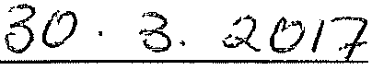
Signed Date:

Endorsement by School Network Lead.er

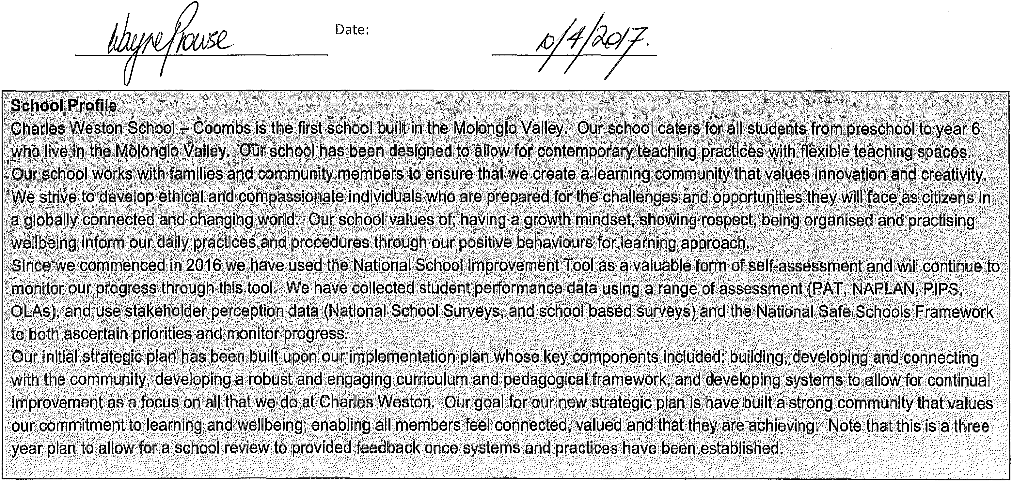
Name: Wayne Prowse Signed

Teaching and learning
Strategic Priority 1: Develop and sustain a collaborative teaching and learning culture with high expectations of success for all students. Student outcomes to be achieved:
- Increased growth in students' performance in literacy and numeracy over time.
- A whole school approach to intervention and enrichment that responds to the learning needs of all students.
- Consistent practices for teaching literacy and numeracy across the school.
- Consistent use of assessment practices that inform teaching and learning.

Targets:
While target setting in a new school with extremely diverse and growing enrolments is particularly problematic, based on current data our targets are aspirational. By the end of 2019 the school will achieve:
- Achieve the ACT education directorate NAPLAN mean score in reading and numeracy.
- Percentage of students demonstrating at or above expected growth (years 3-5) in reading and numeracy.
- Increase the percentage of students making expected or greater than expected growth in PlPs reading from 40% in 2016 to 65% in 2019.
- 75% of students ILP (Individual learning plans) and TIPS (Targeted intervention plans) learning goals achieved (which indicates a balance.between aspiration and practicality in ILPs).
- 85% of parents agree/strongly agree that they are satisfied with their child's education at this school from the 2016 baseline of 84%.
- 90% of teachers agree/strongly agree that Teachers at this school use results from system testing and system processes to inform planning from the 2016 baseline of 88%.

National Quality Standard Area covered by this priority
- QAl Education Program and Practice
- QA2 Children's health and safety

 | 2018 complete creation of |  | Team release weekly | School based curriculum developed on ATLAS
 | inquiry units P-6 on Rubicon |  | dedicated to planning. | and aligned to Australian Curriculum.
Weston School | Atlas. | team | Professional learning for all | Literacy and numeracy units aligned to inquiry
based inquiry | Develop literacy and numeracy | Teaching teams | teachers: concept based | units where applicable.

curriculum. | plans aligned to inquiry units. Explore the use of ABLES to provide curriculum content for tier 3 students. | Student Achievement team | curriculum , teaching EALD students, differentiation. | ABLES curriculum review completed.  The proportion of staff who rate the school as high or outstanding on the NSIT domain 6 exceeds 80% systematic curriculum delivery.
Embed effective pedagogical practices. | 2017 develop consistent practices for teaching reading and number·  2018 develop consistent practices for teaching writing and maths strands  2017- 2019 coaching/mentoring for all staff aligned to standards and differentiated.  '·- | Leadership team School improvement team | Professional learning - reading  PANL program in 2017 Coaching &/or mentoring professional learning for teachers.  Professional learning - EALD | The proportion of within school matched students achieving expected growth in NAPLAN. The proportion of students who achieve expected growth and above in PlPs reading and numeracy based over a three year average.  The proportion of staff who rate the school as high or outstanding on the NSIT domain 4 expert teaching team and domain 8 effective pedagogical practices.
Develop a | 2017 professional learning to | Leadership team | SAS (trail school in
culture of | increase teacher's data analysis | School improvement | 2017-2018) | SAS used by all staff for data collection and
analysis and | skills. | team |  | analysis.
discussion of | 2018 fully use the of data | SAS implementation |  | Data discussions are held on a regular basis
data to inform | collection component of using | team |  | during planning sessions and whole school staff
teaching and | the Schools Administration |  |  | meetings.
learning. | System. |  |  | Proportion of teachers who agree/strongly
 |  |  |  | agree that teachers at this school use results
 |  |  |  | from system testing and system processes to
 |  |  |  | inform planning.
 |  |  |  | The proportion of staff who rate the school as
 |  |  |  | high or outstanding on the NSIT domain 1 an
 |  |  |  | explicit improvement agenda and domain 2
 |  |  |  | analysis and discussion of data.

Differentiate | 2017 Professional learning
teaching and | focussing on meeting the needs |  |  | The proportion of staff who rate the school as
learning to | of EALD learners. |  |  | high or outstanding on the NSIT domain 7
meet the | 2017 Student Achievement |  |  | differentiated teaching and learning.
needs of all | team identification of tier 2 and |  |  | Evidence in planning documentation that
students. | 3 students. |  |  | differentiation has occurred (core, enabling and
 | 2018 Professional learning on |  |  | extending prompts)
 | pedagogy that supports
 | planning for differentiation
 | (core, enabling and extending)
 | 2017 - 2019 Use of student data
 | to ensure targeted
 | differentiation.

School Culture
Strategic Priority 2: Create and foster a positive and welcoming school culture

Student outcomes to be achieved:
- All members of the school community understand our school GROW expectations
- All students and staff consistently demonstrate our school GROW expectations
- All students and staff have opportunities to develop their skills, interests and talents
- All members of the school community feel connected and engaged

Targets:
While target setting in a new school with extremely diverse and growing enrolments is particularly problematic, based on current data our targets are aspirational. By the end of 2019 the school will achieve;·...
- All components of Kidsmatter have been completed and visibly actioned in all classes evidenced by staff survey and learning walks.
- 96% of students agree/strongly agree that my school gives me opportunities to do interesting things from the 2016 baseline of 96%.
- 95% of students agree/strongly agree that/ feel safe at my school.from the 2016 baseline of 91%.
- 85% of parents agree/strongly agree that community partnerships are valued and maintained from the 2016 baseline of 80%.
- 90% of parents agree/strongly agree that This school takes parents' opinions seriously.from the 2016 baseline of 85%.

National Quality Standard Area covered by this priority

- QA 5 Relationships with children
- QA 6 Collaborative partnerships with families and communities
Embed Positive Behaviours for
Learning.
2017 Launch PBL PBL team
2018 Fully implement All staff classroom components
2019 complete all elements
of the PBL action plan
PBL budget
Professional learning for all staff
Professional learning for PBL
internal coaches.
PBL successfully launched
All measures on PBL SAS completed PBL action plan items completed
The proportion of staff who rate the school as high or outstanding on the NSIT domain 3 a

 |  |  |  | culture that promotes learning.
Embed Kidsmatter at  cwsc | 2017 complete  components 2  2018 complete  components 3  2019 complete component  4. | Leadership team Student achievement team  Kidsmatter team School improvement team  School Psychologist | Kidsmatter Professional Learning provided by the Kidsmatter team  P&C to provide opportunities for parent information sessions.  School Psychologist and NSET to provide support for students during component 4. | Kidsmatter components completed.  The proportion of staff who rate the school as high or outstanding on the NSIT domain 3 a culture that promotes learning and domain 9 school - community partnerships.  Proportion of students who agree/strongly agree that I feel safe at my school.  Proportion of students who agree/strongly agree that I like being at school.
Facilitate | 2017 Embed Passions and | Leadership team | Professional development | Proportion of students who agree/strongly agree that my school gives me opportunities to do interesting things.  Number of teachers participating in passions projects/action research.  Number of parents and community members who participate in activities at school.  Completed and published schedule of  - enrichment opportunities.  The proportion of staff and parents who rate the school as high or outstanding on the NSIT domain 7 Differentiated teaching and learning and domain 9 School-community partnerships.
enrichment | pursuits program. | School improvement | fund.
opportunities for | 2018 Schedule enrichment | team
students, staff | opportunities a | All teachers | Allocated time for Passions
and the in-school | for students across the |  | and Pursuits, competitions and
community and | year. |  | extracurricular opportunities,
broader Molonglo | 2017-2019 Engage staff in
community. | self selected passions
 | projects/action research.
 | 2017 - 2019 Engage parents
 | and community members
 | in supporting students in
 | enrichment activities and
 | inquiry unit expertise.
 | 2017 - 2019 School
 | Parliament operational and
 | increasing involvement in
 | school decision making.
Develop and use | Continue to develop the | Leadership team | Seesaw as a reporting and | The proportion of staff and parents who rate

communication | use of Seesaw as an | ICTteam | engagement tool. | the school as high or outstanding on the NSIT
structures to | engagement and reporting | School Parliament |  | domain 4 expert teaching team and domain 9
connect parents | tool. | All teachers |  | school-community partnerships.
and the | Expand the use of video |  |  | Proportion of parents who agree/strongly agree
community to the | sharing to support parents |  |  | that community partnerships are valued and
school and ensure | understanding of school |  |  | maintained.
effective | practices via our website. |  |  | Proportion of parents who agree/strongly agree
reporting |  |  |  | that the school takes parents' opinions
mechanisms. |  |  |  | seriously.

