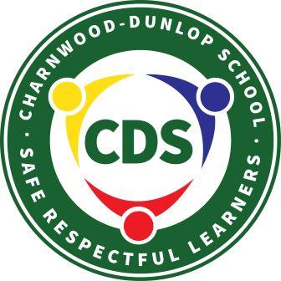
CHARNWOOD-DUNLOP SCHOOL

Annual Action Plan Report 2017

Context
In 2017 our focus for Strategic Priority 1: Improve student outcomes in literacy and numeracy through embedding a culture of data analysis and building teacher expertise was to continue our successful journey of improving reading outcomes across the school and begin a whole school approach to improving writing outcomes through consistent pedagogy and reciprocal teacher feedback. Coaching was another focus across the school and this year we have started the process of working towards a whole school coaching model. Our preschool also underwent the National Quality Standard (NQS)assessment and rating process. We were very pleased to receive a rating of exceeding overall with five of the seven domains receiving an ‘Exceeding National Quality Standard’ rating and the remaining two areas receiving a ‘Meeting National Quality Standard’ rating.
Our focus for Strategic Priority 2: Develop a culture that promotes learning for all through Positive Behaviours for Learning was on embedding and continuing the whole school approach to Positive Behaviours for Learning (PBL) that was launched successfully in 2016.

Methodology
We took a collaborative whole school approach to achieving the targets in our Annual Action Plan in 2017. Based on our plan we created three strategic teams: Curriculum and Assessment; Positive Behaviours for Learning (PBL); Preschool NQS. These teams were led by members of the executive team and met regularly during the year at nominated staff meeting times. Progress from the strategic teams was reported by the team leaders and collated by the principal into the 2017 AAP report. Teachers are also part of year level Professional Learning Teams (PLT). These teams meet weekly during teacher release time to analyse student academic and behaviour data entered into online trackers. Based on this data and the Australian Curriculum the PLT teams collaboratively plan learning experiences for students. The data used to evaluate our achievements and prepare the progress for this report comes from a variety of sources including academic and behaviour data taken from our school online trackers; NAPLAN and PIPS data; School Satisfaction Survey and School Climate Survey data; reflections from staff based on the National School Improvement Tool; suspension data and SET data used to evaluate the progress of PBL.

Evaluation of Performance

Priority 1
Improve student outcomes in literacy and numeracy through embedding a culture of data analysis and building teacher expertise

Targets
- Proportion of within matched students who make expected or better than expected growth in NAPLAN tests in Year 5 improves by 5% points annually
- Proportion of students in the top two bands of NAPLAN reading and maths (Years 3 and 5) increases by 2% points annually
- Proportion of students in the bottom two bands of NAPLAN reading and maths (Year 3 and 5) decreases by 2% points annually
- The proportion of students who achieve expected growth or better in PIPS Reading and Numeracy increases by 2% points as an average over the last 5 years
- Proportion of students who reach reading benchmarks in PM reading (K-2) and PROBE (3-6) improves by 5 % points annually
- Proportion of students who improve by 1 stanine or better annually in PAT Maths (Years 3-6)
- Proportion of staff, students and parents who agree that students are getting a good education at CDS improves by 2% points annually in the school satisfaction survey

Progress
The following table shows the growth for our school as compared to other schools in Belconnen and the ACT over the past four years on the left and the growth of the current Year 5 students at our school from Year 3 to Year 5 on the right.
Table 1: NAPLAN growth charts
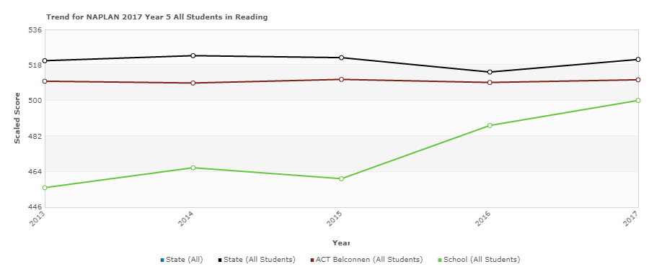 | 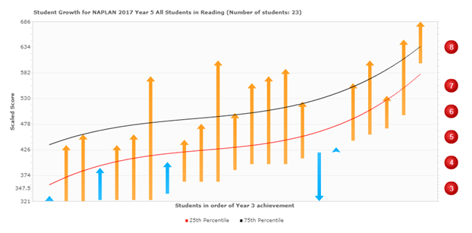
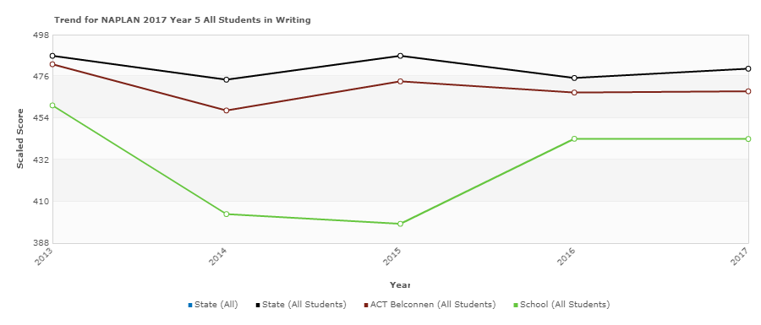 | 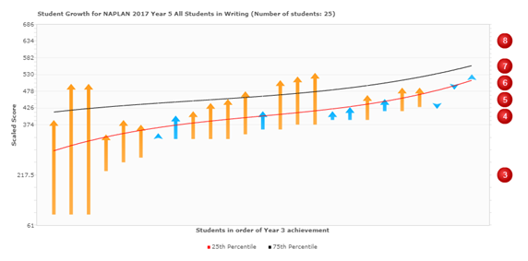
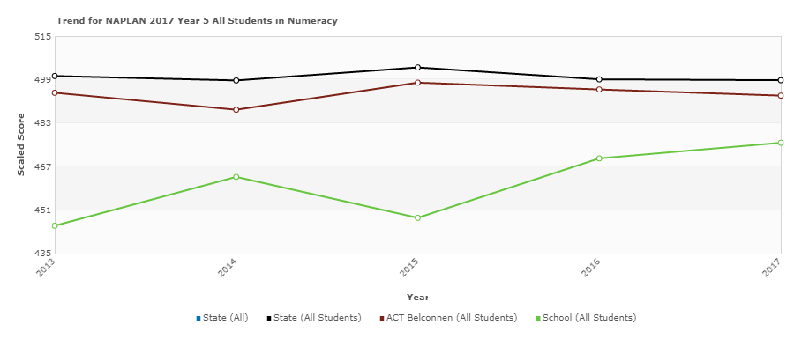 | 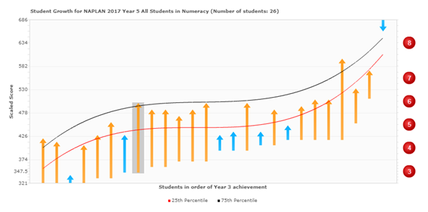
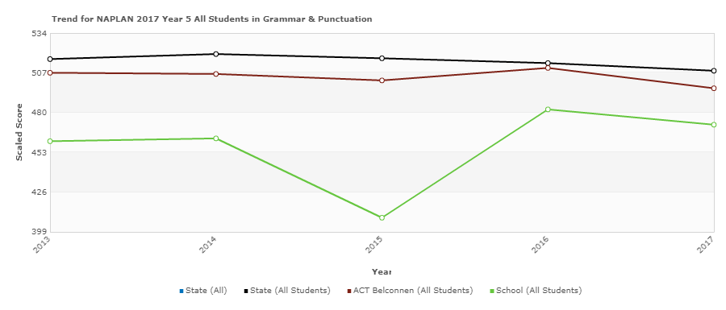 | 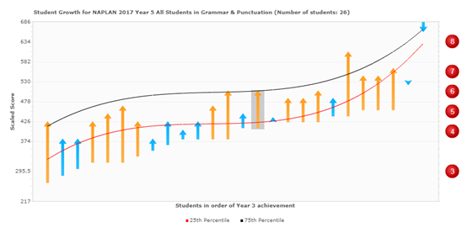
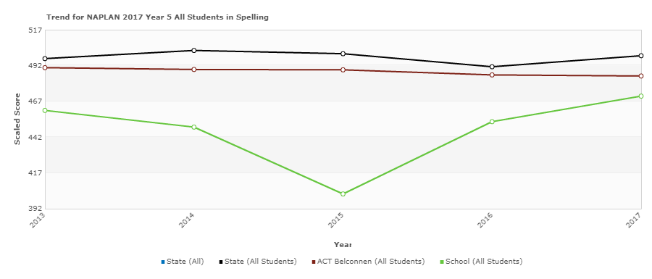 | 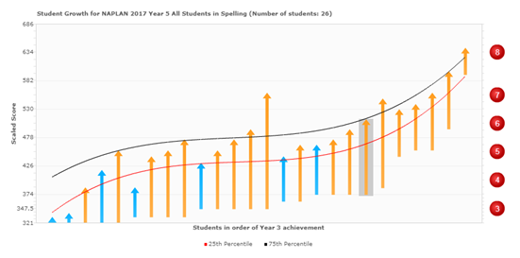

NAPLAN results for 2017 demonstrate strong growth for our current Year 5 students from Year 3 to Year 5 in reading, numeracy and spelling. The reading growth data is particularly strong. Growth in grammar and punctuation is slightly lower than in 2016 but still higher than the three years previous to this. Writing growth remains consistent with 2016.
Satisfaction survey data and school climate data was analysed using a disciplined dialogue approach by the executive team. The disciplined dialogue approach involves looking for trends in the data and asking the three questions: What do we see in the data?; Why are we seeing this?; What if anything should we do about it?
We used the measure of the proportion of staff, students and parents who agree that students are getting a good education at this school as an indicator of success. The proportion of staff and parents who agreed that students were getting a good education at our school increased by 5 points but decreased by 3 points for students. The responses for staff, students and parents were all above the agreement for P-6 schools types.
Table 2: Satisfaction Survey data
Overall I am satisfied I/my child/students at this school are getting a good education
 | Our school (CDS) | P-6 Schools
Students | 88.64 | 83.78
Parents | 92.86 | 87.26
Staff | 100.00 | 95.18
Parents, staff and students all rated above the mean for like P-6 schools for the perception that students were receiving a good education at Charnwood-Dunlop School. However, the student proportion decreased from last year.
Through a disciplined dialogue analysis the executive team found the following trends in the school satisfaction survey data and the school climate data. Generally staff and parent satisfaction increased in 2017 and was at or above the ACT in most areas. The student satisfaction data decreased in 2017 and was at times below the ACT mean.
The following tables show data taken from the School Climate Survey to demonstrate this in more detail:
Table 3: Parent school climate survey data:
Parent Outcomes
 | Strengths  % Excellent | Weaknesses  % Needs Improvement
School and family connections | 83% | 4%
Parent involvement at home | 80% | Less than 1%
Parent involvement at school | 31% | 3%
In the area of ‘parent outcomes’ the largest proportion of parents rated school and family connections as excellent, whereas parent involvement at school was perceived as needs improvement.
Table 4: Parent school climate survey data
Parent School Social Environment
 | Strengths  % Excellent | Weaknesses  % Needs Improvement
Shared values and approach | 90% | Less than 1%
School identification | 88% | 4%
Academic emphasis | 83% | 3%
Relations | 80% | Less than 1%
In the area of ‘school social environment’ the largest proportion of parents rated shared values and approach as excellent, whereas school identification was perceived as needing improvement.

Table 5: Student climate survey data
Student engagement and support
 | Strengths  % Excellent | Weaknesses  % Needs Improvement
Behavioural engagement | 84% | 2%
Perceived support and safety | 51% | 10%
Emotional engagement | 39% | 8%
In the area of ‘student engagement and support’ the largest proportion of students rated behavioural engagement as excellent, whereas emotional engagement was perceived as needs improvement.
Table 6: Student climate survey data
Student school social environment
 | Strengths  % Excellent | Weaknesses  % Needs Improvement
Academic emphasis | 59% | 2%
Shared values and approach | 55% | 2%
School identification | 51% | 2%
Staff and student relations | 45% | 2%
Student relations | 14% | 16%
In the area of ‘student school social environment’ the largest proportion of students rated academic emphasis as excellent, whereas student relations was perceived as ‘needs improvement’.
Table 7: Student climate survey data
Student Challenging Behaviours
 | Strengths  % Excellent | Weaknesses  % Needs Improvement
General aggression | 65% | 10%
Classroom disruption | 57% | 14%
Victimisation | 49% | 35%
In the area of ‘student challenging behaviours’ the largest proportion of students rated general aggression as excellent, whereas victimisation was perceived as needs improvement.

Table 8: Staff climate survey data
Staff outcomes
 | Strengths  % Excellent | Weaknesses  % Needs Improvement
Organisational commitment | 71% | Less than 1%
Stress | 19% | 3%
In the area of staff outcomes the largest proportion of staff rated organisational commitment as excellent, whereas stress was perceived as needs improvement.
Table 9: Staff climate survey data
Staff work environment
 | Strengths  % Excellent | Weaknesses  % Needs Improvement
Team morale | 87% | Less than 1%
Leadership | 84% | Less than 1%
Professional Development | 77% | Less than 1%
In the area of work environment the largest proportion of staff rated team morale as excellent.
Table 10: Staff climate survey data
Staff social environment
 | Strengths  % Excellent | Weaknesses  % Needs Improvement
Staff and student relations | 94% | Less than 1%
School identification | 90% | Less than 1%
Academic emphasis | 90% | Less than 1%
Shared values and approach | 84% | Less than 1%
Work-group identification | 74% | Less than 1%
Staff relations | 74% | 3%
In the area of staff social environment the largest proportion of staff rated staff and student relations as excellent, whereas work-group identification was perceived as needs improvement.

Table 11: School satisfaction survey data 2017
The orange shading indicates we are lower than other like schools and the green shading indicates we are higher than other like schools. The unshaded boxes mean we are similar to other like schools.
 | Student data |  | Parent data |  | Staff data
 | CDS % agreed | Other like schools | CDS % agreed | Other like schools | CDS % agreed | Other like schools
Teachers expect students to do their best | 90.91 | 95.3 | 94.29 | 93.04 | 100 | 98.47
Students receive useful feedback about their work | 75 | 81.43 | 97.10 | 85.84 | 90.32 | 94.64
Students are treated fairly | 65.12 | 71.17 | 92.86 | 88.72 | 96.77 | 96.14
The school is well maintained | 62.5 | 74.22 | 91.3 | 90.52 | 70.97 | 87.71
Students feel safe at school | 71.11 | 77.28 | 91.55 | 91.41 | 100 | 91.71
Student behaviour is well managed | 46.51 | 53.9 | 86.57 | 79.15 | 90.32 | 79.33
Students like being at this school | 73.91 | 76.49 | 92.96 | 92.56 | 96.67 | 95.53
The school looks for ways to improve | 86.36 | 85.94 | 97.02 | 89.08 | 100 | 95.14
Teachers motivate students to learn | 89.13 | 85.41 | 95.71 | 88.2 | 100 | 97.35
Learning technologies are integral to this school | 100.00 | 91.75 | 90.77 | 84.3 | 96.67 | 87.18
Students are getting a good education at this school | 88.64 | 83.78 | 92.86 | 87.26 | 100 | 95.18
The school has high expectations in all it does | 74.42 | 79.93 | 88.41 | 83.71 | 90.32 | 91.76
This table shows clearly that students were not as satisfied as parents and staff in all areas. The main areas of concern for students and staff was that the school is not well maintained and that students do not receive useful feedback about their work. The areas of concern for students were in feeling safe, behaviour management and whether they like being at school. The students also rated high school expectations and teacher expectations as lower than students in like schools.
Using the National School Improvement Tool (NSIT) the staff annually measure the school’s improvement across nine domains. We work in groups at staff meetings at the beginning and end of the year to track where we believe we are achieving in each of the nine domains. Based on this assessment, areas of improvement are selected as the focus each year. Staff are asked to note evidence of where we are achieving and what steps to take next. In 2017 there were a number of areas selected under the two strategic priorities. These became key improvement strategies. The following outlines the progress made under each of the key improvement strategies.
Strategic Priority 1: Improve student outcomes in literacy and numeracy through embedding a culture of data analysis and building teacher expertise.
Key improvement strategy 1: Implement effective pedagogical practices
Key improvement strategy 3: Embed a culture of data analysis and discussion to inform teaching
- Preschool staff actively record observational data to track student progress
- Review and adjust preschool planning and assessment documentation in line with NQS best practice
- Improve use of observational documentation to inform preschool teaching and learning programs
- Improve the way teachers use formative assessment including common formative assessment in classrooms
- Create an essential learning assessment tracker with power standards for maths with input from all teachers
- Staff actively use the essential power standards tracker to record and plan at student point of need
- Use data more effectively in PLT meetings including the documentation of PLT minutes
- IEC actively use the language progressions to track student growth
- LSU staff actively track student growth on an individual data tracker based on ILP goals
- Improve feedback for teachers through coaching and mentoring
- Provide PL, readings and research for all staff and particularly new staff to CDS on reading, writing and maths workshops, visible learning and using formative assessment, using data more effectively for teachers, including staff discussions on understanding power standards
- Survey all staff in term 1 and 4 through an expertise survey with questions related to teaching workshops, visible learning and formative assessment, data use and analysis

Teaching teams developed common assessment essential power standards and common assessment rubrics in mathematics for each year level. These were used to support moderated marking, and tracking using the colour-coded assessment trackers on the school intranet. The colours assisted in identifying whether students were on-track, above or below the achievement standards.
Teams used the data assessment tracker to enter data (pre, mid and post) throughout the year and regularly reviewed data and made plans for intervention and extension where necessary (ABC cafe, Booster groups, LSA support).
Introductory English Centre (IEC) staff actively used the Language Progressions to track student growth.
In term 2 a data tracker was created to track data more accurately for the Learning Support Unit (LSU) students from: AUSVELS, Letter/sound ID, PM level, SENA. Data has been entered (pre, mid, post) and tracked to demonstrate growth. In term 4 a new report format was created which tracks student growth across each term. This final template will be used as a growth tracker throughout the year in 2018 and beyond.
The curriculum strategic team led the school in developing school wide consistent marking rubrics for writing. The rubrics are still being trialed and improved. However each team used a common writing assessment rubric to moderate writing samples based on the achievement standards in the Australian Curriculum to inform reporting at the end of the year.
Charnwood-Dunlop Preschool underwent the National Quality Standard assessment and rating process in 2017. The preschool received an ‘Exceeding National Quality Standard’ rating overall. This was an excellent result as we received an overall rating of ‘working towards the standard’ in 2014 after our last assessment and rating process.
The preschool team worked with the Early Childhood Education section of the Directorate to improve their practice using an action research model. The preschool philosophy was reviewed to ensure the beliefs and practices of the team were aligned, and in doing so, underpin all pedagogical and organisational decisions. Reflection on past practice indicated the need to record individualised, regular recordings of children’s learning that would then be critically analysed and used to inform teaching and learning programs. Readings were provided to the team on the importance of using critical observation, recording and analysis and a consistent format for recording was implemented by all preschool educators.
Key Improvement Strategy 2: Develop an expert teaching team
- Improve induction processes through continuous mentoring
- Teacher development plans (PDPs) linked to Strategic priority 1 & 2 in the AAP & professional standards with links to PL, coaching and a coaching action plan
- Joint analysis of student work and teaching strategies documented through PLT meetings
- Improve feedback through coaching partnerships and leadership initiatives using Coaching Action plans and training in coaching
- Provide readings and PL on indoor/outdoor play in the preschool, including PL on STEM
A coaching model was developed and implemented throughout 2017, which began with learning walks in term 2 and peer feedback terms 3 and 4. In term 4, staff were asked to submit an expression of interest for a more formal coaching model in 2018. A coaching model and handbook is currently being developed for implementation in 2018.
In 2017 mentors met regularly with mentees and also engaged in shoulder-to-shoulder team teaching. A group of teachers and executive staff attended TQI training on mentoring. A TQI representative also worked with the executive team to provide guidance for improving procedures in 2018.
All teachers attended professional learning in January on improving writing as part of the Belconnen cluster. The school participated in a cluster project to improve writing outcomes across the school, culminating in a writing fair at the end of term 3. Whole school PL and implementation of writing workshops with the use of visible learning in the form of bump-it-up walls in all classrooms was a focus for 2017. As indicated earlier, writing outcomes have improved and this will continue to be a focus in 2018.
Teachers trialed the new ACT Directorate Professional Development Plans (PDP) in 2017. PDP priorities were linked to the two school strategic priorities with a third priority chosen by the teachers. Greater clarity on how this is linked to the Annual Action Plan, professional standards with links to professional learning, coaching and the coaching action plan is required and will be a priority in 2018.
The joint analysis of student work was a key component of PLT meetings. Analysis of student work was aided by commonly developed standards and assessment rubrics. The assessment tracker also made it easier to track growth. The 1/2 team used size effect data to analyse student growth in reading. This information was very powerful in demonstrating growth and will be a school-wide focus in 2018.
A literacy intervention team was formed in term 3 to improve the way students are identified and supported for intervention. The team established improved communication systems with teachers and the literacy intervention team and training commenced for the Learning Support Assistants (LSA) to improve the way they support students in the classroom and in small group intervention. The team are preparing a plan to present to staff early in 2018, which will include a suite of assessments, strategies and resources as well as a communication guide.
The decision was made in 2017 to introduce an indoor-outdoor program in the preschool. This was in response to element 3.2.1 of the National Quality Standard: Outdoor and indoor spaces are designed and organised to engage every child in quality experiences in both built and natural environments.
Readings were provided to all preschool educators, including assistants, on the importance of indoor- outdoor programs in providing a sense of agency for children. This involved educators taking a step back and critically reflecting on the need of educators to decide for children. Educators now consider ways of setting up environments, routines and learning experiences to support children to have agency independently of adults.
It was noted in the Assessment and Rating Report that:
Both indoor and outdoor environments were organised in ways that supported diverse interests, preferences and learning styles. Flexible arrangements of furniture and equipment along with open-ended materials encouraged the children to become flexible thinkers and investigators. The arrangement of furniture and equipment also defined clear pathways and children's play was uninterrupted by adults and children walking in the space. Learning environments were set up in ways that supported children to work in small groups or alone and independently without the assistance of an adult.
Key Improvement Strategy 4: Systematic curriculum delivery
- Devise a scope and sequence for integrated Units k-6 with consistent planning documents highlighting AC, EYLF, SA New Arrivals program
- Ensuring that skills and knowledge based on the EYLF and preschool observations of learning form the basis of planning and documentation
- Design a scope and sequence for writing, phonics, phonemic awareness and spelling P-6
- Improve communication of the curriculum taught at CDS to parents and the community via a template
A draft scope and sequence for HASS Integrated Units K-6 was developed by the curriculum and assessment team with hyperlinks to previous units of work. This will be trialed and reviewed in 2018. The curriculum team moderated writing expectations across year levels to ensure continuity and progression from year to year. Rubrics were implemented across the school and individual student progress tracked. A greater emphasis on inquiry learning will be a focus for 2018. Expressions of Interest were asked for teachers interested in coaching inquiry learning in 2018.
The scope and sequence for writing, phonics, phonemic awareness and spelling P-6 has not started but will be part of the focus of the literacy and literacy intervention teams in 2018.
Reflection through the action research process in the preschool identified the need for planning and documentation to be more child centred, viewing children as active participants in meaningful research rather than providing a range of learning experiences centred on a developmental viewpoint or theme based.
Strategic team sessions focused on challenging teachers beliefs on their image of the child and examining the Early Years Learning Framework (EYLF), particularly the elements of principles and practice. A deeper understanding of the planning cycle, aligned with the preschool’s philosophy and the EYLF was gained, using the following questions:
- How could I respond to enrich children's research?
- How many perspectives can I look at this from?
- How can I deepen the learning and sustain the research?

It was noted in the Assessment and Rating Report that:
The team planned opportunities for intentional teaching and knowledge building through worthwhile experiences and interactions that fostered high level thinking skills. For example, the team intentionally taught children about being safe and respectful learners as part of the Positive Behaviours for Learning program which is run across the entire primary school. The team recognised that learning occurs in social contexts and supported this by planning large and small group experiences where children could exchange ideas, share their knowledge and learn from others. For example, a group of children sat down and discussed where pottery came from, what clay was and where clay could be found. The team made use of spontaneous 'teachable moments' to extend children's learning.
It was recommended by the assessor the team continue to consider all elements of the EYLF, including practice and principles, in the analysis of learning and the planning of the curriculum.

Key Improvement Strategy 5: Targeted use of school resources
- Improve communication with families through email, updated website and information sessions
- Youth Support Worker parent sessions and hang-outs

Email was introduced as a primary means of communication with families in 2017. The fortnightly newsletter, permission notes and other information were distributed via email, with hard copies provided to those with no email access.
Two staff attended training on using and updating the school website. The school website now has current notes uploaded and money could be paid through direct deposit via a link.
Regular information sessions were held for families and included:
- Tuning into Kids in conjunction with West Belconnen Child and Family Centre (WBCFC)
- Reading with your child
- What happens in the reading café?
- Parent and student hang-outs
- Youth Support Workers drop-in sessions after school
- Information sessions for prospective preschool and kindergarten families
- Information sessions for new preschool and kindergarten families

Strategic Priority 2: Develop a culture that promotes learning for all through Positive Behaviours for Learning

Key Improvement Strategy 1: A culture that promotes learning
- Improved PBL lesson curriculum where all teachers deliver accountability through the School Assessment Tool and the SET tool
- Ongoing communication and visual evidence through a staff communication board
- An active PBL team that reflects school teams and meets regularly
- Data tracker and regular PLT talks at staff meetings, school assemblies and regular newsletter items
- Induction plan and ongoing staff training
- Introducing PBL behaviour expectations and language in the preschool

A behaviour data tracker was established which allowed incidents to be recorded and trends identified. This in turn led to a proactive focus on teaching and re-teaching positive behaviours and increased levels of supervision in the play ground in areas and at times where it was required. Communication with staff about PBL improved with weekly emails, a display board in the staff room, regular check-ins and professional discussions at staff and team meetings, including up-skilling staff in the use of the tracker and Epraise points. Class teachers recorded PBL lessons in class reflection books which had a differentiated focus on the behaviour needs in the classroom and across the school rather than a more directive curriculum. Staff were also trained in coaching and classroom setting systems. Communication and participation of students and families improved with regular newsletter items, regular distribution of award certificates and incentive prizes and a fortnightly assembly PBL focus.

The results of continued PBL implementation include a significant decrease in the rate of suspensions and over the year a decreased rate of referrals to the burrow for focused behaviour intervention and increased levels of Epraise points awarded. Parent and staff climate data and school satisfaction data also demonstrated a positive increase in students feeling safe at school and behaviour being well managed. The school participated in an external measure ‘SET’ which was administered by the ACTED PBL team. SET measures school integrity of the implementation of PBL as a whole school approach. CDS school results at 99.7% reflected strong whole school agreement, knowledge and implementation of PBL.

Table 12: Suspension Data
Charnwood-Dunlop School | No. of suspensions |  |  | No. of students suspended |  |  | No. of days of suspension
 | 2015 | 2016 | 2017 | 2015 | 2016 | 2017 | 2015 | 2016 | 2017
 | 42 | 73 | 18 | 15 | 30 | 12 | 62 | 62 | 20

Table 13: Satisfaction survey data
 | Student data |  | Parent data |  | Staff data
 | CDS % agreed | Other like schools | CDS % agreed | Other like schools | CDS % agreed | Other like schools
Students feel safe at school | 71.11 | 77.28 | 91.55 | 91.41 | 100 | 91.71
Student behaviour is well managed | 46.51 | 53.9 | 86.57 | 79.15 | 90.32 | 79.33
The data in this table demonstrates that parents and staff perceive that students feel safe at the school and that student behaviour is well managed. The students however ranked these below other like schools.

Table 14: School climate survey data
Student Challenging Behaviours
 | Strengths  % Excellent | Weaknesses  % Needs Improvement
General aggression | 65% | 10%
Classroom disruption | 57% | 14%
Victimisation | 49% | 35%
In the school climate survey student challenging behaviours were explored in more depth. ‘Victimisation’ was considered an area for improvement by the students. It is possible that with the introduction of explicit PBL curriculum that students have become more aware of challenging behaviours in the school and even identify these in themselves, which would explain the rise in concern about these challenging behaviours.

The introduction of the ‘burrow’ as a sensory space and two Youth Support Workers in the school has made a significant difference in managing challenging behaviours, emotional regulation and re-engaging students in learning. The Youth Support Workers have built strong relationships with students and are better able to monitor, predict and manage behaviour allowing re-engagement to be more timely and successful. Communication between the burrow and classroom teachers is improving with the introduction of behaviour slips and safe passes. Teachers are also encouraged to record low level behaviours in the tracker, whether they occur on the playground or in the classroom.

Positive Behaviours for Learning behaviour expectations and language was introduced to the preschool program, to varying degrees across the classes.

All classes used the language of safe, respectful learners and class teachers and educators made the pedagogical shift to understanding behaviours need to be taught, rather than using punitive measures to create change.

Children use the appropriate terminology and many can verbalise what it means to be a safe, respectful learner. A behaviour matrix of expectations for preschool has been drafted and posters are in the early production phase to be introduced in 2018.

It was noted in the Assessment and Rating Report that:

The team planned opportunities for intentional teaching and knowledge building through worthwhile experiences and interactions that fostered high level thinking skills. For example, the team intentionally taught children about being safe and respectful learners as part of the Positive Behaviours for Learning program which is run across the entire primary school

Key Improvement Strategy 2: Differentiate teaching and learning to meet needs of all
- Plan a process and timeline for ILPs and PLPs to be written and reviewed
- PL on differentiated learning
- Develop common formative assessments collaboratively in teams to continuously identify student needs
- Planning documents and workshop teaching demonstrates differentiated learning
- Promote peer social interactions with preschool children who have additional needs
- Case management in teams provides a collaborative approach to problem solving how to meet differing student needs
- Intervention such as Reading café and Learning Support Groups (LSG) is evident and tracked to show progress
- Enrichment programs such as Magellan, Wakakirri and after school clubs are offered for students

A consistent school process and timeline for the writing and reviewing of ILPs and PLPs has been created in 2017, with a view to trialling and reviewing this in 2018.

Whole school feedback was sought on ACTED Aboriginal and Torres Strait Islander Cultural Integrity continuum. Staff identified a need for training in writing a PLP which will also be a focus for 2018.
In term 4, the ATSI team strategised how PLP processes could be refined in 2018. The team will lead whole school PL in writing PLP’s and engaging the whole school community in personalised goal setting. The principal attended three days of professional learning on Cultural Integrity during term 3 and 4. This will be a focus for January PL and continue throughout 2018.
Several teachers in the curriculum and assessment strategic team attended professional learning on reporting on, implementing and differentiating the Australian Curriculum. They presented their learning to a whole staff meeting, which resulted in improvements in planning and reporting based on the Australian Curriculum.

The Literacy Intervention PLT team was introduced in 2017. Interventions such as Reading Cafe & LSG groups have been very successful and data has been tracked to show progress. Data is very encouraging and demonstrates success.

The design and implementation of common formative assessments has been reported on in key strategic priority 1. Case management has been implemented in PLT teams with a review of the recording process and expectations early in 2018. Case management informs referrals to the special needs (Student Wellbeing) team which includes the School Psychologist in term 3 and 4. Previously we were not allocated a school psychologist in 2017.
With input from the Support at Preschool team teachers planned purposeful opportunities to support children who have difficulty entering play and maintaining friendships, particularly those who have limited expressive language. Children were explicitly taught language to enable them to successfully enter play and use language and skills to engage in social tasks.
It was noted in the Assessment and Rating Report that:
The team recognised that learning occurs in social contexts and supported this by planning large and small group experiences where children could exchange ideas, share their knowledge and learn from others.

Key Improvement Strategy 2: Targeted use of resources
- Chromebooks continue to be purchased and maintained from Year 3-6 to enable Google classroom program for all senior school
- Promote improved use of technology in the preschool
- Sensory spaces such as the burrow and LSU are carefully planned and implemented

Technology resourcing is a priority in the budget with reserves set aside for continual upgrading of chromebooks. Students also pay a contribution to Reading Eggs and Mathletics in their book packs to ensure continued application of these online resources.
Promoting improved use of technology in the preschool is an ongoing improvement strategy. Technology resourcing has been improved, with VGA cables purchased and used to connect iPads to the Interactive White Boards in the preschool. Further professional development for teachers needs to be prioritised in 2018 to ensure all educators effectively use technology in their teaching and learning programs to cater for the ‘digital native’ generation.
Sensory spaces have been established in the burrow and in the rooms alongside the year 1/2 classrooms. A sensory program commenced during 2017, involving all the students in the LSU and other students identified with poor muscle tone of over activity. The program runs three mornings a week and the improvements are already evident. Parents, students and teachers are noticing improved muscle strength and concentration for students involved in the program.

