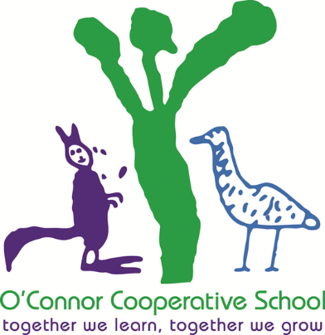

O'Connor Cooperative School

Annual School Board Report

2018

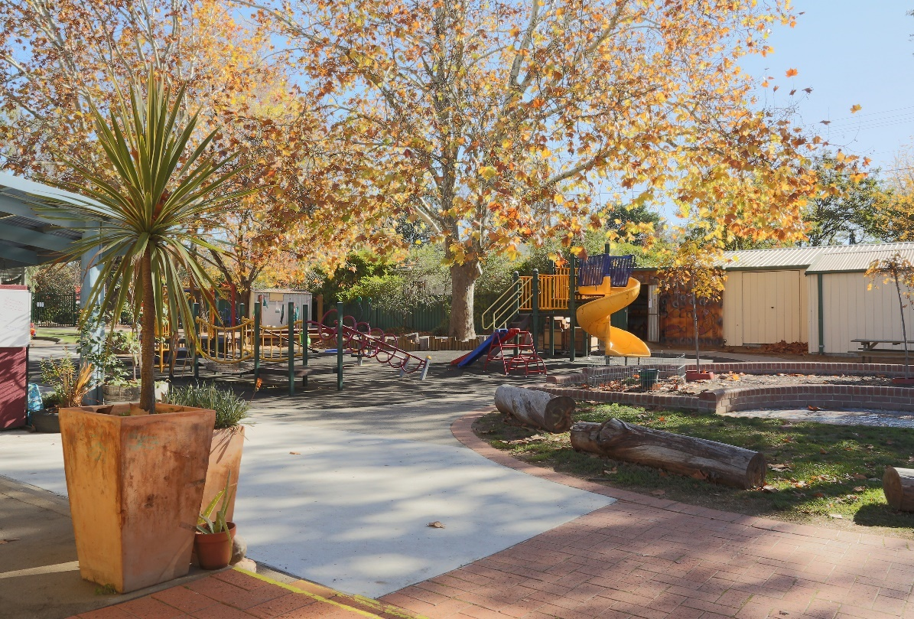

This page is intentionally left blank.



This report supports the work being done in the ACT Education Directorate, as outlined in *Strategic Plan 2018-21: A Leading Learning Organisation*.

Accessibility

The ACT Government is committed to making its information services, events and venues accessible to as many people as possible.

If you have difficulty reading a standard document and would like to receive this publication in an alternate format, such as large print and audio, please telephone (02) 6247 4580.

If English is not your first language and you require the translating and interpreting service, please telephone 13 14 50.

If you are deaf or hearing impaired and require the National Relay Service, please telephone 13 36 77.

© Australian Capital Territory, Canberra, 2018

Material in this publication may be reproduced provided due acknowledgement is made.

Contents

Reporting to the community 1

Summary of School Board activity 1

School Context 1

Student Information 1

Student enrolment 1

Student attendance 2

Supporting attendance and managing non-attendance 2

Staff Information 2

Teacher qualifications 2

Workforce composition 2

School Review and Development 3

School Satisfaction 3

Overall Satisfaction 4

Learning and Assessment 5

Performance in Literacy and Numeracy 5

Early years assessment 5

Financial Summary 6

Voluntary Contributions 7

Reserves 7

Endorsement Page 8

Members of the School Board 8

# Reporting to the community

School report to communities in range of ways, including through:

* Annual School Board Reports
* a (5-year) School Improvement Plan (formerly School Strategic Plan)
* annual Impact Reports/ Annual Action Plan Reports
* newsletters
* other sources such as My School.

# Summary of School Board activity

Throughout 2018 the Board have continued to oversee the strategic direction of the school, including review of school policies and the expenditure of the school budget. The Board worked collaboratively with the school community through the school executive, staff, parents and carers during 2018 and enjoyed a friendly and supportive relationship. It is pleasing to see the children across our school appropriately engaged in an investigation model of play based learning opportunities, a key component of Early Childhood Learning Pedagogy, linking the Early Years Learning Framework and the Australian Curriculum. The model of engaging and promoting learning has been noted in anecdotal evidence from parents and carers as being one of the major drawcards in children attending and thriving in our school.

The school underwent external review through the Australian Council for Educational Research - National School Improvement Tool during term 3. It was affirming for our community to see the rich list of commendations and affirmations. Some of the many highlights of the year included a highly successful community Fete, renovations to the kindergarten classroom, library, staff room and principal’s office and our whole school interactive concert held in Llewelyn Hall. Providing an opportunity for young children to engage with their families and perform in such a special venue was a truly unique and highly valued experience for all. We thank Dr Susan West and the Music Outreach Engagement Program for their ongoing support.

As you will see later in this report the School Satisfaction Survey data once again showed a pleasing result with high levels of satisfaction by both parents and staff across many areas.

# School Context

As a thriving school community, we acknowledge the Ngunnawal people as the traditional owners and custodians of the land. We acknowledge their elder’s past, present and emerging and welcome Aboriginal and Torres Strait Islander people to our school and community events. We value our connections and continue to build relationships with local Aboriginal people and acknowledge that Ngunnawal people have been sharing their knowledge on this land for thousands of years as we do today.

The O'Connor Cooperative School has a long history of providing innovative, high quality early childhood education to the children and connection for families enrolled at the school. We value a thriving school community where staff and families openly work as willing partners to further the education and development of the whole child; a safe and inclusive setting where strengths and needs of all members of our school community are recognised respected and valued; a family-friendly environment; the professionalism of staff as educational leaders committed to play-based best practice in early learning. In 2018, the school had four classes, one each of Preschool, Kindergarten, Year 1 and Year 2. Our school provides opportunities for children to investigate, research, take risks, ponder, wonder, experiment, experience, engage and express themselves every day.  Through a play-based approach, children are able to engage in a wide variety of high-quality learning experiences, that are supported with explicit teaching, designed to meet each child's individual needs. O'Connor Cooperative School has been a committed AuSSi School since the inception of the program and successfully implements a wide range of sustainable schools’ initiatives.

## Student Information

### Student enrolment

In 2018 there were a total of 60 students enrolled at this school.

Table: 2018 Student enrolment

|  |  |
| --- | --- |
| **Student type** | **Number of students** |
| Male | 32 |
| Female | 28 |
| Aboriginal and Torres Strait Islander | 1 |
| LBOTE* | 11 |

*Language Background Other Than English

Source: Analytics and Evaluation, December 2018

### Student attendance

The following table identifies the attendance rate of students by year level during 2018. Student attendance rate is the percentage of school days attended by students in each year level at the school. Student attendance is measured over two school terms; that is from the first day of the school year for students in term 1 to the last day of term 2.

Table: 2018 Attendance rates in percentages*

|  |  |
| --- | --- |
| **Year level** | **Attendance rate** |
| 1 | 93.0 |
| 2 | 92.0 |

Source: Analytics and Evaluation, December 2018

* Attendance data for 2018 have been derived from a school administration system in the process of implementation. Care should be taken when comparing these data with data from previous years and from other jurisdictions.

## Supporting attendance and managing non-attendance

All ACT public schools put into effect the education participation requirements in the *Education Act 2004* and the responsibilities of schools in relation to compulsory education. The Education Directorate’s *Education Participation (Enrolment and Attendance) Policy* describes its position with regard to supporting attendance and managing non-attendance. A suite of procedures supports the implementation of the policy. Please refer to <https://www.education.act.gov.au/> for further details.

## Staff Information

### Teacher qualifications

All teachers at this school meet the professional requirements for teaching in an ACT public school. The ACT Teacher Quality Institute (TQI) specifies two main types of provision for teachers at different stages of their career, these are detailed below.

* ***Full registration*** is for teachers with experience working in a registered school in Australia or New Zealand who have been assessed as meeting the Proficient level of the Australian Professional Standards for Teachers.
* ***Provisional registration*** is for newly qualified teachers or teachers who do not have recent experience teaching in a school in Australia and New Zealand. Many teachers moving to Australia from another country apply for Provisional registration.

### Workforce composition

Workforce composition for the year of reporting is highlighted in the following table. The data is taken from the school’s verified August staffing report. For reporting purposes it incorporates all school staff including preschools, staff absent for a period of less than four consecutive weeks and staff replacing staff absent for more than four consecutive weeks. It does not include casuals and staff absent for a period of four consecutive weeks or longer.

The Education Directorate is required to report Aboriginal and Torres Strait Islander staff figures. As of June 2018, 101 Aboriginal and Torres Strait Islander staff members were employed across the Directorate.

Table: 2018 Workforce composition numbers

|  |  |
| --- | --- |
| **Staff employment category** | **TOTAL** |
| Teaching Staff: Full Time Equivalent Permanent | 5.60 |
| Teaching Staff: Full Time Equivalent Temporary | 0.00 |
| Non Teaching Staff: Full Time Equivalent | 2.32 |

Source: This data is from the 2018 August census date and is calculated using the parameters provided by the ABS.

# School Review and Development

The ACT Education Directorate’s Strategic Plan 2018-2021 provides the framework and strategic direction for School Improvement Plans (formerly School Strategic Plans). This is supported by the school performance and accountability framework, ‘*People, Practice and Performance: School Improvement in Canberra Public Schools, A Framework for Performance and Accountability’*. This framework has school improvement at its centre, with the National School Improvement Tool (NSIT) as its core feature, providing support to achieve high standards in student learning, innovation and best practice in ACT public schools.

Prior to 2016 all ACT public schools participated in a four-year cycle of school review and development. In the fourth year schools underwent an external validation process. In 2016 this changed to a five-year cycle with an External School Review at the end.

Our school was reviewed in 2018. A copy of the Review Report Summary can be found on our school website.

## School Satisfaction

Schools use a range evidence to gain an understanding of the satisfaction levels of their parents and carers, staff and students. In August/ September of this reporting period ACT schools undertook a survey to gain an understanding of school satisfaction at that time. This information was collected from Staff, parents and students from year 5 and above (with the exception of students in special schools) through an online survey.

## Overall Satisfaction

In 2018, 91% of parents and carers and 100% of staff at this school indicated they were satisfied with the education provided by the school.

Included in the survey were 16 staff, 14 parent, and 12 student items which are described as the national opinion items. These items were approved by the then Standing Council on School Education and Early Childhood (SCSEEC) for use from 2015. The following tables show the percentage of parents and carers and staff who agreed with each of the national opinion items at this school.

A total of 7 staff responded to the survey. Please note that not all responders answered every question.

Table: Proportion of staff in agreement with each national opinion item

|  |  |  |
| --- | --- | --- |
| **National opinion item** | |  | | --- | | Proportion of staff | |
| Teachers at this school expect students to do their best. | 86 |
| Teachers give useful feedback. | 100 |
| Teachers at this school treat students fairly. | 86 |
| This school is well maintained. | 86 |
| Students feel safe at this school. | 86 |
| Students at this school can talk to their teachers about their concerns. | 86 |
| Parents at this school can talk to teachers about their concerns. | 86 |
| Student behaviour is well managed at this school. | 86 |
| Students like being at this school. | 86 |
| This school looks for ways to improve. | 86 |
| This school takes staff opinions seriously. | 86 |
| Teachers at this school motivate students to learn. | 86 |
| Students’ learning needs are being met at this school. | 86 |
| This school works with parents to support students' learning. | 86 |
| Staff get quality feedback on their performance | 71 |
| Staff are well supported at this school. | 86 |

Source: 2018 School Satisfaction Surveys, August/September 2018

*Prior to 2018, the item wording and placement was slightly different.

A total of 46 parents responded to the survey. Please note that not all responders answered every question.

Table: Proportion of parents and carers in agreement with each national opinion item

|  |  |  |
| --- | --- | --- |
| **National opinion item** | |  | | --- | | Proportion of parents and carers | |
| Teachers at this school expect my child to do his or her best. | 96 |
| Teachers give useful feedback. | 83 |
| Teachers at this school treat students fairly. | 98 |
| This school is well maintained. | 100 |
| My child feels safe at this school. | 96 |
| I can talk to my child’s teachers about my concerns. | 96 |
| Student behaviour is well managed at this school. | 85 |
| My child likes being at this school. | 100 |
| This school looks for ways to improve. | 93 |
| This school takes parents’ opinions seriously. | 89 |
| Teachers at this school motivate my child to learn. | 91 |
| My child is making good progress at this school. | 87 |
| My child's learning needs are being met at this school. | 80 |
| This school works with me to support my child's learning. | 91 |

Source: 2018 School Satisfaction Surveys, August/September 2018

*Prior to 2018, the item wording and placement was slightly different.

These results, as well as the continual review of school performance, contributed to the evaluation of our Strategic Plan and the development of Annual Action Plans. The Strategic Plan (or School Improvement Plan) is available on the school website.

# Learning and Assessment

## Performance in Literacy and Numeracy

### Early years assessment

Students in kindergarten undertake an on-entry assessment of their early reading and numeracy skills using the Performance Indicators in Primary Schools (PIPS) program. Student results are reported against five performance bands at the end of semester 1 and 2. Below are the results for this school.

***Table: The O'Connor Co-Operative School PIPS 2018 mean raw scores***

|  |  |  |  |  |
| --- | --- | --- | --- | --- |
| **Agency** | **Reading start** | **Reading end** | **Mathematics start** | **Mathematics end** |
| **School** | 52 | 120 | 41 | 55 |
| **ACT** | 49 | 124 | 39 | 54 |

Source: Analytics and Evaluation

# Financial Summary

The school has provided the Directorate with an end of year financial statement that was approved by the school board. Further details concerning the statement can be obtained by contacting the school. The following summary covers use of funds for operating costs and does not include expenditure in areas such as permanent salaries, buildings and major maintenance.

Table: Financial Summary

|  |  |  |  |
| --- | --- | --- | --- |
| **INCOME** | **January-June** | **July-December** | **January-December** |
| Self-management funds | 92116.28 | 51019.65 | 143135.93 |
| Voluntary contributions | 4411.00 | 440.00 | 4851.00 |
| Contributions & donations | 0.00 | 250.45 | 250.45 |
| Subject contributions | 4590.00 | 450.00 | 5040.00 |
| External income (including community use) | 418.18 | 686.37 | 1104.55 |
| Proceeds from sale of assets | 0.00 | 0.00 | 0.00 |
| Bank Interest | 2828.40 | 1954.59 | 4782.99 |
| **TOTAL INCOME** | 104363.86 | 54801.06 | 159164.92 |
| **EXPENDITURE** |  |  |  |
| Utilities and general overheads | 3513.18 | 5483.21 | 8996.39 |
| Cleaning | 13743.75 | 18693.75 | 32437.50 |
| Security | 790.00 | 0.00 | 790.00 |
| Maintenance | 3633.82 | 10526.84 | 14160.66 |
| Administration | 1082.49 | 185.49 | 1267.98 |
| Staffing | 0.00 | 0.00 | 0.00 |
| Communication | 3826.24 | 0.00 | 3826.24 |
| Assets | 918.64 | 2258.81 | 3177.45 |
| Leases | 0.00 | 0.00 | 0.00 |
| General office expenditure | 8480.46 | 1533.91 | 10014.37 |
| Educational | 3262.69 | 5365.74 | 8628.43 |
| Subject consumables | 3138.40 | 1612.72 | 4751.12 |
| **TOTAL EXPENDITURE** | 42389.67 | 45660.47 | 88050.14 |
| **OPERATING RESULT** | 61974.19 | 9140.59 | 71114.78 |
| **Actual** Accumulated Funds | 62761.16 | 62761.16 | 62761.16 |
| Outstanding commitments (minus) | -664.39 | 0.00 | -664.39 |
| **BALANCE** | 124070.96 | 71901.75 | 133211.55 |

## Voluntary Contributions

The funds listed were used to support the general operations of the school. The spending of voluntary contributions is in line with the approved budget for 2018.

## Reserves

|  |  |  |
| --- | --- | --- |
| **Name and Purpose** | **Amount** | **Expected Completion** |
| Site Enhancement   * Painting * Toilets * Costs associated with new shed (concreting, rubbish removal , labour) | $60 000 | 2020 |
| I.T Equipment – Use to purchase additional Chromebooks if required | $4,193.02 | 2020 |
| Furniture – Use in refurbishment if needed | $8 000 | 2020 |
| Sheds | $25 000 | 2020 |
|  |  |  |
|  | = $97,193.03 |  |

# Endorsement Page

## Members of the School Board

|  |  |  |  |
| --- | --- | --- | --- |
| Parent Representative(s): | Angela Corin | Peter Jones, |  |
| Community Representative(s): | Colin Rea |  |  |
| Teacher Representative(s): | Rose Patrick |  |  |
|  |  |  |  |
| Board Chair: | Angela Corin |  |  |
| Principal: | Jenny Loudon |  |  |

I approve the report, prepared in accordance with the provision of the ACT *Education Act* *2004*, section 52.

|  |  |  |  |
| --- | --- | --- | --- |
| Board Chair Signature: | Angela Corin | Date: | 25 / 05/ 2019 |

I certify that to the best of my knowledge and belief the evidence and information reported in this Annual School Board Report represents an accurate record of the Board’s operations during this reporting period.

|  |  |  |  |
| --- | --- | --- | --- |
| Principal Signature: | Jenny Loudon | Date: | 25 / 05/ 2019 |