Belconnen High School
Annual School Board Report 2020

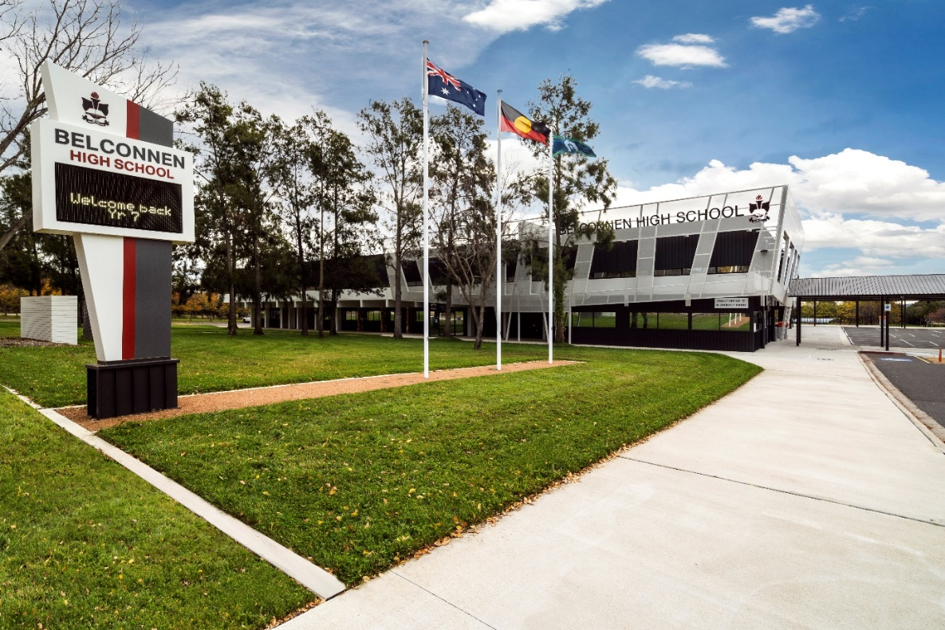

This page is intentionally left blank.

This report supports the work being done in the ACT Education Directorate, as outlined in Strategic Plan 2018-21: A Leading Learning Organisation.

Accessibility
The ACT Government is committed to making its information services, events and venues accessible to as many people as possible.
If you have difficulty reading a standard document and would like to receive this publication in an alternate format, such as large print and audio, please telephone (02) 6247 4580.
If English is not your first language and you require the translating and interpreting service, please telephone 13 14 50.
If you are deaf or hearing impaired and require the National Relay Service, please telephone 13 36 77.
© Australian Capital Territory, Canberra, 2021

Material in this publication may be reproduced provided due acknowledgement is made.

Contents
Reporting to the community 1
Summary of School Board activity 1
School Context 1
Student Information 1
Student enrolment 1
Student attendance 2
Supporting attendance and managing non-attendance 2
Staff Information 3
Teacher qualifications 3
Workforce composition 3
School Review and Development 3
School Satisfaction 4
Overall Satisfaction 4
Learning and Assessment 6
Performance in Literacy and Numeracy 6
Early years assessment 6
NAPLAN 6
Outcomes for College Students 7
Post School Destination 7
Financial Summary 8
Voluntary Contributions 9
Reserves 9
Endorsement Page 10
Members of the School Board 10

Reporting to the community
Schools report to communities in range of ways, including through:
- Annual School Board Reports
- a (5-year) School Improvement Plan (formerly School Strategic Plan)
- annual Impact Reports
- newsletters
- other sources such as My School.

Summary of School Board activity
The School Board continued to meet regularly during 2020 with the impact of COVID-19 pandemic moving a number of the board meetings online. Despite this change in format, the board continued to review and approve the financial aspects of the school.
The School Board received presentations on the School Nurse Program and the NT Camp 2021. Both of these programs are an important addition to the school in terms of care and opportunities for students and their families.

School Context
Belconnen High School opened in 1971 and enjoys a rich history such as the school hall being the Tally Room for the 1972 Federal election. We cater for students from years 7 to 10 with our core values of strength, integrity and knowledge and having a positive attitude and commitment. The school is situated in the ACT suburb of Hawker and has close links to both the Primary Schools (years P to 6) and Hawker College (years 11 and 12) in the local area. This year our school has again experienced enrolment growth in our Year 7 cohort.
Our School Board and Parent and Citizens (P&C) work closely with our school community to provide an environment that promotes excellence, celebrates success, nurtures the wellbeing of all students and successfully provides students with the skills and values that will prepare them for the challenges and responsibilities of adult citizenship. The P&C provide the service of a second-hand uniform shop for the school community.
Pastoral care is an integral part of the school staffed by our Student Services Executive Teacher, Year Co-ordinators, School Psychologist, Youth Worker and School Youth Health Nurse. Positive Behaviours for Learning has been adopted within our school with our staff and students encouraging all to be respectful, responsible learners. As a team we ensure a supportive House system and a Student Representative Council (SRC) that is connected to the governance of the school.
The school offers a comprehensive curriculum that is structured around the Key Learning Areas of English, Mathematics, Science, Humanities and Social Sciences (HaSS), Physical Education, the Arts, Technology and Languages other than English (LOTE). The school has a Language program called “Connecting to Country”. The course focuses on the indigenous languages of our local area.
Students are extended and challenged through the highly successful enrichment program (PEP) in the areas of English, Mathematics, HaSS and Physical Education. The school now offers students the opportunity to study Vocational Education and Training courses in the areas of Hospitality and Building and Construction and may begin an Australian School Based Apprenticeship (ASBA).
Complementary to the traditional curriculum the school runs a number of targeted programs designed to engage and connect students to the school and their learning. Amongst these is a highly successful program that caters for students with a diagnosis of Autism Spectrum Disorder (ASD). This program enables the students to be integrated into the school. The program is staffed by both teaching and support staff who design and facilitate the student’s learning through an Individual Learning Plan (ILP). The program successfully transitions the students into a mainstream college for years 11 and 12.

Student Information

Student enrolment
In this reporting period there were a total of 521 students enrolled at this school.
Table: Student enrolment
Student type | Number of students
Gender - Male | 279
Gender - Female | 242
Gender - Non-binary or other* | 0
Aboriginal and Torres Strait Islander | 18
LBOTE** | 118
Source: ACT Education Directorate, Analytics and Evaluation Branch
* If the number of non binary students is less than six, or if gender is unknown, these are randomly assigned 'Male' or 'Female' and included in the counts.
** Language Background Other Than English

Student attendance
Due to the effects of the COVID-19 pandemic, 2020 attendance data has not been published in the Annual School Board Report.

Supporting attendance and managing non-attendance
ACT public schools support parents and careers to meet their legal responsibilities in relation to the compulsory education requirements of the Education Act 2004. The Education Directorate’s Education Participation (Enrolment and Attendance) Policy describes its position with regard to supporting attendance and managing non-attendance. A suite of procedures supports the implementation of the policy. Please refer to https://www.education.act.gov.au/ for further details.

Staff Information

Teacher qualifications
All teachers at this school meet the professional requirements for teaching in an ACT public school. The ACT Teacher Quality Institute (TQI) specifies two main types of provision for teachers at different stages of their career, these are detailed below.
- Full registration is for teachers with experience working in a registered school in Australia or New Zealand who have been assessed as meeting the Proficient level of the Australian Professional Standards for Teachers.
- Provisional registration is for newly qualified teachers or teachers who do not have recent experience teaching in a school in Australia and New Zealand. Many teachers moving to Australia from another country apply for Provisional registration.

Workforce composition
Workforce composition for the current reporting period is provided in the following table. The data is taken from the school’s verified August staffing report. For reporting purposes, it incorporates all school staff including preschools, staff absent for a period of less than four consecutive weeks and staff replacing staff absent for more than four consecutive weeks. It does not include casuals and staff absent for a period of four consecutive weeks or longer.
The Education Directorate is required to report Aboriginal and Torres Strait Islander staff figures. As of June of the reporting period, 135 Aboriginal and Torres Strait Islander staff members were employed across the Directorate.
Table: Workforce composition numbers
Staff employment category | TOTAL
Teaching Staff: Full Time Equivalent Permanent | 38.21
Teaching Staff: Full Time Equivalent Temporary | 1.60
Non Teaching Staff: Full Time Equivalent | 16.20
Source: ACT Education Directorate, People and Performance Branch

School Review and Development
The ACT Education Directorate’s Strategic Plan 2018-2021 provides the framework and strategic direction for School Improvement Plans (formerly School Strategic Plans). This is supported by the school performance and accountability framework ‘People, Practice and Performance: School Improvement in Canberra Public Schools, A Framework for Performance and Accountability’. Annually, system and school level data are used alongside the National School Improvement Tool to support targeted school improvement, high standards in student learning, innovation and best practice in ACT public schools.
Our school was reviewed in 2019. A copy of the Report of Review can be found on our school website.

School Satisfaction
Schools use a range evidence to gain an understanding of the satisfaction levels of their parents and carers, staff and students. Annually in August/ September ACT schools undertake a survey to gain an understanding of school satisfaction at that time. This information is collected from staff, parents and from 2020 students from year 4 and above (previously year 5 and above) through an online survey.

Overall Satisfaction
In this period of reporting, 88% of parents and carers, 91% of staff, and 68% of students at this school indicated they were satisfied with the education provided by the school.
Included in the survey were 16 staff, 14 parent, and 12 student items which are described as the national opinion items. These items were approved by the then Standing Council on School Education and Early Childhood (SCSEEC) for use from 2015. The following tables show the percentage of parents and carers, students and staff who agreed with each of the national opinion items at this school.
Note: The overall response rate for parents and carers in ACT public schools was negatively impacted by COVID-19, dropping from 31% in 2019 to 23% in 2020.
A total of 45 staff responded to the survey. Please note that not all responders answered every question.
Table: Proportion of staff* in agreement with each national opinion item
National opinion item | Proportion of staff
Parents at this school can talk to teachers about their concerns. | 100
Staff are well supported at this school. | 89
Staff get quality feedback on their performance. | 58
Student behaviour is well managed at this school. | 69
Students at this school can talk to their teachers about their concerns. | 96
Students feel safe at this school. | 93
Students like being at this school. | 93
Students’ learning needs are being met at this school. | 91
Teachers at this school expect students to do their best. | 98
Teachers at this school motivate students to learn. | 91
Teachers at this school treat students fairly. | 98
Teachers give useful feedback. | 82
This school is well maintained. | 98
This school looks for ways to improve. | 98
This school takes staff opinions seriously. | 76
This school works with parents to support students' learning. | 93
Source: ACT Education Directorate, Analytics and Evaluation Branch
*Proportion of those who responded to each individual survey question

A total of 109 parents responded to the survey. Please note that not all responders answered every question.
Table: Proportion of parents and carers* in agreement with each national opinion item
National opinion item | Proportion of parents and carers
I can talk to my child’s teachers about my concerns. | 87
My child feels safe at this school. | 89
My child is making good progress at this school. | 84
My child likes being at this school. | 87
My child's learning needs are being met at this school. | 83
Student behaviour is well managed at this school. | 70
Teachers at this school expect my child to do his or her best. | 86
Teachers at this school give useful feedback. | 72
Teachers at this school motivate my child to learn. | 79
Teachers at this school treat students fairly. | 75
This school is well maintained. | 95
This school looks for ways to improve. | 84
This school takes parents’ opinions seriously. | 67
This school works with me to support my child's learning. | 69
Source: ACT Education Directorate, Analytics and Evaluation Branch
*Proportion of those who responded to each individual survey question

A total of 370 students responded to the survey. Please note that not all responders answered every question.
Table: Proportion of students* in agreement with each national opinion item
National opinion item | Proportion of students
I can talk to my teachers about my concerns. | 44
I feel safe at this school. | 65
I like being at my school. | 56
My school gives me opportunities to do interesting things. | 63
My school is well maintained. | 66
My school looks for ways to improve. | 65
My teachers expect me to do my best. | 71
My teachers motivate me to learn. | 61
Staff take students’ concerns seriously. | 50
Student behaviour is well managed at my school. | 36
Teachers at my school treat students fairly. | 50
Teachers give useful feedback. | 53
Source: ACT Education Directorate, Analytics and Evaluation Branch
*Proportion of those who responded to each individual survey question

Learning and Assessment

Performance in Literacy and Numeracy

Early years assessment
Students in kindergarten undertake an on-entry and on-exit assessment of their early reading and numeracy skills using the BASE program. Student results are reported against five performance bands at the end of semester 1 and 2. Below are the results for this school for the current reporting period.
Due to the impact of COVID-19, analysis of BASE data for 2020 has been delayed. Analysis will be provided to schools in 2021. Please speak with the school should you require further information.

NAPLAN
Students in years 3, 5, 7 and 9 in all ACT schools participate in the National Assessment Program-Literacy and Numeracy (NAPLAN). This program assesses skills in reading, writing, spelling, grammar and punctuation, and numeracy.
*Note: There are no NAPLAN results for 2020, with the assessments not being conducted due to the impacts of COVID-19.

Financial Summary
The school has provided the Directorate with an end of year financial statement that was approved by the school board. Further details concerning the statement can be obtained by contacting the school. The following summary covers use of funds for operating costs and does not include expenditure in areas such as permanent salaries, buildings and major maintenance.
Table: Financial Summary
INCOME | January-June | July-December | January-December
Self-management funds | 228732.90 | 228842.91 | 457575.81
Voluntary contributions | 680.00 | 0.00 | 680.00
Contributions & donations | 2191.31 | 19904.32 | 22095.63
Subject contributions | 4057.73 | 6599.83 | 10657.56
External income (including community use) | 0.00 | 12906.31 | 12906.31
Proceeds from sale of assets | 0.00 | 0.00 | 0.00
Bank Interest | 3903.34 | 3408.68 | 7312.02
TOTAL INCOME | 239565.28 | 271662.05 | 511227.33
EXPENDITURE
Utilities and general overheads | 74050.76 | 91710.12 | 165760.88
Cleaning | 0.00 | 0.00 | 0.00
Security | 1849.68 | 0.00 | 1849.68
Maintenance | 26399.65 | 19797.29 | 46196.94
Administration | 4798.74 | 26777.75 | 31576.49
Staffing | 0.00 | 684.70 | 684.70
Communication | 2167.24 | 3982.74 | 6149.98
Assets | 65914.14 | 16261.40 | 82175.54
Leases | 0.00 | 0.00 | 0.00
General office expenditure | 13567.78 | 20989.56 | 34557.34
Educational | 26859.34 | 37853.59 | 64712.93
Subject consumables | 35762.87 | 15352.07 | 51114.94
Other Payments | 0.00 | 16267.20 | 16267.20
Directorate Funded Payments | 0.00 | 34827.18 | 34827.18
TOTAL EXPENDITUIRE | 251370.20 | 284503.60 | 535873.80
OPERATING RESULT | -11804.92 | - 12841.55 | -24646.47
Actual Accumulated Funds (31.12.20) | 249044.55 | 260447.94 | 260447.94
Outstanding commitments (minus) | -29266.84 | 0.00 | 0.00
BALANCE | 219777.71 | 260447.94 | 260447.94

Voluntary Contributions
The funds listed were used to support the general operations of the school. The spending of voluntary contributions is in line with the approved budget for this reporting period.

Reserves
Name and Purpose | Amount | Expected Completion
- New Furniture  - Staff and student furniture to accommodate increasing numbers | $8000 | June 2021
- Facilities Upgrade  - New faculty space to accommodate growing staff numbers | $50000 | November 2021
- IT Projects  - Additional student devices for the chromebook equity and loan system to ensure access for all students | $20000 | August 2021

Endorsement Page

Members of the School Board
Parent Representative(s): | Petrina Olds | Marka Selmes | Dianne Gleeson
Teacher Representative(s): | Eva Bugledich | Janet Cooke
Student Representative(s): | Brianna Barbour | Kelly Chen
Board Chair: | Petrina Olds
Principal: | Rebecca Pearce
I approve the report, prepared in accordance with the provision of the ACT Education Act 2004, section 52.

2020 Board Chair Signature: | Petrina Olds | Date: | 28/ 06/ 2021

I certify that to the best of my knowledge and belief the evidence and information reported in this Annual School Board Report represents an accurate record of the Board’s operations during this reporting period.

Principal Signature: | Rebecca Pearce | Date: | 23 / 06 / 2021

