Hawker Primary School
  - Network: Belconnen

Impact Report 2021

The purpose of this document
This document flows directly from our Action Plan for 2021 which translated our school priorities into actions for the current year of our five-year improvement cycle. These actions were responsive to identified challenges, changes or risks to delivery of improvement for student learning.

Our school’s contribution to whole-of-system Strategic Indicators

Education Directorate Strategic Indicator 2018-2021
To promote greater equity in learning outcomes in and across ACT public schools
In 2021 our school supported this Strategic Indicator through – Priority 1 (see reporting for detail):
- improving student learning outcomes in spelling

Education Directorate Strategic Indicator 2018-2021
To facilitate high quality teaching in ACT public schools and strengthen educational outcomes.
In 2021 our school supported this Strategic Indicator through – Priority 3 (see reporting for detail):
- strengthening the Hawker Primary School professional learning community using a maturity matrix to track growth and to identify areas for future development
- developing the Hawker coaching and mentoring model

Education Directorate Strategic Indicator 2018-2021
To centre teaching and learning around students as individuals
In 2021 our school supported this Strategic Indicator through – Priority 2 (see reporting for detail):
- ensuring consistent teaching practices in mathematics K-6 including differentiation and feedback
- enhancing the use of data to inform the teaching mathematics

Reporting against our priorities

Priority 1: Improve student learning outcomes in spelling

Targets or measures
By the end of 2023 we will achieve:
- An increase in students achieving at/above expected growth in writing
- An increase in students achieving at/above expected growth in spelling
- Increase the proportion of students in the top two bands for writing
- Increase the proportion of students in the top two bands for spelling
- Increase the proportion of parents indicating the school has high expectations in all that it does
- Increase the percentage of class teachers demonstrating differentiation of spelling and writing in their planning/program
- Increase the difference between the 95th percentile at Hawker School and the norming reference group for PAT Spelling
In 2021 we implemented this priority through the following strategies.
- Implementing current evidenced based teaching strategies in spelling
- Creating a PLT with a focus on spelling
- Working with Christine Topfer as a critical friend on a spelling inquiry
Below is our progress towards our five-year targets with an emphasis on the accumulation and analysis of evidence over the term of our plan.

Student learning data
Targets or Measures | Base | Year 1  2019 | Year 2  2020 | Year 3  2021 | Year 4  2022 | Year 5  2023
An increase in students achieving at/above expected growth in writing | 69% | 57.8% | N/A | 59.5%
An increase in students achieving at/above expected growth in spelling | 61% | 40.4% |  | 52.4%
Increase the proportion of students in the top two bands for writing (Year 3) | 64% | 60.9% |  | 66.7%
Increase the proportion of students in the top two bands for writing (Year 5) | 29% | 16.4% |  | 28.3%
Increase the proportion of students in the top two bands for spelling (Year 3) | 56% | 46.8% |  | 60%
Increase the proportion of students in the top two bands for spelling (Year 5) | 34% | 33.9% |  | 43.5%

Perception Data
Targets or Measures | Base | Year 1  2019 | Year 2  2020 | Year 3  2021 | Year 4  2022 | Year  2023
Increase the proportion of parents indicating the school has high expectations in all that it does | 85.2% | 91% | 92% | 88.7%

School program and process data
Targets or Measures | Base | Year 1  2019 | Year 2  2020 | Year 3  2021 | Year 4  2022 | Year 5  2023
Increase the percentage of class teachers demonstrating differentiation of spelling and writing in their planning/program | 80% | 85% | Strongly Agree  Spelling: 33.3%  Writing: 16.7%  Agree  Spelling: 33.3%  Writing: 83.3% | Strongly Agree  Spelling: 25%  Writing: 50%  Agree  Spelling: 75%  Writing: 50%
Increase the difference between the 95th percentile at Hawker School and the norming reference group for PAT Spelling  H = Hawker School  AN = Australian Norms | TBA | N/A | H AN Diff  Yr2 139.7 118 +21.7  Yr3 136.8 137 -0.2  Yr4 150.7 152 -1.3  Yr5 159.5 162 -2.5  Yr6 166.7 168 -1.3 | H AN Diff  Yr2 129.1 118 +11.1  Yr3 153.7 137 +16.7  Yr4 160.7 152 +8.7  Yr5 158 162 -4.0  Yr6 166.7 168 -1.3

What this evidence tells us
- Both the spelling and writing NAPLAN data indicates an increase in performance when compared to 2019 data.
- PAT spelling was added in 2020 as an additional data source to assist in monitoring student performance. This data was used in 2021 by the PLT to investigate progress and identify areas of need.
- Using PAT spelling in 2020/21 has allowed us to monitor growth across the transition from junior to senior school.
- PAT spelling data indicates the need to further differentiate.
- PAT spelling was one data source used to identify students for tier 3 intervention.
- A collection of school-based data allows us to cross reference against system data.
- Below is additional writing data from My Schools. This is useful growth data and indicates Hawker students’ growth to be similar to ‘like’ schools.
- We need to continue to support teachers to build their confidence and their efficacy in their teaching of spelling and writing.
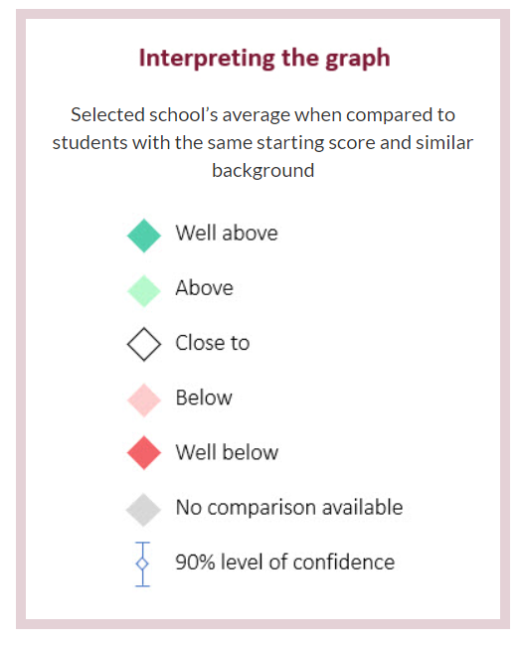

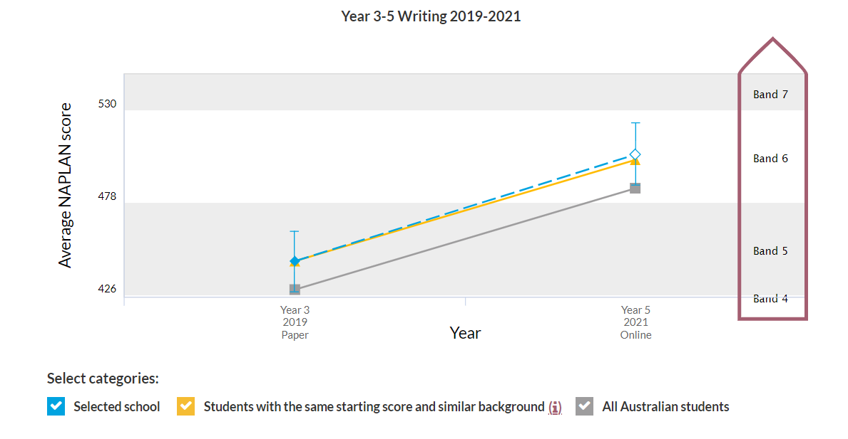

Our achievements for this priority
Teacher Efficacy
- Teachers participated in a day of professional learning with Christine Topfer. She continued to work closely with the Spelling PLT throughout the year being a critical friend.
- Staff were surveyed on confidence levels for teaching spelling. This information was used to
target professional learning for all staff including data interrogation, best pedagogical practice, differentiation.
- A school based instructional mentor partnered with a beginning teacher in a coaching and mentoring role. This approach was shared with the staff and will be enhanced in 2022.
- The spelling PLT leader was provided with additional release time to plan and prepare.
- The PLT coordinated a spelling expo for all staff from P- Year 6. This was an opportunity to show case quality teaching practices with the aim of increasing teacher confidence.
- The PLT created belief statements around best pedagogical practices. These are clearly articulated and used in planning documents.
- The spelling PLT investigated several scope and sequence documents and determined the way forward with the result being a whole school scope and sequence to be implemented in 2022.
- We continued a professional partnership with Tessa Daffern (COST spelling)

Targeted intervention
- Spell It Intervention was provided for years 3 – 6 in term 1

Implementing HIITS
- We revisited the High Impact Teaching Strategies with reference to spelling.

Challenges we will address in our next Action Plan
- In 2022 we will implement a new scope and sequence, Hawker belief statements, and preferred resource “Effective Spelling Teaching Guide by Christine Topfer’. Deputy principal to monitor progress, confidence levels and student performance data.
- Further targeted intervention – an additional teacher will be trained in Spell It.
- Regular PL during staff meetings to build teacher efficacy (5 hours TQI accredited).

Priority 2: Improve student learning outcomes for mathematics with an emphasis on high performance and middle years

Targets or measures
By the end of 2023 we will achieve:
- Increasing the difference between the 95th percentile at Hawker School and the norming reference group for PAT Maths
- % of students in the top 2 bands for numeracy 43-46% (Year 5)
- 90% of high performing students (students identified to participate in school-based extension and enrichment for mathematics) indicate that they are challenged in Mathematics Year 3-6
In 2021 we implemented this priority through the following strategies.
- Ensuring consistent teaching practices in Mathematics K-6 including setting goals, differentiation and Feedback
- Enhancing the use of data to inform the teaching of Mathematics (performance vs growth data)
Below is our progress towards our five-year targets with an emphasis on the accumulation and analysis of evidence over the term of our plan.

Student learning data

Targets or Measures | Base | Year 1  2019 | Year 2  2020 | Year 3  2021 | Year 4 | Year 5
Increase the difference between the 95thpercentile at Hawker School and the norming reference group for PAT Maths | Baseline currently being established | Hawker School Australian Norms  Year 1 113.2 117.3 -4.1  Year 2 130.9 127.5 +3.4  Year 3 146.5 134.9 +11.6  Year 4 137.0 140.9 -3.9  Year 5 148.2 143.7 +4.5  Year 6 150.6 147.8 +2.8 | Hawker School Australian Norms  Year 1 126.4 117.3 +9.1  Year 2 128.8 127.5 +0.8  Year 3 134.3 134.9 -0.6  Year 4 137.3 140.9 -3.6  Year 5 144.9 143.7 +1.2  Year 6 150.6 147.8 +2.8 | Hawker School Australian Norms  Year 1 121.8 117.3 +4.5  Year 2 128.1 127.5 +0.6  Year 3 151.8 134.9 +16.9  Year 4 142.4 140.9 +1.5  Year 5 142.2 143.7 -1.5  Year 6 153.2 147.8 +5.4
% of students in the top 2 bands for numeracy 43-46% (Year 5) | 43.5% | 31.5% | N/A | 37%

Perception Data
Targets or Measures | Base | Year 1  2019 | Year 2  2020 | Year 3  2021 | Year 4  2022 | Year 5  2023
90% of high performing students (students identified to participate in school-based extension and enrichment for mathematics) indicate that they are challenged in Mathematics Year 3-6 | Baseline established in 2020 |  | 90.2% | N/A (cohorting due to COVID)

What this evidence tells us
- We need to continue to effectively differentiate. Ensuring high performing students are challenged and that students are met at their point of need.
- Teaching in Year 3 in 2021 was extremely effective.
- 2021 PAT data shows growth from every cohort when compared to 2019
- Below is additional mathematics data from My Schools. This is useful growth data and indicates Hawker students’ growth to be similar to ‘like’ schools.

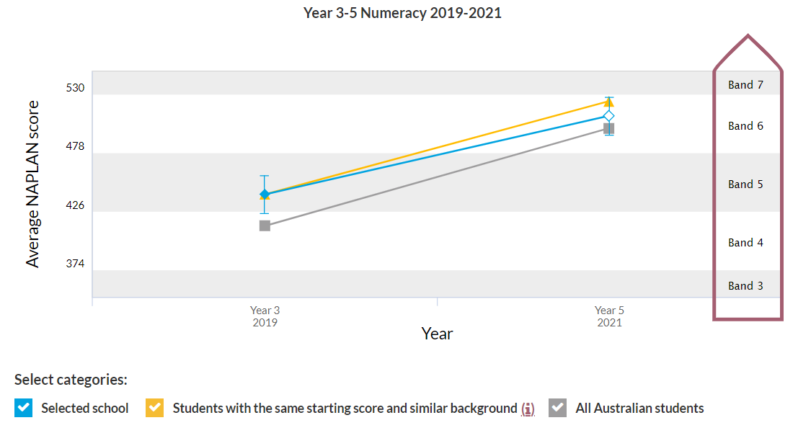

Our achievements for this priority
Teacher Efficacy
- Additional teaching staff were timetabled to support differentiation during mathematics sessions.
- During remote learning the extension groups continued and there was a focus by all classroom teachers on ‘live teaching’ with access to recordings for further support.
- The High Impact Teaching strategies of feedback, differentiation and goal setting were discussed during reflection sessions with the SLC.
- Peer observation and feedback focused on differentiation of Mathematics.
- The school participated in the Directorate ‘Finding the balance’ numeracy project. With an SLC and teacher training as instructional leaders.
- Mathematics PL included a session focusing on quality teaching practices and the successful structure of a maths session.
- The PLT reviewed the maths proficiency strands and how these were implemented at Hawker.
- Draft belief statements have been created and will be reviewed in 2022.

School Wide Consistency
- A variety of resources was investigated as a school wide preferred resource. A comparison of the scope and sequence of a variety of resources was completed.
- A school wide audit of mathematical resources resulted in the purchase of a collection of new manipulatives for each classroom, additional teaching resources and specific maths trolleys for the junior school.
- Online subscriptions were reviewed and updated to support students during the remote learning period and during the transition back to onsite learning.
- The school moved away from Envision as a core teaching resource and focused on building teacher capacity and confidence.
- The Maths PLT has critically analysed the changes to the Australian Curriculum.
Intervention
- During remote learning. Learning Support staff targeted ISP and ILP students with small groups.
- K-2 workshops for parents on how to support their children in the areas of place value, addition and subtraction strategies. Families who attended were provided with a “home learning’ package with manipulatives. An article about the success of these workshops was published by the Teacher Quality Institute as an example of engaging the community post COVID
- A small group support sessions for Year 6 were provided twice per week in preparation for high school transition.
- Extension groups for Years 3- 6 were provided twice per week, culminating with the Australian Maths Trust competition.

Challenges we will address in our next Action Plan
- School wide consistency using a scope and sequence including the changes to the Australian Curriculum. The imaths Investigations will be used to shift the mind set of ‘doing Maths in a book’.
- A continued focus on differentiation including using data to identify high performing students in the early years.
- Maths PLT leading professional learning and a review of student performance data

Priority 3: Strengthen culture of learning to reflect a strong commitment to excellence and academic rigour

Targets or measures
By the end of 2023 we will achieve:
- By 2023, we will have a preschool ACECQA rating of exceeding/excellent in QA1
- During the period of 2021-2023 40% of students in Year 2, 59% of students in Year 4 and 67% of students in Year 6 are achieving above standard in English, Mathematics and Science (those receiving an A or B grade)
- During the period of 2021-2023 an increase of parents and to maintain or increase teachers’ and students’ satisfaction with the education students are receiving
- During the period 2020-2023, an increase of parents have a favourable response to the statement ‘I am satisfied the school has high expectations in all that it does’
- During the period 2019-2023 classroom teachers are participating in coaching to use effective pedagogical practices as articulated in the Hawker School Coaching & Mentoring Model
- During the period 2021-2023 all classroom teachers will have participated in coaching to use data to inform their practice
In 2021 we implemented this priority through the following strategies.
- Develop a clear and consistent understanding of agreed pedagogy
- Strengthen the Hawker Primary School Professional Learning Community
Below is our progress towards our five-year targets with an emphasis on the accumulation and analysis of evidence over the term of our plan.

Student learning data
Targets or Measures | Base | Year 1  2019 | Year 2  2020 | Year 3  2021 | Year 4  2022 | Year 5  2023
By 2023, we will have a preschool ACECQA rating of exceeding/excellent in QA1 | Exceeding rating | N/A | N/A | N/A

Perception Data
Targets or Measures | Base | Year 1  2019 | Year 2  2020 | Year 3  2021 | Year 4  2022 | Year 5  2023
During the period 2019-2023 classroom teachers are participating in coaching to use effective pedagogical practices as articulated in the Hawker School Coaching & Mentoring Model. | N/A | 100% | N/A | N/A  (cohorting due to COVID)
Satisfaction with education - parents | 90.4% | 94.6% | 97.8% | 94.8%
Satisfaction with education - students | 93% | 86% | 88% | 83%
Satisfaction with education - teachers | 98.8% | 91.3% | 100% | 94.1%

What this evidence tells us
- Survey data indicates teacher and parent satisfaction levels remained high despite 2021 being a challenging year.
- Student satisfaction levels declined slightly in 2021 which is understandable due to Covid restrictions, cohorting and cancellation of sporting events, excursions and camps.

Our achievements for this priority
- A maturity matrix for PLTs was utilised to track growth. This indicated our PLTs have evolved with a focus on the use of data.
- As a staff we continued to work on our Hawker School Pedagogical Framework.
- Several staff trialled a targeted approach to coaching and mentoring and shared their experience with the staff.

Challenges we will address in our next Action Plan
- Enhancing and further developing the Hawker School coaching and mentoring model will be a focus for 2022, as will be the use of data to inform practice.
- Updating and embedding the school-based data plan will be a focus for 2022.

Reporting on preschool improvement
All schools with a preschool setting are required to annually review and update their Quality Improvement Plan*. Schools have a choice to report progress and achievements either within their QIP or in the section below.
- QIP reflected upon, updated and new actions identified.
*A copy of the QIP is available for viewing at the school.

