

Ainslie School

Annual School Board Report 2021

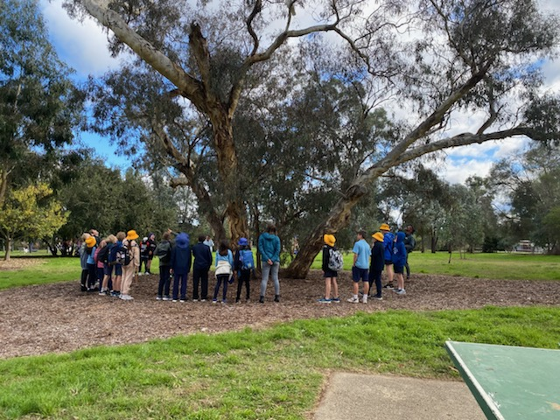

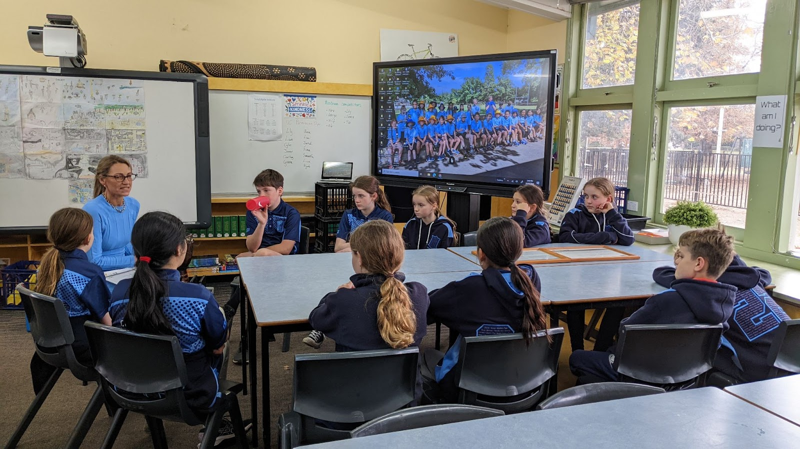

This page is intentionally left blank.



This report supports the work being done in the ACT Education Directorate, as outlined in *Strategic Plan 2018-21: A Leading Learning Organisation*.

Accessibility

The ACT Government is committed to making its information services, events and venues accessible to as many people as possible.

If you have difficulty reading a standard document and would like to receive this publication in an alternate format, such as large print and audio, please telephone (02) 6247 4580.

If English is not your first language and you require the translating and interpreting service, please telephone 13 14 50.

If you are deaf or hearing impaired and require the National Relay Service, please telephone 13 36 77.

© Australian Capital Territory, Canberra, 2022

Material in this publication may be reproduced provided due acknowledgement is made.

Contents

Reporting to the community 1

Summary of School Board activity 1

School Context 2

Student Information 2

Student enrolment 2

Student attendance 3

Supporting attendance and managing non-attendance 3

Staff Information 3

Teacher qualifications 3

Workforce composition 3

School Review and Development 4

School Satisfaction 4

Overall Satisfaction 4

Learning and Assessment 6

Performance in Literacy and Numeracy 6

Early years assessment 6

NAPLAN 6

Outcomes for College Students **Error! Bookmark not defined.**

Post School Destination **Error! Bookmark not defined.**

Financial Summary 8

Voluntary Contributions 9

Reserves 9

Endorsement Page 10

Members of the School Board 10

# Reporting to the community

Schools report to communities in range of ways, including through:

* Annual School Board Reports
* a (5-year) School Improvement Plan (formerly School Strategic Plan)
* annual Impact Reports
* newsletters
* other sources such as My School.

# Summary of School Board activity

In 2021, the covid pandemic continued to present significant challenges for our school community. While we had gained experience in remote learning from our experience in 2020, we still endured disruptions in the form of extended school closures. This led to some differences in timing for the school satisfaction survey and the nature of the questions asked, making it difficult to compare data between the years. Student enrolment numbers have remained steady through 2020-2021 and while attendance numbers were not reported on in 2020 due to the pandemic related closures, student attendance figures in 2021 remained strong, never dropping below 91%.

Ainslie School was able to overcome the difficulties presented by the ongoing nature of the pandemic to focus on issues of importance for the school community. These included a continued focus on improving student learning outcomes through teaching and learning programs designed to engage students. The school also moved rapidly to support online learning during periods of closure, building on its previous experience with remote learning and supporting families to participate online and in person as necessary. Even when students had returned to the classroom, the school continued to utilise online sessions to engage and communicate with parents. This had the benefit of increasing parent participation in school information sessions, better connecting families with the school and supporting public health outcomes. Investments were made in building teacher capability, particularly in the areas of leadership and inclusive practice, as well as with students in initial teacher education. Team teaching was utilised across the school to support the curriculum. Teachers encouraged students to venture out into the neighbourhood and the community was encouraged to utilise school facilities, exemplified by the partnership between Ainslie and a local language school. Ainslie continued to show leadership in demonstrating the positive contribution that creativity makes to learning by supporting the creative in residence program and supporting nutritional practice in a school setting with the “Fuel for Thought” program. Ainslie School’s finances remained solid, in spite of the external challenges, and investments were made in school maintenance, office upgrades and much welcomed interactive white boards.

The Annual School Board Report provides a great opportunity to look back on the challenges and opportunities of the year just gone. After 8 years as a member of Ainslie School Board, it has been a privilege to see the school go from strength to strength. I leave knowing the school has the resilience to weather any future challenges, in the hands of a capable and experienced board and a committed school community.

Sarah Reid, Ainslie School Board Chair

# School Context

Ainslie School provides education services for students from Preschool to Year 6  across three sites - the Primary campus in Braddon, Baker Gardens Preschool in Ainslie and Reid Preschool.

Founded in 1927, the facilities and grounds of Ainslie School hold heritage significance and its curriculum reflects the community’s enduring aspiration for a progressive, student centred experience.  Cultural integrity, human dignity and environmental sustainability are driving concepts in programs and practices across the school.

Values of kindness, responsibility, respect, community and excellence are acknowledged and celebrated by the Ainslie School community.  The principles of purposeful play, personalised learning and student agency are honoured as teachers cultivate knowledge, skills and dispositions that enable inquiry and citizenship.  Diversity is celebrated at Ainslie School and inclusive approaches maximise student engagement.

The Arts hold a prominent place at Ainslie School. Programs include opportunities for creating and interpreting music across the grades and senior students enhance musicianship and social capabilities as members of strings and brass ensembles.  Ainslie School’s Creative In Residence enables students to access the curriculum and showcase learning through visual and performing arts.  Students, staff and families enjoy resources and partnerships with neighbouring organisations including Arts centres, galleries, universities and Canberra’s cultural institutions.

In 1964 Ainslie School was the first in Australia to establish a relationship with a Japanese school and the Japanese language program has been offered since 1967. This program is supported by a language specialist and community connections.

Ainslie School benefits from research engagement and is shaping contemporary practice as an Affiliate School with the University of Canberra.  Staff are currently progressing innovation in wellbeing through intergenerational initiatives with local seniors groups and the Fuel for Thought school lunches program.

## Student Information

### Student enrolment

In this reporting period there were a total of 356 students enrolled at this school.

Table: Student enrolment

|  |  |
| --- | --- |
| **Student type** | **Number of students** |
| Gender - Male | 177 |
| Gender - Female | 179 |
| Gender - Non-binary or other* | 0 |

Source: ACT Education Directorate, Analytics and Evaluation Branch

* If the number of non-binary students is less than six, or if gender is unknown, these are randomly assigned 'Male' or 'Female' and included in the counts.

### Student attendance

The following table identifies the attendance rate of students by year level during this reporting period. Student attendance rate is the percentage of school days attended by students in each year level at the school. Student attendance is measured over two school terms; that is from the first day of the school year for students in term 1 to the last day of term 2.

*NOTE: Student attendance data for this period should be understood within the context of flexible learning arrangements enacted in response to COVID19. Comparison of attendance figures to previous reporting periods is not valid.

Table: Attendance rates in percentages

|  |  |
| --- | --- |
| **Year level** | **Attendance rate** |
| 1 | 92.0 |
| 2 | 94.0 |
| 3 | 93.0 |
| 4 | 94.0 |
| 5 | 94.0 |
| 6 | 91.0 |

Source: ACT Education Directorate, Analytics and Evaluation Branch

## Supporting attendance and managing non-attendance

ACT public schools support parents and careers to meet their legal responsibilities in relation to the compulsory education requirements of the *Education Act 2004.* The Education Directorate’s *Education Participation (Enrolment and Attendance) Policy* describes its position with regard to supporting attendance and managing non-attendance. A suite of procedures supports the implementation of the policy. Please refer to <https://www.education.act.gov.au/> for further details.

## Staff Information

### Teacher qualifications

All teachers at this school meet the professional requirements for teaching in an ACT public school. The ACT Teacher Quality Institute (TQI) specifies two main types of provision for teachers at different stages of their career, these are detailed below.

* ***Full registration*** is for teachers with experience working in a registered school in Australia or New Zealand who have been assessed as meeting the Proficient level of the Australian Professional Standards for Teachers.
* ***Provisional registration*** is for newly qualified teachers or teachers who do not have recent experience teaching in a school in Australia and New Zealand. Many teachers moving to Australia from another country apply for Provisional registration.

### Workforce composition

Workforce composition for the current reporting period is provided in the following table. The data is taken from the school’s verified August staffing report. For reporting purposes, it incorporates all school staff including preschools, staff absent for a period of less than four consecutive weeks and staff replacing staff absent for more than four consecutive weeks. It does not include casuals and staff absent for a period of four consecutive weeks or longer.

The Education Directorate is required to report Aboriginal and Torres Strait Islander staff figures. As of June of the reporting period, 135 Aboriginal and/or Torres Strait Islander staff members were employed across the Directorate.

Table: Workforce composition numbers

|  |  |
| --- | --- |
| **Staff employment category** | **TOTAL** |
| Teaching Staff: Full Time Equivalent Permanent | 20.40 |
| Teaching Staff: Full Time Equivalent Temporary | 2.60 |
| Non Teaching Staff: Full Time Equivalent | 12.08 |

Source: ACT Education Directorate, People and Performance Branch

# School Review and Development

The ACT Education Directorate’s Strategic Plan 2018-2021 provides the framework and strategic direction for School Improvement Plans (formerly School Strategic Plans). This is supported by the school performance and accountability framework ‘*People, Practice and Performance: School Improvement in Canberra Public Schools, A Framework for Performance and Accountability’*. Annually, system and school level data are used alongside the National School Improvement Tool to support targeted school improvement, high standards in student learning, innovation and best practice in ACT public schools.

Our school was reviewed in 2018. A copy of the Report of Review can be found on our school website.

## School Satisfaction

Schools use a range evidence to gain an understanding of the satisfaction levels of their parents and carers, staff and students. Annually in August/ September ACT schools undertake a survey to gain an understanding of school satisfaction at that time. This information is collected from staff, parents and from 2020 students from year 4 and above (previously year 5 and above) through an online survey.

### Overall Satisfaction

In this period of reporting, 72.4% of parents and carers, 100.0% of staff, and 73.6% of students at this school indicated they were satisfied with the education provided by the school.

Included in the survey were 8 staff, 9 parent, and 10 student items which are described as the national opinion items. These items were approved by the then Standing Council on School Education and Early Childhood (SCSEEC) for use from 2015. The following tables show the percentage of parents and carers, students and staff who agreed with each of the national opinion items at this school.

Due to the impacts of the COVID-19 pandemic, the survey was taken in November, rather than in August as has been done in previous years. This was just after the majority of students and staff returned to school-based learning after a period of around 3 months of remote learning. A number of questions were removed from previous years to shorten the time required by community members to complete the survey.

A total of 23 staff responded to the survey. Please note that not all responders answered every question.

Table: Proportion of staff* in agreement with each national opinion item

|  |  |  |
| --- | --- | --- |
| **National opinion item** | |  | | --- | | Proportion of staff | |
| Parents at this school can talk to teachers about their concerns. | 100 |
| Staff get quality feedback on their performance. | 58 |
| Student behaviour is well managed at this school. | 65 |
| Teachers want every student to do their best. (Replaces 'Teachers at this school expect students to do their best') | 100 |
| Staff at this school treat students with respect. (Replaces 'Teachers at this school treat students fairly') | 96 |
| Teachers give useful feedback. | 95 |
| This school is well maintained. | 78 |
| The way decisions are made in this school are appropriate (Replaces 'This school takes staff opinions seriously') | 65 |

Source: ACT Education Directorate, Analytics and Evaluation Branch

*Proportion of those who responded to each individual survey question

A total of 87 parents responded to the survey. Please note that not all responders answered every question.

Table: Proportion of parents and carers* in agreement with each national opinion item

|  |  |  |
| --- | --- | --- |
| **National opinion item** | |  | | --- | | Proportion of parents and carers | |
| My child feels safe at this school. | 82 |
| My child is making good progress at this school. | 71 |
| Student behaviour is well managed at this school. | 66 |
| Teachers at this school believe that every student can be a success. (Replaces 'Teachers at this school expect my child to do his or her best') | 76 |
| Teachers give useful feedback. | 72 |
| Staff at this school treat students with respect. (Replaces 'Teachers at this school treat students fairly') | 91 |
| This school is well maintained. | 75 |
| This school is active in seeking parents' opinion and ideas for making important decisions.(Replaces 'This school takes parents’ opinions seriously') | 63 |
| This school works with me to support my child's learning. | 66 |

Source: ACT Education Directorate, Analytics and Evaluation Branch

*Proportion of those who responded to each individual survey question

A total of 125 students responded to the survey. Please note that not all responders answered every question.

Table: Proportion of students* in agreement with each national opinion item

|  |  |  |
| --- | --- | --- |
| **National opinion item** | |  | | --- | | Proportion of students | |
| Teachers encourage students to try out new ideas. (Replaces 'My teachers motivate me to learn') | 79 |
| Staff take students’ concerns seriously. | 58 |
| Staff treat students with respect. (Replaces 'Teachers at my school treat students fairly') | 84 |
| Teachers give useful feedback. | 61 |
| I feel I can talk to teachers about problems at school. (Replaces 'I can talk to teachers about my concern') | 54 |
| I feel safe at this school. | 66 |
| I am happy to be part of this school.(Replaces 'I like being at my school') | 72 |
| I am interested in what I learn in school. (Replaces 'My school gives me opportunities to do interesting things') | 55 |
| My school is well maintained. | 51 |
| Teachers want every student to do their best.(Replaces 'My teachers expect me to do my best') | 89 |

Source: ACT Education Directorate, Analytics and Evaluation Branch

*Proportion of those who responded to each individual survey question

# Learning and Assessment

## Performance in Literacy and Numeracy

### Early years assessment

Students in kindergarten undertake an on-entry and on-exit assessment of their early reading and numeracy skills using the BASE program. Student results are reported against five performance bands at the end of semester 1 and 2. Below are the results for this school for the current reporting period.

***Table: Ainslie School BASE 2021 mean raw scores***

|  |  |  |  |  |
| --- | --- | --- | --- | --- |
| **Agency** | **Reading start** | **Reading end** | **Numeracy start** | **Numeracy end** |
| **School** | 65 | 134 | 41 | 60 |
| **ACT** | 58 | 125 | 38 | 56 |

Source: ACT Education Directorate, Analytics and Evaluation Branch

### NAPLAN

Students in years 3, 5, 7 and 9 in all ACT schools participate in the National Assessment Program-Literacy and Numeracy (NAPLAN). This program assesses skills in reading, writing, spelling, grammar and punctuation, and numeracy.

In this reporting period, no students were exempt from testing based on nationally agreed criteria.

For reasons of statistical reliability, as well as to protect the privacy of students, results are not reported when the sample size is less than five.

The following table shows the mean scores achieved by students at this school compared to all other ACT public schools for this reporting period.

***Table: NAPLAN Mean Scores***

|  |  |  |  |  |
| --- | --- | --- | --- | --- |
| **Test Domain** | **Year 3 School** | **Year 3 ACT** | **Year 5 School** | **Year 5 ACT** |
| **Reading** | 441 | 437 | 501 | 515 |
| **Writing** | 402 | 418 | 461 | 475 |
| **Spelling** | 397 | 409 | 483 | 502 |
| **Grammar & Punctuation** | 425 | 426 | 503 | 497 |
| **Numeracy** | 398 | 404 | 494 | 492 |

# Financial Summary

The school has provided the Directorate with an end of year financial statement that was approved by the school board. Further details concerning the statement can be obtained by contacting the school. The following summary covers use of funds for operating costs and does not include expenditure in areas such as permanent salaries, buildings and major maintenance.

Table: Financial Summary

|  |  |
| --- | --- |
| **INCOME** | **January-December** |
| Directorate Funding | 366178.83 |
| Contributions and Donations | 58866.10 |
| Subject Contributions | 0.00 |
| Hire of Facilities | 7338.62 |
| External Revenue | 1766.07 |
| Sale of Assets | 0.00 |
| Interest Received | 2483.17 |
| Other School Revenue | 13821.44 |
| **TOTAL INCOME** | 450454.23 |
| **EXPENDITURE** |  |
| Utilities and General Overheads | 91615.55 |
| Security and Caretaking | 1605.76 |
| Maintenance | 71573.29 |
| Administration | 71374.96 |
| Staffing Expenditure | 900.00 |
| Communication | 5664.97 |
| Assets & Leases | 25668.69 |
| General Expenses | 43003.15 |
| Educational Resources | 81558.12 |
| Subject Consumables | 108.09 |
| Directorate Funded Payments | 1112.57 |
| Other Payments | 8169.34 |
| **TOTAL EXPENDITURE** | 402354.49 |
| **OPERATING RESULT** | 48099.74 |
| Accumulated Funds | 192576.93 |
| **BALANCE** | 240676.67 |

## Voluntary Contributions

The funds listed were used to support the general operations of the school. The spending of voluntary contributions is in line with the approved budget for this reporting period.

## Reserves

There was no Reserve allocation in the 2021 School Budget.

# Endorsement Page

## Members of the School Board

|  |  |  |  |
| --- | --- | --- | --- |
| Parent Representative(s): | Sarah Oleson | Chris Price | Candice Cappe |
| Community Representative(s): | Iain Barr |  |  |
| Teacher Representative(s): | Janelle Jack | Carolyn MacLeod |  |
| Board Chair: | Sarah Reid |  |  |
| Principal: | Wendy Cave |  |  |

I approve the report, prepared in accordance with the provision of the ACT *Education Act* *2004*, section 52.

|  |  |  |  |
| --- | --- | --- | --- |
| 2021 Board Chair Signature: |  | Date: | 12/08/2022 |

I certify that to the best of my knowledge and belief the evidence and information reported in this Annual School Board Report represents an accurate record of the Board’s operations during this reporting period.

|  |  |  |  |
| --- | --- | --- | --- |
| Principal Signature: |  | Date: | 12/08/2022 |