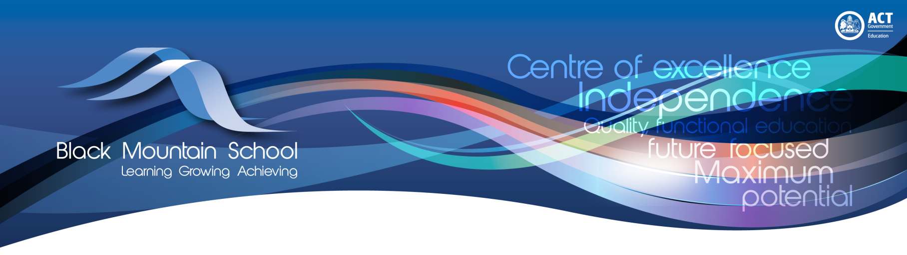

Black Mountain School Strategic Plan

2017-2021

North/Gungahlin Network
Endorsement by School Principal
Name: Frank Fogliati
Signed |  | Date:
Endorsement by School Board Chair
Name: Samanta Salvaneschi
Signed |  | Date:
Endorsement by School Network Leader
Name: Judith Hamilton
Signed |  | Date:

Strategic Priority 1
School Profile
Black Mountain School is a specialist school setting catering for a diverse range of students from Years 7-12.
In 2017 there are 104 enrolments comprising of students with mild to severe intellectual disabilities, some of whom also have a diagnosis of autism spectrum disorder, physical disabilities and/or complex medical issues. Classes are organised within cohorts of students according to age, ability and individual needs.

Positive Behavior for Learning (PBL) is implemented and embedded across the school

Targets:
By the end of 2021 the school will achieve:
- Maintenance of the school satisfaction survey results of above 90% staff and families agree students behaviour at this school is well managed
- 10% increase in whole school aggregated performance scores in assessments of behaviour and wellbeing
- Completion of an appropriate active sensory space
Key Improvement Strategies | Timelines and milestones | Lead roles/  Accountabilities/ Delegations | Targeted Resources | Key Performance Indicators
Establish Positive Behaviour for Learning team that includes across the school representation | 2018 | Deputy Principal  External PBL Coach (Directorate) | Time allocated for PBL meetings  Train PBL coaches  Whole school PL and data collection at Week 0 PL | PBL team is established, coaches are trained and the team meets regularly
Improve and establish learning environments that support all students learning | 2018-2021 | Principal | Allocate budget for upgrades  Secure grant funding  Capital works support | Completion of an active sensory space  Completion of a school library and flexible learning space  Completion of a student wellbeing space
Collect student wellbeing/behaviour data using recognised assessments and surveys | 2018 - 2021 | PBL team  Teaching staff | Time allocation for assessments  PL for staff | Wellbeing/Behaviour data collected on an annual basis
Develop and implement school-wide PBL team action plan as per PBL guidelines | 2018-2021 | PBL team and external coach | Budget for PBL materials – printing, displays etc  Time allocation for PBL team members | Action plan shared with whole school community
Launch Black Mountain School as a PBL school | 2021 | PBL team | Budget for launch | PBL launch

Strategic Priority 2
Black Mountain School will develop and implement a Framework for Teaching and Learning at Black Mountain. The framework will outline assessment, curriculum and pedagogy practices based on the BMS Functional Curriculum, and the Australian Curriculum and AusVELS
Targets:
By the end of 2021 the school will achieve:
- 100% of students ILP and program goals will align with the Framework for Teaching and Learning.
- 100% of student ILP goals will have clear assessment evidence
- 100% of specified students will have ABLES assessments collected twice a year

Key Improvement Strategies | Timelines and milestones | Lead roles/  Accountabilities/ Delegations | Targeted Resources | Key Performance Indicators
Strengthen staff capacity to deliver high quality class programs that support the needs of individual students.  Increase staff capacity to use data and feedback to support high quality teaching and learning.  Build teacher’s knowledge of the Australian Curriculum.  Review all BMS offered classes e.g. horticulture and create documentation clarifying the relevant domain Australian Curriculum | 2017 | Principal, Deputy Principal  Executive Teacher-Professional Practice to lead the process | The Australian Curriculum is used as a basis for ongoing staff discussions about the best ways to maximise student learning and wellbeing  BMS Capacities  Proformas and templates of programs and lesson planning documents | The school demonstrates a school priority in making the curriculum relevant and adopts a strengths-based approach to recognising, valuing and building on students’ existing knowledge and skills.  Teaching staff can demonstrate links to the Australian Curriculum or AusVELS within their ILP goals and planning documents.
Review whole school curriculum planning documents and the reporting format to ensure alignment with Australian Curriculum or AusVELS  Curriulum team to review exemplary special education teaching and learning frameworks  Curriculum team to review BMS functional Curriculum | 2018 | Curriculum Committee | The Australian Curriculum is used as a basis for ongoing staff discussions about the best ways to maximise student learning and wellbeing.  BMS Capacities  Proformas and templates of programs and lesson planning documents. | Teaching staff can demonstrate links to the Australian Curriculum or AusVELS within their class programming and planning documents.  General capabilities and cross-  curriculum priorities are understood, valued and used as active learning streams for all students.
Implement ABLES assessment across the school for all relevant students, twice yearly. | 2018-2021 | Executive Staff | Allocation at Teacher meetings to complete ABLES assessment | ABLEs assessment occurs twice a year.
Curriculum delivery is designed to meet the needs of the range of students within each year level as well as those within specific cohorts and with a range of diverse learning needs.  The Framework for Teaching and Learning will reflect a shared vision (by the school’s governing body, principal, school leadership team, and teachers) for the school, and outlines the assessment, curriculum and pedagogical practices of our school. | 2010-2021 | Principal  Deputy Principal  Executive Team  Curriculum Team  Community |  | A strong alignment has been achieved between the overall curriculum delivery plan, classroom teaching and the regular assessment of student progress in relation to curriculum expectations.  The school’s curriculum delivery plan identifies curriculum, teaching and learning priorities and requirements.

Strategic Priority 3
Improve staff capacity through an identified formal induction and coaching program targeting best practice pedagogy.

Targets:
By the end of 2021 the school will achieve:
- 100% of teaching staff in their second year at BMS have completed the BMS induction modules
- 100% of CBI programs document progression of student learning linked with curriculum.
- 80% of identified Students achieve level 2 on the AAC Iceberg Framework
- 100% of teachers implement systematic instruction approaches for appropriate ILP and program goals.
- 100% of teachers work with an identified coach.

Key Improvement Strategies | Timelines and milestones | Lead roles/  Accountabilities/ Delegations | Targeted Resources | Key Performance Indicators
Develop a whole school plan to deliver a formal coaching program that includes: goal setting, teacher feedback, lesson observations and coaching contracts.  Evaluation of Educator Impact using individual teacher’s development plans. | 2017-2021 | Deputy Principal will lead the process  All teaching staff will participate | Educator Impact resources, online support and surveys.  Educator Impact development plans.  ACT ED Teacher and School Leader Performance and Development Process  ACEL resources | All teachers and leaders strategically evaluate their own practice and develop goals to improve their own practice.  School leaders coach teachers to improve their teaching practices, including modelling, evaluating and providing feedback on classroom teaching.  PDP plan indicates that staff have shown an improvement in their identified areas of improvement by the end of the year.
Launch a streamlined Induction for teachers new to the school in 2018 | 2018 | Leadership Team  Teaching staff | The BMS induction  AITSL resources  Time allocation at team meetings for induction. | Every teacher new to the school in 2018 will have completed induction by the end of 2018  Pre and post testing indicate an improvement in best practice teaching for students with disability.
Implement an executive in charge of whole school development in AAC implementation  The reestablishment of ‘chat groups’  Symbol resource pack for all staff  Training of all staff to promote AAC teaching and learning | 2010-2021 | Leadership Team  AAC coach  NSET Speech therapist | Time allocation for chat group  Administration support for the development of the resource pack | An increase in student and staff performance against the AAC Iceberg Framework
Professional Learning Communities are embedded throughout each cohort. | 2018-2021 | Leadership Team  Teaching staff | Exec to be trained in coaching | All teachers are highly committed to the continuous improvement of their own teaching and are focused on the development of knowledge and skills required to improve student learning.

