Ainslie School
  - Network: North Canberra/ Gungahlin

Impact Report 2021

The purpose of this document
This document flows directly from our Action Plan for 2021 which translated our school priorities into actions for the current year of our five-year improvement cycle. These actions were responsive to identified challenges, changes or risks to delivery of improvement for student learning.

Our school’s contribution to whole-of-system Strategic Indicators

Education Directorate Strategic Indicator 2018-2021
To promote greater equity in learning outcomes in and across ACT public schools
In 2021 our school supported this Strategic Indicator through:
- midyear information captured through Semester reporting, informed teacher performance development plan reviews and supporting planning for staff development opportunities
- promoting differentiation and personalised service delivery during community lockdown
- working with a team representing Infrastructure and Capital Works and Inclusion Support to ensure facilities within the Yerra and its surrounds will support the safety, wellbeing and learning of all students entering our Kindergarten classes

Education Directorate Strategic Indicator 2018-2021
To facilitate high quality teaching in ACT public schools and strengthen educational outcomes.
In 2021 our school supported this Strategic Indicator through:
- embedding school-wide systems for analysis of student growth in writing and mathematics using multiple sources of data within professional learning communities
- engagement in the ACT Education Directorate’s ‘Finding the Balance’ program focussed on strengthening educational outcomes in mathematics
- engagement in the University of Canberra and ACT Affiliate School Teacher as Researcher program focussed on action research examining approaches to strengthening student learning outcomes in writing

Education Directorate Strategic Indicator 2018-2021
To centre teaching and learning around students as individuals
In 2021 our school supported this Strategic Indicator through:
- professional development at the beginning of the year focussed on strengthening formative assessment practices across the school
- engaging with families to tailor learning experiences to meet the needs of individuals during the community lockdown
- engaging the services of an experienced literacy leader to guide our inquiry into how overt, explicit routine and systematic learning conversations, between home and school, can impact parent perceptions and student learning progress

Reporting against our priorities

Priority 1: Improve growth in writing

Targets or measures
By the end of 2023 we will achieve:

Student learning data
Target or measure: Proportion of students in top two bands equal to or above like schools in writing.
Source: NAPLAN Scout Data
Target or measure: By 2023 80% of our Year 5 students will be achieving at/or above expected growth from Year 3 to Year 5 in writing.
Source: NAPLAN Scout Data
Target or measure: A to E – Increase proportion of children maintaining a grade or achieving a higher grade in English)
Source: Student Reports/SAS Insights
Target or measure: Proportion of students achieving expected or high growth in BASE Reading
Source: BASE

Perception Data
Target or measure: To increase the proportion of students who agree or strongly agree with the statement:
The texts I compose have impact.
Source: Satisfaction Survey and/or alternative tool, to be developed during 2019 - Students
Target or measure: To increase the proportion of staff who agree or strongly agree with the statement:
I feel confident and capable to enable students to compose texts with impact.
Source: Satisfaction Survey and/or alternative tool to be developed during 2019 - Teachers

School program and process data
Target or measure: By 2023, a whole school approach to planning and monitoring will be articulated.
Source: Policy implementation guidelines and planning documents
In 2021 we implemented this priority through the following strategies.

Strengthening an inquiry approach and a focus on differentiated practice and identifying authentic contexts for writing.
Below is our progress towards our five-year targets with an emphasis on the accumulation and analysis of evidence over the term of our plan.

Student learning data
Targets or Measures | Base | 2019 | 2020 | 2021 | 2022 | 2023
Proportion of students in top two bands in writing (Year 3) | 47% | 48.8% |  | 32.2%
Proportion of students in top two bands in writing (Year 5) | 13.6% | 23.1% |  | 14.9%
Proportion in top 2 bands equal to or above like schools in writing (Year 7)
By 2023 80% of our Year 5 students will be achieving at/or above expected growth from Year 3 to Year 5 in writing. | 58.3% | 66.7% |  | 50%
Increase the proportion of students achieving at or above expected growth in writing (Years 5-7)
A to E – Proportion of children maintaining a grade or achieving a higher grade in English. | Measured from 2020 |  | 79% | 86%
Proportion of children achieving expected or high growth in BASE Reading | 89.1% | 81% | 75% | 75%

Perception Data
Targets or Measures | Base | 2019 | 2020 | 2021 | 2022 | 2023
Increase the proportion of students who agree  or strongly agree with the statement  ‘The texts I compose have impact’ | Through analysis of baseline data sets, this measure has been modified to the measure below.
Student responses to the statement:  ‘Why is this your best piece of writing?’ | See Attachment A
Increase the proportion of staff who agree or  strongly agree with the statement  ‘I feel confident and capable to enable students to compose texts with impact’ | To be collected start of 2021. |  |  | 88%

School program and process data
Targets or Measures | Base | 2019 | 2020 | 2021 | 2022 | 2023
By 2023, a whole school approach to planning and monitoring will be articulated. | There is philosophical misalignment and inconsistency of practice across the school. | A tool was developed for analysis of writing and a semesterly routine was introduced.  Disciplined dialogue around data sets – annually in the development of the impact report. | Shared Inquiry Planners were used to document learning and teaching throughout the year.  Majority of samples that students identified as their best writing was a product of an inquiry experience.  The Ainslie School Literacy Coalition led the continued implementation of the Writing Analysis Tool in 2020, and continued to engage in disciplined dialogue around the data that teams collected | A literacy coalition group was established to lead this priority.  Literacy coalition led the school in the collection of data around children’s perception of themselves as writers.  Whole school programs included time for children to write for their own purposes.  Use of Writing Analysis tool continued.  An inquiry examined the current state of routines and processes for communication about learning with families.

What this evidence tells us
- The evidence indicates a decline in some of the student learning and perception data sets.
- Data sets Introduced in 2022:
Information gathered from inquiry into routines and systems used by teachers to communicate with families about student earning in writing.
NAPLAN Data examining growth from years 5 –7
Staff perception data gathered to examine perceived abilities of staff to enable students to write with agency and impact
- A focus in 2022 will be supporting teachers to provide quality feedback to progress student learning.

Our achievements for this priority
Teacher as Researcher Project
- Investigated shared beliefs and practices around the teaching of text composition
- Identified and implemented resources and routines to expand writing opportunities
- Initial identification of formative assessment strategies to strengthen writing performance
Whole School Monitoring
- A whole school approach to monitoring student progress in writing was refined in 2021
- Planning commenced to support tracking of oral language in preschool and kindergarten
- Data sets updated to include whole school student growth data now available through the School Administration System

Challenges we will address in our next Action Plan
- Improving routines and systems between students, teachers and families for providing feedback around student progress in writing
- Embedding the use of work samples from ACARA to guide moderation across the school
- Identify the ways in which oral language development will be monitored, tracked and enhanced in the Early Years

Priority 2: Improve growth in mathematics

Targets or measures
By the end of 2023 we will achieve:

Student learning data
Target or measure: Proportion of students in top two bands equal to or above like schools in mathematics.
Source: NAPLAN Scout Data
Target or measure: By 2023 80% of our Year 5 students will be achieving at/or above expected growth from Year 3 to Year 5 in Numeracy.
Source: NAPLAN Scout Data
Target or measure: To increase the proportion of students achieving average and above expected level raw scores.
Source: PAT Testing
Target or measure: To increase the proportion of students achieving average and above expected growth.
Source: PAT Testing
Target or measure: To increase the proportion of students achieving average and above expected growth in BASE Testing.
Source: BASE

Perception Data
Target or measure: To increase the proportion of students who agree or strongly agree with the statements:
I use mathematics effectively
The mathematics I have learnt about is relevant to me
Source: Satisfaction Survey and/or alternative tool to be developed during 2019 - Students
Target or measure: To increase the proportion of staff who agree or strongly agree with the statement:
I feel confident and capable to enable students to use mathematics effectively
Source: Satisfaction Survey and/or alternative tool, to be developed during 2019 - Teachers

School program and process data
Target or measure: By 2023, a whole school approach to planning and monitoring will be articulated.
Source: Policy implementation guidelines and planning documents
In 2021 we implemented this priority through the following strategies.

Strengthening an inquiry approach and a focus on differentiated practice and identifying authentic contexts for mathematics.

Teacher development to support the conditions for numeracy development

Teacher development in analysis of students’ application of numeracy

Below is our progress towards our five-year targets with an emphasis on the accumulation and analysis of evidence over the term of our plan.

Student learning data
Targets or Measures | Base | 2019 | 2020 | 2021 | 2022 | 2023
Proportion in top 2 bands equal to or above like schools in Mathematics (Year 3) | 46.5% | 46.5% |  | 33.33%
Proportion in top 2 bands equal to or above like schools in Mathematics (Year 5) | 31.7% | 30.8% |  | 21.7%
Proportion in top 2 bands equal to or above like schools in Mathematics (Year 7)
80% of our Year 5 students will be achieving at/or above expected growth from Year 3 to Year 5 in Numeracy | 50% | 58% |  | 44.1%
80% of our Year 5 students will be achieving at/or above expected growth from Year 5 to Year 7 in Numeracy
PAT Testing - To increase the proportion of students achieving average (stanine 4/5/6) and above expected (stanine 7/8/9) level raw scores. |  |  | 93.5% | 91%
PAT Testing - To increase the proportion of students achieving average and above expected growth. |  |  | Baseline Data Collected | 82.25%  149/179 students years 2-6
A to E – Proportion of children maintaining a grade or achieving a higher grade in mathematics. | Measured from 2020 |  | 80% | 80%
Proportion of children achieving expected or high growth in BASE Mathematics. | 85.5% | 90.8% | 87.5% | 84.1%

Perception Data
Targets or Measures | Base | 2019 | 2020 | 2021 | 2022 | 2023
- To increase the proportion of students who agree or strongly agree with the statements  ‘I use mathematics effectively’  ‘The mathematics I have learnt about is relevant to me.’ | Data Collected from 2019 | 81.8%  90.9% | 79 %  88.7% | 71.2%  73.1%
- To increase the proportion of staff who agree or strongly agree with the statement  ‘I feel confident and capable to enable students to use mathematics effectively.’ | Data Collected from 2019 |  | 87.5% | 84%

School program and process data
Targets or Measures | Base | 2019 | 2020 | 2021 | 2022 | 2023
By 2023, a whole school approach to planning and monitoring will be articulated. | There is philosophical misalignment and inconsistency of practice across the school. | Data gathered to explore existing practice in mathematics  Mixed pedagogical and assessment approaches identified | Teachers experimented with numeracy through inquiry  K-2 classes experimented with Kath Murdoch’s ‘Discovery Workshops’ and authentic contexts to drive numeracy experiences  PAT-Maths introduced and baseline data collected.  Year 1-6 PAT-Data analysis through Disciplined Dialogue conducted by Numeracy Coalition members and shared with staff. | Teachers participated in the Directorate's ‘Finding the Balance’.  Maths Champion Group focused on Inquiry Maths approach in the classroom.  Maths Champion Group explored staff perception, knowledge and skill.  Maths perception data collected for students and staff.  PAT – Maths was completed by Years 2-6 students.  Years 2-6 PAT Data analysis through Disciplined Dialogue conducted by Executive team and shared with staff

What this evidence tells us
- There has been a decrease in NAPLAN performance data.
- PAT Testing provides data that indicates a significant proportion of students are achieving expected growth
- The percentage of students who selected ‘Agree’ and ‘Strongly Agree’ to the statement ‘I use mathematics effectively’ decreased from 2020 79% to 2021 71.2%
- The percentage of students who selected ‘Strongly Disagree’ and ‘Disagree’ was 3.3% indicating that a portion of students were non-committal
- The percentage of students who selected ‘Agree’ and ‘Strongly Agree’ to the statement ‘The mathematics I have learnt is relevant to me’ decreased 2020 88.7% to 2021 73.1%
- The percentage of students who selected ‘Strongly Disagree’ and ‘Disagree’ was 8% indicating that a portion of students were non-committal
- Implications for the next AP involves supporting students to reflect on and translate new learning to authentic contexts

Our achievements for this priority
Our achievements for this priority
Finding the Balance Program
  - Engagement in Professional Development
  - Identification of the mathematics and numeracy needs of the school
  - Leadership Development
  - Collected baseline staff data around Inquiry Maths
  - Creation of shared Google Drive for exemplars, inquiry ideas, strategies
  - Focus on whole school use of Mathematical language to extend student vocabulary and promote consistent language use across the school
  - Engagement in Professional Networks: ReSolve, Enabling Pedagogies, NRich
Staff Survey
- Staff survey provided baseline data around knowledge, use, and understanding of an inquiry approach to mathematics

Challenges we will address in our next Action Plan
- Managing and sustaining teacher motivation and confidence in a context of surprising student performance data on some measures.
- Highlight and continue to integrate mathematics opportunities into the contexts that inquiries present.
- Continue to build teacher capabilities in numeracy and mathematics education.

Attachment A – Responses to question: Why is this your best piece of writing?

2019

2020
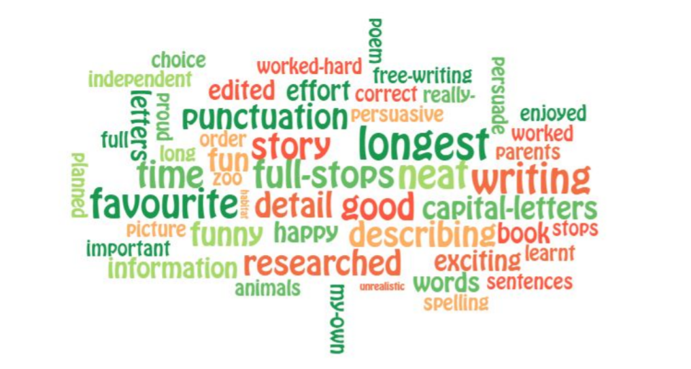

2021
