Canberra College
Network: South Weston Network

Impact Report 2020
The purpose of this document
This document flows directly from our Action Plan for 2020 which translated our school priorities into actions for the current year of our five-year improvement cycle. These actions were responsive to identified challenges, changes or risks to delivery of improvement for student learning.

Our school’s contribution to whole-of-system Strategic Indicators 2
Reporting against our priorities 4
2020 Priority 4
What evidence was collected to inform impact 4
What successes will continue to be included and monitored in future Action Plans 5
Challenges we will address in our next Action Plan 5
Targets or measures 6
Perception data 6
2020 Priority 10
What evidence was collected to inform impact 11
What successes will continue to be included and monitored in future Action Plans 11
Challenges we will address in our next Action Plan 11
Targets or measures 12
Perception data 14

Our school’s contribution to whole-of-system Strategic Indicators
Education Directorate Strategic Indicator 2018-2021
To promote greater equity in learning outcomes in and across ACT public schools

In 2020 our school supported this Strategic Indicator through our college priority
“To advance the engagement and connectedness of our students to the college community.”

Strategies
- Formulate a program to advance student engagement and connectedness
  - Develop an explicit improvement plan expressed in specific outcomes for student learning and wellbeing. These should be well defined, time-bound and measurable. Build a shared ownership of this plan to enable teachers to enact the changes in practice required to achieve college targets .
- College Review Recommendations

- Strengthen the Cultural Integrity initiatives at the college
  - The college culture is underpinned by highly respectful interactions. Students share a sense of belonging and connectedness with their college.
- College Review Commendations

- Improve the physical infrastructure of the college campus.

Education Directorate Strategic Indicator 2018-2021
To facilitate high quality teaching in ACT public schools and strengthen educational outcomes.

In 2020 our school supported this Strategic Indicator through our college priority
“To advance the effectiveness of teaching practice to enhance student learning outcomes.”

Strategies
- Continue to deliver high quality learning and teaching based on best practice research and support the regular use of differentiated teaching practices to ensure every student is engaged and learning successfully.
- College Review recommendations
- Develop an explicit improvement plan expressed in specific outcomes for student learning and wellbeing. These should be well defined, time-bound and measurable. Build a shared ownership of this plan to enable teachers to enact the changes in practice required to achieve college targets .
- College Review Recommendations
- Continue to build a strong professional learning community characterised by:
  - Leaders who spend time working with teachers modelling, evaluating and providing feedback on classroom teaching;
  - A culture of collective responsibility for improving student learning;
  - Routines that enable teachers to work together and learn from each other's practice;
  - Formalised mentoring and coaching;
  - Professional learning tailored to individual and group needs.
- College Review recommendations
- Ensure that high priority in curriculum planning and delivery is given to progressive development of the general capabilities
- Formalised mentoring and coaching
- College Review Recommendations
- An expert team of leadership coaches and instructional mentors will work with school leaders to support schools to develop expertise in coaching and mentoring.
Education Directorate Leadership plan

Education Directorate Strategic Indicator 2018-2021
To centre teaching and learning around students as individuals

In 2019 our school supported this Strategic Indicator through our college priority
“To advance the effectiveness of teaching practice to enhance student learning outcomes.”

Strategies
- Continue to build the data culture. Establish clear expectations in terms of consistent practice and routines in the use of learning and wellbeing data and enact these at whole­ of-college, faculty and classroom levels.
- College Review Recommendations
- Identify and monitor individual student needs.
- College Review Recommendations
- Know your students and how they learn.
AITSL Standard 1

Reporting against our priorities
The college developed our priorities, targets and measures following the School Review recommendations in 2019. With the interruption of COVID -19 the following adjusted priorities resulted.

2020 Priority
To advance the engagement and connectedness of our students to the college community.

Actions
- Relaunch iGroup as CCConnect Group
- Revitalise student meetings to be inclusive and engaging
- Continue to strengthen the transitions process to engage students via a program of orientation events
- Better market extracurricular activities and the Wellbeing Program - get involved at CC
- Cultural Integrity Program
- Gender and Sexual Alliance (GSA)
- Student Voice Program
- Community Engagement (Vocational, Volunteer, Charity)
- College Interior - Asgard, Old Canteen, Toilets, Furniture (BP)
- College Building - Innovation Centre
- College Exterior - CCares Cafe, Front Garden, Urban Farm

What evidence was collected to inform impact
- ACS Markbook - Academic performance (Unit Grades - Year Cohort Semester 1, 2 and 3)
- Canberra College Unit Evaluation Survey - Year Cohort Semester 1, 2 and 3
- System Satisfaction Survey - Climate Survey (Annual cohort report)
Note: The responses are for Year 11 and Year 12 Cohort combined.
- General Capability Self-Assessment Matrix (in development)
Note: This instrument is yet to be developed.

What successes will continue to be included and monitored in future Action Plans
- Our measures show an increase in semester 2 2020 in the proportion of Grad 2021 students reporting Improvement in Teacher Feedback of +4% Strongly Agree (Fig 2) and Challenging but Achievable set tasks of +4% Strongly Agree (Fig 3).
- Our measures show an increase in students' School Identification by 8%, from 3% below the ACT Mean to 6% above the ACT Mean. (Fig 4)
- Our measures show an increase in students' Behavioural Engagement by 6%, from 1% below the ACT Mean to 5% above the ACT Mean. (Fig 5)
- Our measures show an increase in students' Emotional Engagement by 3%, from 1% below the ACT Mean to 7% above the ACT Mean. (Fig 6)

Challenges we will address in our next Action Plan
- Our measures show an increase in semester 2 2020 in the proportion of non-submission by the Grad 2021 cohort (0.9%) led by an increase of non-submission in (A) units (3.5%). We hope to address this by implementing the following strategies:
  - Deeper analysis of data to determine
    - which assessment practices are working well and apply those practices in targeted areas of need.
    - which course areas are working well and apply those practices in targeted areas of need.
- Our data shows the sample size in the System Satisfaction Survey - Climate Survey is low. This will be addressed by
  - Review timing, promotion and communication of the System Satisfaction Survey - Climate Survey in order to increase response rates.
- Our data shows the sample size in the Unit Evaluation Survey is low. This will be addressed by
  - Review timing, promotion and communication of the Unit Evaluation Survey in order to increase response rates.
- We will investigate the possibility of disaggregating Climate Survey information by cohort.
- We will develop General Capability Self-Assessment Matrix as a measurement tool of the engagement and connectedness of students

Targets or measures
Student learning data

Measure | Starting point (2020) | Target (2024)
To reduce or maintain change in the base level proportion of non-submission of assessment by cohort by semester to 2024. | First Year Cohort - Year 11 Sem 1 2020 (Graduating 2021) | To be set at the end of 2021.
Source: ACS Markbook - Academic performance (Unit Grades - Year Cohort Semester 1, 2 and 3)

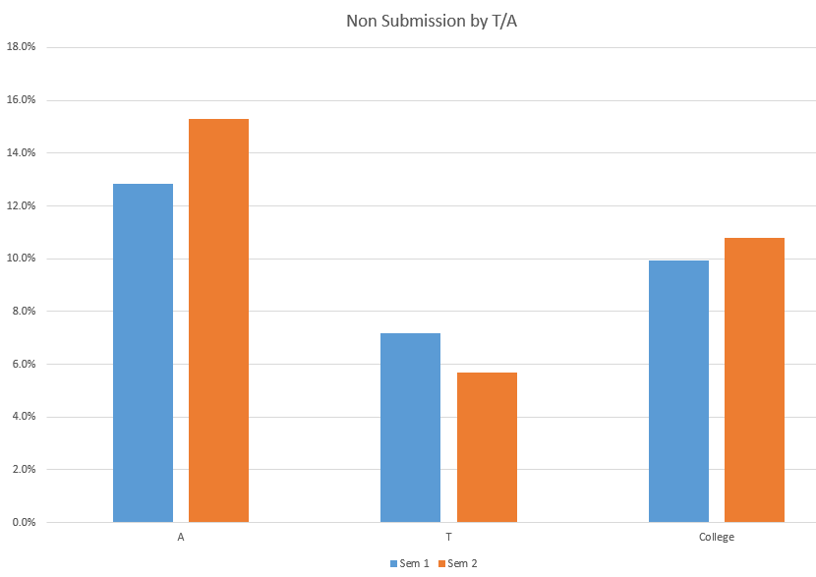
Figure 1

Proportion of assessment items not submitted = (Assessment items not submitted)/(Total Assessment Items)

Perception data

Measure | Starting point (2020) | Target (2024)
Target or measure  To advance or maintain change in the base level proportion of student perception of engagement and connectedness by cohort by semester to 2024. | First Year Cohort - Year 11 Sem 1 2020 (Graduating 2021)  Survey Questions:  Q1. Teacher feedback helped to improve my learning?  Q2. My teacher presented learning activities that were challenging but achievable? | To be set at the end of 2021.
Source: Canberra College Unit Evaluation Survey - Year Cohort Semester 1, 2 and 3

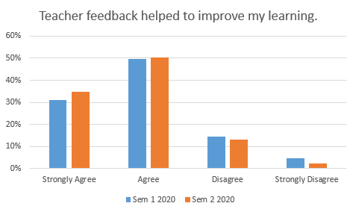
Figure 2
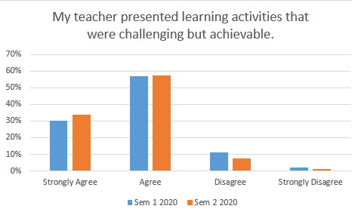
Figure 3

Measure | Starting point (2020) | Target (2024)
To advance or maintain change in the base level proportion of student perception of engagement and connectedness by cohort by year to 2024. | First Year Cohort - Year 11 Sem 1 2020 (Graduating 2021)  Survey Question:  Q1. I like being at my school. | To be set at the end of 2021.
Source: System Satisfaction Survey - Climate Survey (Annual cohort report)
Note: The responses are for Year 11 and Year 12 Cohort combined.

Survey School Identification
Students who identify with their school are more likely to engage in learning and to behave in line with school norms and values. Concepts measured by school identification are: whether a student is happy to be a part of their school; whether they feel a strong connection with the school; whether they feel they belong; as well as whether they care about the school.
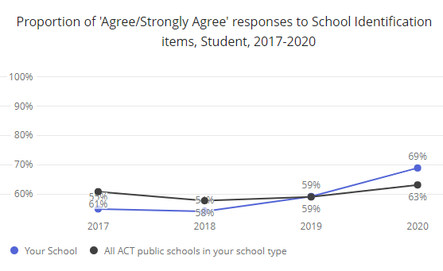
Figure 4
Behavioural Engagement
The Behavioural Engagement domain describes how intensely a student tries their best, both in completing work and undertaking work to the best of their ability. It also includes student self-reported levels of hard work, active participation and how effort. It includes their perceptions that they are able to be a good student.
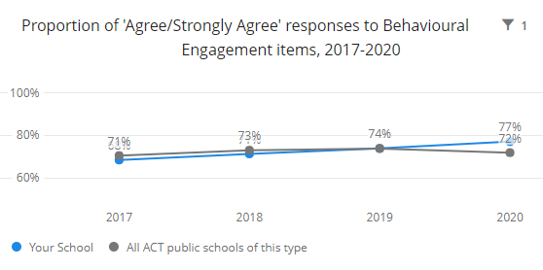
Figure 5

Emotional Engagement
The Emotional Engagement domain includes concepts such as students enjoying the work they do in class and feeling excited about their work. It also addresses levels of student interest in what they are learning and their perceptions of how much fun learning in class is.
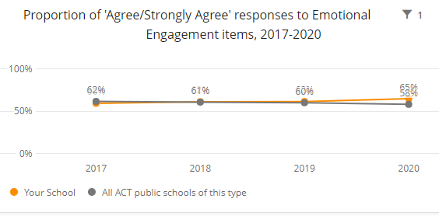
Figure 6

School program and process data

Measure | Starting point (2020) | Target (2024)
Target or measure  Maintain or increase measures of engagement and connectedness of students by cohort by semester to 2024. | Executive Team - Develop an instrument to monitor qualitative indication of trends in the Australian Curriculum - personal and social capabilities. | To be set at the end of 2021.
Source: General Capability Self-Assessment Matrix (in development)

This instrument is yet to be developed.

Measure | Starting point (2020) | Target (2024)
Target or measure  To advance or maintain the proportion of students engaging in the college opportunities including Connections Program, Volunteering, Careers Markets and sports. | First Year Cohort - Year 11 Sem 1 2020 (Graduating 2021) | To be set at the end of 2021.
Source: Data collected during the course of the program including but not limited to connections attendance, volunteering, college sport, competitions, extra-curricular activities.

This data is yet to be collated.

2020 Priority
To advance the effectiveness of teaching practice to enhance student learning outcomes.

Actions
- PLC - Effective pedagogies including those from Visible Learning and High Impact Teaching
- Maintain focus on Learning Intentions and monitor students’ perception of how well they are achieving them
- Development of PL for staff regarding the General Capabilities
- Emphasis on the development of students’ general capabilities in curriculum planning and delivery. (For 2021?)
- Create the opportunity to engage in a formalised mentoring and coaching PL program
- Establish and implement a data plan with appropriate policy and procedures
- Establish a program of PL to improve data literacy, data capture and processing, and the interpretation and use of information.
- Develop ways to support students to improve their level of assessment submission.

What evidence was collected to inform impact
- ACS Markbook - Academic performance (Unit Grades - Year Cohort Semester 1, 2 and 3)
- Canberra College Unit Evaluation Survey - Year Cohort Semester 1, 2 and 3

What successes will continue to be included and monitored in future Action Plans
- Our measures show maintenance in semester 2 2020 in the proportion of Grad 2021 students reporting Grade Point Average. (Fig 7)
Over the next year we will continue to focus on providing support for our students to achieve their best.
- Our measures show an increase in semester 2 2020 in the proportion of Grad 2021 students reporting
  - Valuing their Learning of +4% Agree (Fig 11)
  - Clear Rubrics and/or Marking Schemes of +3% Strongly Agree -1% Agree (Fig 12)
  - Teacher feedback improved my learning +4% Strongly Agree (Fig 9)
  - Lesson Intentions Clear of +2% Strongly Agree +3% Agree (Fig 13) and
  - Tasks Challenging but Achievable +4% Strongly Agree (Fig 10)
- Over the next year we will aim to at least maintain those proportions.
Challenges we will address in our next Action Plan
- Our data shows the sample size in the System Satisfaction Survey - Climate Survey is low. This will be addressed by
  - Review timing, promotion and communication of the System Satisfaction Survey - Climate Survey in order to increase response rates.
- Our data shows the sample size in the Unit Evaluation Survey is low. This will be addressed by
  - Review timing, promotion and communication of the Unit Evaluation Survey in order to increase response rates.

Challenges we will address in our next Action Plan
- Our measures show an increase in semester 2 2020 in the proportion of non-submission by the Grad 2021 cohort (0.9%) led by an increase of non-submission in (A) units (3.5%). We hope to address this by implementing the following strategies:
  - Analysis of data to determine which assessment practices are working well and apply those practices in targeted areas of need.
- Our data shows the sample size in the System Satisfaction Survey - Climate Survey is low. This will be addressed by
  - Review timing, promotion and communication of the System Satisfaction Survey - Climate Survey in order to increase response rates.
- Our data shows the sample size in the Unit Evaluation Survey is low. This will be addressed by
  - Review timing, promotion and communication of the Unit Evaluation Survey in order to increase response rates.
- We will investigate the possibility of disaggregating Climate Survey information by cohort.
- We will develop General Capability Self-Assessment Matrix as a measurement tool of the engagement and connectedness of students

Targets or measures
Student learning data

Measure | Starting point (2020) | Target (2024)
To advance or maintain change in the base level student GPA | First Year Cohort - Year 11 Sem 1 2020 (Graduating 2021) | To be set at the end of 2021.

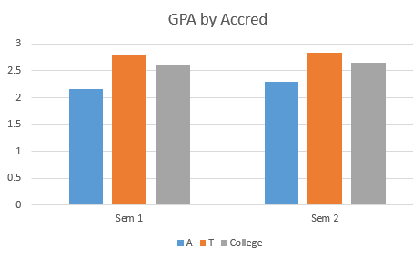
Figure 7
GPA is calculated by converting grades to numbers, and then averaging those numbers for each student. A= 5, B= 4, C = 3, D = 2, E = 1, V = 0

Measure | Starting point (2020) | Target (2024)
To advance or maintain change in the base level proportion of student assessment submission. | First Year Cohort - Year 11 Sem 1 2020 (Graduating 2021) | To be set at the end of 2021.
Figure 8

Proportion of assessment items not submitted = (Assessment items not submitted)/(Total Assessment Items)

Perception data

Measure | Starting point (2020) | Target (2024)
Target or measure  To advance or maintain change in the base level proportion of student perception of engagement and connectedness by cohort by semester to 2024. | First Year Cohort - Year 11 Sem 1 2020 (Graduating 2021)  Survey Questions:  Q1. Teacher feedback helped to improve my learning?  Q2. My teacher presented learning activities that were challenging but achievable? | To be set at the end of 2021.
Source: Canberra College Unit Evaluation Survey - Year Cohort Semester 1, 2 and 3

Agreement is calculated by averaging the following values:

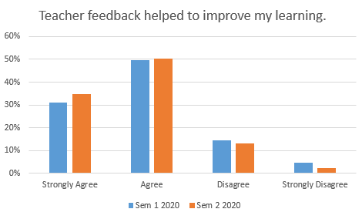

Figure 9

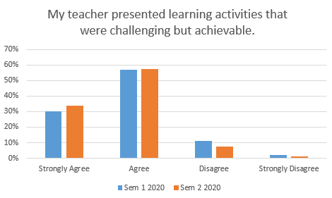

Figure 10
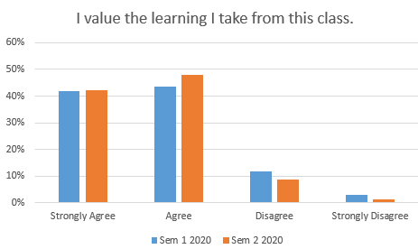

Figure 11

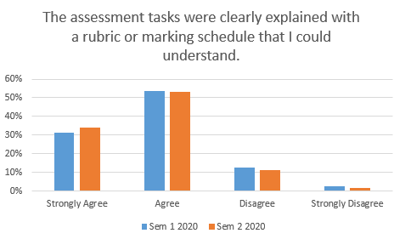
Figure 12

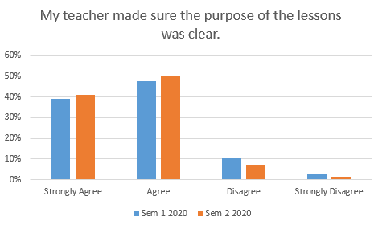
Figure 13

Behavioural Engagement
The Behavioural Engagement domain describes how intensely a student tries their best, both in completing work and undertaking work to the best of their ability. It also includes student self-reported levels of hard work, active participation and how effort. It includes their perceptions that they are able to be a good student.
Figure 14

Emotional Engagement
The Emotional Engagement domain includes concepts such as students enjoying the work they do in class and feeling excited about their work. It also addresses levels of student interest in what they are learning and their perceptions of how much fun learning in class is.
Figure 15

