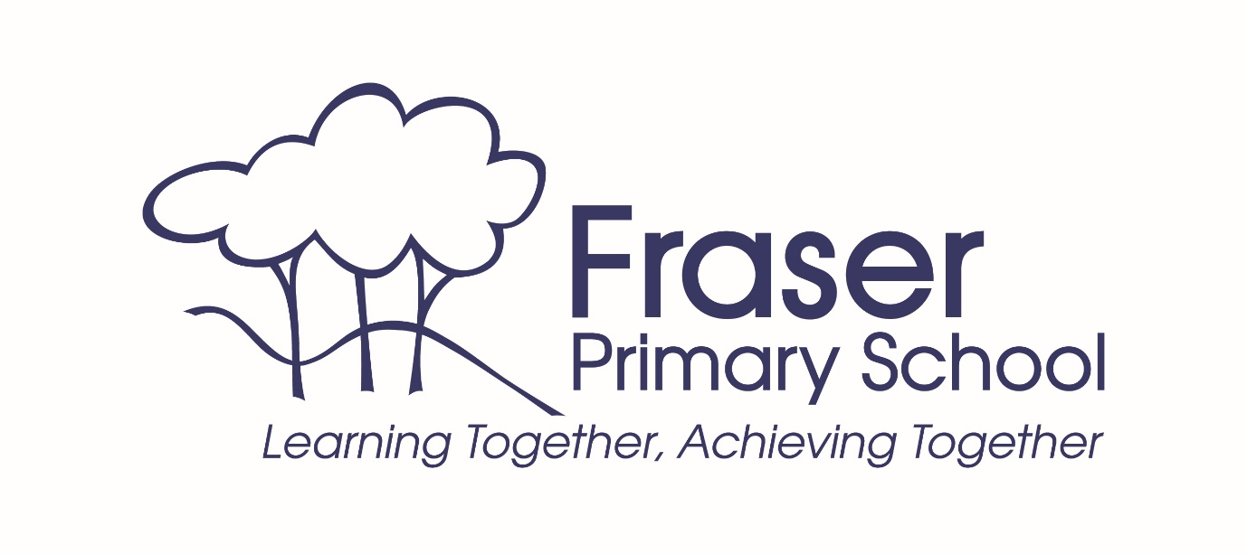

Fraser Primary School
Annual School Board Report 2020

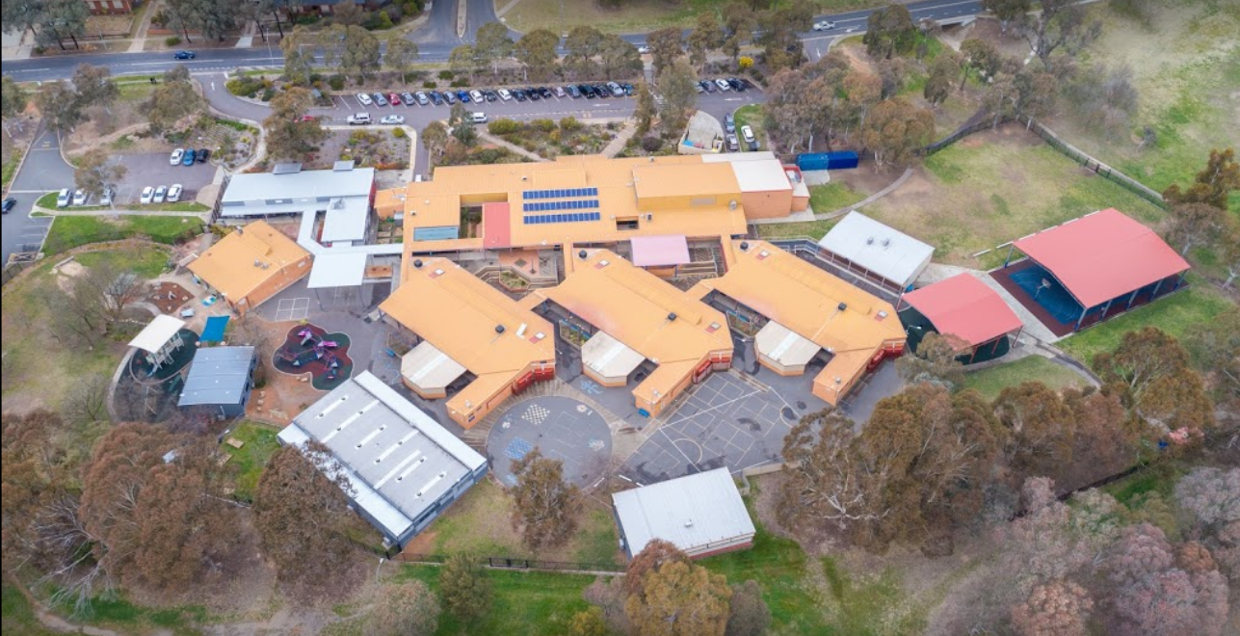

This page is intentionally left blank.

This report supports the work being done in the ACT Education Directorate, as outlined in Strategic Plan 2018-21: A Leading Learning Organisation.

Accessibility
The ACT Government is committed to making its information services, events and venues accessible to as many people as possible.
If you have difficulty reading a standard document and would like to receive this publication in an alternate format, such as large print and audio, please telephone (02) 6247 4580.
If English is not your first language and you require the translating and interpreting service, please telephone 13 14 50.
If you are deaf or hearing impaired and require the National Relay Service, please telephone 13 36 77.
© Australian Capital Territory, Canberra, 2021

Material in this publication may be reproduced provided due acknowledgement is made.

Contents
Reporting to the community 1
Summary of School Board activity 1
School Context 1
Student Information 1
Student enrolment 1
Student attendance 2
Supporting attendance and managing non-attendance 2
Staff Information 3
Teacher qualifications 3
Workforce composition 3
School Review and Development 3
School Satisfaction 4
Overall Satisfaction 4
Learning and Assessment 6
Performance in Literacy and Numeracy 6
Early years assessment 6
NAPLAN 6
Outcomes for College Students 7
Post School Destination 7
Financial Summary 8
Voluntary Contributions 9
Reserves 9
Endorsement Page 10
Members of the School Board 10

Reporting to the community
Schools report to communities in range of ways, including through:
- Annual School Board Reports
- a (5-year) School Improvement Plan (formerly School Strategic Plan)
- annual Impact Reports
- newsletters
- other sources such as My School.

Summary of School Board activity
2020 was a year like no other! The temporary move to online learning presented challenges to everyone, but the Fraser spirit shone throughout, with uplifting stories like teachers delivering easter eggs and the Year 6 class of 2020 shirts, community walks, funny videos of teachers dancing and teddy bears peeking out of windows throughout the neighbourhood. Small things to make a difficult time that much happier for students.
Fraser Primary continues to grow, with K-6 enrolments going from 497 in 2019 to 520 in 2020. This led to another demountable building and a strong push by the School Board to seek resolution to our shrinking outdoor spaces and longer-term planning for more permanent buildings given the sustained growth over many decades. The June opening of a new sandpit and outdoor learning area by Ms Yvette Berry MLA, Deputy Chief Minister and Minister for Education and Early Childhood Development, and Ms Katy Haire, Director General of the Education Directorate, was followed by Board correspondence seeking the Minister’s support to expand the school fence line and longer-term planning for permanent buildings to support our growing student cohort.
In August, the Board was thrilled to receive the Minister’s response advising her strong support for our requests and instruction to the Directorate to start the process. Expanding the fence line is a long process, requiring rezoning of land and community consultation. I look forward to this starting and I am sure the community will support more green space for students in the safety and security of the school fence line, on land controlled and maintained by the school.
Another highlight of 2020 was the amazing results of our school review. This involved a detailed review and consultation with the Board, teachers and some students and parents. The Review found the school ‘outstanding’ in many categories, with particularly positive conclusions including that ‘there is a happy, optimistic feel to the school’ and ‘a strong sense of belonging and pride in the school’. This is something the Board is very proud of, and it was only possible thanks to our school’s students, parents, teachers and leadership.
Lastly, as the departing Chair, I want to pass on my sincere thanks for the honour of representing our community on the school board. I learnt a lot in my 2 years on the board and I thank the school leadership team and all that I have served with. It has been a pleasure and a privilege contributing towards making our great school an even better one.
Chris Flinders
2020 Fraser Primary School Board Chair

School Context
Fraser Primary School opened in 1979. It is situated in the North-West region of Canberra and includes students from the suburb of Fraser and areas of Dunlop, Flynn and Charnwood. Fraser Primary School provides education for students from preschool to year 6 and has an enrolment of around 610 students. The school motto Learning Together Achieving Together underpins all our activities and interactions. The school motto reflects the dedication and professionalism of the staff, the support of the parents/carers and the enthusiasm of the students all of which creates a successful combination and a school that makes a positive difference to the lives of our whole community.
With everyone working together we provide our students with a wide range of high-quality educational experiences in a supportive and caring environment. Fraser Primary School provides quality education for all students. We implement a relevant and innovative curriculum that develops the whole child. Students are engaged in a range of learning experiences that actively develop skills and understandings and allow students to achieve success. Our school values underpin a safe friendly and supportive environment that encourages students to become lifelong learners. Our students are given opportunities to be active and effective citizens in their local and global community. Fraser Preschool is located on site and is an integral part of our school.
The Fraser Preschool program provides the foundation for successful early childhood learning and we provide a rich variety of learning experiences for all our students. The rich Fraser Preschool curriculum is guided by the Early Years Framework and the National Quality Standards. Fraser Primary School prides itself on high expectations and is constantly striving to improve student outcomes.
The Australian Curriculum is implemented from Kindergarten to year 6. National and school based assessment provides parents/carers with ongoing information on their child’s progress. School improvement strategies have included whole school approaches to all aspects of the curriculum with a strong focus on differentiated literacy and numeracy and integrated inquiry programs. The school is committed to ensuring that every child has the best possible opportunity to achieve a standard of excellence in all academic pursuits. High quality instruction from classroom teachers along with intensive short-term support for students from specialist staff when required provides a platform for successful student outcomes.
At Fraser we use the inquiry approach to learning. Our integrated inquiry units provide a valuable context for students to display their understanding knowledge and skills through performance on trans-disciplinary activities that are intellectually demanding and are connected to the world beyond the classroom. Students are provided with the opportunity to negotiate their inquiry-based quest. This gives students a sense of ownership of their learning and the opportunity to utilise their preferred individual learning styles.
Fraser Primary School is committed to ensuring ICT is integral to all aspects of learning. We provide an inclusive environment where all students have opportunities to succeed and offer a diverse range of programs for all students A performing arts specialist implements a developmental performing arts program for years K-6. The school also has a year 5 and 6 instrumental band program. The school offers a comprehensive STEM (Science, Technology, engineering and Maths) program as well as specialist programs incorporating. Science, literacy, dance and physical education. The school promotes a healthy lifestyle through active participation in sporting teams, the explicit teaching of fundamental motor skills and a health promoting curriculum. Students engage with environmental sustainability programs and learning activities.
We recognise students who act as positive role models and citizens in our community through displaying our school values and whole school Positive Behaviours for Learning program (PBL). The school values: support, cooperation, acceptance, respect and friendliness are explicitly taught to students and students displaying these values are acknowledged at school assemblies and across the school community. The school offers a safe learning environment promoting respectful relationships across the whole school. Fraser Primary School is a community-based school that prides itself on the quality of its partnerships with the school community. We believe that the partnership between home and school is the most important relationship of all and we do all we can to ensure the strength of this partnership. The school community is actively involved in celebrating the learning of our students throughout the year.

Student Information

Student enrolment
In this reporting period there were a total of 520 (K-6) students enrolled at this school.
Table: Student enrolment
Student type | Number of students
Gender - Male | 265
Gender - Female | 255
Gender - Non-binary or other* | 0
Aboriginal and Torres Strait Islander | 26
LBOTE** | 84
Source: ACT Education Directorate, Analytics and Evaluation Branch
* If the number of non binary students is less than six, or if gender is unknown, these are randomly assigned 'Male' or 'Female' and included in the counts.
** Language Background Other Than English

Student attendance
Due to the effects of the COVID-19 pandemic, 2020 attendance data has not been published in the Annual School Board Report.

Supporting attendance and managing non-attendance
ACT public schools support parents and careers to meet their legal responsibilities in relation to the compulsory education requirements of the Education Act 2004. The Education Directorate’s Education Participation (Enrolment and Attendance) Policy describes its position with regard to supporting attendance and managing non-attendance. A suite of procedures supports the implementation of the policy. Please refer to https://www.education.act.gov.au/ for further details.

Staff Information

Teacher qualifications
All teachers at this school meet the professional requirements for teaching in an ACT public school. The ACT Teacher Quality Institute (TQI) specifies two main types of provision for teachers at different stages of their career, these are detailed below.
- Full registration is for teachers with experience working in a registered school in Australia or New Zealand who have been assessed as meeting the Proficient level of the Australian Professional Standards for Teachers.
- Provisional registration is for newly qualified teachers or teachers who do not have recent experience teaching in a school in Australia and New Zealand. Many teachers moving to Australia from another country apply for Provisional registration.

Workforce composition
Workforce composition for the current reporting period is provided in the following table. The data is taken from the school’s verified August staffing report. For reporting purposes, it incorporates all school staff including preschools, staff absent for a period of less than four consecutive weeks and staff replacing staff absent for more than four consecutive weeks. It does not include casuals and staff absent for a period of four consecutive weeks or longer.
The Education Directorate is required to report Aboriginal and Torres Strait Islander staff figures. As of June of the reporting period, 135 Aboriginal and Torres Strait Islander staff members were employed across the Directorate.
Table: Workforce composition numbers
Staff employment category | TOTAL
Teaching Staff: Full Time Equivalent Permanent | 26.35
Teaching Staff: Full Time Equivalent Temporary | 5.11
Non Teaching Staff: Full Time Equivalent | 14.71
Source: ACT Education Directorate, People and Performance Branch

School Review and Development
The ACT Education Directorate’s Strategic Plan 2018-2021 provides the framework and strategic direction for School Improvement Plans (formerly School Strategic Plans). This is supported by the school performance and accountability framework ‘People, Practice and Performance: School Improvement in Canberra Public Schools, A Framework for Performance and Accountability’. Annually, system and school level data are used alongside the National School Improvement Tool to support targeted school improvement, high standards in student learning, innovation and best practice in ACT public schools.
Our school was reviewed in 2020. A copy of the Report of Review can be found on our school website.

School Satisfaction
Schools use a range evidence to gain an understanding of the satisfaction levels of their parents and carers, staff and students. Annually in August/ September ACT schools undertake a survey to gain an understanding of school satisfaction at that time. This information is collected from staff, parents and from 2020 students from year 4 and above (previously year 5 and above) through an online survey.

Overall Satisfaction
In this period of reporting, 94% of parents and carers, 98% of staff, and 95% of students at this school indicated they were satisfied with the education provided by the school.
Included in the survey were 16 staff, 14 parent, and 12 student items which are described as the national opinion items. These items were approved by the then Standing Council on School Education and Early Childhood (SCSEEC) for use from 2015. The following tables show the percentage of parents and carers, students and staff who agreed with each of the national opinion items at this school.
Note: The overall response rate for parents and carers in ACT public schools was negatively impacted by COVID-19, dropping from 31% in 2019 to 23% in 2020.
A total of 54 staff responded to the survey. Please note that not all responders answered every question.
Table: Proportion of staff* in agreement with each national opinion item
National opinion item | Proportion of staff
Parents at this school can talk to teachers about their concerns. | 98
Staff are well supported at this school. | 87
Staff get quality feedback on their performance. | 86
Student behaviour is well managed at this school. | 82
Students at this school can talk to their teachers about their concerns. | 100
Students feel safe at this school. | 96
Students like being at this school. | 98
Students’ learning needs are being met at this school. | 98
Teachers at this school expect students to do their best. | 98
Teachers at this school motivate students to learn. | 98
Teachers at this school treat students fairly. | 100
Teachers give useful feedback. | 95
This school is well maintained. | 100
This school looks for ways to improve. | 93
This school takes staff opinions seriously. | 87
This school works with parents to support students' learning. | 98
Source: ACT Education Directorate, Analytics and Evaluation Branch
*Proportion of those who responded to each individual survey question

A total of 162 parents responded to the survey. Please note that not all responders answered every question.
Table: Proportion of parents and carers* in agreement with each national opinion item
National opinion item | Proportion of parents and carers
I can talk to my child’s teachers about my concerns. | 93
My child feels safe at this school. | 91
My child is making good progress at this school. | 89
My child likes being at this school. | 92
My child's learning needs are being met at this school. | 89
Student behaviour is well managed at this school. | 83
Teachers at this school expect my child to do his or her best. | 96
Teachers at this school give useful feedback. | 89
Teachers at this school motivate my child to learn. | 90
Teachers at this school treat students fairly. | 92
This school is well maintained. | 97
This school looks for ways to improve. | 91
This school takes parents’ opinions seriously. | 82
This school works with me to support my child's learning. | 84
Source: ACT Education Directorate, Analytics and Evaluation Branch
*Proportion of those who responded to each individual survey question

A total of 198 students responded to the survey. Please note that not all responders answered every question.
Table: Proportion of students* in agreement with each national opinion item
National opinion item | Proportion of students
I can talk to my teachers about my concerns. | 83
I feel safe at this school. | 90
I like being at my school. | 82
My school gives me opportunities to do interesting things. | 90
My school is well maintained. | 95
My school looks for ways to improve. | 96
My teachers expect me to do my best. | 98
My teachers motivate me to learn. | 92
Staff take students’ concerns seriously. | 90
Student behaviour is well managed at my school. | 77
Teachers at my school treat students fairly. | 82
Teachers give useful feedback. | 92
Source: ACT Education Directorate, Analytics and Evaluation Branch
*Proportion of those who responded to each individual survey question

Learning and Assessment

Performance in Literacy and Numeracy

Early years assessment
Students in kindergarten undertake an on-entry and on-exit assessment of their early reading and numeracy skills using the BASE program. Student results are reported against five performance bands at the end of semester 1 and 2. Below are the results for this school for the current reporting period.
Due to the impact of COVID-19, analysis of BASE data for 2020 has been delayed. Analysis will be provided to schools in 2021. Please speak with the school should you require further information.

NAPLAN
Students in years 3, 5, 7 and 9 in all ACT schools participate in the National Assessment Program-Literacy and Numeracy (NAPLAN). This program assesses skills in reading, writing, spelling, grammar and punctuation, and numeracy.
*Note: There are no NAPLAN results for 2020, with the assessments not being conducted due to the impacts of COVID-19.

Financial Summary
The school has provided the Directorate with an end of year financial statement that was approved by the school board. Further details concerning the statement can be obtained by contacting the school. The following summary covers use of funds for operating costs and does not include expenditure in areas such as permanent salaries, buildings and major maintenance.

INCOME | January-June | July-December | January-December
Self-management funds | 136794.67 | 135326.82 | 272121.49
Voluntary contributions | 2180.00 | 3420.00 | 5600.00
Contributions & donations | 2475.00 | 12272.88 | 14747.88
Subject contributions | 5156.48 | 622.34 | 5778.82
External income (including community use) | 6159.67 | 5718.93 | 11878.60
Proceeds from sale of assets | 0.00 | 0.00 | 0.00
Bank Interest | 2052.39 | 1580.55 | 3632.94
TOTAL INCOME | 154818.21 | 158941.52 | 313759.73
EXPENDITURE
Utilities and general overheads | 47531.56 | 61285.48 | 108817.04
Cleaning | 327.27 | 0.00 | 327.27
Security | 811.49 | 1176.37 | 1987.86
Maintenance | 38000.73 | 35870.14 | 73870.87
Administration | 9453.69 | 12411.96 | 21865.65
Staffing | 0.00 | 711.22 | 711.22
Communication | 1529.14 | 2028.62 | 3557.76
Assets | 26698.43 | 11832.15 | 38530.58
Leases | 0.00 | 0.00 | 0.00
General office expenditure | 28830.13 | 22410.48 | 51240.61
Educational | 47088.66 | 28130.73 | 75219.39
Subject consumables | 6077.37 | -36.30 | 6041.07
Other Payments | 0.00 | 6671.20 | 6671.20
Directorate Funded Payments | 0.00 | 8920.02 | 8920.02
TOTAL EXPENDITUIRE | 206348.47 | 191412.07 | 397760.54
OPERATING RESULT | -51530.26 | -32470.55 | -84000.81
Actual Accumulated Funds (31.12.20) | 232491.48 | 232491.48 | 232491.48
Outstanding commitments (minus) | -4573.04 | 0.00 | 0.00
BALANCE | 227918.44 | 232491.48 | 232491.48

Voluntary Contributions
The funds listed were used to support the general operations of the school. The spending of voluntary contributions is in line with the approved budget for this reporting period.

Reserves
Name and Purpose | Amount | Expected Completion
Nil | $ 0

Endorsement Page

Members of the School Board
Parent Representative(s): | Melina Tsembis, | Chiara McNabb
Community Representative(s):
Teacher Representative(s): | Melinda Clarke, | Emily Vernon,
Student Representative(s):
Board Chair: | Chris Flinders
Principal: | Mark Deeker
I approve the report, prepared in accordance with the provision of the ACT Education Act 2004, section 52.

2020 Board Chair Signature: | Chris Flinders | Date: | 19/ 07/ 2021

I certify that to the best of my knowledge and belief the evidence and information reported in this Annual School Board Report represents an accurate record of the Board’s operations during this reporting period.

Principal Signature: | Mark Deeker | Date: | 16 / 07 / 2021

