Red Hill Primary School
Annual School Board Report 2020

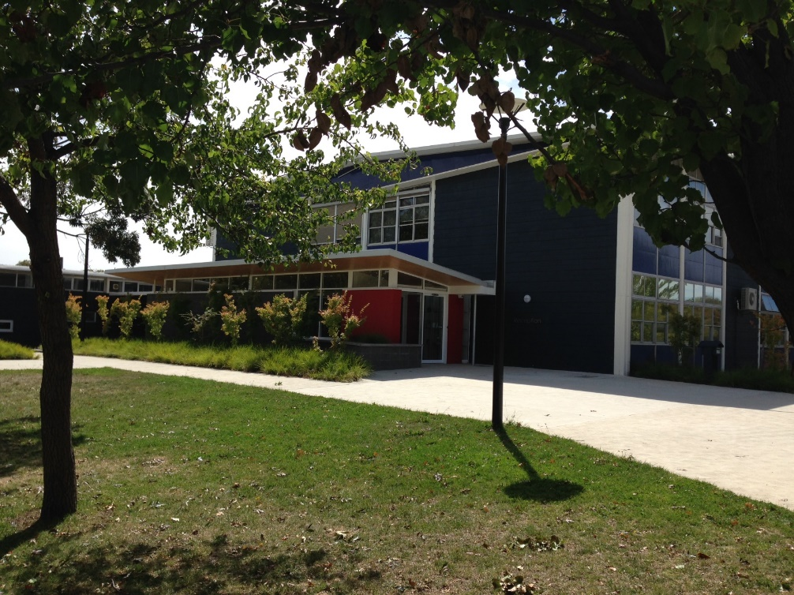

This page is intentionally left blank.

This report supports the work being done in the ACT Education Directorate, as outlined in Strategic Plan 2018-21: A Leading Learning Organisation.

Accessibility
The ACT Government is committed to making its information services, events and venues accessible to as many people as possible.
If you have difficulty reading a standard document and would like to receive this publication in an alternate format, such as large print and audio, please telephone (02) 6247 4580.
If English is not your first language and you require the translating and interpreting service, please telephone 13 14 50.
If you are deaf or hearing impaired and require the National Relay Service, please telephone 13 36 77.
© Australian Capital Territory, Canberra, 2021

Material in this publication may be reproduced provided due acknowledgement is made.

Contents
Reporting to the community 1
Summary of School Board activity 1
School Context 1
Student Information 2
Student enrolment 2
Student attendance 2
Supporting attendance and managing non-attendance 2
Staff Information 2
Teacher qualifications 2
Workforce composition 3
School Review and Development 3
School Satisfaction 3
Overall Satisfaction 3
Learning and Assessment 5
Performance in Literacy and Numeracy 5
Early years assessment 5
NAPLAN 6
Financial Summary 7
Voluntary Contributions 8
Reserves 8
Endorsement Page 9
Members of the School Board 9

Reporting to the community
Schools report to communities in range of ways, including through:
- Annual School Board Reports
- a (5-year) School Improvement Plan (formerly School Strategic Plan)
- annual Impact Reports
- newsletters
- other sources such as My School.

Summary of School Board activity
Progress towards achieving Red Hill School’s strategic priorities was reported to the Board each term. The Board has been very supportive of the school’s Positive Education Journey, approving an ongoing ‘critical friendship’ with Dr Justin Coulson to facilitate the implementation of positive education principles in the school curriculum. In 2020 our Positive Education Implementation Team introduced the first two domains of the school’s Positive Education framework (Health & Strengths).
The School Board played a key role in the review of our Assessment and Reporting Policy, which was approved by the Board for implementation from 2021 onwards. The Board also contributed to the school’s self-assessment against the International Baccalaureate (IB) Primary Years Program standards and practices in preparation for our IB Evaluation and School Review in April 2021.
The School Board also supported two very successful community partnerships in 2020. The first was with the Healthy Kids Association to provide a canteen service three days a week. The second partnership was with the school’s P&C and the Education Directorate, and resulted in the creation of a greatly enhanced Voyager Park to provide an outdoor curriculum resource and weekend community play space to promote physical activity. Voyager Park now includes a turfed football field, outdoor shaded structure, new play equipment and a one kilometre mountain bike track.
Our 60th birthday celebrations were sadly postponed because of Covid 19, however we look forward to holding a special Heritage celebration in April 2021.

School Context
Opened in 1960, Red Hill Primary School caters to a diverse student clientele in the inner south of Canberra, drawing families from diplomatic, government, defence force, university and other backgrounds. As an International Baccalaureate (IB) World School, Red Hill provides an inclusive, international education for 830 students in preschool to year 6.
Red Hill School’s strengths are a systematic delivery of curriculum; the promotion of a learning culture with a strong focus on high expectations and collaboration; the development of a positive and inclusive school environment; the provision of enrichment opportunities that encourage students to become active life-long learners; and community partnerships.
Our mission is to prepare students to become active, caring, lifelong learners who demonstrate respect for themselves and others and have the capacity to participate in the world around them with open hearts and inquiring minds. We focus on the development of the whole child. We create collaborative partnerships with parents and the community that foster intercultural understanding and develop inquiring, knowledgeable, compassionate and resilient young people who are able to make a difference in our world.

Student Information

Student enrolment
In this reporting period there were a total of 717 students enrolled at this school in kindergarten to year six. We also had 88 students enrolled in preschool.
Table: Student enrolment
Student type | Number of students
Gender - Male | 370
Gender - Female | 347
Gender - Non-binary or other* | 0
Aboriginal and Torres Strait Islander | 22
LBOTE** | 285
Source: ACT Education Directorate, Analytics and Evaluation Branch
* If the number of non-binary students is less than six, or if gender is unknown, these are randomly assigned 'Male' or 'Female' and included in the counts.
** Language Background Other Than English

Student attendance
Due to the effects of the COVID-19 pandemic, 2020 attendance data has not been published in the Annual School Board Report.

Supporting attendance and managing non-attendance
ACT public schools support parents and careers to meet their legal responsibilities in relation to the compulsory education requirements of the Education Act 2004. The Education Directorate’s Education Participation (Enrolment and Attendance) Policy describes its position with regard to supporting attendance and managing non-attendance. A suite of procedures supports the implementation of the policy. Please refer to https://www.education.act.gov.au/ for further details.

Staff Information

Teacher qualifications
All teachers at this school meet the professional requirements for teaching in an ACT public school. The ACT Teacher Quality Institute (TQI) specifies two main types of provision for teachers at different stages of their career, these are detailed below.
- Full registration is for teachers with experience working in a registered school in Australia or New Zealand who have been assessed as meeting the Proficient level of the Australian Professional Standards for Teachers.
- Provisional registration is for newly qualified teachers or teachers who do not have recent experience teaching in a school in Australia and New Zealand. Many teachers moving to Australia from another country apply for Provisional registration.

Workforce composition
Workforce composition for the current reporting period is provided in the following table. The data is taken from the school’s verified August staffing report. For reporting purposes, it incorporates all school staff including preschools, staff absent for a period of less than four consecutive weeks and staff replacing staff absent for more than four consecutive weeks. It does not include casuals and staff absent for a period of four consecutive weeks or longer.
The Education Directorate is required to report Aboriginal and Torres Strait Islander staff figures. As of June of the reporting period, 135 Aboriginal and Torres Strait Islander staff members were employed across the Directorate.
Table: Workforce composition numbers
Staff employment category | TOTAL
Teaching Staff: Full Time Equivalent Permanent | 32.49
Teaching Staff: Full Time Equivalent Temporary | 12.00
Non-Teaching Staff: Full Time Equivalent | 13.67
Source: ACT Education Directorate, People and Performance Branch

School Review and Development
The ACT Education Directorate’s Strategic Plan 2018-2021 provides the framework and strategic direction for School Improvement Plans (formerly School Strategic Plans). This is supported by the school performance and accountability framework ‘People, Practice and Performance: School Improvement in Canberra Public Schools, A Framework for Performance and Accountability’. Annually, system and school level data are used alongside the National School Improvement Tool to support targeted school improvement, high standards in student learning, innovation and best practice in ACT public schools.
Our school will be reviewed in April 2021.

School Satisfaction
Schools use a range evidence to gain an understanding of the satisfaction levels of their parents and carers, staff and students. Annually in August/ September ACT schools undertake a survey to gain an understanding of school satisfaction at that time. This information is collected from staff, parents and from 2020 students from year 4 and above (previously year 5 and above) through an online survey.

Overall Satisfaction
In this period of reporting, 88% of parents and carers, 93% of staff, and 80% of students at this school indicated they were satisfied with the education provided by the school.
Included in the survey were 16 staff, 14 parent, and 12 student items which are described as the national opinion items. These items were approved by the then Standing Council on School Education and Early Childhood (SCSEEC) for use from 2015. The following tables show the percentage of parents and carers, students and staff who agreed with each of the national opinion items at this school.
Note: The overall response rate for parents and carers in ACT public schools was negatively impacted by COVID-19, dropping from 31% in 2019 to 23% in 2020.
A total of 59 staff responded to the survey. Please note that not all responders answered every question.
Table: Proportion of staff* in agreement with each national opinion item
National opinion item | Proportion of staff
Parents at this school can talk to teachers about their concerns. | 98
Staff are well supported at this school. | 71
Staff get quality feedback on their performance. | 62
Student behaviour is well managed at this school. | 61
Students at this school can talk to their teachers about their concerns. | 92
Students feel safe at this school. | 92
Students like being at this school. | 97
Students’ learning needs are being met at this school. | 92
Teachers at this school expect students to do their best. | 95
Teachers at this school motivate students to learn. | 93
Teachers at this school treat students fairly. | 90
Teachers give useful feedback. | 90
Teachers give useful feedback. | 90
This school is well maintained. | 70
This school looks for ways to improve. | 88
This school takes staff opinions seriously. | 66
This school works with parents to support students' learning. | 95
Source: ACT Education Directorate, Analytics and Evaluation Branch
*Proportion of those who responded to each individual survey question

A total of 225 parents responded to the survey. Please note that not all responders answered every question.
Table: Proportion of parents and carers* in agreement with each national opinion item
National opinion item | Proportion of parents and carers
I can talk to my child’s teachers about my concerns. | 93
My child feels safe at this school. | 91
My child is making good progress at this school. | 84
My child likes being at this school. | 91
My child's learning needs are being met at this school. | 83
Student behaviour is well managed at this school. | 79
Teachers at this school expect my child to do his or her best. | 89
Teachers at this school give useful feedback. | 80
Teachers at this school motivate my child to learn. | 83
Teachers at this school treat students fairly. | 86
This school is well maintained. | 87
This school looks for ways to improve. | 91
This school takes parents’ opinions seriously. | 76
This school works with me to support my child's learning. | 81
Source: ACT Education Directorate, Analytics and Evaluation Branch
*Proportion of those who responded to each individual survey question

A total of 264 students responded to the survey. Please note that not all responders answered every question.
Table: Proportion of students* in agreement with each national opinion item
National opinion item | Proportion of students
I can talk to my teachers about my concerns. | 58
I feel safe at this school. | 71
I like being at my school. | 70
My school gives me opportunities to do interesting things. | 86
My school is well maintained. | 69
My school looks for ways to improve. | 82
My teachers expect me to do my best. | 91
My teachers motivate me to learn. | 77
Staff take students’ concerns seriously. | 61
Student behaviour is well managed at my school. | 46
Teachers at my school treat students fairly. | 63
Teachers give useful feedback. | 72
Source: ACT Education Directorate, Analytics and Evaluation Branch
*Proportion of those who responded to each individual survey question

Learning and Assessment

Performance in Literacy and Numeracy

Early years assessment
Students in kindergarten undertake an on-entry and on-exit assessment of their early reading and numeracy skills using the BASE program. Student results are reported against five performance bands at the end of semester 1 and 2. Below are the results for this school for the current reporting period.
Due to the impact of COVID-19, analysis of BASE data for 2020 has been delayed. Analysis will be provided to schools in 2021. Please speak with the school should you require further information.

NAPLAN
Students in years 3, 5, 7 and 9 in all ACT schools participate in the National Assessment Program-Literacy and Numeracy (NAPLAN). This program assesses skills in reading, writing, spelling, grammar and punctuation, and numeracy.
*Note: There are no NAPLAN results for 2020, with the assessments not being conducted due to the impacts of COVID-19.

Financial Summary
The school has provided the Directorate with an end of year financial statement that was approved by the school board. Further details concerning the statement can be obtained by contacting the school. The following summary covers use of funds for operating costs and does not include expenditure in areas such as permanent salaries, buildings and major maintenance.
Table: Financial Summary
INCOME | January-June | July- December | January-December
Self-management funds | 186604.05 | 190704.06 | 377308.11
Voluntary contributions | 8020.00 | 4700.00 | 12720.00
Contributions & donations | 0.00 | 2432.22 | 2432.22
Subject contributions | 0.00 | 6606.00 | 6606.00
External income (including community use) | 9529.19 | 4675.17 | 14204.36
Proceeds from sale of assets | 0.00 | 0.00 | 0.00
Bank Interest | 2769.36 | 1824.20 | 4593.56
TOTAL INCOME | 206922.60 | 210941.65 | 417864.25
EXPENDITURE
Utilities and general overheads | 150622.86 | 112247.17 | 262870.03
Cleaning | 2360.60 | 0.00 | 2360.60
Security | 198.83 | 0.00 | 198.83
Maintenance | 56578.63 | 26744.25 | 83322.88
Administration | 17808.22 | 12793.85 | 30602.07
Staffing | 0.00 | 900.00 | 900.00
Communication | 1583.65 | 1993.80 | 3577.45
Assets | 58941.45 | 21943.58 | 80885.03
Leases | 0.00 | 0.00 | 0.00
General office expenditure | 18250.78 | 20592.69 | 38843.47
Educational | 35532.16 | 31564.92 | 67097.08
Subject consumables | 0.00 | 508.18 | 508.18
Other Payments | 0.00 | 4782.49 | 4782.49
Directorate Funded Payments | 0.00 | 7534.04 | 7534.04
TOTAL EXPENDITUIRE | 341877.18 | 241604.97 | 583482.15
OPERATING RESULT | -134954.58 | -30663.32 | -165617.90
Actual Accumulated Funds (31.12.20) | 270735.05 | 270735.05 | 270735.05
Outstanding commitments (minus) | 0.00 | 0.00 | 0.00
BALANCE | 270735.05 | 270735.05 | 270735.05

Voluntary Contributions
The funds listed were used to support the general operations of the school. The spending of voluntary contributions is in line with the approved budget for this reporting period.

Reserves
Name and Purpose | Amount | Expected Completion
Facilities & equipment upgrade  The school was built in 1960. Some health and safety issues are arising because of the age and design of the school facilities which require repair.  The school is also endeavouring to create a more contemporary learning space which requires new furniture. | $20,000 | 02/2021
Information Communication Technologies  As part of our strategic plan the school is enhancing teaching and learning through the use of contemporary learning technologies. This requires ongoing upgrades of equipment and relevant professional learning. | $50,000 | 12/2021
Oval upgrade  The school oval is zoned for community use, although it belongs to the school. Increased use by a larger school population and the wider community, accompanied by a drought, have caused significant disrepair to the oval which requires remediation. The school is working with the Education Directorate and local community to make the oval an enhanced play space for Red Hill and the surrounding environment. | $50,000 | 02/2021
Redevelopment project  This is linked to the first reserve. In creating a more contemporary learning space the school requires changes to the physical lay-out of some areas e.g. new walls in shared corridor spaces. | $30,000 | 12/2021

Endorsement Page

Members of the School Board
Parent Representative(s): | Jim Roy, | Sharon Bown, | Dr Philip Coote.
Community Representative(s): | Paul Whyte,
Teacher Representative(s): | Kirsten Gardner, | Toni Constable
Board Chair: | Jim Roy
Principal: | Louise Owens
I approve the report, prepared in accordance with the provision of the ACT Education Act 2004, section 52.

2020 Board Chair Signature: | Jim Roy | Date: | 19/07/2021

I certify that to the best of my knowledge and belief the evidence and information reported in this Annual School Board Report represents an accurate record of the Board’s operations during this reporting period.

Principal Signature: | Louise Owens | Date: | 19 / 07 / 2021

