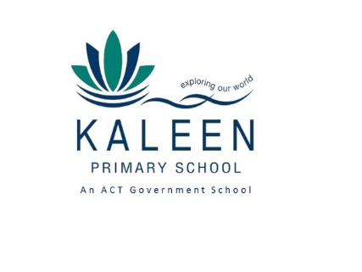
Kaleen Primary School
  - Network: Belconnen

School Improvement Plan 2018-2022

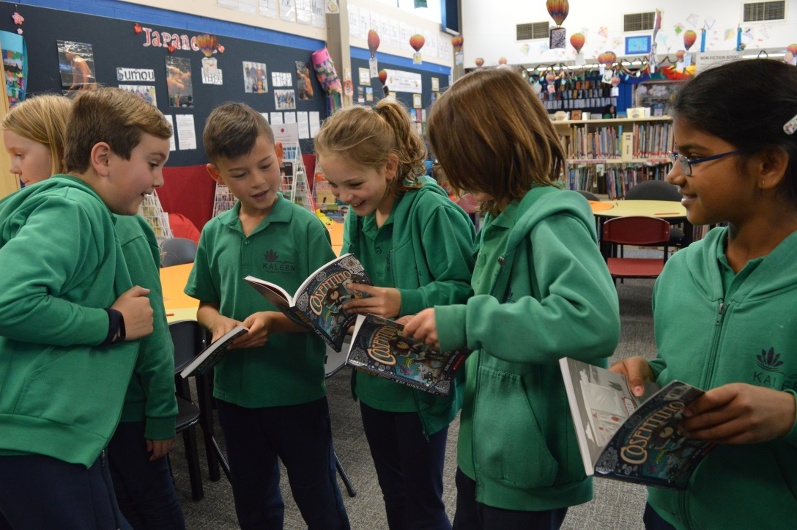

The purpose of school improvement planning
This plan establishes a strong improvement agenda to be driven by school leaders over the next five years. It was informed by the Directorate’s Strategic Plan and system-level and school-based analysis of multiple sources of evidence including our School Review findings. Analysis of these multiple sources of evidence is supported by an annual provision to each school of a data summary as a key enabler of our improvement planning and implementation.
Each school undertakes a school review as an integral component of in its five-year improvement planning cycle. The reviews are an important part of how the Directorate supports and monitors school improvement. Reviews provide schools with quality and independent feedback, tailored to the school’s context. Each school is reviewed at least every five years, providing valuable opportunities for self-reflection, planning and improvement. The school improvement planning process is below. This representation is used in the footer of all school-based improvement documents to indicate the stage of planning or implementation.
Analysis Priorities Strategies Actions Impact (for student)
Our school improvement planning is grounded in evidence from research and practice and expressed in terms of improvements in measurable student outcomes. Explicit five-year targets for improvement have been set and will give life to monitoring, evaluation and communication of progress to teachers, families and students.

Our school’s improvement agenda positioned within the Directorate’s Strategic Plan

Context
Kaleen suburb is undergoing significant urban renewal and demographic change and these factors are reflected in the changing student population of Kaleen Primary School. In addition, over the last four years Kaleen Primary School has taken a direction away from streamed classes to an inclusive model. The school has recently developed a School Enrolment Management Plan (SEMP) to prioritise ‘in area’ and ‘concurrent sibling’ enrolments. In area enrolments have increased from 50% of the school population in 2014 to 52% in 2018. During that same period the Index of Community Socio-Educational Advantage (ICSEA) rating dropped from 1139 to 1115. This identifies changing factors in our students’ family backgrounds (parents’ occupation, school education and non-school education) from information provided by parents. In 2014, 42% of students were identified with language backgrounds other than English and this has increased to approximately 49% of students in 2018.

Vision
Directorate’s vision: We will be a leading learning organisation where people know they matter.

School’s vision:
At Kaleen Primary School we are committed to working with parents as partners in learning to ensure that all students succeed. We are committed to the holistic development of every child - socially, emotionally, academically, culturally and physically. We build our student’s knowledge in cross-disciplinary, critical and creative thinking, and problem solving skills with the aim of developing our students as future focused 21st century learners. As a professional learning community, we work collaboratively to ensure all students achieve their learning potential and enjoy coming to school to learn, share, celebrate and have fun.

Mission
Directorate’s mission: We develop and deliver educational services to empower each child and young person in the ACT to learn for life.
School’s mission: To engage, equip and empower all children and young people to learn for life.

Values
Directorate’s Values: Respect, Integrity, Collaboration, Innovation.
School’s values: Respect, Learning, Responsibility, Creativity, Empathy.
These values are integral to our school’s 2018-2022 Positive Behaviour for Learning (PBL) program’s expectations that: We are safe, respectful, responsible learners.

Teacher Beliefs
- All students can learn and develop a love of learning
- We are passionate about teaching and learning
- Assessment is feedback to us about us (we don’t blame our students)
- Learning is a dialogue not a monologue
- Everyone is free to make mistakes
- We are learners, evaluators and change agents

Education Directorate’s Strategic Goals for 2018-2021
- Schools where students love to learn
- Investing in early childhood
- Evidence informed decisions
- Learning culture
- United leadership team

Education Directorate’s Strategic Indicators for 2018-2021
- To promote greater equity in learning outcomes in and across ACT public schools
- To facilitate high quality teaching in ACT public schools and strengthen educational outcomes
- To centre teaching and learning around students as individuals
The Directorate annually publishes progress against its strategic indicators. Our school’s contributions to these strategic indicators are detailed in our annual Impact Reports.

Multiple sources of evidence
Evidence informing this School Improvement Plan includes:
- analysis of system-level data
- analysis of school-based evidence over time (past 4/5 years)
- recommendations from School Review
- Quality Ratings from assessment against the National Quality Framework.

Our improvement priorities

Priority 1: Improve student outcomes in literacy (reading and writing), numeracy and STEM using an evidence-based approach
The statement below details our vision for how this priority will change the experience of school for our students.
Student outcomes to be achieved through this priority include:
- The percentage of students achieving expected or above expected growth as measured by PIPS and NAPLAN Targets is increased
- The percentage of student outcomes in Literacy, Numeracy and STEM as measure by PAT Online and School Based Reports is increased
Targets/Measures to be achieved by 2022
The following targets have been created to ensure the school is sustaining and building upon its current level of performance. ‘Measure a’ (green text) is focused on maintaining current level of performance, ‘measure b’ (orange text) aims to extend on previous performance and ‘measure c’ is ambitious and highly aspirational.

Student learning data
Target: P1.1
- P1.1a: Ensure at least 60% of students achieve at or above expected growth (‘value added’) in Maths and Reading
- P1.1b: Ensure at least 70% of students achieve at or above expected growth (‘value added’) in Maths and Reading
- P1.1c: Ensure at least 80% of students achieve at or above expected growth (‘value added’) in Maths and Reading
Source: PIPs
Starting point: From 2014 to 2017 the average percentage of students who achieved at or above expected growth was 84% in Maths and 82% in Reading.

Target: P1.2
- P1.2a: Achieve at or above the ACT Education Directorate Average Scaled Score Growth in Reading, Writing & Numeracy
- P1.2b: Achieve 5 points or more above the ACT Education Directorate Average Scaled Score Growth in Reading, Writing & Numeracy
- P1.2c: Achieve 10 points or more above the ACT Education Directorate Average Scaled Score Growth in Reading, Writing & Numeracy
Source: NAPLAN
Starting point: From 2014 to 2017 the average Scaled Score Growth comparison between KPS and the ACT was -1.7025 in Reading, 5.175 in Writing and 0.635 in Numeracy.

Target: P1.3
- P1.3a: Ensure that at least 60% of our students achieve at or above expected growth in Reading, Writing & Numeracy
- P1.3b: Ensure that at least 65% of our students achieve at or above expected growth in Reading, Writing & Numeracy
- P1.3c: Ensure that at least 70% of our students achieve at or above expected growth in Reading, Writing & Numeracy
Source: NAPLAN
Starting point: From 2014 – 2017 the average percentage of students who achieved at or above expected growth was 67.8% in Reading, 66.46% in Writing* and 62.25% in Numeracy.
*Data for writing growth was not available in 2016.
Target: P1.4
- P1.4a: Achieve results that are within 0.2 (+or-) of a standard deviation of the results of ‘Similar Schools’ in Reading, Writing & Numeracy (NAPLAN My School Data).
- P1.4b: Achieve one or more results that are above 0.2 (+) of a standard deviation of the results of ‘Similar Schools’ in Reading, Writing & Numeracy (NAPLAN My School Data).
- P1.4c: Achieve two or more results that are above 0.2 (+) of a standard deviation of the results of ‘Similar Schools’ in Reading, Writing & Numeracy (NAPLAN My School Data).
Source: My Schools Website - Against Similar Schools
Starting point: Within 0.2 (+or-) of a standard deviation in all areas from 2014-2017.
Target: P1.5
- P1.5a: Maintain the average level of Y1-6 achievement demonstrated in Number
- P1.5b: Increase the average level of Y1-6 achievement demonstrated in Number by between 0.1 & 0.5
- P1.5c: Increase the average level of Y1-6 achievement demonstrated in Number by more than 0.5 Source: Semester 1 & 2 student school based reports
Starting point: 3.43 average (A=5, B=4, C=3, D=2 E=1)
Target: P1.6
- P1.6a: Maintain the school’s average Stanine score of PAT Maths Term 4 Assessment (Y2-6)
- P1.6b: Increase the school’s average Stanine score of PAT Maths Term 4 Assessment by 0.1 to 0.5 stanine (Y2-6)
- P1.6c: Increase the school’s average school Stanine score of PAT Maths Term 4 Assessment by more than 0.5 stanines (Y2-6)
Source: PAT Maths
Starting point: 6.09 average (A=5, B=4, C=3, D=2 E=1)

Target: P1.7
- P1.7a: Maintain or increase the average level of Y1-6 achievement demonstrated in Science Inquiry
- P1.7b: Increase the average level of Y1-6 achievement demonstrated in Science Inquiry by more than 0.1
- P1.7C: Increase the average level of Y1-6 achievement demonstrated in Science Inquiry by more than 0.5
Source: Semester 1 & 2 student school based reports
Starting point: 3.46 average (A=5, B=4, C=3, D=2 E=1)

Target: P1.8
- P1.8a: Maintain or increase the average level of Y1-6 achievement demonstrated in Design Technology outcomes
- P1.8b: Increase the average level of Y1-6 achievement demonstrated in Design Technology by more than 0.1
- P1.8c: Increase the average level of Y1-6 achievement demonstrated in Design Technology by more than 0.5
Source: Semester 1 & 2 student school based reports
Starting point: 3.38 average (A=5, B=4, C=3, D=2 E=1)
Target: P1.9
- P1.9a: Maintain the school’s average Stanine score of PAT Science Term 4 Assessment (Y3-6) *2018 Baseline data established in term 1
- P1.9b: Increase the school’s average Stanine score of PAT Science Term 4 Assessment by 0.1 to 0.5 stanine (Y3-6) *2018 Baseline data established in term 1
- P1.9c: Increase the school’s average Stanine score of PAT Science Term 4 Assessment by more than 0.5 stanines (Y3-6)
Source: PAT Science
Starting point: 5.04 Average Stanine

Perception data
Target: P1.10
- P1.10a: Maintain or increase the number of parents who agree or strongly agree that community partnerships are valued and maintained from 83% (2014-2017 average) in 2021
- P1.10b: Increase the number of parents who agree or strongly agree that community partnerships are valued and maintained from 83% (2014-2017 average) to 85% or above in 2021
- P1.10c: Increase the number of parents who agree or strongly agree that community partnerships are valued and maintained from 83% (2014-2017 average) 87% or above in 2021
Source: ASCSIMT
Starting point: Stated within the targets

Priority 2: Enhance school culture and promote social and emotional wellbeing
The statement below details our vision for how this priority will change the experience of school for our students.
Student outcomes to be achieved through this priority include:
- Increase student outcomes in Social Emotional Learning as measured by student school based reports and school/system surveys.
Targets/Measures to be achieved by 2022
Student learning data
Target: P2.1
- P2.1a: Maintain or increase the average level of Y1-6 achievement demonstrated in SEL outcomes
- P2.1b: Increase the average level of Y1-6 achievement demonstrated in SEL outcomes by between 0.1 or above
- P2.1c: Increase the average level of Y1-6 achievement demonstrated in SEL outcomes by above 0.2
Source: Semester 1 & 2 student school based reports
Starting point: Establish baseline data

Perception data
Target: P2.2
- P2.2a: Reduce the number of students who are severely concerned about ‘Classroom Disruption’ from 10.9% in 2017 by 2022
- P2.2b: Reduce the number of students who are severely concerned about ‘Classroom Disruption’ from 10.9% in 2017 to below 9% in 2022
- P2.2c: Reduce the number of students who are severely concerned about ‘Classroom Disruption’ from 10.9% in 2017 to below 5% in 2022
Source: ASCSIMT
Starting point: Stated within the target. This item has shown a downward trend over the past few years.
Target: P2.3
- P2.3a: Reduce the number of students who are severely and moderately concerned about ‘Classroom Disruption’ from 18.7% in 2017 by 2021
- P2.3b: Reduce the number of students who are severely and moderately concerned about ‘Classroom Disruption’ from 18.7% in 2017 to below 14% in 2021
- P2.3c: Reduce the number of students who are severely and moderately concerned about ‘Classroom Disruption’ from 18.7% in 2017 to below 10% in 2021
Source: ASCSIMT
Starting point: Stated within the target. This item has shown a downward trend over the past few years.

School program and process data
Target: P2.4
- P2.4a: Achieve above 65% average on all PBL School Evaluation Tool (SET) assessments
- P2.4b: Achieve above 75% average on all PBL School Evaluation Tool (SET) assessments
- P2.4c: Achieve above 85% average on all PBL School Evaluation Tool (SET) assessments
Source: School Evaluation Tool external assessments
Starting point: The school receives a rating below 44.9% in the initial SET assessment in 2017
Evidence Informed Reference List
Literacy
Bayetto, A. (2009). Principals As Literacy Leaders (PALLs). Available, https://www.appa.asn.au/publications/principals-as-literacy-leaders/
Cameron, S & Dempsey, L. (2013) The Writing Book: A practical guide for teachers. Auckland, NZ: S&L Publishing.
Commonwealth of Australia (2005). Teaching reading; National inquiry into the teaching of literacy: Report and recommendations. Canberra: author.
International Reading Association (2000). Excellent reading teachers: A position statement of the International Reading Association. Newark, DE: author.
Numeracy
Council of Australian Governments (2008). National Numeracy Review report. Canberra: Commonwealth of Australia. http://oggiconsulting.com/wp-content/uploads/2013/08/national_numeracy_review-1.pdf (retrieved March 2018)
Sullivan, P. (2011). Teaching mathematics: Using research informed strategies. Australian Education Review, Australian Council for Educational Research, Camberwell: Victoria.
Swann, P. (2018) Mathematics Resources. Available, http://www.drpaulswan.com.au/
STEM
Australian Government Educational Council (2015) National STEM School Education 2016 – 2026. Canberra: Author.
Pedagogical Practice
Hattie, J. A.C. (2009). Visible Learning: A synthesis of 800+ meta analyses on achievement. London and New York: Routledge.
Mitchell, D (2016). What Really Works in Special and Inclusive Education: Using evidenced based teaching strategies (2nd ed.) London: Routledge.
Shaddock, A.J. (2014). Using data to improve learning: A practical guide for busy teachers. Melbourne: Australian Council for Educational Research.
Positive School Culture
Carr, E.G. et al. (2002) Positive Behavior Support: Evolution of an applied science. Journal of Positive Behavior Interventions, 4 (1), 4-16.
DuFour, R. (2006). Learning by doing: A handbook for professional learning communities at work. Bloomington, Ind: Solution Tree.
Dweck, Carol S. (2008) Mindset :the new psychology of success New York : Ballantine Books.
NSW Education, Public Schools (ND) About PBL. Sydney: Author.
Professional Learning
Timperley, H., Wilson, A., Barrar, H., & Fung, I. (2007). Teacher professional learning and development: Best evidence synthesis iteration [BES]. Wellington New Zealand: New Zealand Ministry of Education.

Endorsement
This School Improvement Plan has been endorsed electronically by our Principal, Director School Improvement and Board Chair.

Principal
Name: Chris Shaddock
Date: February 2019

Director School Improvement
Name: Kris Willis
Date: February 2019

Board Chair
Name: Bruce Whitby
Date: February 2019

