O'Connor Co-Operative School
Annual School Board Report 2019

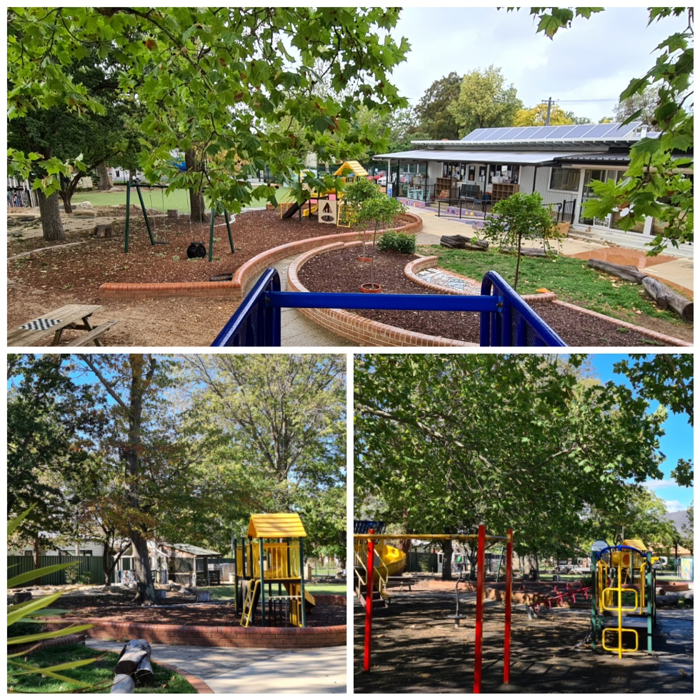

This page is intentionally left blank.

This report supports the work being done in the ACT Education Directorate, as outlined in Strategic Plan 2018-21: A Leading Learning Organisation.

Accessibility
The ACT Government is committed to making its information services, events and venues accessible to as many people as possible.
If you have difficulty reading a standard document and would like to receive this publication in an alternate format, such as large print and audio, please telephone (02) 6247 4580.
If English is not your first language and you require the translating and interpreting service, please telephone 13 14 50.
If you are deaf or hearing impaired and require the National Relay Service, please telephone 13 36 77.
© Australian Capital Territory, Canberra, 2020

Material in this publication may be reproduced provided due acknowledgement is made.

Contents
Reporting to the community 1
Summary of School Board activity 1
School Context 1
Student Information 2
Student enrolment 2
Student attendance 3
Supporting attendance and managing non-attendance 3
Staff Information 3
Teacher qualifications 3
Workforce composition 3
School Review and Development 4
School Satisfaction 4
Overall Satisfaction 4
Learning and Assessment 6
Performance in Literacy and Numeracy 6
Early years assessment 6
Financial Summary 7
Voluntary Contributions 8
Reserves 8
Endorsement Page 9
Members of the School Board 9

Reporting to the community
Schools report to communities in range of ways, including through:
- Annual School Board Reports
- a (5-year) School Improvement Plan (formerly School Strategic Plan)
- annual Impact Reports
- newsletters
- other sources such as My School.

Summary of School Board activity
Throughout 2019 the Board have continued to oversee the strategic direction of the school, including review of school policies and the expenditure of the school budget. The Board worked collaboratively with the school community through the school leadership team, staff, parents and carers during 2019 and enjoyed a friendly and supportive relationship. It is pleasing to see the children across our school continue to be engaged in an investigation model of play based learning opportunities, a key component of Early Childhood Learning Pedagogy, linking the Early Years Learning Framework and the Australian Curriculum. The model of engaging and promoting learning has been noted in anecdotal evidence from parents and carers as being one of the major drawcards in children attending and thriving in our school.
During the year renovations were carried out in the front office foyer as well as staff and student bathrooms. Some of the many highlights of the year included a highly successful community fete, and our whole school production of The Pied Piper performed at Lyneham High Performing Arts Centre. Providing an opportunity for young children to engage with their families and perform in such a venue was a highly valued experience for all. We thank Dr Susan West and the Music Outreach Engagement Program for their ongoing support.
Parents continued to be actively engaged throughout the year supporting excursions, in class learning and attending whole school community events. School Satisfaction Survey data once again shows high levels of satisfaction by both parents and staff across many areas.

School Context
O'Connor Cooperative School is committed to excellence in early childhood education. As a thriving school community, we acknowledge the Ngunnawal people as the traditional owners and custodians of the land. We acknowledge their elder’s past, present and emerging and welcome Aboriginal and Torres Strait Islander people to our school and community. We value our connections and continue to build relationships with local Aboriginal people and acknowledge that Ngunnawal people have been sharing their knowledge on this land for thousands of years, as we do today.
As a community of learners, we work together to create sustainable connections between each other and our learning environments, whilst developing intellectual, personal, social and environmental responsibility. We promote Positive Behaviours for Learning and provide quality education programs for children from preschool to year two.
We value
· a thriving school community where staff and families openly work as willing partners to further the education and development of the whole child;
· a safe and inclusive setting where strengths and needs of all members of our school community are recognised, respected and valued;
· a family-friendly environment;
· the professionalism of staff as educational leaders committed to play-based best practice in early years learning.
Our learning programs deliver quality, evidenced based early childhood practices and ensure explicit teaching links to child led investigation sessions. The principles, practices and outcomes of the Early Years Learning Framework form the foundation for curriculum delivery across the school. In Kindergarten to year two Australian Curriculum content is planned and delivered in a way that caters for the varying abilities, interests and cultural backgrounds of our children and families. In recognition of a variety of learning styles our classroom experiences are delivered individually, in small groups, as a whole class, in multi age groups or as a whole school. Many of our experiences are open ended and take place in both our indoor and outdoor environments, ensuring learning for each child is continuous and expanding. Staff add to their professional knowledge by engaging in professional learning conducted by a range of early childhood specialists and by forging links with other exemplary early childhood programs.
The O'Connor Cooperative School has high expectations for all students and meets the needs of all learners including exceptional learners across the range of the learning spectrum. Although we are a small school, we provide a program of quality learning across the curriculum. Throughout the year we engage specialists and visiting experts who work with our staff to deliver meaningful learning experiences. Our Arts program is a strong component of learning where children engage in a range of singing, visual arts, instrumental music and drama experiences. We have a strong focus on ‘giving’ through our Outreach singing within our community. Students have the opportunity to engage in a range of ICT learning through the use of Chromebooks, interactive screens and iPads which enable children to record and report on their learning using current applications and technologies.
O'Connor Cooperative School is an accredited ACTSmart School and successfully implements a wide range of sustainable schools’ initiatives with a focus to save energy, conserve water, increase recycling, protect biodiversity, cut greenhouse gas emissions and integrate sustainability into the curriculum. The school has implemented water conservation and waste management programs across the school. Other initiatives over past years have included 'The Co-op Coop' hen house, installation of solar panels and vegetable gardens.
We are, we are the Cooperative school - small and great.
What do we do at the Cooperative school? We cooperate!

Student Information

Student enrolment
In this reporting period there were a total of 55 students enrolled at this school.
Table: Student enrolment
Student type | Number of students
Male | 35
Female | 20
Aboriginal and Torres Strait Islander | 3
LBOTE* | 10
Source: ACT Education Directorate, Analytics and Evaluation Branch
*Language Background Other Than English

Student attendance
The following table identifies the attendance rate of students by year level during this reporting period. Student attendance rate is the percentage of school days attended by students in each year level at the school. Student attendance is measured over two school terms; that is from the first day of the school year for students in term 1 to the last day of term 2.
Table: Attendance rates in percentages
Year level | Attendance rate
1 | 92.0
2 | 93.0
Source: ACT Education Directorate, Analytics and Evaluation Branch

Supporting attendance and managing non-attendance
ACT public schools support parents and careers to meet their legal responsibilities in relation to the compulsory education requirements of the Education Act 2004. The Education Directorate’s Education Participation (Enrolment and Attendance) Policy describes its position with regard to supporting attendance and managing non-attendance. A suite of procedures supports the implementation of the policy. Please refer to https://www.education.act.gov.au/ for further details.

Staff Information

Teacher qualifications
All teachers at this school meet the professional requirements for teaching in an ACT public school. The ACT Teacher Quality Institute (TQI) specifies two main types of provision for teachers at different stages of their career, these are detailed below.
- Full registration is for teachers with experience working in a registered school in Australia or New Zealand who have been assessed as meeting the Proficient level of the Australian Professional Standards for Teachers.
- Provisional registration is for newly qualified teachers or teachers who do not have recent experience teaching in a school in Australia and New Zealand. Many teachers moving to Australia from another country apply for Provisional registration.

Workforce composition
Workforce composition for the current reporting period is provided in the following table. The data is taken from the school’s verified August staffing report. For reporting purposes, it incorporates all school staff including preschools, staff absent for a period of less than four consecutive weeks and staff replacing staff absent for more than four consecutive weeks. It does not include casuals and staff absent for a period of four consecutive weeks or longer.
The Education Directorate is required to report Aboriginal and Torres Strait Islander staff figures. As of June of the reporting period, 119 Aboriginal and/or Torres Strait Islander staff members were employed across the Directorate.
Table: Workforce composition numbers
Staff employment category | TOTAL
Teaching Staff: Full Time Equivalent Permanent | 4.93
Teaching Staff: Full Time Equivalent Temporary | 0.00
Non Teaching Staff: Full Time Equivalent | 3.72
Source: ACT Education Directorate, People and Performance Branch

School Review and Development
The ACT Education Directorate’s Strategic Plan 2018-2021 provides the framework and strategic direction for School Improvement Plans (formerly School Strategic Plans). This is supported by the school performance and accountability framework ‘People, Practice and Performance: School Improvement in Canberra Public Schools, A Framework for Performance and Accountability’. Annually, system and school level data are used alongside the National School Improvement Tool to support targeted school improvement, high standards in student learning, innovation and best practice in ACT public schools.
Prior to 2016 all ACT public schools participated in a four-year improvement cycle. In the fourth year schools underwent an external Validation process. In 2016 this changed to a five-year cycle with a School Review at the end.
Our school was reviewed in 2018. A copy of the Report of Review can be found on our school website.

School Satisfaction
Schools use a range evidence to gain an understanding of the satisfaction levels of their parents and carers, staff and students. Annually in August/ September ACT schools undertake a survey to gain an understanding of school satisfaction at that time. This information is collected from staff, parents and students from year 5 and above through an online survey.

Overall Satisfaction
In this period of reporting, 86% of parents and carers and 100% of staff at this school indicated they were satisfied with the education provided by the school.
Included in the survey were 16 staff, 14 parent, and 12 student items which are described as the national opinion items. These items were approved by the then Standing Council on School Education and Early Childhood (SCSEEC) for use from 2015. The following tables show the percentage of parents and carers staff who agreed with each of the national opinion items at this school.
A total of 6 staff responded to the survey. Please note that not all responders answered every question.
Table: Proportion of staff in agreement with each national opinion item
National opinion item | Proportion of staff
Parents at this school can talk to teachers about their concerns. | 100
Staff are well supported at this school. | 100
Staff get quality feedback on their performance. | 83
Student behaviour is well managed at this school. | 83
Students at this school can talk to their teachers about their concerns. | 100
Students feel safe at this school. | 100
Students like being at this school. | 100
Students’ learning needs are being met at this school. | 100
Teachers at this school expect students to do their best. | 100
Teachers at this school motivate students to learn. | 100
Teachers at this school treat students fairly. | 100
Teachers give useful feedback. | 100
This school is well maintained. | 67
This school looks for ways to improve. | 83
This school takes staff opinions seriously. | 83
This school works with parents to support students' learning. | 100
Teachers give useful feedback. | 100
Source: ACT Education Directorate, Analytics and Evaluation Branch
*Data derived from annual School Satisfaction Survey

A total of 42 parents responded to the survey. Please note that not all responders answered every question.
Table: Proportion of parents and carers in agreement with each national opinion item
National opinion item | Proportion of parents and carers
I can talk to my child’s teachers about my concerns. | 93
My child feels safe at this school. | 95
My child is making good progress at this school. | 79
My child likes being at this school. | 98
My child's learning needs are being met at this school. | 81
Student behaviour is well managed at this school. | 76
Teachers at this school expect my child to do his or her best. | 81
Teachers at this school give useful feedback. | 81
Teachers at this school motivate my child to learn. | 86
Teachers at this school treat students fairly. | 86
This school is well maintained. | 91
This school looks for ways to improve. | 93
This school takes parents’ opinions seriously. | 86
This school works with me to support my child's learning. | 79
Source: ACT Education Directorate, Analytics and Evaluation Branch
*Data derived from annual School Satisfaction Survey

Learning and Assessment

Performance in Literacy and Numeracy

Early years assessment
Students in kindergarten undertake an on-entry and on-exit assessment of their early reading and numeracy skills using the Performance Indicators in Primary Schools (PIPS) program. Student results are reported against five performance bands at the end of semester 1 and 2. Below are the results for this school for the current reporting period.
Table: O'Connor Co-Operative School PIPS 2019 mean raw scores
Agency | Reading start | Reading end | Mathematics start | Mathematics end
School | 50 | 144 | 41 | 56
ACT | 49 | 123 | 39 | 55
Source: ACT Education Directorate, Analytics and Evaluation Branch

Financial Summary
The school has provided the Directorate with an end of year financial statement that was approved by the school board. Further details concerning the statement can be obtained by contacting the school. The following summary covers use of funds for operating costs and does not include expenditure in areas such as permanent salaries, buildings and major maintenance.
Table: Financial Summary
INCOME | January-June | July-December | January-December
Self-management funds | 110377.90 | 39101.15 | 149479.05
Voluntary contributions | 2650.00 | 550.00 | 3200.00
Contributions & donations | 0.00 | 134.00 | 134.00
Subject contributions | 2860.00 | 725.00 | 3585.00
External income (including community use) | 213.63 | 939.86 | 1153.49
Proceeds from sale of assets | 0.00 | 0.00 | 0.00
Bank Interest | 3423.77 | 2855.82 | 6279.59
TOTAL INCOME | 119525.30 | 44305.83 | 163831.13
EXPENDITURE
Utilities and general overheads | 3920.24 | 23841.97 | 27762.21
Cleaning | 16322.40 | 0.00 | 16322.40
Security | 0.00 | 0.00 | 0.00
Maintenance | 2146.50 | 7716.97 | 9863.47
Administration | 713.43 | 1097.83 | 1811.26
Staffing | 5170.00 | 0.00 | 5170.00
Communication | 4219.17 | -56.80 | 4162.37
Assets | 15583.00 | 4084.65 | 19667.65
Leases | 0.00 | 0.00 | 0.00
General office expenditure | 4517.80 | 4326.96 | 8844.76
Educational | 7838.95 | 19180.14 | 27019.09
Subject consumables | 5661.71 | 76.04 | 5737.75
TOTAL EXPENDITURE | 66093.20 | 60267.76 | 126360.96
OPERATING RESULT | 53432.10 | -15961.93 | 37470.17
Actual Accumulated Funds | 134625.94 | 247675.74 | 247675.74
Outstanding commitments (minus) | -1746.56 | 0.00 | -1746.56
BALANCE | 186311.48 | 231713.81 | 283399.35

Voluntary Contributions
The funds listed were used to support the general operations of the school. The spending of voluntary contributions is in line with the approved budget for this reporting period.

Reserves
Name and Purpose | Amount | Expected Completion
At commencement of the school year 2019 reserves were as follows
9918-000-00 Sheds  9917-000-00 Furniture  9916-000-00 ICT  9915-000-00 Site Enhancement | $25,000.00  $ 8,000.00  $ 4,193.03  $60,000.00  TOTAL - $97,193.03
During planning for the 2020 budget the decision was made to focus on design and construction of a large new shed to replace existing collection of smaller aging sheds. Initial planning projections estimated at $100,000.00.  The Board agreed to collapse all reserves listed above to enable funds to be utilised for the shed project.  All funds were transferred to a new shed ledger in Nov 2019.  3533-000-00 MNW Shed Replacement | $97,193.03 | December 2020

Endorsement Page

Members of the School Board
Parent Representative(s): | Louisa Bobeldijk | Angela Corin
Community Representative(s): | Colin Rae
Teacher Representative(s): | Rose Patrick
Board Chair: | Angela Corin
Principal: | Jenny Loudon
I approve the report, prepared in accordance with the provision of the ACT Education Act 2004, section 52.

Board Chair Signature: | Angela Corin | Date: | 11 / 06 / 2020

I certify that to the best of my knowledge and belief the evidence and information reported in this Annual School Board Report represents an accurate record of the Board’s operations during this reporting period.

Principal Signature: | Jenny Loudon | Date: | 11 /06 / 2020

