Lyneham High School
  - Network: North Canberra/ Gungahlin

Impact Report 2019

The purpose of this document
This document flows directly from our Action Plan for 2019 which translated our school priorities into actions for the current year of our five-year improvement cycle. These actions were responsive to identified challenges, changes or risks to delivery of improvement for student learning.

Our school’s contribution to whole-of-system Strategic Indicators

Education Directorate Strategic Indicator 2018-2021
To promote greater equity in learning outcomes in and across ACT public schools

In 2019, LHS supported this Strategic Indicator through – Priority 1&2 (see reporting for detail):
- Complete Trauma Informed Education PL to support student learning
- Implement SAS Academic Reporting in Semester 2 2019
- Implement strategies to build Cultural Integrity within the school community

Education Directorate Strategic Indicator 2018-2021
To facilitate high quality teaching in ACT public schools and strengthen educational outcomes.

In 2019, LHS supported this Strategic Indicator through – Priority 1&2 (see reporting for detail):
- Collaborative and meaningful Professional Learning Teams that differentiate teaching and learning with a focus on student engagement, success and progress
- Support staff to develop an inquiry approach that collects and uses evidence of student learning
- Innovation Fund round conducted to support new learning initiatives for students
- Pilot the Year 8 Seek Program as part of the Cluster Contemporary Literacies Project

Education Directorate Strategic Indicator 2018-2021
To centre teaching and learning around students as individuals

In 2019, LHS supported this Strategic Indicator through – Priority 1&2 (see reporting for detail):
- Develop and implement a targeted Literacy Program
- Develop and implement a targeted Numeracy Program
- Student Forum will plan and deliver student-led projects and events
- Record and track student engagement in extra-curricular activities

Reporting against our priorities

Priority 1: All students are engaged and successful learners

Targets or measures
By the end of 2021 we will achieve:
- The percentage of students who report excellent emotional engagement in the school on the Australian School Climate and School Identification Measurement Tool (ASCSIMT) will increase from 39 percent in 2016 to 45 percent by 2021.
- The percentage of students who report excellent behavioural engagement in the school on the ASCSIMT will increase from 60 percent in 2016 to 65 percent by 2021. The total percentage of students who report excellent or adequate behavioural engagement will remain at 98 percent or higher.
- Attendance in years 9 and 10 will be above 90 percent in each term by 2021.
- Using a school tool developed in 2017, 100 percent of students will indicate that they have been involved in at least one extra-curricular activity over the course of each year 2018 – 2021.
- Selected elements of the Quality Teaching model related to cognitive engagement will be coded at an average of 2.5 or higher each year, 2017-2021.
- By 2020 the proportion of below standard (D and E) grades awarded to year 9 students at the end of year 9 will be reduced from 10.6 percent in 2016 to no more than 8 percent in 2020.
- By 2021 the proportion of within school matched year 9 students achieving in the bottom two bands in NAPLAN writing will be reduced to 18 percent from the current level of 21.1 percent in 2016.
- By the end of 2020 the proportion of above standard (A and B) grades awarded to year 9 students at the end of year 9 will be increased from 57.6 percent in 2016 to 65 percent in 2020.
- By 2021 the proportion of within school matched year 9 students achieving at the Proficient Standard in NAPLAN writing (top two bands) will be increased to 23 percent from the current level of 17.6 percent in 2016.
In 2019 we implemented this priority through the following strategies.
- Work to engage all students (emotionally, behaviourally and cognitively) in learning
- Improve effective use of data in the school
- Differentiate learning to cater for individual differences

Below is our progress towards our five-year targets with an emphasis on the accumulation and analysis of evidence over the term of our plan.

Student learning data
Targets or Measures | Base  (2016) | Year 1  (2017) | Year 2  (2018) | Year 3  (2019) | Year 4  (2020) | Year 5  (2021)
By the end of 2020 the proportion of above standard (A and B) grades awarded to year 9 students at the end of year 9 will be increased from 57.6 percent in 2016 to 65 percent in 2020. | 57.6% | 59.3% | 60.0% | 55.1% | 65%
By 2020 the proportion of below standard (D and E) grades awarded to year 9 students at the end of year 9 will be reduced from 10.6 percent in 2016 to no more than 8 percent in 2020. | 10.6% | 6.8% | 8.5% | 8.0% |  | <=8%
By 2021 the proportion of within school matched year 9 students achieving at the Proficient Standard in NAPLAN writing (top two bands) will be increased to 23 percent from the current level of 17.6 percent in 2016. | 17.6% | 31.6% | 19.9% | 19.1% |  | 23%
By 2021 the proportion of within school matched year 9 students achieving in the bottom two bands in NAPLAN writing will be reduced to 18 percent from the current level of 21.1 percent in 2016. | 21.1% | 22.5% | 27.8% | 23.2% |  | 18%

Perception Data
Targets or Measures | Base  (2016) | Year 1  (2017) | Year 2  (2018) | Year 3  (2019) | Year 4  (2020) | Year 5  (2021)
Trend Analysis - Behavioural Engagement (Average Response) | 4.1 | 3.9 | 4.0 | 4.0
Trend Analysis - Behavioural Engagement  (% Agree or Strongly Agree) | 61.0% | 71.2% | 77.4% | 76.2%
Trend Analysis - Emotional Engagement (Average Response) | 3.6 | 3.5 | 3.4 | 3.4
Trend Analysis - Emotional Engagement  (% Agree or Strongly Agree) | 39.5% | 51.9% | 48.2% | 47.8%
Trend Analysis – Perceived Safety & Support  (Average Response) | 3.7 | 3.5 | 3.6 | 3.7
Trend Analysis – Perceived Safety & Support  (% Agree or Strongly Agree) | 44.8% | 56.0% | 59.6% | 59.9%
The percentage of students who report excellent emotional engagement in the school on the Australian School Climate and School Identification Measurement Tool (ASCSIMT) will increase from 39 percent in 2016 to 45 percent by 2021 | 39.1% | 30.6% |  |  |  | 45%
The percentage of students who report excellent behavioural engagement in the school on the ASCSIMT will increase from 60 percent in 2016 to 65 percent by 2021. The total percentage of students who report excellent or adequate behavioural engagement will remain at 98 percent or higher. | 60.4% | 54.7% |  |  |  | 65%

School program and process data
Targets or Measures | Base  (2016) | Year 1  (2017) | Year 2  (2018) | Year 3  (2019) | Year 4  (2020) | Year 5  (2021)
Attendance in year 9 will be above 90 percent in each term by 2021. | 90% | 91% | 87% | 87% |  | >90%
Attendance in year 10 will be above 90 percent in each term by 2021. | 88% | 88% | 88% | 87% |  | >90%
Using a school tool developed in 2017, 100 percent of students will indicate that they have been involved in at least one extra-curricular activity over the course of each year 2018 – 2021. |  |  | 92%  (SSS) |  |  | 100%
Selected elements of the Quality Teaching model related to cognitive engagement will be coded at an average of 2.5 or higher each year, 2017-2021. |  | 3.74 | 3.60 | 4.13 |  | >=2.5

What this evidence tells us
Year 9 Grade Analysis
Following a steady trend towards our target over the last three years, the 2019 percentage of students being awarded above standard grades (A or B) has fallen by almost 5% to a level below the baseline measurement in 2016. Despite some fluctuation, the percentage of students being awarded below standard grades (D or E) is 8.0%, a reduction of 0.5% in the last year, meeting our target of no more than 8.0%.

Year 9 NAPLAN Writing Analysis
The percentage of students achieving in the top two bands (Bands 9 and 10) in NAPLAN Writing continues to fluctuate with different cohorts of students. While there was a 0.8% reduction in the percentage in 2019, the 19.1% level is still higher than the base starting percentage of 17.6%. In 2019, we saw a 4.6% reduction in the percentage of students achieving in the bottom two bands (Bands 5 and 6) in NAPLAN Writing to a level of 23.2%. However there remains a negative trend away from our 18% target by 2021.

Behavioural Engagement
Behavioural Engagement concerns the extent to which students actively involve themselves in their own learning at school. Behaviourally engaged students arrive to class on time, participate in activities, and apply themselves to the required tasks.
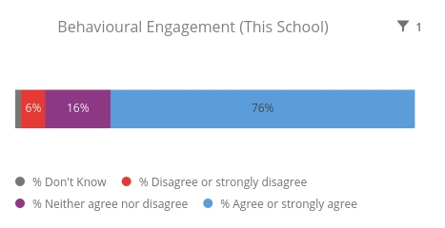
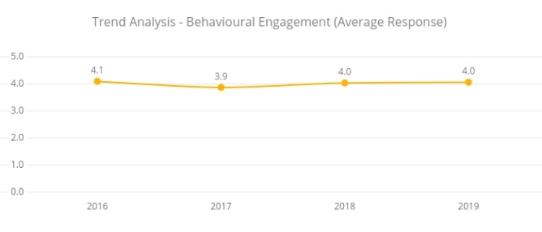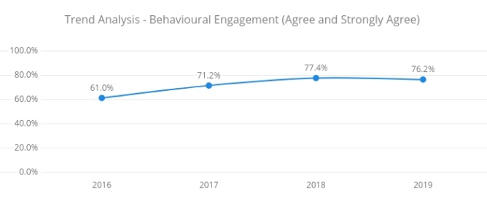
The 2019 student survey results and Qualtrics trend analysis for Behavioural Engagement show:
- that the average response to survey items has remained steady at 4.0
- that the percentage of students who have indicated positive behavioural engagement by either strongly agreeing or agreeing with survey items has reduced slightly to 76.2% after an increasing trend over the last three years.

Emotional Engagement
Emotional Engagement concerns the extent to which students are interested in and enjoying their learning at school. Emotionally engaged students will find the lessons fun and exciting, subsequently learning more.
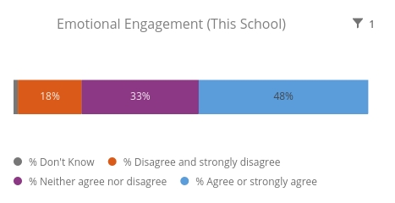
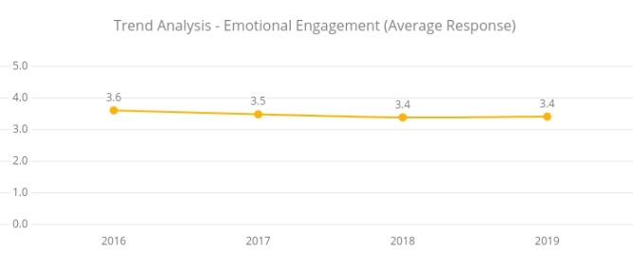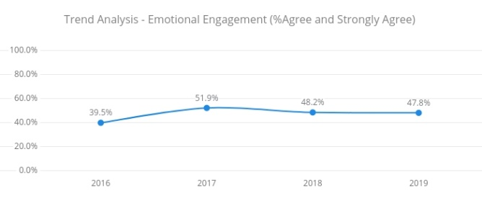
The 2019 student survey results and Qualtrics trend analysis for Emotional Engagement show:
- that the average response to survey items has remained steady at 3.4
- that the percentage of students who have indicated positive emotional engagement by either strongly agreeing or agreeing with survey items has remained steady at approximately 48%.

Perceived Safety and Support
Perceived Safety and Support concerns the degree to which students feel safe and emotionally connected to others at school.
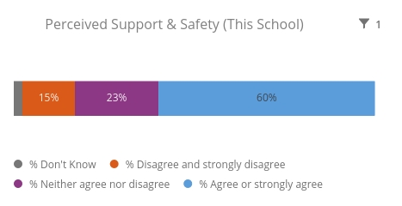
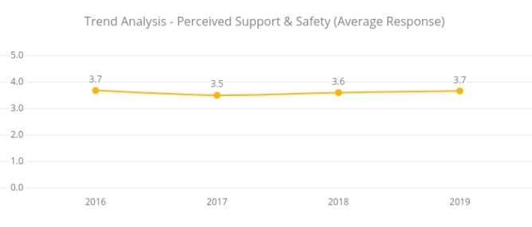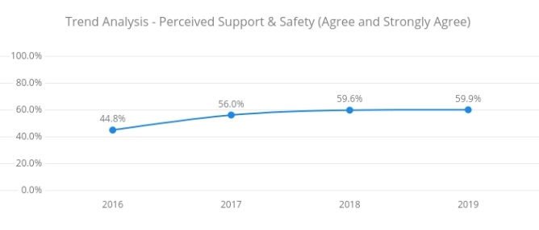
The 2019 student survey results and Qualtrics trend analysis for Perceived Support and Safety show:
- that the average response to survey items has increased slightly to 3.6
- that the percentage of students who have indicated positive perceived support and safety by either strongly agreeing or agreeing with survey items has remained steady at approximately 60% after an increasing trend over the last three years.

Our achievements for this priority
Work collaboratively within our LHS Professional Learning Community (PLC), and meaningful Professional Learning Teams (PLTs), to investigate, develop, implement and evaluate strategies that differentiate teaching and learning with a focus on student engagement, success and progress.
- Professional learning undertaken to clarify “What is a Professional Learning Community?” and explore DuFour and Marzano’s three big ideas that drive the PLC process and the four essential questions to guide a PLC.
- Shared understanding that we are one Professional Learning Community (PLC).
- Change to the organisational structure of Professional Learning Teams (PLTs) was implemented with a focus on:
  - meaningful, collaborative and purposeful teams (mostly faculty based)
  - the impact of what we do as educators to deliver improvement and growth in the learning outcomes of all our students.
- Recognition that PLT work relies on:
  - strong professional relationships with colleagues
  - a shared purpose and clear goals for improvement
  - a collaborative approach to problem solving and sharing of ideas
  - a culture of trust that supports the giving and receiving of honest feedback
- PLTs were provided autonomy to identify appropriate QTm elements relevant to their work to support teacher self-reflection on, and improvement to, pedagogical practices.
- More timely observation, QTm coding and feedback cycles were scheduled to occur that were relevant to the work being undertaken by each PLT.

Professional Learning for staff to support a whole school inquiry model and collection and use of data
- All Executive Team members undertook PL at SLA / SLB and SLC Leadership Forums to explore and understand the Helen Timperley Spiral of Inquiry and multiple sources of data.
- Executive Team members to take a leadership and monitoring role to embed the new PLT structure and foster an inquiry approach connected to student engagement and success.
- PLTs to collect and use data (school and system data, formative assessment, “small” data from classroom observations, etc.) to inform, guide and evaluate their professional practice.
- Focus on teachers being “hungry” to find evidence of student learning.

Complete Trauma Informed Education PL to support student learning
- Whole staff PL delivered by Senior Psychologists as part of January PL program.
- Feedback from staff showed:
  - that the professional learning was engaging, informative and well received.
  - strong positive responses in regard to an increased understanding of the neuroscience of trauma and how it impacts on student behaviour and learning.
  - an appreciation for the practical strategies provided and a focus on action to embed them into classroom practice.
- Follow up session undertaken by LHS School Psychologist (staff meeting 15/5/2019) regarding reasonable adjustments to the learning program that supports student engagement and success.
- Follow up session undertaken by Special Needs staff members (staff meeting 21/8/2019) regarding universal adjustments for students in classes.

Develop and implement a targeted Literacy Program
- Literacy Team established under the leadership of the ET Professional Practice.
- Research undertaken to explore best practice and inform the LHS Literacy Program model.
- Literacy Plan documented.
- PL undertaken to strengthen analysis of student data (PAT-R, MacqLit).
- Data used to identify students for intensive literacy support.
- Literacy supports delivered to approximately 88 students not eligible for other support programs (e.g. disability support, inclusion support program)
- Review of Literacy Program undertaken and recommendations made for 2020.

Develop and implement a targeted Numeracy Program
- Literacy Program established under the leadership of the ET Mathematics.
- PL undertaken to strengthen analysis of student data (PAT-M).
- Students identified for numeracy support by classroom teachers based on class observations, formative assessment data and curriculum data.
- Support delivered to 32 identified students in:
  - the classroom (4 classes across years 7, 9 and 10)
  - small withdrawal groups (occurs twice a fortnight)

Implement SAS Academic Reporting in Semester 2 2019
- Action Plan developed under the leadership of the ET Student Administration.
- Key staff undertaken SAS/Sentral Coordinator Training for Academic Reporting
- Development and delivery of administrative supports and templates to enable ETs in all faculties to map Achievement Standard sentences to unit assessment, marksheets to record student outcomes and progress and build end of semester reporting templates.
- PL delivered to Executive Teachers and at staff meetings to support teachers to use Sentral to report during semester 2.
- Mid semester reports produced and distributed to parents/carers in Week 9 of Term 3.
- Decision taken to remove the teacher comment from the semester report given the detail provided by reporting against the achievement standard sentences and work habits while also recognising the complexity, workload and quality assurance issues relating to this change management process.
- Develop and implement process for the collection of student reflection on their behaviours and learning which are used to populate the personal and social capabilities on the end of semester report.
- End of semester reports produced and distributed to parents/carers in Week 10 of Term 4.

Innovation Fund round conducted to support new learning initiatives for students
- Innovation Fund information and documentation (process and assessment criteria) developed by Business Manager and distributed to Executive Team.
- Submissions received, reviewed and assessed by the School Board.
- Successful initiative was the refurbishment of Room 12 to develop a flexible learning space (makerspace) to support the introduction of STEM units.
- Construction works and procurement of equipment and resources should be completed prior to the start of the 2020 school year.

Challenges we will address in our next Action Plan
- Despite a strong initial start to the implementation of the PLC/PLT structure in 2019, major disruption within the school and a subsequent loss of focus resulted in a “loose” and variable understanding and application of the intended strategies. In 2020, there is a need for greater clarity in communication, processes and timelines.
- Build greater teacher consistency and confidence in the effective collection, analysis and use of data to understand and meet the learning needs of students.
- Overcome staffing and resourcing pressures to ensure the full implementation of the Numeracy Program.

Priority 2: All students will be critical and creative thinkers and resilient people

Targets or measures
By the end of 2021 we will achieve:
- The percentage of students giving a positive response to the System Survey question “Overall, I am satisfied that the school has High Expectations in all that it does” is consistently at 85 percentage points or higher in each year 2017-2021.
- The percentage of students who ranked anxiety levels as needing improvement using the ASCSIMT is reduced from 24 percent in 2016 to 19 percent or lower by 2021.
- By 2021, of those students assessed against the general capability of critical and creative thinking, 80 percent or more will, usually or always, demonstrate appropriate knowledge, skills and dispositions.
- By 2021, 80 percent or more of those students assessed against the general capability sub-element of “becoming confident, resilient and adaptable” will, usually or always, demonstrate this capacity.
In 2019 we implemented this priority through the following strategies.
- Use the Australian Curriculum Critical and Creative Thinking capability to inform effective teaching practices and monitor student development.
- Use the Australian Curriculum sub-element of Resilience from the Personal and Social Capability to inform teaching practices and monitor student development

Below is our progress towards our five-year targets with an emphasis on the accumulation and analysis of evidence over the term of our plan.

Student learning data
Targets or Measures | Base  (2016) | Year 1  (2017) | Year 2  (2018) | Year 3  (2019) | Year 4  (2020) | Year 5  (2021)
By 2021, of those students assessed against the general capability of critical and creative thinking, 80 percent or more will, usually or always, demonstrate appropriate knowledge, skills and dispositions. |  |  |  |  |  | >=80%
By 2021, 80 percent or more of those students assessed against the general capability sub-element of “becoming confident, resilient and adaptable” will, usually or always, demonstrate this capacity. |  |  |  |  |  | >=80%

Perception Data
Targets or Measures | Base  (2016) | Year 1  (2017) | Year 2  (2018) | Year 3  (2019) | Year 4  (2020) | Year 5  (2021)
The percentage of students giving a positive response to the System Survey question “Overall, I am satisfied that the school has High Expectations in all that it does” is consistently at 85 percentage points or higher in each year 2017-2021. | 83.9% | 81.3% | 74.1% | 71.0% |  | >=85%
Trend Analysis – Anxiety  (Average Response) | 2.0 | 2.0 | 2.1 | 2.1
Trend Analysis - Anxiety  (% Not and Hardly True) | 31.1% | 30.4% | 27.9% | 28.1%
Trend Analysis – Depression  (Average Response) | 2.0 | 2.1 | 2.4 | 2.5
Trend Analysis – Depression  (% Applies Sometimes and Does not Apply) | 57.3% | 58.4% | 63.7% | 54.1%
Trend Analysis – Positive Affect  (Average Response) | 2.2 | 2.2 | 3.8 | 3.8
Trend Analysis – Positive Affect  (% Most and All of the time) |  | 18.7% | 37.2% | 34.3%
Trend Analysis – Resilience  (Average Response) |  | 2.0 | 3.1 | 3.3
Trend Analysis – Resilience  (% Strong) |  | 8.7% | 36.9% | 37.6%
The percentage of students who ranked anxiety levels as needing improvement using the ASCSIMT is reduced from 24 percent in 2016 to 19 percent or lower by 2021. | 24% | 25% |  |  |  | <=19%

School program and process data
Targets or Measures | Base  (2016) | Year 1  (2017) | Year 2  (2018) | Year 3  (2019) | Year 4  (2020) | Year 5  (2021)
The percentage of students who ranked anxiety levels as needing improvement using the ASCSIMT is reduced from 24 percent in 2016 to 19 percent or lower by 2021. | 24% | 25% |  |  |  | <=19%
By 2021, 80 percent or more of those students assessed against the general capability sub-element of “becoming confident, resilient and adaptable” will, usually or always, demonstrate this capacity. |  |  |  |  |  | >=80%

What this evidence tells us
Student satisfaction that the school has high expectations
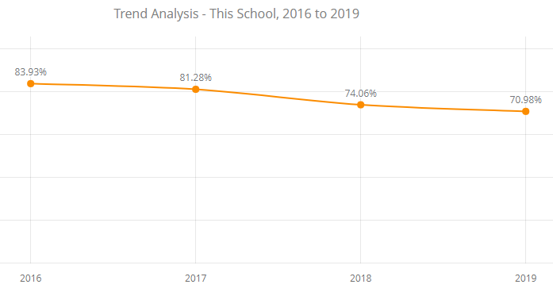

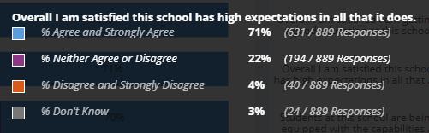

The 2019 student survey results and Qualtrics trend analysis show:
- that the percentage of students who have indicated overall satisfaction that the school has high expectations by either strongly agreeing or agreeing with the survey item has decreased to 71.0% following a trend downwards over the last three years.
- that the percentage of students who have indicated overall dissatisfaction that the school has high expectations by either strongly disagreeing or disagreeing with the survey item is 4.0%

Anxiety
The Anxiety scale assesses autonomic arousal, skeletal muscle effects, situational anxiety, and subjective experience of anxious affect. Students were asked to use 4-point frequency scales to rate the extent to which they have experienced each state over the past week.
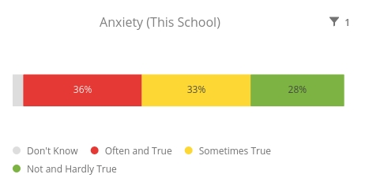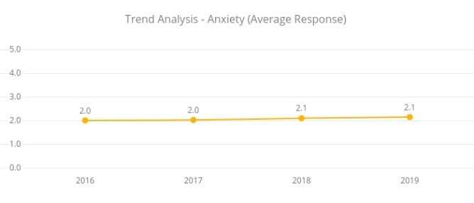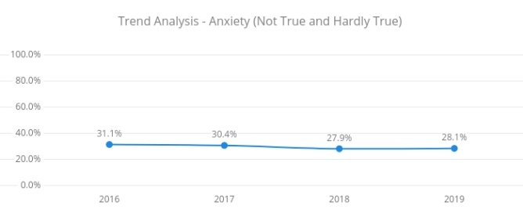
The 2019 student survey results and Qualtrics trend analysis for Anxiety show:
- that the average response to survey items has remained steady at 2.1
- that the overall trend of students indicating that they are hardly or not at all experiencing anxiety has remained steady at approximately 28%

Depression
The Depression scale assesses dysphoria, hopelessness, devaluation of life, self-deprecation, lack of interest, anhedonia, and inertia. Students were asked to use 4-point frequency scales to rate the extent to which they have experienced each state over the past week.
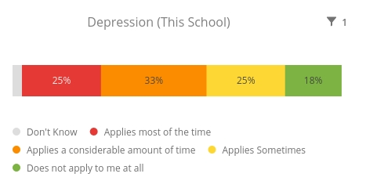
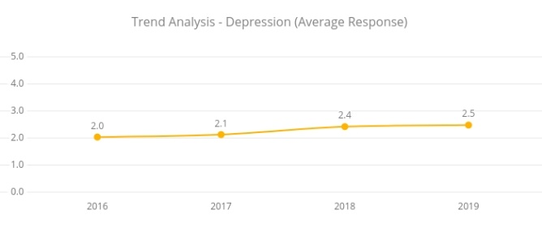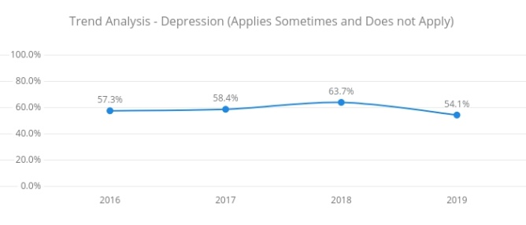
The 2019 student survey results and Qualtrics trend analysis for Depression show:
- that the average response to survey items has increased slightly to 2.5
- that the percentage of students who have indicated that depression does not apply or applies sometimes to them has decreased to 54.1% after an increasing trend over the last three years.

Positive Affect
Positive Affect refers to one's propensity to experience positive emotions and interact with others and with life's challenges in a positive way. This survey asks students to rate terms on a scale of 1 to 4 to indicate the extent to which the respondent agrees that this applies to them.
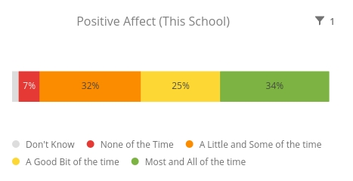
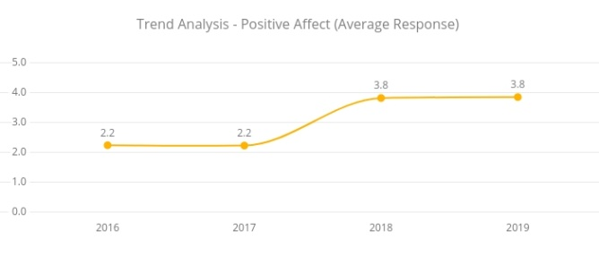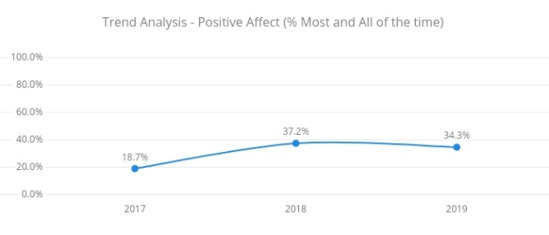
The 2019 student survey results and Qualtrics trend analysis for Positive Affect show:
- that the average response to survey items has remained steady at 3.8
- that the percentage of students who have indicated positive affect by indicating either most and all of the time to survey items has decreased to 34.3%.
Resilience
Resilience is generally thought of as a "positive adaptation" after a stressful or adverse situation.
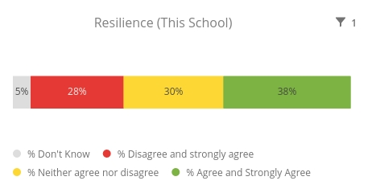
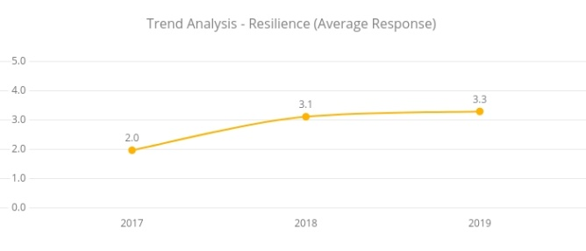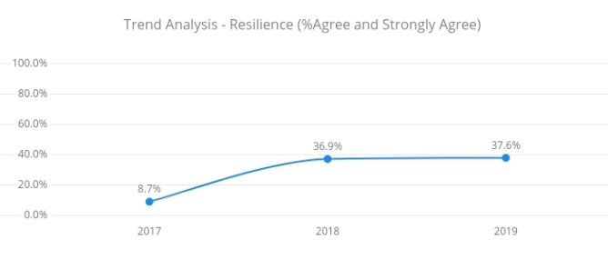
The 2019 student survey results and Qualtrics trend analysis for Resilience show:
- that the average response to survey items has increased to 3.3
- that the percentage of students who have indicated positive resilience by either strongly agreeing or agreeing with survey items has slightly increased to 37.6% continuing an increasing trend over the last three years.

Our achievements for this priority
Student Forum will plan and deliver student-led projects and events
- Student Forum representatives under the leadership of the School Captains and Student Leadership Group identified Student Action Teams to organise and deliver events and projects including: Valentine’s Day fundraiser, Easter hunt, Running Festival canteen (snow cones), Silent Disco, Environment Awareness assembly presentation, Lunchtime sport (twice a week during terms 2 & 3), 5 Ways Week, Multicultural Day and National Day of Action against Bullying and Violence.

Pilot the Year 8 Seek Program and trial assessment of targeted General Capabilities as part of the Cluster Contemporary Literacies Project
- School leaders and teachers in the SEEK Program established as a Professional Learning Team
- Commencement of the first class in the Year 8 Seek Program
- Regular and ongoing feedback from students (every 5 weeks) collected and used to inform effective implementation
- Decision to expand program by adding a Year 9 SEEK class in 2020.
- Two staff members identified for 2020 and they completed professional learning in Project Based Learning and planned and developed the full year interdisciplinary mapping of curriculum for the Year 9 SEEK class.
- Parent and student information sessions held that resulted in successful enrolment of a Year 8 and Year 9 class in 2020.
- Seek Project PLT engaged in the cluster Contemporary Literacies Project, attending a meeting each term that provided professional learning opportunities to build innovative pedagogies, share resources, teaching tools and approaches and connect with transition schools. This included work to develop and trial measurement tools for general capabilities, particularly Critical and Creative Thinking and Personal and Social Capability.

Record and track student engagement in extra-curricular activities
- Program, learning area and school event staff have monitored student engagement trends
- Increase in the number of lunch time and after school clubs and activities as well as a marked increase in student numbers and engagement.
- Tracking of student participation in most extracurricular activities being recorded in Sentral.

Finalise and implement the LHS Social & Emotional Learning (SEL) Plan
- Lyneham High School staff introduced to Be You Program in a staff meeting (term 4) with an option to complete online professional learning modules
- Students participate in HIVE sessions that support aspects of Social and Emotional Learning
- Teaching Personal and Social Responsibility (TPSR) is being trialled by the Health and PE Faculty in class to support students self-regulate and reframe behaviour
- The Personal and Social Capability section of the semester report is based on student reflections of their own behaviours and learning, collected via a student survey and imported into their final report. This page provides parents with an opportunity to see how their child views their social and emotional learning at Lyneham High School and possibly prompt discussions in relation to work habits assessed by their teachers in individual classes.

Implement strategies to build Cultural Integrity within the school community
- Whole staff Professional Learning Day including visits to develop teacher learning about Aboriginal and Torres Strait Islander history and culture through experience, confidence in creating opportunities for student learning of Aboriginal and Torres Strait Islander history and culture within their learning area / classes and increased knowledge of the community resources available within close proximity of LHS to support learning about Aboriginal and Torres Strait Islander history and culture.
- Cluster initiative to employ a shared Indigenous Education Officer to strengthen connection and engagement with our Aboriginal and Torres Strait Islander students and families
- Initial consultation with the community to inform an artist’s brief for an Aboriginal and Torres Strait Islander mural to be located in the school canteen.

Challenges we will address in our next Action Plan
- Lyneham High School has been identified to commence the implementation of the Positive Behaviours for Learning (PBL) framework in 2020.
- Investigate the capacity of Sentral to report on student engagement in extracurricular activities in an efficient way to measurably track progress towards our school plan action
- Track semester data relating to student self-reflection of the Personal and Social Capabilities
- Develop a more strategic school plan to develop Cultural Integrity at Lyneham High School through priorities that align with the ED Cultural Integrity Continuum.

