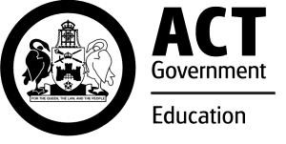
Charles Weston School
Network: South Canberra/ Weston

Impact Report 2020
The purpose of this document
This document flows directly from our Action Plan (AP) for 2020 which translated our priorities into actions to be taken in the current year of our five-year school improvement cycle. This included continuing the emphasis on; improving student outcomes, monitoring and implementation of an inquiry approach to action school improvement, and monitoring and inquiry to inform daily teaching.
Note: Due to the signficant disruptive events of 2020 the data collection cycles of some measures were interrupted. Where this has occurred an N/A entry has been used.

Reporting against our priorities
Priority 1: All students are capable and successful mathematicians.
Targets or measures
By the end of 2024 we will achieve:
- 62% or more of our year 5 students will be achieving at or above expected growth in numeracy.
- 25% or more of kindergarten students will be achieving high growth in PIPS mathematics. The target was set by averaging the percentage of ACT students achieving high growth in PIPS mathematics over 2013 to 2018.
- Growth in the Maths median scaled score for each year level at CWS is at or above the growth in the national Maths median scaled score for the corresponding time period. For the 2018-2019 time period the national growth scaled scores are: Year 2: 9.8 scaled scores, Year 3: 7.9 scaled scores, Year 4: 6.5 scaled scores, Year 5: 5.3 scaled scores, Year 6: 4.3 scale scores.
- Increase agreement from students who state ‘Teachers explain what we are learning about and why’ to at or above ACT system average.

In 2020 we implemented this priority through the following strategies:
- Consolidate consistent mathematics practices across the school.
- Explore the use of the National Numeracy Learning Progressions to assess student achievement and inform learning and teaching.
Below is our progress towards our five-year targets with an emphasis on the accumulation and analysis of evidence over the term of our plan.

Student learning data
Targets or Measures | Base |  |  |  |  |  |  | Year 1 2020 |  |  | Year  2  2021 | Year 3 2022 | Year 4 2023 | Year 5 2024
62% or more of our year 5 students will be achieving at or above expected growth in numeracy | 47% |  |  |  |  |  |  | N/A
25% or more of kindergarten students will be achieving high growth in PIPS/BASE mathematics. | 20% |  |  |  |  |  |  | Data not available at time of reporting
Growth in the Maths median scaled score for each year level at CWS is at or above the growth in the national Maths median scaled score for the corresponding time period. | Y1 2018 to  Y2 2019  CWSC: 4.5  AUS: 9.8 |  |  |  |  |  |  | Y1 2019 to  Y2 2020  CWSC: 4.9  AUS: 9.8  -4.9
 |  |  |  |  | -5.3
 | Y2 2018-to  Y3 2019 |  |  |  |  |  |  | Y2 2019 to  Y3 2020  CWSC: 7  AUS: 7.9
 | CWSC: |  | 10.9
 | AUS: | 7.9
 |  |  |  |  |  | +3 |  |  | -0.9
 | Y3 2018-to  Y4 2019  CWSC: 7  AUS: 6.5 |  |  |  |  |  |  | Y3 2019 to  Y4 2020  CWSC: -0.4  AUS: 6.5
 |  |  |  |  | +0. |  | 5 |  | -6.9
 | Y4 2018-to  Y5 2019  CWSC: -2.1  AUS: 5.3 |  |  |  |  |  |  | Y4 2019 to  Y5 2020  CWSC: 4.6  AUS: 5.3
 |  |  |  |  | -7.4 |  |  |  | -0.7
 | Y5 2018-to  Y6 2019  Data not available |  |  |  |  |  |  | Y5 2019 to  Y6 2020  CWSC: 7.8  AUS: 4.3
 |  |  |  |  |  |  |  |  |  | 3.5

Perception Data
Targets or Measures | Base | Year 1 2020 | Year 2 2021 | Year 3 2022 | Year 4 2023 | Year 5 2024
Increase agreement from students who state ‘Teachers explain what we are learning about and why’ to at or above  ACT system average | In 2019  CWSC =  74.3%  ACT = 85.3% | 2020  CWSC = 88.6%  ACT = 81.3%

2020 Baseline Teacher Survey Data
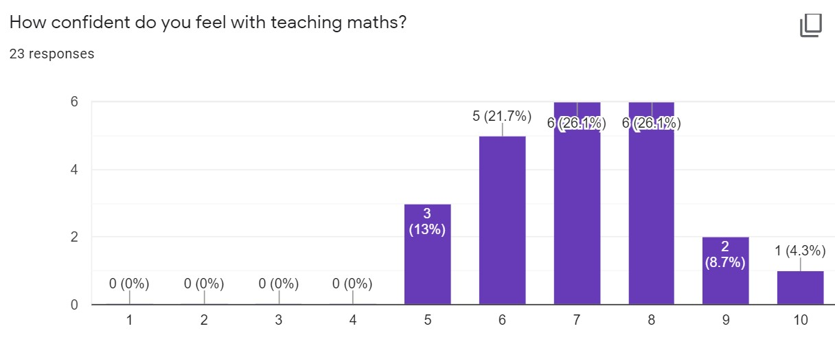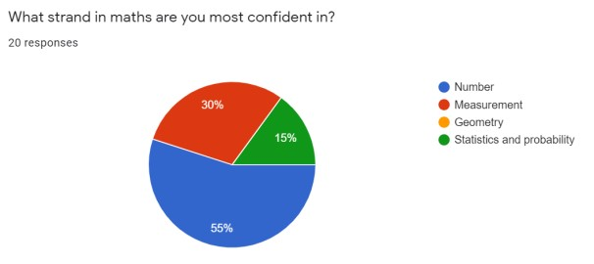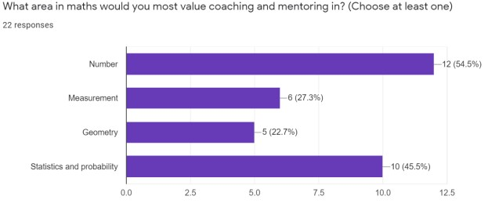

What this evidence tells us
NAPLAN was not administered in 2020 and BASE information has yet to be delivered. This has resulted in our limited data set in mathematics for year 1 of the plan.

Our PAT data indicates each cohort’s median scale score grows year to year, yet the rate is inconsistent when compared to the AUS norm median scale score growth.

We saw a 14% increase in response from our students agreeing that ‘Teachers explain what we are learning about and why’ whilst the ACT average dropped 4%, between 2019 and 2020.

Our 2020 teacher maths survey has provided our baseline data regarding teacher confidence and areas for further professional learning and staff development.

Our achievements for this priority
School Improvement Team (SIT) for mathematics established in February 2020 and met fortnightly. Members included teacher representation from Pre – year 6 (Ellen Baillie, Monique Robinson, Katherine Heritage, Carolyn Holloway, Annette Pass, Lauren Quilter and Jodie Cochrane) supported by executive teacher Johnathan Price.

Achieved a shared understanding of how mathematics is taught at CWSC. Documented and communicated with staff via our CWSC Important Book, outlining our beliefs, values and practices.
Consistent approach for planning and delivering mathematics which includes an agreed framework of warm up, explicit teaching, practice through inquiry, and reflection.
Classroom walkthroughs and audits of programming confirmed staff are consistently using the Google Slide maths planning and delivery template. We have consistency of language used with students and dedicated time for students to use an inquiry approach in mathematics.
The SIT supported teachers during remote learning to devise mathematics learning opportunities that continued our maths by inquiry approach and ensured continuity of learning at home.
We are well resourced for mathematics learning and have quality materials to engage and support students to explore a range of mathematical concepts through an inquiry approach.
Members of the SIT were provided additional time off class in pairs to conduct audits, observe colleagues, analyse datasets, and develop a plan for the rollout of National Numeracy Learning Progressions (NNLPs).
A baseline survey was conducted to determine staff confidence with teaching mathematics. Triangulation of survey and assessment data contributed to decision to have a specific focus on number. This is able to be tracked P-6 and was an area staff indicated they would like additional support.
Members of the Maths SIT trialled the use of the NNLPs with their classes and shared this practice with colleagues through collaborative planning and whole school PL. They identified enabling, core and extending students to use as models for NNLP tracking.
We revised our assessment schedule, updated our data plan and developed and trialled the use of a school wide central data base that included maths. This data then informed collaborative planning discussions and decision making around student support needs. We revised our data plan to include PAT, MYMC, SENA, NAPLAN.

The Maths SIT presented PL to staff in Term 3 weeks 2 and 9 and Term 4, week 2 focused on - familiarisation with the NNLPs
- unpacking expected achievement levels of cohorts against the NNLPs.
- using evidence of student worksamples in maths to plot students on the progression - analysis of our PAT maths data
- moderation of student maths abilities for reporting

Challenges we will address in our next Action Plan
With new staff joining us ensure consistency in quality practice across staff through action inquiry cycles, ongoing PL and coaching.

Develop a coaching model that enables expert maths teachers in the school to continue to build capacity of all staff.

Triangulating data with NAPLAN, BASE and other school based datasets such as Middle Years Mental Computation (MYMC) and SENA to show growth and track the impact of our actions.

Continue to build capacity of staff to use the NNLP so we don’t lose traction. It is a very broad tool. We need to consolidate our implementation of Number, specifically Place Value first and then use this as a platform to explore other strands.

We need to revisit our staff survey to see what changes we have in staff confidence and competence with our new teachers for 2021 and to develop our coaching and PL priorities.
Develop and undertake a student survey to seek feedback on their attitudes towards and feelings of competency in mathematics.
Use our Collaborative Planning PLC structures to analyse data and inform teaching and learning cycles, and provide timely intervention.
Potentially revise our School Plan 2020-2024 priority to sharpen the focus to ‘All students are successful and capable in number’.

Priority 2: All students are capable and successful writers.
Targets or measures
By the end of 2024 we will achieve:
- To increase the percentage of year 5 students in the top two bands of writing to 25% or more.
- To increase the Year 3 to Year 5 growth in mean scale scores in Writing to 57 mean scale scores or more.
- 87% or more of our students agree or strongly agree that ‘Teachers give useful feedback’. The target was set by averaging the percentages of agree or strongly agree over 2016-2019 for system schools (79%) plus 8%.
- To increase the percentage of students achieving at or above year level expectation on the National Literacy Learning Progressions to 65% or more.
In 2020 we implemented this priority through the following strategies.
- Explore the 10 Essential Literacy Practices across preschool – year 6
- Implement visible learning structures in writing connected to the National Literacy Learning Progressions (NLLP)
Below is our progress towards our five-year targets with an emphasis on the accumulation and analysis of evidence over the term of our plan.

Student learning data
Targets or Measures | Base | Year 1 | Year 2 | Year 3 | Year 4 | Year 5
To increase the percentage of year 5 students in the top two bands of writing to 25% or more. | 16% (average from 2016-2018) | N/A
To increase the Year 3 to Year 5 growth in mean scale scores in Writing to 57 mean scale scores or more. | 55 mean scale scores (average of similar schools  2016-19) | N/A

Perception Data
Targets or Measures | Base | Year 1 | Year 2 | Year 3 | Year 4 | Year 5
87% or more of our students agree or strongly agree that ‘Teachers give useful feedback’. The target was set by averaging the percentages of agree or strongly agree over 2016-2019 for system schools (79%) plus 8%. | 84%  (average of  CWSC data  2016-2019) | 69.7%

School program and process data
Targets or Measures | Base | Year 1 |  | Year 2 | Year 3 | Year 4 | Year 5
To increase the percentage of students achieving at or above year level expectation on the National Literacy Learning Progressions (for creating texts) to 65% or more. | 45%  (average of data from each cohort  K-6) | TBC | – finalising
 |  | Kaitlin

What this evidence tells us
NAPLAN was not administered in 2020. This has resulted in our limited data set in writing for year 1 of the plan.

School based data analysis of NLLP was inconclusive as we did not achieve consistent collection of data from all areas.

In 2020 we saw a decline in students agreeing with the statement ‘Teachers give useful feedback’. Staff feel that this data was significantly impacted by COVID and remote learning interruptions.
Our achievements for this priority
A School Improvement Team (SIT) for literacy was established in February 2020. Members included teacher representation from each cohort Pre – year 6 Mandy Wheelahan, Brittany Champion, Karen Cossins, Alinta Turner, Kaitlin van den Engel and Dawn-Maree Dunn. They were supported by Executive Teacher Jen Hearne.

- Whole school data tracker established including tracking National Literacy Learning Progressions (NLLP) - Creating texts - across the school.
- Staff used the NLLP (creating texts) data from the whole school tracker for data conversations within collaborative planning sessions and this informed responsive teaching workshops.
- Staff ran whole school professional learning and coaching and modelling sessions on using and conferring with the NLLP (creating texts).
- The Literacy SIT began to develop the Early Childhood prompting tool focussing on Oral language.
- Teachers are using a consistent Conferencing Tip sheet when conferencing with writing.
- Students all had individualised writing goals and many classes began implementing bump it up walls to support visible and personalised learning.
- Students were receiving specific feedback related to the NLLP (creating texts) in sections across the school.
- Assemblies continued to feature an ‘Author’s Chair’.
- Return from remote learning saw a need to revisit routines and build stamina in literacy across the whole school. We conducted staff refreshers on Daily 5 and worked collaboratively as a whole school to reinvigorate our balanced literacy approach and support students to use a shared language and follow a Daily 5 framework.
- Developed consistency of practice with The Daily 5 across the school. Observation and feedback for every teaching team was provided twice in semester two through walk throughs and a feedback template.
- Teams began setting and reflecting on SMART goals linked to improving practice and student outcomes in literacy.
Challenges we will address in our next Action Plan
• | We are yet to collect data on whether students see themselves as writers. We need to develop a self assessment tool for collating student efficacy in individual writing ability.
• | Formalise our assessment schedule, data plan and use PLC structures within our collaborative planning cycle to inform the teaching, learning and response to intervention.
• | Consistently provide students with descriptive feedback in all classes K-6, related to writing through individual conferencing against the NLLPs.
• | Teachers who have been leading the NLLP process in our school, found providing students specific feedback against the NLLP creating texts too limiting at times. We need to explore whether we should expand into other areas of the NLLP.
• | Continue to explore effective ways to support teachers to input writing data to provide us a whole school picture.
• | Due to COVID interruptions, our engagement in the Masterclass series was postponed.
• | Review Daily 5 with a deep focus on the elements of Work on Writing and Word Work.
• | Ensure writing is connected to units of inquiry for purpose and authenticity.
• | Develop a school year book of writing samples with one from every student. Encourage students as authors and give them voice and choice in what they submit.

Priority 3: All learners are safe, connected and academically challenged.
Targets or measures
By the end of 2024 we will achieve:
- Increase percentage of students receiving Bs and As.
- Improve percentage of students and staff who agree with the statement ‘I/Students feel safe at this school’ to at or above the system average.
- Maintain or improve percentage of students in each cohort (years 2 – 6) who agree with the statement ‘I love to learn’.
- Increase percentage of stakeholders who agree with the statement ‘Students at this school are being equipped with the capabilities to learn and live successfully’ to at or above other P-6 ACT schools.
- Maintain or increase agreement from parents that ‘Students’ learning needs are being met at this school’.

In 2020 we implemented this priority through the following strategies.
  - Transition from candidate to authorised Primary Years Programme (PYP) school
  - Consolidate and then extend our Positive Behaviour for Learning (PBL) approach
  - Implement targeted opportunities to engage, connect and support our community of learners

Below is our progress towards our five-year targets with an emphasis on the accumulation and analysis of evidence over the term of our plan.

Student learning data
Targets or Measures | Base | Year 1 | Year 2 | Year 3 | Year 4 | Year 5
Increase percentage of students receiving Bs and As. | 2% As  22% Bs | Sem 2, 2020 only  3.5% As  27.6% Bs

Perception Data
Targets or Measures | Base | Year 1 | Year 2 | Year 3 | Year 4 | Year 5
Improve percentage of students and staff who agree with the statement ‘I/Students feel safe at this school’ to at or above the system average | Students  44.5%  (72.1%)  Staff  41%  (86.8%) | Students  54.6% (71.4%)  Closing gap  Staff  53.3% (87.5%)  Closing gap
Maintain or improve percentage of students in each cohort (years 2 – 6) who agree with the statement ‘I love to learn’. | 85%  (74% boys & girls 97%) | 80.35%  Boys 75.32%  Girls  85.38%
Increase percentage of stakeholders who agree with the statement ‘Students at this school are being equipped with the capabilities to learn and live successfully’ to at or above other P-6 ACT schools. | Staff  87.2%  (91.2% ACT)  Students  66.4%  (79.2% ACT)  Parents  86.1%  (83.4% ACT) | Staff  91.1%  (89.9% ACT)  Students  73.3%  (76.8% ACT)  Parents  88%  (81.3% ACT )
Maintain or increase agreement from parents that ‘Students’ learning needs are being met at this school’. | 87.2% | 91.3%

What this evidence tells us
• | We have had improvement in our academic grades from 2019-2020 (moving from 2-3.5% As and 22-27.6% Bs achieved)
• | We are progressing in closing the gap to both students and staff feeling safe at school
• | We’ve regressed in students yr2-6 with I love to learn (interestingly a deeper analysis of data indicates a shift in responses with boys increasing and girls decreasing).
• | Excellent growth is evident in students being equipped with the capabilities to learn…  Staff moved from 87.2-91.1%  Students moved from 66.4-73.3%  Parents moved from 86.1- 88%  With parents and staff response above the ACT average and students slightly below.
• | Parent agreement that student learning needs are being met at this school are consistently high and continued to increase from 87.2-91.3%

Our achievements for this priority
Our SITs for this area were divided into 3 sub groups:
Each of these groups met fortnightly to examine datasets, conduct research, plan professional learning, create resources and communicate progress. Teams were also provided time off class to work in pairs to do audits of classroom practice, coach colleagues and work on action plans.

Inquiry (Primary Years Programme) team - Champa Kaluarachchi, Maha Siddiqui, Liz Thompson,
Holly Pelengaris, Lyndsey Simcoe, Matt O’Dwyer, Cara Clarke, Felicity Boate
- Professional learning for all staff - both IB formal workshops (2 days with PYP network) and in school inquiry workshops (one per term)
- Development of consistent inquiry board expectations
- Successful consultant visit to determine readiness for authorisation
- Candidacy report received and PYP Authorisation application open
- Design and roll out of Learner Profile Awards
- Successful first exhibition
- Scope and sequence of transdisciplinary themes from P-6
- Mapping of Australian Curriculum achievement standards against the transdisciplinary themes K-6
- Connecting with the ACT PYP network

Positive Behaviour for Learning (PBL) - Jennie Thomas, Dave Combe, Helen Crane, Jessica
Symonds, Georgia Stephinson, Hayley Stensholt, Kadiya Bilston and supported by principal Nicole
Nicholson and external coach Simone Dawson
- We continued to successfully embed PBL universal systems across the whole school. Our SET results were outstanding with 100% achieved across all elements. Our BOQ results had 100% in 3 of the 10 elements and an overall score of 92%
- Our internal coaches presented PL to our staff termly as well as presenting to other schools through network meetings.
- We investigated the possibility of Tier 2 however COVID prevented us visiting schools.
- We made a strategic decision not to progress to Tier 2 based on community need and lack of evidence and resourcing.
- We had a deep dive into our PBL universal practices in term 3, where an external coach spent 2 weeks in our school evaluating our practice. Feedback was positive about our universal approaches. Suggestions for improvement in playground/break time opportunities were explored and implemented. The school also recruited a Youth Worker.

Connect & Challenge - Michelle Murphy, Tam Barden, Jenny Brereton, Emma Snowden, Sharee Harrild, Sami Wansink, Grace Jasinski, Mary Kingsford, Corey Grafan, Tessa Dorman. This group included more of our specialist and support staff who brought different perspectives to our classroom teachers.

- Tucker and Yarn evenings were held twice to make connections with Aboriginal and Torres Strait Islander community and professionals
- Acknowledgement to countries developed by classes and staff increasing confidence in using them at the beginning of meetings. School Board and P+C now routinely give an acknowledgement at the commencement of meetings.
- Students and parents involved in National Sorry Day and NAIDOC celebrations and learning opportunities. Including parent volunteers contributing to the development of Aboriginal artwork for the school.
• | The school employed an Aboriginal Educator 1 day per week to support Aboriginal and Torres Strait Islander students with their engagement and connection to culture and schooling. The educator also supported teacher planning and consideration of cultural perspectives as well as attended excursions and ran presentations/assemblies to raise cultural awareness.
• | The school employed a Defence Support Mentor 1 day per week who connected with our defence families and continued to raise the profile of our service families, their work and significance to our country.
• | We connected successfully with our students and families during COVID through authentic learning engagements on Seesaw and Google Classroom. We had very high participation rates in remote learning and a smooth return to learning at school with high attendance rates during the transition phase.
• | Our year 4-6 teachers engaged in an action research project with Helen Timperley exploring the benefits of teacher collaboration and flipped learning on student engagement. This provided timely evidence regarding student agency, engagement and feedback to students.
• | The school established relationships with external providers to support wellbeing of teachers, students and families.
• | CAMHS provided teachers 3 professional learning sessions to build capacity around personal wellbeing and vicarious trauma. They ran a semester long URFaB program for selected students and families in year 3 and a semester long program with one year 5/6 class.
• | Bungee Program (art and drumming) was implemented for identified tier 2 students.
• | Woden Community Services had a Family Support Worker who was based at our school 1 day per week. She additionally provided Circles of Security workshops for families.  Additionally we connected with a Youth Worker from the Multicultural Hub Canberra.
• | School psychologist and senior psychologist worked with our senior teachers and leadership to support staff to recognise and assist students with mental health.
• | We employed a ‘Wellbeing Officer’ in term 2 who provided weekly 1:1 catch up sessions with all staff as well as whole staff wellbeing workshops during COVID.

Challenges we will address in our next Action Plan
• | Complete authorisation process for IB PYP.
• | Use feedback from authorisation process to inform action plan.
• | We will dig deeper into the PAT social and emotional wellbeing data to further analyse student responses to the statement ‘I love to learn’.
• | We will continue to explore feedback and work with students, staff and families to unpack what feedback is.
• | Enhance our Inclusive Practices, fine tune our systems and processes to identify and systematically refer student for additional support.
• | Continue to promote and enhance our cultural integrity journey.
• | PBL focus will remain at the universal level but with a specific emphasis on ECPs 8, 9 and 10.

Reporting on preschool improvement
All schools with a preschool setting are required to annually review and update their Quality Improvement Plan*. Schools have a choice to either report against their QIP using the Directorate template or to report progress here.
Our preschool team, led by Bianca Bailetti, regularly review and update our QIP. The documentation of progress is on the QIP which is a living, evolving document. We have a Google Site which is interactive and allows it to be more visible and user friendly.
*A copy of the QIP is available for viewing at the school.

