Red Hill Primary School
  - Network: South/Weston

School Improvement Plan 2022-2026

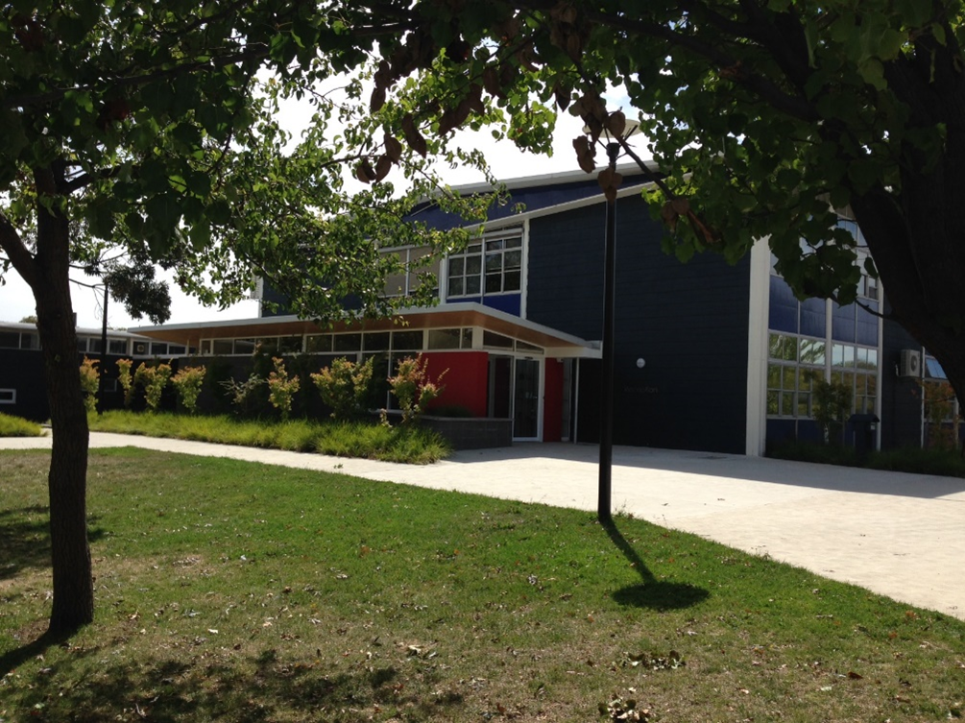

The purpose of school improvement planning
This plan establishes a strong improvement agenda to be driven by school leaders over the next five years. It was informed by the Directorate’s Strategic Plan and system-level and school-based analysis of multiple sources of evidence. Analysis of these multiple sources of evidence is supported by an annual provision to each school of a data summary as a key enabler of our improvement planning and implementation.
Each school participates in School Review as an integral component of in its five-year improvement planning cycle. Review findings support annual improvement planning (Action Plan) and are an important component of Directorate monitoring and support of school improvement. Reviews provide schools with quality and independent feedback, tailored to the school’s context. Each school is reviewed at least every five years, providing valuable opportunities for self-reflection, planning and improvement. The school improvement planning process is below. This representation is used in the footer of all school-based improvement documents to indicate the stage of planning or implementation.
Analysis Priorities Strategies Actions Impact (for student)
Our school improvement planning is grounded in evidence from research and practice and expressed in terms of improvements in measurable student outcomes. Explicit five-year targets for improvement have been set and will give life to monitoring, evaluation and communication of progress to teachers, families and students.

Our school’s improvement agenda positioned within the Directorate’s Strategic Plan

Vision
Directorate’s vision: We will be a leading learning organisation where people know they matter.
School’s vision: We will create a positive inquiry-based learning culture that encompasses all aspects of teaching and learning, meets the needs of all members of our school community (children and adults) and is driven by evidence-based practice.

Mission
Directorate’s mission: We develop and deliver educational services to empower each child and young person in the ACT to learn for life.
School’s mission: We prepare students to become active, caring, lifelong learners who demonstrate respect for themselves and others and have the capacity to participate in the world around them with open hearts and inquiring minds. We focus on the development of the whole child.
We create collaborative partnerships with parents and the community that foster intercultural understanding and develop inquiring, knowledgeable, compassionate and resilient young people who are able to make a difference in our world.

Values
Directorate’s Values: Respect, Integrity, Collaboration, Innovation.
School’s values: We are committed to the attributes of the IB learner profile, which help all members of the school community learn to respect themselves, others and the world around them.
The profile aims to develop learners who are:
- Inquirers
- Knowledgeable
- Thinkers
- Communicators
- Principled
- Open-minded
- Caring
- Risk-takers
- Balanced
- Reflective
The learner profile is underpinned by these values and attitudes:
Respect, Integrity, Creativity, Cooperation, Empathy, Tolerance, Curiosity, Appreciation, Confidence, Commitment, Resilience, Enthusiasm, Independence and Courage.

Education Directorate’s Strategic Goals for 2018-2021
- Schools where students love to learn
- Investing in early childhood
- Evidence informed decisions
- Learning culture
- United leadership team

Education Directorate’s Strategic Indicators for 2018-2021
- To promote greater equity in learning outcomes in and across ACT public schools
- To facilitate high quality teaching in ACT public schools and strengthen educational outcomes
- To centre teaching and learning around students as individuals
The Directorate annually publishes progress against its Strategic Indicators. Our school’s contributions to these Strategic Indicators are detailed in our annual Impact Reports.

Multiple sources of evidence
Evidence informing this School Improvement Plan includes:
- analysis of system-level data
- analysis of school-based evidence over time (past 4/5 years)
- for schools with a preschool setting, Quality Ratings from assessment against the National Quality Framework. *
*For schools with a preschool setting their Quality Improvement Plan (QIP) is revised each year as part of the annual planning process.

Our improvement priorities
Priority 1: To improve student growth in numeracy
The statement below details our vision for how this priority will change the experience of school for our students.

At the end of our five-year plan:
- students will have a sense of self-efficacy as mathematicians
- students will be setting and achieving personal learning goals in mathematics
- students will demonstrate mathematical proficiency (fluency, conceptual understanding, reasoning and problem-solving) across all strands of mathematics, and
- students will be using mathematical vocabulary to articulate their mathematical thinking and solve problems.

Targets/Measures to be achieved by 2026

Student learning data
Target or measure: 65% or more of our year 5 students will be achieving at or above expected growth in numeracy.
This target was determined by averaging percentages of students in SSSG achieving at or above expected growth over 2018-2021.

Source: NAPLAN growth data as available through SCOUT
Starting point: Baseline data of 47% was determined by averaging percentages of Red Hill students achieving at or above expected growth from 2018-2021. On average the school is 18.4% points below SSSG (65.17%) and 9.9% points below the ACT (56.63%) for the last three years.

Target or measure: The scaled growth score for our year 5 students in numeracy will be equal to, or above, like schools (SSSG) averaged at 91 score points over 2018-2021.
Source: NAPLAN growth data as available through SCOUT
Starting point: Baseline data of 74 points was determined by averaging the scaled score growth of Red Hill students from 2018-2021. On average the school is 17 points below SSSG (91) and 5 points below the ACT (89) for the last three years.

Target or measure: Percentage of students in the top two bands for numeracy will be equal to, or above, like schools (SSSG), so targets are 64.6% for year 3 and 56.4% for year 5, averaged over the last three years of the plan.
Source: NAPLAN data as available through SCOUT.
Starting point: On average the school is 12.3% points below SSSG for year 3(64.6%) and 20% points for year 5 (56.4%) over the last three years.

Target or Measure: Growth in the PAT median scaled score in mathematics for each year level at Red Hill is at or above the growth in the norm reference group median scaled score for the corresponding time period.
Source: ACER Progressive Achievement Testing (PAT) Mathematics Longitudinal Report data
Starting Point: The average growth in the median scaled scores of Red Hill for each year level for the 2018-2021 time period is: Year 2: 7.5 scaled score, Year 3: 8.5 scaled score, Year 4: 7.2 scaled score, Year 5: 5.6 scaled score, Year 6: 3.3 scaled score. The average growth in median scaled scores for each year level in the norm reference groups in the same time period is: Year 2: 10 scaled score, Year 3: 9 scaled score, Year 4: 8 scaled score, Year 5: 6.7 scaled score, Year 6: 5.3 scaled score.

Perception data
Target or measure: 84% or above % of Red Hill students agree/strongly agree that ‘Teachers explain what we are learning about and why’.

Source: System Satisfaction Survey – students
Starting point: Baseline data of 80.3% was determined by averaging the percentages of agreement compared to system average of 83.3% in 2019-2020.

Target or measure: 76% or above of Red Hill students agree/strongly agree that ‘Teachers give useful feedback’.

Source: System Satisfaction Survey – students
Starting point: Baseline data of 71% was determined by averaging the percentages of agreement compared to system average of 75.25% in 2019-2020.

School program and process data
Target or measure: The percentage of students with a high level of self-efficacy in mathematics increases over the life of the plan.

Source: School mathematics self-efficacy survey

Starting point: Baseline data to be determined in February 2022.

Priority 2: To improve students’ resilience and capabilities as learners
The statement below details our vision for how this priority will change the experience of school for our students.

At the end of our five year plan:
- students will demonstrate all attributes of the IB PYP learner profile (thinker, inquirer, knowledgeable, communicator, balanced, open-minded, risk-taker, reflective, principled, caring)
- students will have a strong sense of self-efficacy
- students will be independent learners who actively seek clarification to understand
- students will reflect on their personal strengths and understand that everyone is on their own learning journey
- students will be enthusiastic, curious learners who are engaged and appropriately challenged, and
- students will recognise and regulate emotions, develop empathy for themselves and others and manage challenging situations constructively.

Targets/Measures to be achieved by 2026

Student learning data
Target or measure: Increase percentage of students receiving B’s and A’s across all learning areas.
Source: School Based Academic Reports
Starting point: Baseline data determined from average percentage of As and Bs awarded to students in Years K-6 from semesters 1 and 2, 2021.
 | English | Maths | Science | HASS | Arts | Technology | Physical Education | Languages | Total
K | 39.25 | 63 | 47.25 | 40.5 | 46.25 | 40 | 30.5 | 37 | 43
1 | 38.5 | 64.25 | 55 | 50 | 46 | 58.5 | 36 | 42.25 | 49
2 | 48 | 47 | 41 | 44 | 25.75 | 42.25 | 48.5 | 49.25 | 43.2
3 | 45.5 | 48.5 | 39.25 | 38.5 | 46 | 37.5 | 36 | 38 | 41.2
4 | 44.5 | 56.5 | 54.5 | 61.25 | 45 | 49 | 33 | 34 | 47.2
5 | 52 | 47 | 50.75 | 42.5 | 55.5 | 39.5 | 37.25 | 42 | 46
6 | 58.5 | 63.5 | 58.5 | 60 | 58 | 53.5 | 54.5 | 43 | 56.2

Student learning data
Target or measure: Increase percentage of students consistently applying effort across all learning areas.
Source: School Based Academic Reports
Starting point: Baseline data determined from average percentage of students consistently applying effort in Years K-6 from semesters 1 and 2, 2021.
 | English | Maths | Science | HASS | Arts | Technology | Physical Education | Languages | Total
K | 60.5% | 66% | 62% | 68% | 76% | 57% | 100% | 73% | 70%
1 | 76% | 91% | 91.5% | 88% | 93.5% | 67% | 90% | 78.5% | 84%
2 | 82% | 81% | 95.5% | 89% | 98% | 84.5% | 94.5% | 75.5% | 88%
3 | 78% | 90% | 69% | 75% | 100% | 73% | 99% | 64% | 81%
4 | 83% | 84% | 93% | 83.5% | 99% | 91.5% | 100% | 98% | 92%
5 | 71% | 74.5% | 81% | 76% | 93% | 88% | 95.5% | 80.5% | 82%
6 | 81% | 84% | 89.5% | 84% | 95% | 80% | 95% | 81% | 86%

Perception data
Target or measure: 86% or above of parents and students agree/strongly agree that ‘Students at this school are being equipped with the capabilities to learn and live successfully’.

Source: System Satisfaction Survey – students
Starting point: Baseline data of 84%(students) and 85% (parents) was determined by averaging the percentages of agreement in 2019-2020.

Target or measure: 66% or above of students agree/strongly agree that ‘I can talk to my teachers about my concerns’.

Source: System Satisfaction Survey – students
Starting point: Baseline data of 62.75%(students) was determined by averaging the percentages of agreement, compared to the system average of 66% in 2019-2020.

Target or measure: Improve the percentage of students in each cohort (years 2 – 6) who agree with the statements:
- I worry a lot about my schoolwork or what others think about me
- When I do badly in my schoolwork, I think “I’m stupid”.
- When I do not understand something, I give up easily.
- I can calm down quickly when I feel bad.
- I love to learn.

Source: ACER Social Emotional Wellbeing Survey
Starting point: Baseline data was determined by averaging percentages of student agreement across years 2 – 6 for each statement during the period 2020-2021 and comparing to the national norm reference group.
 | I worry a lot about my schoolwork or what others think about me. |  | When I do badly in my schoolwork, I think “I’m stupid”. |  | When I do not understand something, I give up easily. |  | I can calm down quickly when I feel bad. |  | I love to learn
 | School | Norm | School | Norm | School | Norm | School | Norm | School | Norm
Year 2 | 35 | 35.5 | 29.5 | 18 | 21 | 16.5 | 62 | 73 | 81 | 90
Year 3 | 38 | 36 | 16.5 | 19 | 16 | 15 | 70.5 | 71 | 90 | 89.5
Year 4 | 47.5 | 37.5 | 29 | 20 | 22.5 | 15 | 56.5 | 69 | 84 | 88.5
Year 5 | 39.5 | 40.5 | 28 | 24 | 22 | 17.5 | 57 | 68.5 | 80 | 89
Year 6 | 52 | 43 | 31.5 | 28 | 23 | 18.5 | 60 | 69 | 69.5 | 80
Total | 57 | 38.5 | 27 | 22 | 21 | 16.5 | 61 | 70 | 81 | 87.5

Endorsement
This School Improvement Plan has been endorsed electronically by our Principal, Director School Improvement and Board Chair.

Principal
Name: Louise Owens
Date: 8.2.22

Director School Improvement
Name: Angela Spence
Date: 8.2.22

Board Chair
Name: Dr Phil Coote
Date: 8.2.22

