Alfred Deakin High School
Annual School Board Report 2021

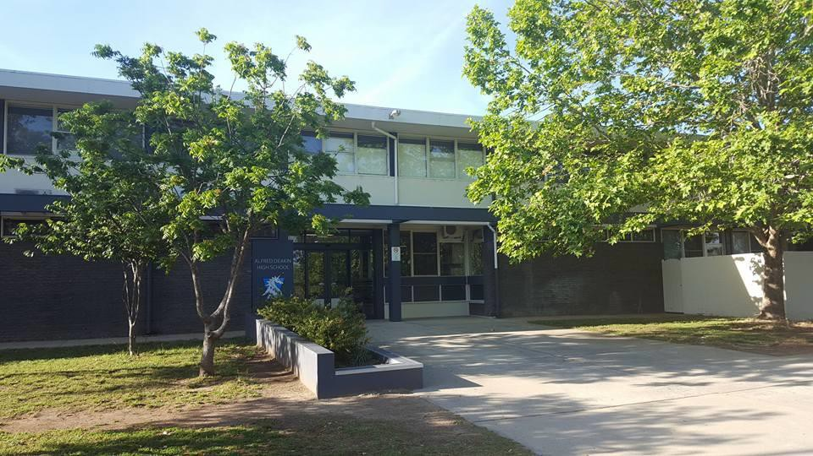

This page is intentionally left blank.

This report supports the work being done in the ACT Education Directorate, as outlined in Strategic Plan 2018-21: A Leading Learning Organisation.

Accessibility
The ACT Government is committed to making its information services, events and venues accessible to as many people as possible.

If you have difficulty reading a standard document and would like to receive this publication in an alternate format, such as large print and audio, please telephone (02) 6247 4580.

If English is not your first language and you require the translating and interpreting service, please telephone 13 14 50.

If you are deaf or hearing impaired and require the National Relay Service, please telephone 13 36 77.

© Australian Capital Territory, Canberra, 2022

Material in this publication may be reproduced provided due acknowledgement is made.

Contents
Reporting to the community 1
School Context 1
Student Information 2
Student enrolment 2
Student attendance 2
Supporting attendance and managing non-attendance 3
Staff Information 3
Teacher qualifications 3
Workforce composition 3
School Review and Development 4
School Satisfaction 4
Overall Satisfaction 4
Learning and Assessment 6
NAPLAN 6
Financial Summary 7
Voluntary Contributions 8
Reserves 8
Endorsement Page 9
Members of the School Board 9

Reporting to the community

Schools report to communities in range of ways, including through:

- Annual School Board Reports
- a (5-year) School Improvement Plan (formerly School Strategic Plan)
- annual Impact Reports
- newsletters
- other sources such as My School.

School Context

ADHS is a Year 7-10 high school located in the suburb of Deakin in the Australian Capital Territory. Established in 1966 and with an enrolment of 845, ADHS draws students from many different cultural backgrounds. The school community values the diversity of its population and celebrates the advantages that this diversity brings to the school. ADHS seeks to enrich student lives through innovative education, a pursuit of excellence in learning, and the celebration of personal success.
Together we engage with the community and work to develop creative and confident young people. Our school values of Excellence, Respect, Responsibility, and Community are mirrored in our learning programs, our policies and in the overall culture of the school.

The school promotes the development of individuals through a broad range of learning experiences. These include a strong core curriculum of English, Maths, Humanities and the Social Sciences, Science, Languages (French, Japanese, Italian and Indonesian), and PE and Health, and a diverse elective curriculum in Technology and the Arts.

Students have access to a range of programs to meet both aptitude and interest, including the Unicorn program (for identified gifted and talented students), extension and flexible and personalised learning pathways. The school also has an E-Study and Gryphon program that cater for a range of student learning needs, including students requiring specific and individual learning support.

ADHS emphasises restorative practices and a pastoral care program focused developing social and emotional learning skills. The strong co-curricular program includes overseas and national excursions camps and activities that add value to experiential learning. Leadership opportunities are a focus at ADHS for developing confident, resilient and compassionate global citizens.

The Panthers (boys) and Elements (girls) education programs for Years 9 and 10 students, a Year 10 Leadership recognition system, an active Student Executive Group, the Youth Leadership program offering Peer Support to Year 7 students and an Advanced Outdoor Education program are widely recognised as examples of excellence. The Disability Awareness Program delivered to Year 10 students in partnership with Woden School is unique in the ACT.

The use of learning technologies is embedded in the teaching and learning environment at ADHS. Every student has a Chromebook and accesses learning resources through the networked environment. The Google G Suite is the online learning management system used across all classes to issue materials, check student progress and provide feedback for learning.

Strategies to improve literacy and numeracy have included a focus on quality teaching, building the capacity of staff to effectively utilise reading strategies across all curriculum areas, and targeted

intervention support for all students identified through annual school-based numeracy and literacy testing.

Students at ADHS value having diverse opportunities in a positive and inclusive atmosphere where everyone’s individuality is respected. ADHS values the active and supportive relationships with its parents and carers and the inclusive and friendly relationships that exist in the school.

Student Information

Student enrolment
In this reporting period there were a total of 845 students enrolled at this school.

Table: Student enrolment

Student type | Number of students
Gender - Male | 460
Gender - Female | 385
Gender - Non-binary or other* | 0
Aboriginal and Torres Strait Islander | 24
LBOTE** | 257
Source: ACT Education Directorate, Analytics and Evaluation Branch
* If the number of non-binary students is less than six, or if gender is unknown, these are randomly assigned 'Male' or 'Female' and included in the counts.
** Language Background Other Than English

Student attendance
The following table identifies the attendance rate of students by year level during this reporting period. Student attendance rate is the percentage of school days attended by students in each year level at the school. Student attendance is measured over two school terms; that is from the first day of the school year for students in term 1 to the last day of term 2.

*NOTE: Student attendance data for this period should be understood within the context of flexible learning arrangements enacted in response to COVID19. Comparison of attendance figures to previous reporting periods is not valid.

Table: Attendance rates in percentages

Year level | Attendance rate
7 | 93.0
8 | 88.0
9 | 88.0
10 | 87.0

Source: ACT Education Directorate, Analytics and Evaluation Branch

Supporting attendance and managing non-attendance
ACT public schools support parents and careers to meet their legal responsibilities in relation to the compulsory education requirements of the Education Act 2004. The Education Directorate’s Education Participation (Enrolment and Attendance) Policy describes its position with regard to supporting attendance and managing non-attendance. A suite of procedures supports the implementation of the policy. Please refer to https://www.education.act.gov.au/ for further details.

Staff Information

Teacher qualifications
All teachers at this school meet the professional requirements for teaching in an ACT public school. The ACT Teacher Quality Institute (TQI) specifies two main types of provision for teachers at different stages of their career, these are detailed below.

- Full registration is for teachers with experience working in a registered school in Australia or New Zealand who have been assessed as meeting the Proficient level of the Australian Professional Standards for Teachers.

- Provisional registration is for newly qualified teachers or teachers who do not have recent experience teaching in a school in Australia and New Zealand. Many teachers moving to Australia from another country apply for Provisional registration.

Workforce composition
Workforce composition for the current reporting period is provided in the following table. The data is taken from the school’s verified August staffing report. For reporting purposes, it incorporates all school staff including preschools, staff absent for a period of less than four consecutive weeks and staff replacing staff absent for more than four consecutive weeks. It does not include casuals and staff absent for a period of four consecutive weeks or longer.

The Education Directorate is required to report Aboriginal and Torres Strait Islander staff figures. As of June of the reporting period, 135 Aboriginal and/or Torres Strait Islander staff members were employed across the Directorate.

Table: Workforce composition numbers

Staff employment category | TOTAL
Teaching Staff: Full Time Equivalent Permanent | 47.90
Teaching Staff: Full Time Equivalent Temporary | 5.20
Non Teaching Staff: Full Time Equivalent | 23.06
Source: ACT Education Directorate, People and Performance Branch

School Review and Development

The ACT Education Directorate’s Strategic Plan 2018-2021 provides the framework and strategic direction for School Improvement Plans (formerly School Strategic Plans). This is supported by the school performance and accountability framework ‘People, Practice and Performance: School
Improvement in Canberra Public Schools, A Framework for Performance and Accountability’. Annually, system and school level data are used alongside the National School Improvement Tool to support targeted school improvement, high standards in student learning, innovation and best practice in ACT public schools.

Our school will be reviewed in 2022

School Satisfaction
Schools use a range evidence to gain an understanding of the satisfaction levels of their parents and carers, staff and students. Annually in August/ September ACT schools undertake a survey to gain an understanding of school satisfaction at that time. This information is collected from staff, parents and from 2020 students from year 4 and above (previously year 5 and above) through an online survey.

Overall Satisfaction
In this period of reporting, 86.6% of parents and carers, 88.7% of staff, and 72.1% of students at this school indicated they were satisfied with the education provided by the school.

Included in the survey were 8 staff, 9 parent, and 10 student items which are described as the national opinion items. These items were approved by the then Standing Council on School Education and Early Childhood (SCSEEC) for use from 2015. The following tables show the percentage of parents and carers, students and staff who agreed with each of the national opinion items at this school.

Due to the impacts of the COVID-19 pandemic, the survey was taken in November, rather than in August as has been done in previous years. This was just after the majority of students and staff returned to school-based learning after a period of around 3 months of remote learning. A number of questions were removed from previous years’ to shorten the time required by community members to complete the survey.

A total of 62 staff responded to the survey. Please note that not all responders answered every question.

Table: Proportion of staff* in agreement with each national opinion item

National opinion item
Parents at this school can talk to teachers about their concerns. | 95
Staff get quality feedback on their performance. | 53
Student behaviour is well managed at this school. | 74
Teachers want every student to do their best. (Replaces 'Teachers at this school expect students to do their best') | 92
Staff at this school treat students with respect. (Replaces 'Teachers at this school treat students fairly') | 98

Teachers give useful feedback. | 86
This school is well maintained. | 87
The way decisions are made in this school are appropriate (Replaces 'This school takes staff opinions seriously') | 76
Source: ACT Education Directorate, Analytics and Evaluation Branch
*Proportion of those who responded to each individual survey question

A total of 187 parents responded to the survey. Please note that not all responders answered every question.

Table: Proportion of parents and carers* in agreement with each national opinion item

National opinion item
My child feels safe at this school. | 91
My child is making good progress at this school. | 85
Student behaviour is well managed at this school. | 78
Teachers at this school believe that every student can be a success. (Replaces 'Teachers at this school expect my child to do his or her best') | 76
Teachers give useful feedback. | 74
Staff at this school treat students with respect. (Replaces 'Teachers at this school treat students fairly') | 87
This school is well maintained. | 83
This school is active in seeking parents' opinion and ideas for making important  decisions.(Replaces 'This school takes parents’ opinions seriously') | 61
This school works with me to support my child's learning. | 72
Source: ACT Education Directorate, Analytics and Evaluation Branch
*Proportion of those who responded to each individual survey question

A total of 494 students responded to the survey. Please note that not all responders answered every question.

Table: Proportion of students* in agreement with each national opinion item

National opinion item
I feel I can talk to teachers about problems at school. (Replaces 'I can talk to teachers about my concern') | 44
I feel safe at this school. | 64
I am happy to be part of this school.(Replaces 'I like being at my school') | 74
I am interested in what I learn in school. (Replaces 'My school gives me opportunities to do interesting things') | 46
My school is well maintained. | 62
Teachers want every student to do their best.(Replaces 'My teachers expect me to do my best') | 79
Teachers encourage students to try out new ideas. (Replaces 'My teachers motivate me to learn') | 69

Staff take students’ concerns seriously. | 56
Staff treat students with respect. (Replaces 'Teachers at my school treat students fairly') | 69
Teachers give useful feedback. | 58
Source: ACT Education Directorate, Analytics and Evaluation Branch
*Proportion of those who responded to each individual survey question

Learning and Assessment

NAPLAN
Students in years 3, 5, 7 and 9 in all ACT schools participate in the National Assessment Program- Literacy and Numeracy (NAPLAN). This program assesses skills in reading, writing, spelling, grammar and punctuation, and numeracy.

In this reporting period, 1.50 % of year 7 students and 1.82 % of year 9 students were exempt from testing based on nationally agreed criteria.

For reasons of statistical reliability, as well as to protect the privacy of students, results are not reported when the sample size is less than five.

The following table shows the mean scores achieved by students at this school compared to all other ACT public schools for this reporting period.

Table: NAPLAN Mean Scores

Test Domain | Year 7 School | Year 7 ACT | Year 9 School | Year 9 ACT
Reading | 566 | 541 | 618 | 584
Writing | 538 | 522 | 573 | 544
Spelling | 555 | 543 | 601 | 576
Grammar & Punctuation | 557 | 538 | 598 | 576
Numeracy | 574 | 548 | 615 | 588

Financial Summary

The school has provided the Directorate with an end of year financial statement that was approved by the school board. Further details concerning the statement can be obtained by contacting the school. The following summary covers use of funds for operating costs and does not include expenditure in areas such as permanent salaries, buildings and major maintenance.

Table: Financial Summary

INCOME | January-December
Directorate Funding | 640671.80
Contributions and Donations | 34071.02
Subject Contributions | 77848.51
Hire of Facilities | 15036.80
External Revenue | 3125.00
Sale of Assets | 0.00
Interest Received | 7439.45
Other School Revenue | 33275.85
TOTAL INCOME | 811468.43
EXPENDITURE
Utilities and General Overheads | 151440.35
Security and Caretaking | 0.00
Maintenance | 130036.67
Administration | 36349.16
Staffing Expenditure | -10058.07
Communication | 11913.43
Assets & Leases | 115204.17
General Expenses | 36861.72
Educational Resources | 57678.93
Subject Consumables | 106465.52
Directorate Funded Payments | 22366.50
Other Payments | 23694.26
TOTAL EXPENDITURE | 681952.64
OPERATING RESULT | 129515.79
Accumulated Funds | 150123.62
BALANCE | 279639.41

Voluntary Contributions
The funds listed were used to support the general operations of the school. The spending of voluntary contributions is in line with the approved budget for this reporting period.

Reserves

Name and Purpose | Amount | Expected Completion
STEM/ Tech future upgrade – The goal is to refurbish the outdated and restricted spaces in the Technology Wing, providing a modern and flexible design and maker space incorporating science and technology | 190,000.00 | 2022/23
School Development Plan - furniture for flexible learning to encourage innovative projects aligned to school improvement goals, primarily through staffing support | 16,000.00 | 2022
The mower will allow the BSO to complete the mowing, so this is not outsourced | 20,000.00 | Completed - February  2022
To upgrade the student services area, stage 1 – to renovate and refurbish the Student Wellbeing space, making it more functional for staff and students | 105,000.00 | 2023

Endorsement Page

Members of the School Board

Parent Representative(s): | Trevor Hickman | Thao Nguyen
Community Representative(s): | Denis O’Hare | Cheryl O’Donnell
Teacher Representative(s): | Robin Ricketts | Scott Ritchie
Student Representative(s): | Minh Phan | Fatima Syed
Board Chair: | Denis O’Dea
Principal: | Brian Downton

I approve the report, prepared in accordance with the provision of the ACT Education Act 2004, section 52.

2022 Board Chair Signature: | Denis O’Dea | Date: | 10/06/2022

I certify that to the best of my knowledge and belief the evidence and information reported in this Annual School Board Report represents an accurate record of the Board’s operations during this reporting period.

Principal Signature: | Brian Downton | Date: | 10/ 06/ 2022

/

