Calwell Primary School
Annual School Board Report 2020

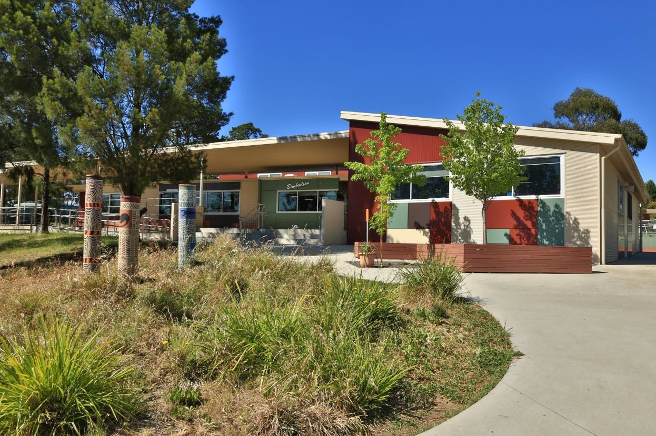

This page is intentionally left blank.

This report supports the work being done in the ACT Education Directorate, as outlined in Strategic Plan 2018-21: A Leading Learning Organisation.

Accessibility
The ACT Government is committed to making its information services, events and venues accessible to as many people as possible.

If you have difficulty reading a standard document and would like to receive this publication in an alternate format, such as large print and audio, please telephone (02) 6247 4580.

If English is not your first language and you require the translating and interpreting service, please telephone 13 14 50.

If you are deaf or hearing impaired and require the National Relay Service, please telephone 13 36 77.

© Australian Capital Territory, Canberra, 2021

Material in this publication may be reproduced provided due acknowledgement is made.

Contents
Reporting to the community 1
Summary of School Board activity 1
School Context 2
Student Information 2
Student enrolment 2
Student attendance Error! Bookmark not defined.
Supporting attendance and managing non-attendance 3
Staff Information 3
Teacher qualifications 3
Workforce composition 3
School Review and Development 4
School Satisfaction 4
Overall Satisfaction 4
Learning and Assessment 6
Performance in Literacy and Numeracy 6
Early years assessment 6
NAPLAN 6
Outcomes for College Students Error! Bookmark not defined.
Post School Destination Error! Bookmark not defined.
Financial Summary 7
Voluntary Contributions 8
Reserves 8
Endorsement Page 9
Members of the School Board 9

Reporting to the community

Schools report to communities in range of ways, including through:

- Annual School Board Reports
- a (5-year) School Improvement Plan (formerly School Strategic Plan)
- annual Impact Reports
- newsletters
- other sources such as My School.

Summary of School Board activity

2020 presented challenges for the school community as it responded to the impact of COVID 19. The school was very successful in adjusting quickly and effectively to on-line learning. This was readily achieved as the integration of information technology in teaching and learning at the school was already well established. The School Board in collaboration with the school’s leadership team had, over the past 5-10 years, actively focussed on building IT infrastructure and resourcing in the school to support engaging and contemporary educational practices. This positioned the school well when it was unexpectedly faced with delivering educational programs on-line. The school had sufficient resources to supply a device to every student and teachers and students were already familiar with the use of Google Classroom, Seesaw and a variety of education apps as these were already embedded into the teaching and learning environment at Calwell.

COVID impacted on the school environment at varying levels throughout the year. The uncertainty around whether activities could or would go ahead, and the need to build in contingency plans added a layer of complexity to day-to-day planning and the overall operation of the school. The School Board worked closely with the leadership team to ensure that Calwell students were provided with the best opportunities and experiences despite the challenges faced in this unprecedented year. The school community actively supported requests and changes such as limited access to teaching units, limiting attendance at assemblies and events, and engaging with the school through Seesaw, Facebook and via the emailed Newsletter.

2020 also provided the catalyst and opportunity for the school community to think about how teaching and learning occurs. During the period of home learning, many parents/carers reported developing a greater understanding of what and how their child/ren learn as well as a renewed appreciation of the work of teachers. The impact of COVID also highlighted the value of students developing the Learning Assets the school had recently started to integrate into curriculum delivery. The ability to be an effective communicator, collaborator, researcher, thinker and self-manager was equally evident as valuable in a different learning environment and situation.

The changing environment also underlined the value and importance of parental support and engagement in student learning. The School Board suggested applying for grant funding that was available to foster parental engagement. The school was successful in this application receiving
$18,000. The grant consisted of a number of mini projects to meet the varying interests of students, parent/carers and staff. The projects identified were based on community feedback received though the 2019/2020 Annual School Improvement and Climate Surveys, feedback received through the 2020 Learning Journey and recommendations suggested to the school through the 2018/2019 school review process.

The Board is looking forward to working with the school in progressing the work of the grant and reviewing the impact of the grant funding.

Whilst 2020 presented a range of challenges, the school and its community rose to these and positive progress was made against the school’s Annual Action and Strategic Improvement Plans.

Megan Fox Linda Neeson
School Board Chair Principal

School Context

Calwell Primary School provides an inclusive learning environment where children are respected and their individuality recognised, encouraged and supported. Our educational program strives to develop inquiring, knowledgeable, caring and respectful young people. The school has adopted the Positive Behaviours for Learning framework which clearly articulates school expectations. This has been highly successful with the school achieving consistently high outcomes in The school
provides a well- balanced, contemporary curriculum that is relevant, engaging and challenging for all students from Preschool to Year six. Supporting the curriculum and student social-emotional development is the adoption of the five Learning Assets - Communicator, Self Manager, Researcher, Collaborator & Thinker. The school strives to develop our students as confident and articulate young people, able to contribute positively to the community and to meet the challenges of the 21st Century.

Student Information

Student enrolment
In this reporting period there were a total of 252 students enrolled at this school.

Table: Student enrolment*

Student type | Number of students
Gender - Male | 119
Gender - Female | 133
Gender - Non-binary or other | 0
Aboriginal and Torres Strait Islander | 9
LBOTE** | 45
Source: ACT Education Directorate, Analytics and Evaluation Branch
* To protect personally identifiable information any figures less than six are not reported.
** Language Background Other Than English

Student attendance
Due to the effects of the COVID-19 pandemic, 2020 attendance data has not been published in the Annual School Board Report.

Supporting attendance and managing non-attendance
ACT public schools support parents and careers to meet their legal responsibilities in relation to the compulsory education requirements of the Education Act 2004. The Education Directorate’s Education Participation (Enrolment and Attendance) Policy describes its position with regard to supporting attendance and managing non-attendance. A suite of procedures supports the implementation of the policy. Please refer to https://www.education.act.gov.au/ for further details.

Staff Information

Teacher qualifications
All teachers at this school meet the professional requirements for teaching in an ACT public school. The ACT Teacher Quality Institute (TQI) specifies two main types of provision for teachers at different stages of their career, these are detailed below.

- Full registration is for teachers with experience working in a registered school in Australia or New Zealand who have been assessed as meeting the Proficient level of the Australian Professional Standards for Teachers.

- Provisional registration is for newly qualified teachers or teachers who do not have recent experience teaching in a school in Australia and New Zealand. Many teachers moving to Australia from another country apply for Provisional registration.

Workforce composition
Workforce composition for the current reporting period is provided in the following table. The data is taken from the school’s verified August staffing report. For reporting purposes, it incorporates all school staff including preschools, staff absent for a period of less than four consecutive weeks and staff replacing staff absent for more than four consecutive weeks. It does not include casuals and staff absent for a period of four consecutive weeks or longer.

The Education Directorate is required to report Aboriginal and Torres Strait Islander staff figures. As of June of the reporting period, 135 Aboriginal and Torres Strait Islander staff members were employed across the Directorate.

Table: Workforce composition numbers

Staff employment category | TOTAL
Teaching Staff: Full Time Equivalent Permanent | 17.23
Teaching Staff: Full Time Equivalent Temporary | 0.60
Non Teaching Staff: Full Time Equivalent | 11.23
Source: ACT Education Directorate, People and Performance Branch

School Review and Development

The ACT Education Directorate’s Strategic Plan 2018-2021 provides the framework and strategic direction for School Improvement Plans (formerly School Strategic Plans). This is supported by the school performance and accountability framework ‘People, Practice and Performance: School
Improvement in Canberra Public Schools, A Framework for Performance and Accountability’. Annually, system and school level data are used alongside the National School Improvement Tool to support targeted school improvement, high standards in student learning, innovation and best practice in ACT public schools.

ur school was reviewed in 2018. A copy of the Report of Review can be found on our school website.

School Satisfaction
Schools use a range evidence to gain an understanding of the satisfaction levels of their parents and carers, staff and students. Annually in August/ September ACT schools undertake a survey to gain an understanding of school satisfaction at that time. This information is collected from staff, parents and from 2020 students from year 4 and above (previously year 5 and above) through an online survey.

Overall Satisfaction
In this period of reporting, 86% of parents and carers, 100% of staff, and 95% of students at this school indicated they were satisfied with the education provided by the school.

Included in the survey were 16 staff, 14 parent, and 12 student items which are described as the national opinion items. These items were approved by the then Standing Council on School Education and Early Childhood (SCSEEC) for use from 2015. The following tables show the percentage of parents and carers, students and staff who agreed with each of the national opinion items at this school.

Note: The overall response rate for parents and carers in ACT public schools was negatively impacted by COVID-19, dropping from 31% in 2019 to 23% in 2020.

A total of 32 staff responded to the survey. Please note that not all responders answered every question.

Table: Proportion of staff* in agreement with each national opinion item

National opinion item
Parents at this school can talk to teachers about their concerns. | 91
Staff are well supported at this school. | 91
Staff get quality feedback on their performance. | 88
Student behaviour is well managed at this school. | 94
Students at this school can talk to their teachers about their concerns. | 88
Students feel safe at this school. | 91
Students like being at this school. | 94
Students’ learning needs are being met at this school. | 100
Teachers at this school expect students to do their best. | 100

Teachers at this school motivate students to learn. | 97
Teachers at this school treat students fairly. | 100
Teachers give useful feedback. | 82
This school is well maintained. | 84
This school looks for ways to improve. | 97
This school takes staff opinions seriously. | 81
This school works with parents to support students' learning. | 91
Source: ACT Education Directorate, Analytics and Evaluation Branch
*Proportion of those who responded to each individual survey question

A total of 74 parents responded to the survey. Please note that not all responders answered every question.

Table: Proportion of parents and carers* in agreement with each national opinion item

National opinion item
I can talk to my child’s teachers about my concerns. | 96
My child feels safe at this school. | 89
My child is making good progress at this school. | 81
My child likes being at this school. | 91
My child's learning needs are being met at this school. | 82
Student behaviour is well managed at this school. | 66
Teachers at this school expect my child to do his or her best. | 89
Teachers at this school give useful feedback. | 85
Teachers at this school motivate my child to learn. | 82
Teachers at this school treat students fairly. | 78
This school is well maintained. | 92
This school looks for ways to improve. | 74
This school takes parents’ opinions seriously. | 65
This school works with me to support my child's learning. | 76
Source: ACT Education Directorate, Analytics and Evaluation Branch
*Proportion of those who responded to each individual survey question

A total of 97 students responded to the survey. Please note that not all responders answered every question.

Table: Proportion of students* in agreement with each national opinion item

National opinion item
I can talk to my teachers about my concerns. | 86
I feel safe at this school. | 80
I like being at my school. | 87
My school gives me opportunities to do interesting things. | 94
My school is well maintained. | 100

My school looks for ways to improve. | 97
My teachers expect me to do my best. | 100
My teachers motivate me to learn. | 98
Staff take students’ concerns seriously. | 90
Student behaviour is well managed at my school. | 90
Teachers at my school treat students fairly. | 95
Teachers give useful feedback. | 90
Source: ACT Education Directorate, Analytics and Evaluation Branch
*Proportion of those who responded to each individual survey question

Learning and Assessment

Performance in Literacy and Numeracy

Early years assessment
Students in kindergarten undertake an on-entry and on-exit assessment of their early reading and numeracy skills using the BASE program. Student results are reported against five performance bands at the end of semester 1 and 2. Below are the results for this school for the current reporting period.

Due to the impact of COVID-19, analysis of BASE data for 2020 has been delayed. Analysis will be provided to schools in 2021. Please speak with the school should you require further information.

NAPLAN
Students in years 3, 5, 7 and 9 in all ACT schools participate in the National Assessment Program- Literacy and Numeracy (NAPLAN). This program assesses skills in reading, writing, spelling, grammar and punctuation, and numeracy.

*Note: There are no NAPLAN results for 2020, with the assessments not being conducted due to the impacts of COVID-19.

Financial Summary

The school has provided the Directorate with an end of year financial statement that was approved by the school board. Further details concerning the statement can be obtained by contacting the school. The following summary covers use of funds for operating costs and does not include expenditure in areas such as permanent salaries, buildings and major maintenance.

Table: Financial Summary

INCOME | January-June | July-December | January-December
Self-management funds | 106407.13 | 109753.62 | 216160.75
Voluntary contributions | 873.75 | 2345.00 | 3218.75
Contributions & donations | 138.36 | 982.51 | 1120.87
External income (including community use) | 525.00 | 1219.74 | 1744.74
Proceeds from sale of assets | 0.00 | 0.00 | 0.00
Bank Interest | 2324.60 | 1881.73 | 4206.33
TOTAL INCOME | 110268.84 | 116182.60 | 226451.44
EXPENDITURE
Utilities and general overheads | 30067.71 | 42050.51 | 72118.22
Cleaning | 0.00 | 0.00 | 0.00
Security | 0.00 | 0.00 | 0.00
Maintenance | 24898.80 | 29785.39 | 54684.19
Administration | 1084.57 | 4001.96 | 5086.53
Communication | 763.31 | 989.33 | 1752.64
Assets | 26813.26 | 22464.06 | 49277.32
Leases | 0.00 | 0.00 | 0.00
General office expenditure | 9567.84 | 10149.40 | 19717.24
Educational | 9524.27 | 15115.91 | 24640.18
TOTAL EXPENDITURE | 102719.76 | 124556.56 | 227276.32
OPERATING RESULT | 7549.08 | -8373.96 | -824.88
Actual Accumulated Funds | 179778.33 | 179778.33 | 179778.33
Outstanding commitments (minus) | -3079.50 | 0.00 | -3079.50
BALANCE | 184247.91 | 171404.37 | 175873.95

Voluntary Contributions
The funds listed were used to support the general operations of the school. The spending of voluntary contributions is in line with the approved budget for this reporting period.

Reserves

Name and Purpose | Amount | Expected Completion
Curriculum Resources – to purchase additional resources outside of allocated educational budget to enable the school to improve student outcomes | $20,000 | 12/2023
IT Equipment – to purchase additional resources outside of allocated ICT Budget to enable the school to improve student outcomes | $50,000 | 12/2023
Site management & Enhancements – to be used for ongoing maintenance of amphitheatre, blacktop and playground areas to improve safety of students when outdoors | $45,000 | 12/2023
Staffing/PL – additional funds to support staff professional learning and support or relief staff when required | $32,000 | 12/2023

Endorsement Page

Members of the School Board

Parent Representative(s): | Megan Fox | Rebbecca Nudleman | Christine Waslin
Community Representative(s): | Jennifer Cross
Teacher Representative(s): | Ashley Coutts | Tamara Player,
Student Representative(s): | N/A
Board Chair: | Megan Fox
Principal: | Linda Neeson

I approve the report, prepared in accordance with the provision of the ACT Education Act 2004, section 52.

2020 Board Chair Signature: | M Fox Date: 25/06/2021

I certify that to the best of my knowledge and belief the evidence and information reported in this Annual School Board Report represents an accurate record of the Board’s operations during this reporting period.

Principal Signature: | L Neeson | Date: | 25 / 06 / 2021

