Forrest Primary School logo

Forrest Primary School

Annual School Board Report 2020

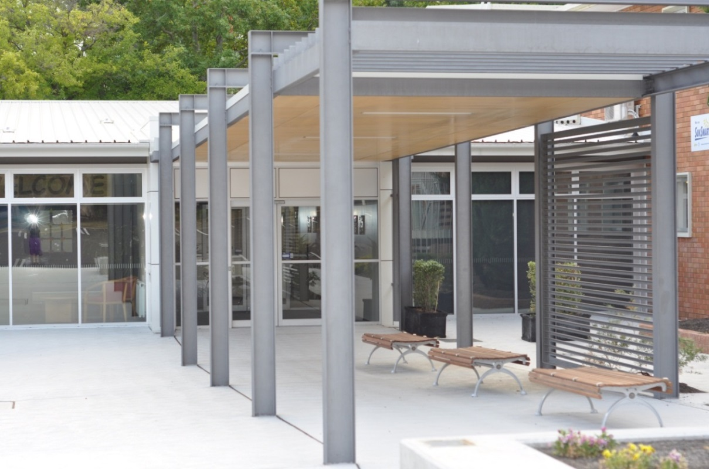

This page is intentionally left blank.



This report supports the work being done in the ACT Education Directorate, as outlined in *Strategic Plan 2018-21: A Leading Learning Organisation*.

Accessibility

The ACT Government is committed to making its information services, events and venues accessible to as many people as possible.

If you have difficulty reading a standard document and would like to receive this publication in an alternate format, such as large print and audio, please telephone (02) 6247 4580.

If English is not your first language and you require the translating and interpreting service, please telephone 13 14 50.

If you are deaf or hearing impaired and require the National Relay Service, please telephone 13 36 77.

© Australian Capital Territory, Canberra, 2021

Material in this publication may be reproduced provided due acknowledgement is made.

Contents

Reporting to the community 1

Summary of School Board activity 1

School Context 2

Student Information 3

Student enrolment 3

Student attendance **Error! Bookmark not defined.**

Supporting attendance and managing non-attendance 3

Staff Information 3

Teacher qualifications 3

Workforce composition 4

School Review and Development 4

School Satisfaction 4

Overall Satisfaction 4

Learning and Assessment 6

Performance in Literacy and Numeracy 6

Early years assessment 6

NAPLAN 7

Outcomes for College Students **Error! Bookmark not defined.**

Post School Destination **Error! Bookmark not defined.**

Financial Summary 8

Voluntary Contributions 9

Reserves 9

Endorsement Page 10

Members of the School Board 10

# Reporting to the community

Schools report to communities in range of ways, including through:

* Annual School Board Reports
* a (5-year) School Improvement Plan (formerly School Strategic Plan)
* annual Impact Reports
* newsletters
* other sources such as My School.

# Summary of School Board activity

I am pleased write this report on behalf of the 2020 Forrest Primary School Board. 2020 was a year like no other. We started the year with bush fires that caused pollution and threatened to keep children away from school. We were then hit by hail that caused a great deal of damage in our area. Then we were hit with COVID. This set the tone for the year and changed the way we lived indefinitely.

Remote learning was introduced from late Term 1 until late Term 2. In this period staff, students, parents and carers all adapted amazingly to online learning. Whilst lockdown was a new and at times difficult experience as whole the staff and students demonstrated great resilience, flexibility and commitment to learning. Staff (teaching and non teaching), students, parents and carers are to be commended on their efforts during lockdown.

Chris Pilgrim and the Executive set a great example for the staff and school community throughout the entire lockdown period and return to school.

2020 was a challenging year for the budget and finances for a number of reasons, listed below:

* The new enterprise agreement which reduced class sizes- this required 6 extra teachers;
* Income was reduced from the P&C due to COVID;
* New furniture was required for the demountable classrooms;
* Ongoing building maintenance required for an aging school.

The School Executive and Board were able to manage the finances throughout the year whilst also upgrading the junior corridors and start on the development and planning of the Indigenous garden. The board would like to thank the P&C for their generous contributions to the school during the year. The board also acknowledges all families that made voluntary contributions during the year.

Later in the year the school went through the School Review with the Education Directorate and IB Evaluation. The School Review process helps guide the Strategic Plan for the next 5 years. The IB Evaluation evaluates the school on how it is progressing as an IB World School and on our success in putting previous recommendations into place. The Executive Team and all staff put an amazing amount of effort and work into both these processes and these efforts were rewarded with positive results received from both reviews. The school will now continue to grow, build and improve. These results were fantastic especially given the limitations and restrictions in place due to COVID. Everyone involved in both reviews is to be commended on their efforts.

The Deakin Pre School also went through assessment and rating during the year. This was led by Hayley Munsie and the preschool team. Again the results were positive and the school was provided with positive feedback and areas to improve.

The Board would like to acknowledge the leadership and work undertaken by the principal Chris Pilgrim, the school Executive Team, teachers and all staff. Without their efforts we would not have made it through 2020 as successfully as we did. Forrest Primary continues to be a wonderful environment for all out children.

I would also like to thank all the 2020 Board Members for their time and efforts that they volunteer on top of everyday life in helping the school community. I know it is greatly appreciated by the school.

Kind Regards

Simone Alabaster

Forrest Primary School Board Chair

# School Context

Forrest Primary School, an international Baccalaureate (IB) World school, is well-situated in the National Parliamentary Triangle with the iconic flagpole dominating the landscape. The school has an international feel with 40% of enrolments from diverse linguistic and cultural backgrounds, and it sits in the heart of the Canberra diplomatic community. The school is growing with an increasing number of enrolments year on year and currently educates 537 students.

Forrest responds to our community by providing an international style of education whereby we bring hearts and minds together to develop global citizens who will make a difference in the world. In order to develop learners who are knowledgeable and compassionate we provide an inspiring, challenging, significant and relevant educational programme.

The Preschool to Year 6 programme uses an inquiry model in which student question, research, think and reach their own conclusions, showing their understanding in a variety of ways. We celebrate students who take action to make a difference in our world. The programme uses Australian Curriculum outcomes to explore big concepts, driving deep-thinking and helping students make connections. A Pre-6 Programme of Inquiry (PoI), which can be observed in the school foyer, balances the short term and long term knowledge needs of each child and helps them make considered choices and take positive actions to make the world a better place.

In all our endeavours we maintain the integrity of an individualised programme that is tailored to the needs of every child. This has the effect of providing both extension and remediation as appropriate. Forrest offers support to learners of English as necessary. This includes a Reading Recovery programme for individual children in Year One, Learning Assistance (also called Response to Intervention or RTI ) to children across the school, extension curriculum for Gifted and Talented students, English as an Additional Language or Dialect (EALD), an Indigenous Culture Club and a range of interest clubs at lunch times. The school has strengthened its Restorative Practice approach to both student welfare and staff cohesion. This approach focuses on developing and maintaining healthy, thriving relationships that underpin effective learning. From this approach we cultivate a strong staff culture and we develop students who are confident, emotionally literate and resilient.

Forrest Primary School has a transient clientele. This is for various reasons such as travel, diplomatic postings, global mobility and transition to private schools in preparation for high school. We have found that this is important to keep in mind when attempting to interpret the data sets of the school as a lower than normal retention rate has a significant impact on perceptions of the data.

## Student Information

### Student enrolment

In this reporting period there were a total of 563 students enrolled at this school.

Table: Student enrolment*

|  |  |
| --- | --- |
| **Student type** | **Number of students** |
| Gender - Male | 287 |
| Gender - Female | 276 |
| Gender - Non-binary or other | 0 |
| Aboriginal and Torres Strait Islander | 25 |
| LBOTE** | 244 |

Source: ACT Education Directorate, Analytics and Evaluation Branch

* To protect personally identifiable information any figures less than six are not reported.

** Language Background Other Than English

### Student attendance

Due to the effects of the COVID-19 pandemic, 2020 attendance data has not been published in the Annual School Board Report.

## Supporting attendance and managing non-attendance

ACT public schools support parents and careers to meet their legal responsibilities in relation to the compulsory education requirements of the *Education Act 2004.* The Education Directorate’s *Education Participation (Enrolment and Attendance) Policy* describes its position with regard to supporting attendance and managing non-attendance. A suite of procedures supports the implementation of the policy. Please refer to <https://www.education.act.gov.au/> for further details.

## Staff Information

### Teacher qualifications

All teachers at this school meet the professional requirements for teaching in an ACT public school. The ACT Teacher Quality Institute (TQI) specifies two main types of provision for teachers at different stages of their career, these are detailed below.

* ***Full registration*** is for teachers with experience working in a registered school in Australia or New Zealand who have been assessed as meeting the Proficient level of the Australian Professional Standards for Teachers.
* ***Provisional registration*** is for newly qualified teachers or teachers who do not have recent experience teaching in a school in Australia and New Zealand. Many teachers moving to Australia from another country apply for Provisional registration.

### Workforce composition

Workforce composition for the current reporting period is provided in the following table. The data is taken from the school’s verified August staffing report. For reporting purposes, it incorporates all school staff including preschools, staff absent for a period of less than four consecutive weeks and staff replacing staff absent for more than four consecutive weeks. It does not include casuals and staff absent for a period of four consecutive weeks or longer.

The Education Directorate is required to report Aboriginal and Torres Strait Islander staff figures. As of June of the reporting period, 135 Aboriginal and Torres Strait Islander staff members were employed across the Directorate.

Table: Workforce composition numbers

|  |  |
| --- | --- |
| **Staff employment category** | **TOTAL** |
| Teaching Staff: Full Time Equivalent Permanent | 27.12 |
| Teaching Staff: Full Time Equivalent Temporary | 7.58 |
| Non Teaching Staff: Full Time Equivalent | 11.51 |

Source: ACT Education Directorate, People and Performance Branch

# School Review and Development

The ACT Education Directorate’s Strategic Plan 2018-2021 provides the framework and strategic direction for School Improvement Plans (formerly School Strategic Plans). This is supported by the school performance and accountability framework ‘*People, Practice and Performance: School Improvement in Canberra Public Schools, A Framework for Performance and Accountability’*. Annually, system and school level data are used alongside the National School Improvement Tool to support targeted school improvement, high standards in student learning, innovation and best practice in ACT public schools.

Our school was reviewed in 2020. A copy of the Report of Review can be found on our school website.

## School Satisfaction

Schools use a range evidence to gain an understanding of the satisfaction levels of their parents and carers, staff and students. Annually in August/ September ACT schools undertake a survey to gain an understanding of school satisfaction at that time. This information is collected from staff, parents and from 2020 students from year 4 and above (previously year 5 and above) through an online survey.

## Overall Satisfaction

In this period of reporting, 75% of parents and carers, 95% of staff, and 86% of students at this school indicated they were satisfied with the education provided by the school.

Included in the survey were 16 staff, 14 parent, and 12 student items which are described as the national opinion items. These items were approved by the then Standing Council on School Education and Early Childhood (SCSEEC) for use from 2015. The following tables show the percentage of parents and carers, students and staff who agreed with each of the national opinion items at this school.

Note: The overall response rate for parents and carers in ACT public schools was negatively impacted by COVID-19, dropping from 31% in 2019 to 23% in 2020.

A total of 42 staff responded to the survey. Please note that not all responders answered every question.

Table: Proportion of staff* in agreement with each national opinion item

|  |  |  |
| --- | --- | --- |
| **National opinion item** | |  | | --- | | Proportion of staff | |
| Parents at this school can talk to teachers about their concerns. | 95 |
| Staff are well supported at this school. | 93 |
| Staff get quality feedback on their performance. | 81 |
| Student behaviour is well managed at this school. | 88 |
| Students at this school can talk to their teachers about their concerns. | 98 |
| Students feel safe at this school. | 98 |
| Students like being at this school. | 93 |
| Students’ learning needs are being met at this school. | 93 |
| Teachers at this school expect students to do their best. | 98 |
| Teachers at this school motivate students to learn. | 98 |
| Teachers at this school treat students fairly. | 95 |
| Teachers give useful feedback. | 88 |
| This school is well maintained. | 83 |
| This school looks for ways to improve. | 95 |
| This school takes staff opinions seriously. | 88 |
| This school works with parents to support students' learning. | 93 |

Source: ACT Education Directorate, Analytics and Evaluation Branch

*Proportion of those who responded to each individual survey question

A total of 118 parents responded to the survey. Please note that not all responders answered every question.

Table: Proportion of parents and carers* in agreement with each national opinion item

|  |  |  |
| --- | --- | --- |
| **National opinion item** | |  | | --- | | Proportion of parents and carers | |
| I can talk to my child’s teachers about my concerns. | 82 |
| My child feels safe at this school. | 88 |
| My child is making good progress at this school. | 78 |
| My child likes being at this school. | 91 |
| My child's learning needs are being met at this school. | 71 |
| Student behaviour is well managed at this school. | 74 |
| Teachers at this school expect my child to do his or her best. | 80 |
| Teachers at this school give useful feedback. | 71 |
| Teachers at this school motivate my child to learn. | 77 |
| Teachers at this school treat students fairly. | 76 |
| This school is well maintained. | 77 |
| This school looks for ways to improve. | 68 |
| This school takes parents’ opinions seriously. | 61 |
| This school works with me to support my child's learning. | 71 |

Source: ACT Education Directorate, Analytics and Evaluation Branch

*Proportion of those who responded to each individual survey question

A total of 214 students responded to the survey. Please note that not all responders answered every question.

Table: Proportion of students* in agreement with each national opinion item

|  |  |  |
| --- | --- | --- |
| **National opinion item** | |  | | --- | | Proportion of students | |
| I can talk to my teachers about my concerns. | 68 |
| I feel safe at this school. | 84 |
| I like being at my school. | 84 |
| My school gives me opportunities to do interesting things. | 84 |
| My school is well maintained. | 75 |
| My school looks for ways to improve. | 83 |
| My teachers expect me to do my best. | 97 |
| My teachers motivate me to learn. | 86 |
| Staff take students’ concerns seriously. | 74 |
| Student behaviour is well managed at my school. | 64 |
| Teachers at my school treat students fairly. | 79 |
| Teachers give useful feedback. | 82 |

Source: ACT Education Directorate, Analytics and Evaluation Branch

*Proportion of those who responded to each individual survey question

# Learning and Assessment

## Performance in Literacy and Numeracy

### Early years assessment

Students in kindergarten undertake an on-entry and on-exit assessment of their early reading and numeracy skills using the BASE program. Student results are reported against five performance bands at the end of semester 1 and 2. Below are the results for this school for the current reporting period.

Due to the impact of COVID-19, analysis of BASE data for 2020 has been delayed. Analysis will be provided to schools in 2021. Please speak with the school should you require further information.

### NAPLAN

Students in years 3, 5, 7 and 9 in all ACT schools participate in the National Assessment Program-Literacy and Numeracy (NAPLAN). This program assesses skills in reading, writing, spelling, grammar and punctuation, and numeracy.

*Note: There are no NAPLAN results for 2020, with the assessments not being conducted due to the impacts of COVID-19.

# Financial Summary

The school has provided the Directorate with an end of year financial statement that was approved by the school board. Further details concerning the statement can be obtained by contacting the school. The following summary covers use of funds for operating costs and does not include expenditure in areas such as permanent salaries, buildings and major maintenance.

Table: Financial Summary

|  |  |  |  |
| --- | --- | --- | --- |
| **INCOME** | **January-June** | **July-December** | **January-December** |
| Self-management funds | 166134.31 | 156094.81 | 322229.12 |
| Voluntary contributions | 26380.00 | 4575.00 | 30955.00 |
| Contributions & donations | 21172.00 | 8942.60 | 30114.60 |
| Subject contributions | 6220.00 | 865.00 | 7085.00 |
| External income (including community use) | 3570.31 | 302.12 | 3872.43 |
| Bank Interest | 1217.01 | 1353.88 | 2570.89 |
| **TOTAL INCOME** | 224693.63 | 172133.41 | 396827.04 |
| **EXPENDITURE** |  |  |  |
| Utilities and general overheads | 48208.15 | 77482.01 | 125690.16 |
| Cleaning | 0.00 | 0.00 | 0.00 |
| Security | 767.87 | 0.00 | 767.87 |
| Maintenance | 226301.40 | 33198.37 | 259499.77 |
| Administration | 30054.53 | 4966.77 | 35021.30 |
| Staffing | 0.00 | 0.00 | 0.00 |
| Communication | 1730.73 | 2175.57 | 3906.30 |
| Assets | 0.00 | 0.00 | 0.00 |
| General office expenditure | 15306.17 | 25136.66 | 40442.83 |
| Educational | 15148.21 | 27329.80 | 42478.01 |
| Subject consumables | 5900.00 | 527.18 | 6427.18 |
| **TOTAL EXPENDITURE** | 343417.06 | 170816.36 | 514233.42 |
| **OPERATING RESULT** | -118723.43 | 1317.05 | -117406.38 |
| **Actual** Accumulated Funds | 215332.70 | 151271.67 | 222720.75 |
| Outstanding commitments (minus) | -4460.07 | 0.00 | -4460.07 |
| **BALANCE** | 92149.20 | 152588.72 | 100854.30 |

## Voluntary Contributions

The funds listed were used to support the general operations of the school. The spending of voluntary contributions is in line with the approved budget for this reporting period.

## Reserves

|  |  |  |
| --- | --- | --- |
| Name and Purpose | Amount | Expected Completion |
| No Reserves were set for 2020. | N/A | N/A |

# Endorsement Page

## Members of the School Board

|  |  |  |  |
| --- | --- | --- | --- |
| Parent Representative(s): | Catherine White | Cameron Bowles |  |
| Community Representative(s): | Bill Maiden |  |  |
| Teacher Representative(s): | Daniel Heap | Sarah Bauer |  |
|  |  |  |  |
| Board Chair: | Simone Alabaster |  |  |
| Principal: | Christine Pilgrim |  |  |

I approve the report, prepared in accordance with the provision of the ACT *Education Act* *2004*, section 52.

|  |  |  |  |
| --- | --- | --- | --- |
| 2020 Board Chair Signature: |  | Date: |  |

I certify that to the best of my knowledge and belief the evidence and information reported in this Annual School Board Report represents an accurate record of the Board’s operations during this reporting period.

|  |  |  |  |
| --- | --- | --- | --- |
| Principal Signature: |  | Date: |  |