Hawker College
Annual School Board Report 2019

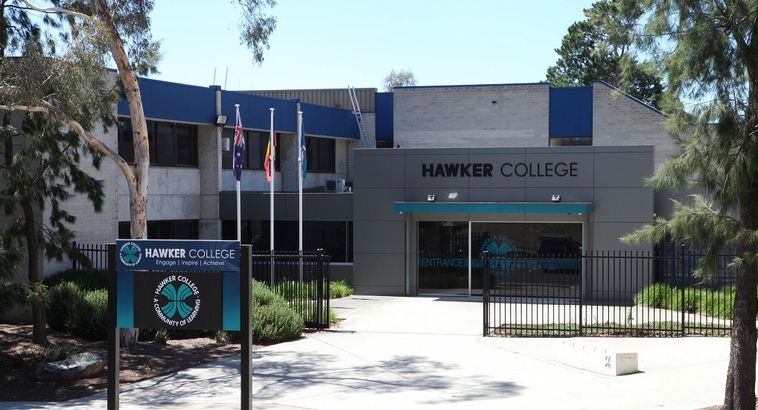

.
This page is intentionally left blank.

This report supports the work being done in the ACT Education Directorate, as outlined in Strategic Plan 2018-21: A Leading Learning Organisation.

Accessibility
The ACT Government is committed to making its information services, events and venues accessible to as many people as possible.
If you have difficulty reading a standard document and would like to receive this publication in an alternate format, such as large print and audio, please telephone (02) 6247 4580.
If English is not your first language and you require the translating and interpreting service, please telephone 13 14 50.
If you are deaf or hearing impaired and require the National Relay Service, please telephone 13 36 77.
© Australian Capital Territory, Canberra, 2020

Material in this publication may be reproduced provided due acknowledgement is made.

Contents
Reporting to the community 1
Summary of School Board activity 1
School Context 1
Student Information 1
Student enrolment 1
Supporting attendance and managing non-attendance 2
Staff Information 2
Teacher qualifications 2
Workforce composition 2
School Review and Development 3
School Satisfaction 3
Overall Satisfaction 3
Learning and Assessment 5
Outcomes for College Students 5
Post School Destination 6
Financial Summary 7
Voluntary Contributions 8
Reserves 8
Endorsement Page 9
Members of the School Board 9

Reporting to the community
Schools report to communities in range of ways, including through:
- Annual School Board Reports
- a (5-year) School Improvement Plan (formerly School Strategic Plan)
- annual Impact Reports
- newsletters
- other sources such as My School.

School Context
Opened in 1976, the Hawker College has established strong traditions in academic achievement, vocational development, and sporting, artistic and cultural activities. We provide a learning environment that is rigorous, purposeful, supportive, caring and friendly. The college promotes values of honesty, excellence, fairness and respect. Quality learning experiences offered at Hawker College are contemporary and are designed to assist our students in achieving their desired future.
The diverse senior secondary curriculum at Hawker College allows students to structure their learning program with choices to suit their individual needs. Teachers have a high level of expertise in their teaching fields and the college has excellent facilities for use in the fields of study offered. The college has a strong record of innovation in senior secondary education.
To ensure our students reach their full potential, they are provided with extensive student support services. This includes transition support, careers counselling, work experience, academic and vocational package support, pastoral care, school counsellor and chaplain services, and Home Group interviews for Student Pathways Planning.
Hawker is a student-centred college. Our students are encouraged to engage in authentic learning and to participate in extra-curricular activities to make new friends and to develop and broaden their interests. We have high expectations in relation to academic performance, attendance and behaviour. Home Group teachers, supported by a Year Coordinator for each year, monitor the overall progress of each student in a Home Group and together with our Careers team advise on their selection of Accredited (A) and Tertiary (T) packages for their secondary college programs.
The priority enrolment area of Hawker College encompasses the suburbs of Hawker, Weetangera, Scullin, Strathnairn, Page, Holt and Higgins.

Student Information

Student enrolment
In this reporting period there were a total of 520 students enrolled at this school.
Table: Student enrolment
Student type | Number of students
Male | 247
Female | 273
Aboriginal and Torres Strait Islander | 23
LBOTE* | 97
Source: ACT Education Directorate, Analytics and Evaluation Branch
*Language Background Other Than English

Supporting attendance and managing non-attendance
ACT public schools support parents and careers to meet their legal responsibilities in relation to the compulsory education requirements of the Education Act 2004. The Education Directorate’s Education Participation (Enrolment and Attendance) Policy describes its position with regard to supporting attendance and managing non-attendance. A suite of procedures supports the implementation of the policy. Please refer to https://www.education.act.gov.au/ for further details.

Staff Information

Teacher qualifications
All teachers at this school meet the professional requirements for teaching in an ACT public school. The ACT Teacher Quality Institute (TQI) specifies two main types of provision for teachers at different stages of their career, these are detailed below.
- Full registration is for teachers with experience working in a registered school in Australia or New Zealand who have been assessed as meeting the Proficient level of the Australian Professional Standards for Teachers.
- Provisional registration is for newly qualified teachers or teachers who do not have recent experience teaching in a school in Australia and New Zealand. Many teachers moving to Australia from another country apply for Provisional registration.

Workforce composition
Workforce composition for the current reporting period is provided in the following table. The data is taken from the school’s verified August staffing report. For reporting purposes, it incorporates all school staff including preschools, staff absent for a period of less than four consecutive weeks and staff replacing staff absent for more than four consecutive weeks. It does not include casuals and staff absent for a period of four consecutive weeks or longer.
The Education Directorate is required to report Aboriginal and Torres Strait Islander staff figures. As of June of the reporting period, 119 Aboriginal and/or Torres Strait Islander staff members were employed across the Directorate.
Table: Workforce composition numbers
Staff employment category | TOTAL
Teaching Staff: Full Time Equivalent Permanent | 30.61
Teaching Staff: Full Time Equivalent Temporary | 2.80
Non Teaching Staff: Full Time Equivalent | 19.15
Source: ACT Education Directorate, People and Performance Branch

School Review and Development
The ACT Education Directorate’s Strategic Plan 2018-2021 provides the framework and strategic direction for School Improvement Plans (formerly School Strategic Plans). This is supported by the school performance and accountability framework ‘People, Practice and Performance: School Improvement in Canberra Public Schools, A Framework for Performance and Accountability’. Annually, system and school level data are used alongside the National School Improvement Tool to support targeted school improvement, high standards in student learning, innovation and best practice in ACT public schools.
Prior to 2016 all ACT public schools participated in a four-year improvement cycle. In the fourth year schools underwent an external Validation process. In 2016 this changed to a five-year cycle with a School Review at the end.
Our school will be reviewed in 2020. A copy of the most recent Validation Report can be found on our school website.

School Satisfaction
Schools use a range evidence to gain an understanding of the satisfaction levels of their parents and carers, staff and students. Annually in August/ September ACT schools undertake a survey to gain an understanding of school satisfaction at that time. This information is collected from staff, parents and students from year 5 and above through an online survey.

Overall Satisfaction
In this period of reporting, 78% of parents and carers, 95% of staff, and 80% of students at this school indicated they were satisfied with the education provided by the school.
Included in the survey were 16 staff, 14 parent, and 12 student items which are described as the national opinion items. These items were approved by the then Standing Council on School Education and Early Childhood (SCSEEC) for use from 2015. The following tables show the percentage of parents and carers, students and staff who agreed with each of the national opinion items at this school.
A total of 42 staff responded to the survey. Please note that not all responders answered every question.
Table: Proportion of staff in agreement with each national opinion item
National opinion item | Proportion of staff
Staff are well supported at this school. | 70
Parents at this school can talk to teachers about their concerns. | 91
Staff get quality feedback on their performance. | 55
Student behaviour is well managed at this school. | 65
Students at this school can talk to their teachers about their concerns. | 93
Students feel safe at this school. | 86
Students like being at this school. | 88
Students’ learning needs are being met at this school. | 86
Teachers at this school expect students to do their best. | 93
Teachers at this school motivate students to learn. | 91
Teachers at this school treat students fairly. | 93
Teachers give useful feedback. | 86
This school is well maintained. | 79
This school looks for ways to improve. | 95
This school takes staff opinions seriously. | 54
This school works with parents to support students' learning. | 77
Teachers give useful feedback. | 86
Source: ACT Education Directorate, Analytics and Evaluation Branch
*Data derived from annual School Satisfaction Survey

A total of 108 parents responded to the survey. Please note that not all responders answered every question.
Table: Proportion of parents and carers in agreement with each national opinion item
National opinion item | Proportion of parents and carers
I can talk to my child’s teachers about my concerns. | 84
My child feels safe at this school. | 92
My child is making good progress at this school. | 73
My child likes being at this school. | 83
My child's learning needs are being met at this school. | 72
Student behaviour is well managed at this school. | 68
Teachers at this school expect my child to do his or her best. | 87
Teachers at this school give useful feedback. | 75
Teachers at this school motivate my child to learn. | 70
Teachers at this school treat students fairly. | 80
This school is well maintained. | 87
This school looks for ways to improve. | 77
This school takes parents’ opinions seriously. | 70
This school works with me to support my child's learning. | 70
Source: ACT Education Directorate, Analytics and Evaluation Branch
*Data derived from annual School Satisfaction Survey

A total of 141 students responded to the survey. Please note that not all responders answered every question.
Table: Proportion of students in agreement with each national opinion item
National opinion item | Proportion of students
I can talk to my teachers about my concerns. | 70
I feel safe at this school. | 81
I like being at my school. | 70
My school gives me opportunities to do interesting things. | 76
My school is well maintained. | 78
My school looks for ways to improve. | 79
My teachers expect me to do my best. | 91
My teachers motivate me to learn. | 64
Staff take students’ concerns seriously. | 69
Student behaviour is well managed at my school. | 62
Teachers at my school treat students fairly. | 76
Teachers give useful feedback. | 67
Source: ACT Education Directorate, Analytics and Evaluation Branch
*Data derived from annual School Satisfaction Survey

Learning and Assessment

Outcomes for College Students
Year 12 outcomes are shown in the following table. The Board of Senior Secondary Studies has provided this data as it relates to the percentage of students receiving an ACT Senior Secondary Certificate (ACT SSC) and the Australian Tertiary Admission Rank (ATAR). It will not include data for those students who were successful in an equivalent pathway organised by the school. The proportion of students is based on the college’s February census enrolment data.
Table: Year 12 outcomes for students by percentage
Outcome | Proportion of students
Receiving a year 12 or equivalent VET Certificate (without duplicates) within the school setting | 84.70
Receiving an ACT Senior Secondary Certificate | 84.70
Receiving an ATAR | 36.30
Source: Board of Senior Secondary Studies

Post School Destination
The following graph shows the post school destination of college students who were awarded an ACT Senior Secondary Certificate in this reporting period. As many of the respondents were engaged in both study and employment, the percentage total is greater than one hundred percent.
Table: Comparison of post school destinations for students by percentage
Outcome | College | ACT
University | 36.5 | 43.3
CIT/TAFE | 14.9 | 11.6
Other training provider | 5.4 | 4.6
Deferred Studies | 28.3 | 29.5
Employed | 71.6 | 75.2
Not studying or employed | 12.2 | 7.2
Source: ACT Education Directorate, Analytics and Evaluation Branch

Financial Summary
The school has provided the Directorate with an end of year financial statement that was approved by the school board. Further details concerning the statement can be obtained by contacting the school. The following summary covers use of funds for operating costs and does not include expenditure in areas such as permanent salaries, buildings and major maintenance.
Table: Financial Summary
INCOME | January-June | July-December | January-December
Self-management funds | 438121.95 | 391191.38 | 829313.33
Voluntary contributions | 11492.50 | 37160.00 | 48652.50
Contributions & donations | 6230.00 | 3130.00 | 9360.00
Subject contributions | 6637.50 | 13030.00 | 19667.50
External income (including community use) | 22205.64 | 17536.22 | 39741.86
Proceeds from sale of assets | 209.08 | 0.00 | 209.08
Bank Interest | 9593.68 | 7072.57 | 16666.25
TOTAL INCOME | 494490.35 | 469120.17 | 963610.52
EXPENDITURE
Utilities and general overheads | 90159.84 | 140640.93 | 230800.77
Cleaning | 68371.36 | 0.00 | 68371.36
Security | 0.00 | 0.00 | 0.00
Maintenance | 201679.81 | 36886.87 | 238566.68
Administration | 37408.74 | 45611.28 | 83020.02
Staffing | 5233.00 | 117989.21 | 123222.21
Communication | 8485.43 | 20096.42 | 28581.85
Assets | 71693.41 | 19154.58 | 90847.99
Leases | 13294.01 | 13990.17 | 27284.18
General office expenditure | 20717.94 | 13621.28 | 34339.22
Educational | 76838.60 | 5974.52 | 82813.12
Subject consumables | 24830.09 | 28120.16 | 52950.25
TOTAL EXPENDITURE | 618712.23 | 442085.42 | 1060797.65
OPERATING RESULT | -124221.88 | 27034.75 | -97187.13
Actual Accumulated Funds | 457688.20 | 293491.85 | 445429.83
Outstanding commitments (minus) | -25512.41 | 0.00 | -25512.41
BALANCE | 307953.91 | 320526.60 | 322730.29

Voluntary Contributions
The funds listed were used to support the general operations of the school. The spending of voluntary contributions is in line with the approved budget for 2019.

Reserves
Name and Purpose | Amount | Expected Completion
Carbon Neutral Loan Reserve  Retained to cover any residual costs associated with the original carbon neutral loan of 2015. | $37 295.34 | 2020
Master Plan Building Works Reserve Monies to be used for ongoing building works and improvements within the Master Plan. | $84 519.10 | 2021
Staffing Reserve  Retained to cover the staffing debt for 2021. | $100 000.00 | 2021

Endorsement Page

Members of the School Board
Parent Representative(s): | Chris Davis, | Jason Lyons.
Community Representative(s): | N/A
Teacher Representative(s): | Chontel Green, | Jane Southerton.
Student Representative(s): | Helen Teng, | Jayden Lee.
Board Chair: | Heather Crawford
Principal: | Andy Mison
I approve the report, prepared in accordance with the provision of the ACT Education Act 2004, section 52.

Board Chair Signature: | Heather Crawford | Date: | 22 / 07 / 2020

I certify that to the best of my knowledge and belief the evidence and information reported in this Annual School Board Report represents an accurate record of the Board’s operations during this reporting period.

Principal Signature: | Andy Mison | Date: | 24 / 06/ 2020

