Namadgi School
  - Network: Tuggeranong

Impact Report 2020

The purpose of this document
This document flows directly from our Action Plan for 2020 which translated our school priorities into actions for the current year of our five-year improvement cycle. These actions were responsive to identified challenges, changes or risks to delivery of improvement for student learning.

Our school’s contribution to whole-of-system Strategic Indicators

Education Directorate Strategic Indicator 2018-2021
To promote greater equity in learning outcomes in and across ACT public schools
In 2020 our school supported this Strategic Indicator through – Priority 1, Academic Achievement (see achievement against this priority for more detail):
- 1.2 Build the capacity of teachers to use data to differentiate effectively
- 1.3 Maintain and further develop early intervention practices, P - 2 and to develop and implement a whole school response to RTI model.

Education Directorate Strategic Indicator 2018-2021
To facilitate high quality teaching in ACT public schools and strengthen educational outcomes.
In 2020 our school supported this Strategic Indicator through – Priority 1, Academic Achievement (see achievement against this priority for more detail):
  - 1.1 All staff are engaged in a professional improvement cycle – including
coaching, mentoring, peer observation and/or walkthrough observations.
- 1.4 Develop and implement a whole school approach to writing.

Education Directorate Strategic Indicator 2018-2021
To centre teaching and learning around students as individuals
In 2020 our school supported this Strategic Indicator through – Priority 2, Wellbeing and Engagement (see achievement against this priority for more detail):
- 2.1 Development of whole school Engagement Services
- 2.2 Plan and promote school events and programs that support parents and carers to be confidently involved in their child’s learning and school engagement
- 2.3 Further develop and implement Positive Behaviours for Learning (PBL) practices

Reporting against our priorities

Priority 1: Academic Achievement

Targets or measures
By the end of 2020 we will:
- Increase the effect size of students achieving at expected or better growth in reading and writing in predetermined school-based and standardised assessments.
- Work towards achieving benchmarks in the Brigance Screening tool for oral language and reading in Preschool and develop a data tool to share student growth when transitioning from Preschool to Kindergarten.
- One hundred percent of Preschool teachers have a professional development plan goal focused on improving student oral language and reading outcomes.
- 80% of students achieve expected or above growth in BASE reading.
- 80% of students achieve expected or above growth in BASE mathematics.
- Create a Year 10 Graduate Profile – linking learning beyond Year 10 for college and CIT readiness.

In 2020 we implemented this priority through the following strategies:
- All staff are engaged in a professional improvement cycle – including
coaching, mentoring, peer observation and/or walkthrough observations.
- Build the capacity of teachers to use data to differentiate effectively through PLC’s.
- Maintain & further develop early intervention practices, P - 2 and to develop and implement a whole school response to RTI model (tier 3 and tier 2).
- Develop and implement a whole school approach to writing.

Below is our progress towards our five-year targets with an emphasis on the accumulation and analysis of evidence over the term of our plan.

Student learning data
Targets or Measures | Base  2017 | Year 1  2018 | Year 2  2019 | Year 3  2020 | Year 4  2021 | Year 5  2022
NAPLAN Writing Yr 5 (mean score) | 435 | 413 | 436.5 | -
NAPLAN Writing Yr 7 (mean score) | 445 | 459 | 498.4 | -
NAPLAN Writing Yr 9 (mean score) | 500 | 518 | 500.4 | -
PIPS/BASE Reading Students Achieving Expected or Above Growth (percentage) | 61% | 86.7% | 66% | TBA
PIPS/BASE Mathematics Students Achieving Expected or Above Growth (percentage) | 39% | 64.4% | 82% | TBA

Perception Data - *The data indicates the % of responses collected from ‘neither agree or disagree, agree and strongly agree’
Targets or Measures | Base  2017 | Year 1  2018 | Year 2  2019 | Year 3  2020 | Year 4  2021 | Year 5  2022
My teachers motivate me to learn (students). | 78% | 88% | 91% | 79%
My teachers provide useful feedback about my work (students). | 88% | 85% | 85% | 83%
Staff confidence in the leadership team and school plans. The School leadership team deserves its position of authority (staff). | 91% | 96% | 93% | 92%

School program and process data
Targets or Measures | Base | Year 1 | Year 2 | Year 3 | Year 4 | Year 5
Percentage of Preschool teachers having a professional development plan goal focused on improving oral language and reading outcomes. | 0% | 100% | 100% | 100%
Percentage of High School staff with a literacy goal as part of their pathways planning. | 0% | 100% | 100% | 100%

What this evidence tells us
- What does this evidence indicate about your school’s progress towards its five-year targets?
- The NAPLAN scores are not available in 2020 due to testing being terminated.
- In-house school assessment, such as Lexile Writing Assessment in the High School indicates continued growth for students in writing (see attachment 1).
- The PIPS data is now called BASE Assessment and the data from the Directorate is not available. It should be available to add to the data sheet in 2021.
- Student perception in receiving feedback and being motivated to learn has dropped. This might be due to COVID and the isolation of working from home.
- A statistical issue with the current data is that the Year 4 and 5 cohort did not complete the survey. This matter has been addressed by the Principal with the staff directly.
- Staff confidence in the leadership team and school plans remains in the 90th percentile. This indicates high confidence from the staff with school planning and implementation of the capacity building professional learning to support our needs.
- Literacy goal setting for all staff remains a priority with all staff again having a goal written in their professional development plans and actioned within teams throughout the year.

- What implications does this evidence have for your next AP?
- Continuation of all literacy projects is a priority in 2021. Primary staff are engaged in the next stage of the Early Years Literacy Program, whilst High School staff are engaged in the High School Writing Project.
- In the next AP we will be looking to improve student voice and agency hopefully directly impacting on student opinion and feelings of being safe and engaged at school.
- Continuation on our focus to build positive relationships with students and families by feeding back student progress and growth in a timely manner.
- Continue to work collaboratively with staff to share the Action Plan and seek feedback through PLC’s on the development of high impact strategies.

Our achievements for this priority
  - All staff are engaged in a professional improvement cycle – including coaching, mentoring,
peer observation and/or walkthrough observations.
To facilitate high quality teaching in ACT public schools and strengthen educational outcomes.

- Development of defined coaching (GROWTH model), mentoring and peer observation models were completed with accompanying documentation
- All teaching staff undertook a peer observation round with feedback
- All teaching staff were part of walkthrough observations with feedback including two Tuggeranong Network School Improvement walkthrough visits
- New Educators accessed mentors informally and formally through learning teams for curriculum planning and addressing problems of practice.

  - Build the capacity of teachers to use data to differentiate effectively.
To promote greater equity in learning outcomes in and across ACT public schools

- A large proportion of mapping agreed assessment tools and tracking documents have been created and shared through Google Docs. Whole school tracking documents that link curriculum P-10 is nearing completion (although sectors have completed much of this work it requires condensing and storage in a shared access portal).
- Professional Learning for staff on differentiated practices and formative assessment was completed and has been a focus within Professional Learning Communities (PLC’s). Through this model staff have been able to hone their focus on their students reviewing student data, matching professional learning to targeted needs of the teaching team and developing the collective efficacy of each PLC.
- The implementation of summative assessment tasks, with reference to moderation of achievement standards, has been scheduled into our semester meetings for staff. This practice is embedded.
- The use of Sentral for data entry and collection is growing as the Directorate rolls out more functionality with the system. We are using Sentral to collect behavioural data, PBL data, student wellbeing and incidents (positive/negative/medical).

  - Maintain and further develop early intervention practices, P - 2 and to develop and implement a whole school response to RTI model.
To promote greater equity in learning outcomes in and across ACT public schools

- Tiered intervention classes have been established across the school: e.g. Tier 3 offsite High School, Tier 2 in-house High School (Maths, English focus), Preschool Early Intervention and Primary School development of global strategies for teachers. Refinement of the processes and supports is ongoing as we strengthen the models.
- Professional Learning for Preschool and Kindergarten staff has been implemented in relation to building early intervention practices. Tracking tools and assessment tools such as the Brigance screening tool are being used with consistency. The data is being exported to shared files for transition purposes. Initial meetings with families are still being used to track and define any learning difficulties for students prior to the year commencing and the school is supporting families to seek support if learning difficulties are detected through the screening process.

  - Develop and implement a whole school approach to teaching writing.
To facilitate high quality teaching in ACT public schools and strengthen educational outcomes.

- The establishment of two professional teams lead by executive to coordinate professional learning and action steps towards improvement in writing from K-10 were maintained from 2019. These teams attended the Directorate workshops Early Years Literacy Program and High School Writing Project with the purpose of maintaining consistency and oversight. Unfortunately, due to COVID, Misty Adoniou and Christine Topfer were unable to attend the school to conduct visits. This will be picked up again in 2021.
- Each teacher and SLC had writing goals into their pathways plans.

Challenges we will address in our next Action Plan
Early Years Reading:
- Review the early years (early intervention) staffing model given the reduction in preschool numbers and changing arrangements.

Feedback to students:
- Continue the work with staff on formative assessment practices in order to provide timely and meaningful feedback to students.

Development of Professional Learning Communities:
- Develop PLC’s that inquire into specific areas of need or problems of practice that directly relate to the student’s staff teach in order to make more precise and data informed decisions.

Refine the coaching and mentoring models:
- Set explicit coaching roles through the executive team to work with PLC’s. Assign PL for executive using the GROWTH coaching model as a base for consistent practice.

Development of agreed practice documents:
- Embed the agreed practice documents P-10 to ensure clarity of expected assessment tools, moderation guides, data storage, curriculum planning and implementation practices.

Priority 2: Wellbeing and Engagement

Targets or measures
By the end of 2020 we will achieve:
- Increase the percentage of Indigenous students attending 70% or more of the time to 75-80%.
- Minimise suspension rates.
- Increased proportion of students receiving effective and timely early intervention or personalised learning programs.
- Increased proportion of students engaging with health and wellbeing support services (PCYC, Menslink etc.)
- Increased proportion of parents and carers engaging with school communication, events and programs.
- Increased use of PBL structures and implementation of PBL strategies across the school.
- Grow retention rates at the designated transition points (P-K and 6-7) above 50%.
- 100% of teaching staff complete Trauma Informed Practice PL.

In 2020 we implemented this priority through the following strategies:

- Development of whole school Engagement Services.
- Plan and promote school events and programs that support parents and carers to be confidently involved in their child’s learning and school engagement.
- Further develop and implement Positive Behaviours for Learning practices.
- Second whole staff Trauma Informed Practices session with Ian Luscombe in Week 0.

Below is our progress towards our five-year targets with an emphasis on the accumulation and analysis of evidence over the term of our plan.

Student learning data
Targets or Measures | Base  2017 | Year 1  2018 | Year 2  2019 | Year 3  2020 | Year 4  2021 | Year 5  2022
PBL – Distribution of school awards points ‘Namas’ (number of PBL awards distributed) | 0 | 316 | 1208 | 6876

Perception Data - *The data indicates the % of responses collected from ‘neither agree or disagree, agree and strongly agree’
Targets or Measures | Base  2017 | Year 1  2018 | Year 2  2019 | Year 3  2020 | Year 4  2021 | Year 5  2022
I feel safe at my school (students). | 77% | 78% | 74% | 77%
My child feels safe at this school (parents). | 92% | 88% | 88% | 88%
I like being at my school (students). | 79% | 83% | 82% | 70%
Staff are well supported at this school (staff). | 80% | 74% | 91% | 80%
I receive useful feedback about my work at this school (staff). | 50% | 41% | 60% | 58%

School program and process data
Targets or Measures | Base  2017 | Year 1  2018 | Year 2  2019 | Year 3  2020 | Year 4  2021 | Year 5  2022
Student transition percentage from Preschool to Kindergarten. | 49% | 50% | 84% | 75%
Number of partnership programs engaged through the Hub (High School). | 6 | 10 | 15 | 19
Percentage of Indigenous students attendance (average P-10). | 60% | 61.5% | 76.3% | 69%
Suspension Rates (total number in a school year P-10). | 83* | 138 | 133 | 183

What this evidence tells us
- What does this evidence indicate about your school’s progress towards your five-year targets?

- The distribution of PBL awards, “Namas”, has significantly increased again in 2020 due to greater staff awareness and alignment of awards to student data (positive and negative incidents) being recorded in SAS.
- The perception data of feeling safe at Namadgi School is stronger with the parent community again in 2020 than the student community. This might be attributed to the communication throughout COVID-19 and increased use of online/video messages.
- Students declined in perception to the question “I like being at me school’, and the next action plan will look to build greater student voice through the School Captains and SRC to understand why there is a disconnect.
- There was a decrease in staff feeling they were supported at Namadgi School, moving to the 80th percentile. Staff were subject to significant change and disruptions to routines in 2020 due to COVID.
- Preschool transitions to Kindergarten have remained high and we will for the first time in the school’s history have 4 Kindergarten classes starting in 2021.
- Since firming up staff and building capacity within the Hub there has been steady growth in partnership programs on offer to support student engagement, health and wellbeing, transitions to college, Indigenous education initiatives and external activities such as Lyons Youth Haven Farm. These programs and supports have been targeted at student needs.
- The average attendance of Aboriginal and Torres Strait Islander students has dropped to 69% in the last 12 months, but again our SAS data for the COVID period might be skewing percentages as this is a total for the entire year.
- Suspension rates increased in 2020 and in discussions with families and the AFP we have seen an increase in family violence and anti-social behaviours – particularly during the lock-down period.

- What implications does this evidence have for your next AP?

- The PBL program will continue to gain momentum in 2021. A PBL committee will continue to drive improvements and the distribution of ‘Nama’ awards in all settings.
- The PBL committee will need to drive the collection of student data (positive and negative incidents) on SAS to ascertain the longer-term impact of the PBL program.
- Continue to grow student engagement and a feeling of being safe at Namadgi school through building the opportunity for students to voice their opinions and ideas (School Captains and SRC).
- Continue to build peer observation, coaching and mentoring programs for staff.
- Executive staff to continue to be highly accessible and present for information nights, preschool visits, transitions and ceremonies (P – 10).
- Strengthen partnerships for student support through the Hub including the consolidation of the offsite program.
- Continue to build positive relationships and engagement with Indigenous students and families to help grow attendance rates. In 2020 Namadgi reached a maximum of 730 enrolments.
- Continue the development of connected, responsive and proactive student engagement strategies to decrease overall student suspensions.

Our achievements for this priority
2.1 Development of whole school Engagement Services.
To centre teaching and learning around students as individuals
- In coming services and external providers increased in 2020 and were accessed during the year to support students and their families. Such services included the Lyons Youth Haven Farm, Menslink, PCYC, School Psychologist and Nurse, cyber awareness with the AFP, drug and alcohol awareness (Party Safe program), NSET/Senior Psychologists and linking with social workers in the community.
- The Hub worked with disengaged and high functioning students throughout the year to deliver personalised programs that met their needs to support learning. The Tier 2 and 3 programs catered for additional students who met eligibility through specific criteria (disengagement, low academic results, gaps in learning as identified by staff).
- All LSA’s and teaching staff attended professional learning that was linked to the school plans i.e. trauma informed practices.
- Case management meetings were used to determine levels of support for students based on student data and teacher referrals (P-10).

2.2 Plan and promote school events and programs that support parents and carers to be confidently involved in their child’s learning and school engagement.

To centre teaching and learning around students as individuals

- School events were significantly impacted by COVID-19 in 2020. To evolve our delivery of family and community involvement with the school we moved assemblies to a digital format, delivered Principal messages through ‘No Assembly Friday’s’, increased the use of messaging to families through text and email and engaged families through online presentations and meetings.
- In 2020 we developed an online video walk through of the school for the purposes of maintaining and communicating our annual Information Night for prospective families. As COVID restrictions eased we developed small face to face meetings, live streaming of events and information sessions utilising outdoor spaces in preschool for Stay and Play.
- The SeeSaw App has aided in the increased ability of the school to communicate with parents, particularly in the Primary and Preschool. Whilst parents have not been able to enter classrooms this App proved valuable in allowing parents a window of access to school and the everyday events that their children were engaged with.
- Meetings with the School Board and P&C were conducted twice a term – the minutes are recorded and on files. These meetings were conducted remotely during COVID and towards the back end of the year we were able to re-engage with face to face meetings in a COVID Safe manner.

2.3 Further develop and implement Positive Behaviours for Learning practices.
To centre teaching and learning around students as individuals

- The rewards system called ‘Namas’ has been embedded and data indicates consistent use across the school in non-classroom settings. With 6876 ‘Namas’ distributed in 2020 staff have indicated the system is easy to use and is accurately annotated through SAS.
- The in-class settings will continue to be promoted in 2021 with signage dispersed to support the introduction of common language and expectations through the PBL agreed statements.
- PBL survey data indicated growth in teacher knowledge of the PBL values and rewards systems across the school.

Challenges we will address in our next Action Plan
Increase opportunities for student agency – SRC, regular meetings with the Principal and Leadership students reporting to the School Board:
- Year 10 Leaders have been selected for 2021 and this team will meet with the Principal twice a term prior to Board and P&C meetings. Students will be invited to present their ideas at the Board and P&C. This plan was only partially implemented in 2020 due to the disruption of COVID and the impact on gatherings at meetings.

Development of the offsite intervention program:
- The Tier 3 offsite intervention program operated in 2020. An assessment of the program found students felt more connected to staff and learning through the small group approach. Academic data indicated growth for the majority of students as well as improved attendance. This program enabled several students to achieve Year 10 certification who without the additional layer of support would not have met the criteria.

Continuing to build a sense of belonging within the school environment for students:
- With student data indicating 70% satisfaction with feeling a sense of belonging to the school we will aim to continue to grow connections through student support services, teacher practice, student management and engagement practices and providing a strengthened system for hearing the student voice through SRC and leadership meetings in 2021.

Staff receiving useful feedback:
- In 2020 Namadgi School built on the coaching, mentoring and peer observations plans. Whilst they were significantly impacted by COVID the plan to continue the expansion of coaching and mentoring will remain a focus in 2021. Agreed models (GROWTH) have been developed to take notes and provide feedback. Executive staff will be responsible for coaching team members within their PLC’s.
- The peer observation model will require additional work in 2021 to determine a schedule and revisit the agreed methodology and record keeping tools. Professional learning will also be delivered to staff and executive teachers to help coordinate the role out.

Continue to grow transition numbers in Kindergarten and Year 7:
- A continual focus on building transition numbers in key areas of the school such as Preschool to Kindergarten and drawing into Year 7 will be an area to work on in 2021. Whilst our Preschool to Kindy numbers have remained high (4 Kindy classes in 2021), our transition numbers to Year 7 have remained similar to past years. Working closely with our feeder school Taylor PS will be an area of focus in 2021.

Increase communication with parents:
- Development of the SeeSaw App through to the senior years of Primary School will continue to be put into practise in 2021.
- Maintain the approach to contact parents across the P-10 site for positive incidents.
- Continue to improve whole school events to ensure inclusivity and parent participation (including the ongoing invitation to high school parents to attend assemblies when students are receiving awards and inviting parents to remain behind for a coffee following primary assemblies in 2021).
- The addition of video messaging has proven successful in 2020 and the engagement of social media has indicated a significant number of families accessing this format to receive communication from the school.

Reporting on preschool improvement
All schools with a preschool setting are required to annually review and update their Quality Improvement Plan*. Schools have a choice to either report against their QIP using the Directorate template or to report progress here.
2020: Preschool QIP Actions

QA1: Educational Program and Practice
1.2.1: Intentional teaching
1.2.2: Responsive teaching and scaffolding
1.2.3: Child directed learning.
Educators to deliberately, purposefully and thoughtfully engage in daily dialogue episodes with children during play, routines and ongoing projects, to explore ideas and concepts in intellectual ways.
- developed mindful and intentional learning experiences and challenging play environments that provoke ideas and encourage conversations
- planed for meaningful conversations so that children investigate concepts and ideas and develop new ways of talking and thinking about things
- asked open-ended questions to sustain focused conversations
- facilitated higher order thinking by providing more progressively sophisticated communication and collaboration
- Continued with ongoing professional learning, peer observation, coaching and mentoring in using Teacher Talk (Hanen Program)
- Engaged in PLC to engage in regular critical reflection to examine the quality of instructional support and engagement in sustained shared thinking.
1.3.1: Assessment and Planning Cycle
1.3.3: Information for Families
- Gathered information using the Brigance Developmental Screener
- Referred children and families to other services as required for further assessment and support
- Analysed the learning documented in formative assessments in relation to the EYLF learning outcomes and early childhood theory
- Wrote Summative assessments: Preschool Semester Reports, that analysed the children’s learning in relation to EYLF learning outcomes
- Developed Individual Learning Plans for children with additional or teacher identified needs
- Used the Namadgi Preschool Individual Planning Cycle Timeline to develop individual plans for some other preschool children
- Made assessment for learning visible to colleagues, children and families through: Teaching Journals, Class learning journals, Children’s Wonder and Learning Books, Individual Learning Plans, Individual planning cycle templates, weekly educational program communication (Seesaw), conversations with children about their learning and goals.
- Critically reflected on the assessment and analysis of children’s learning through regular Professional Learning Community Meetings where Educational Program and Practice is the core focus.
- Each child's learning and development was assessed or evaluated as part of an ongoing cycle

QA2: Children’s Health and Safety
1.2.3: Child Agency
2.1.2, 2.2.2: Child’s Voice in Risk Assessments and Safety in their Environment
- Children took increasing responsibility for their actions
- Children became more aware of consequences of their actions
- Children were able to identify risks and make decisions with increasing independence
QA3: Physical Environment
3.2.1: Inclusive Indoor/Outdoor Environment
3.2.2: Resources to support play-based environment and enable each child to engage
3.1.1: Fit for purpose outdoor indoor spaces for each child to access
- ART studio was created and maintained
- P&C funded shelving to display photos and information about our pedagogy (Our Stories of Learning)
- Play space/calming space was created
- Bush garden Area was completed, safe, offering opportunities for open ended sand and water play
- P&C to funded helmets for Bike Safety program
QA 4: Staffing Arrangements
4.2.1: Building a collaborative culture with Educators and Assistant Educators for planning and reflection
- Used student evidence, data and QIP to discuss key improvement goal with senior management to outline the benefits of scheduled time for Educator and Assistant Educator to meet
- Approval for collaborative planning was gained
- OPT timetable indicated scheduled regular meeting time between Educators and Assistant Educators
- Reflective discussion points recorded in Teaching Journal. These discussions informed subsequent collaborative planning
- Feedback was sought from educators to outline success and challenges of the strategy
QA 5: Relationships with Children
5.1.2: Dignity and Rights of every Child Maintained
5.2.1: Children supported to collaborate, learn from and help each other
- Continued to develop relationships with all families
- Celebrating cultural events via Seesaw, as well as in class,
- Shared celebrations via Seesaw due to COVID restrictions
- Developed mindful and intentional learning experiences and challenging play environments that provoked ideas and encourage conversations between peers
- Modelled and planned for meaningful conversations so that children investigate concepts and ideas around collaborating with peers
- Asked open-ended questions and invite discussion to sustain focused collaborations together
- Used Teacher Talk (Hanen Program) provided to support practice
- In PLC engaged in regular critical reflection to examine the quality of Children’s interactions in collaborating, learning from and helping each other
- Communicated learning topics and vocabulary used with parents through Seesaw, inviting them to engage in further conversations with their children
- developed Bilingual library, which is representative of the families at preschool.
- Continued engagement with Birthday stories
- Acknowledgement of country shared in each room
- Story stones strategy developed
- Belonging art gallery created for one of the Children’s Art Exhibitions
- Sharing songs from different cultures
- Inked their return to school with their home learning e.g. same stories as used on COVID and similar games and activities scaffolded into return to school

QA 6: Collaborative Partnerships with Families and Communities
6.1.2: Community Involvement in decision making process
6.2.1: Transition from Preschool to Kindergarten
- Added requests for feedback to events and process already in place to ensure comprehensive documentation.
- Record verbal community feedback in PLC meetings.
- Family feedback sought through learning journals and seesaw.
- Parent feedback was sought on the QIP – hard copies were provided, digital were also sent (feedback in teams Evidence folder)
- Parent feedback requested on the preschool educational program via the class learning journals (EVIDENCED in the journals).
  - Parents have been consulted via seesaw for input on the children’s learning goals (EVIDENCED in Echidnas seesaw stories).
QA 6: Governance and Leadership
7.1.2: Policies and Procedures Reviewed
- Advice sort from the Directorate as to how to go about reviewing all documents. Guidelines in the School’s Bulletin were used to meet compliance requirements.
- Advice and support sought from other preschools to guide development of policies and procedures.
- Completed a comprehensive list of Policies and Procedures
- Families and the community have access to the Policies and Procedures – hard copy and online.
- All Educators are aware and informed of the Policies and Procedures.
- Policies and procedures to be linked in the school’s website once it’s completed

*A copy of the QIP is available for viewing at the school.

Attachment 1:
Below is an example of ‘in-house’ assessments that were made in 2020. This data reflects literacy assessment in High School. Similar assessments have been conducted in classes for Mathematics and other Key Learning Areas. The Primary School has also developed a Google Document that records all our shared data from Preschool to Year 5. Teachers access this data to share student progress for transitions and also for planning work.

Lexile Data Review – Sample of ‘in-house” assessments Years 6-10

In the absence of NAPLAN data, there are several statistical conclusions we can draw from our Lexile data.
The mean score increases for students from year to year, which is expected, students improve as they progress through school. The slight exception to this rule is the 2020 year 10 cohort who are statistically exceptional as detailed later.
Lexile measures reading comprehension and vocabulary and assigns a calibrated score. Students in year 6 should start the year on a score of 600 and finish the year on 700, this pattern repeats for all year levels with their grade multiplied by 100 being the starting score. “Natural growth” is expected to be 100 points worth per year, the assumption being that this score reflects an average user of that age in the Lexile system.
Our year 6 cohort demonstrated a median score of 720 in August, this represents the median student being 9 months ahead of growth based on an natural growth of 665.
Year 7 achieved a median score of 842, also placing them 9 months ahead of the benchmark. Owing to the size of new enrolments in this cohort a direct comparison to their year 6 results is not statistically valid.
The year 8 class achieved a median of 959 placing them 1 year ahead of benchmark. Most of this growth occurred between the end of year 6 and year 7. Growth still occurred during 2020 but was less pronounced than previous years. Year 8 also has the greatest diversity of achievement, with outliers at both ends of the spectrum, this presents challenges as well as opportunities for teaching this cohort in 2021.
Year 9 has maintained a year above benchmark in 2020, although their growth rate had slightly declined in 2020. However the distribution of scores is biased to the upper end of the achievements bands suggesting that the majority of students are responding to classroom intervention.
Year 10 had a median score fractionally below year 9, however, their growth history shows them starting below benchmark in 2018, crossing over the benchmark in 2019 and exceeding the benchmark in 2020.
In looking at these trends, it is important to note that year 10 demonstrated the most dramatic growth, and year 9 demonstrates the most consistent achievement.
Overall, despite growth slowing in 2020, every grade level has exceeded the statistical benchmark as measured by the Lexile program.
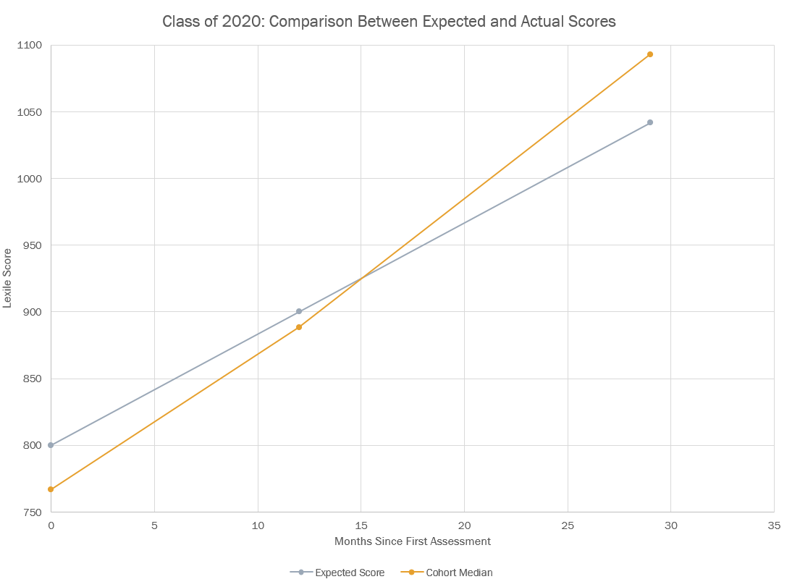
Year 10, 2020
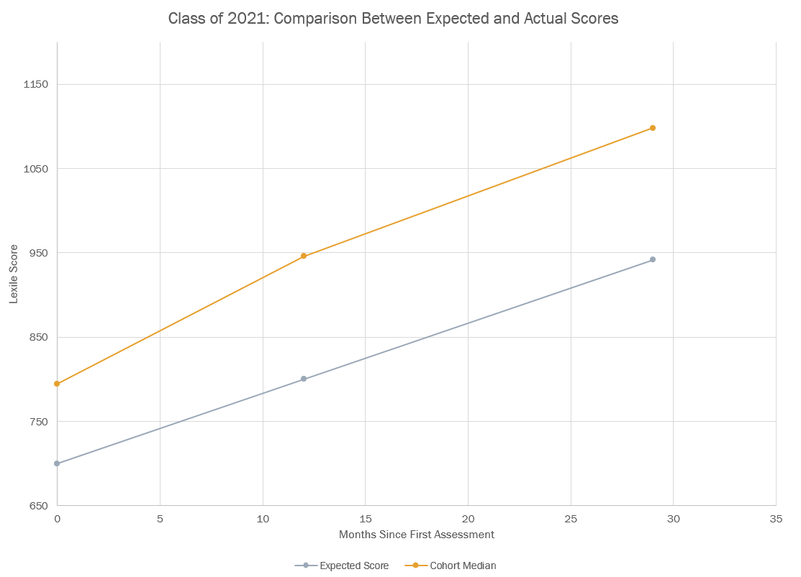
Year 9, 2020
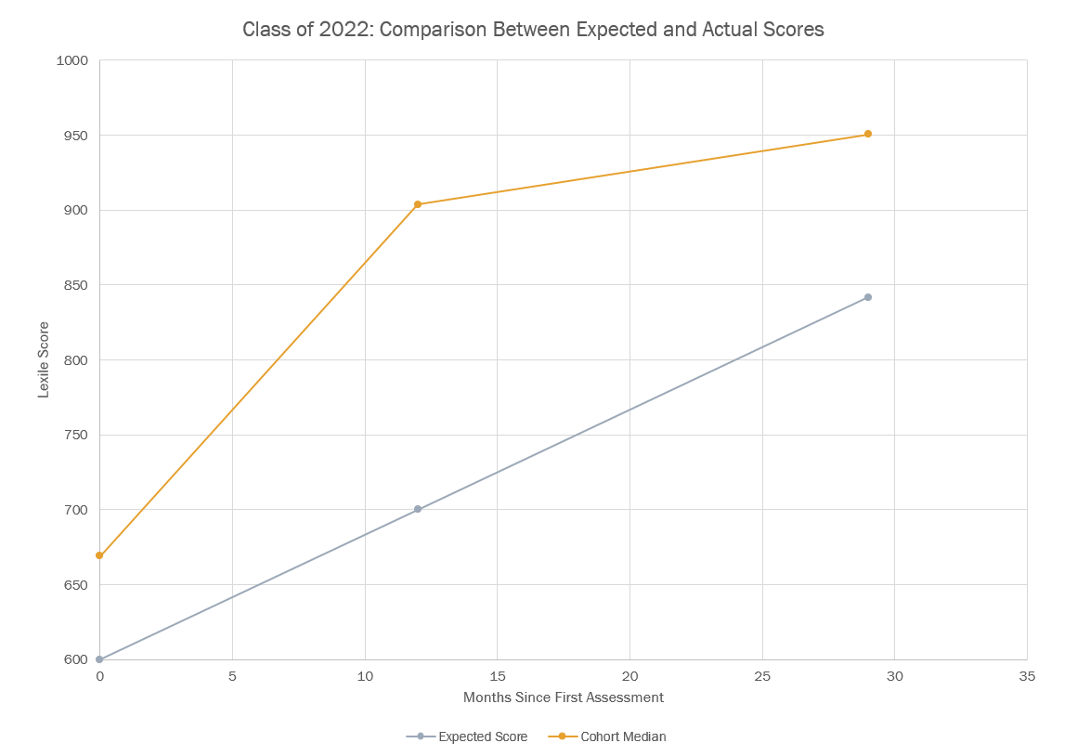
Year 8, 2020

