

Malkara School

Annual School Board Report

2017

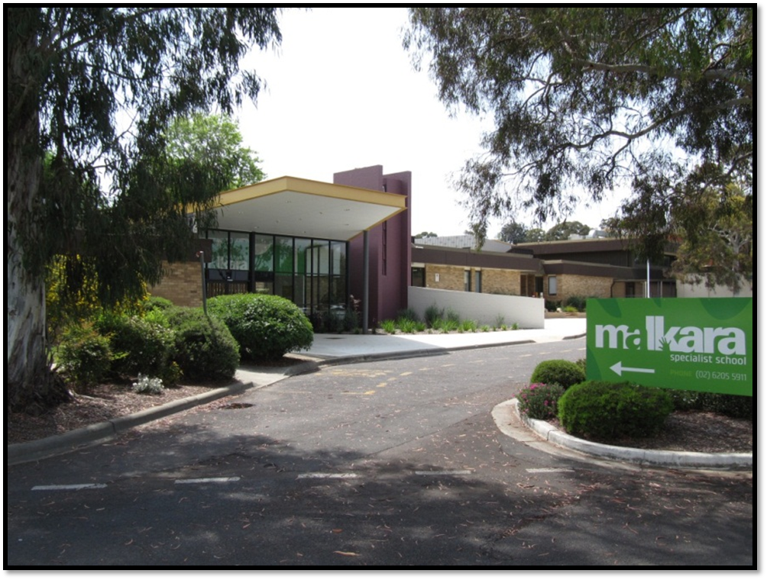

This page is intentionally left blank.



This report supports the work being done in the ACT Education Directorate, as outlined in the ‘*Education Capital: Leading the Nation Strategic Plan 2014-17’*.

Accessibility

The ACT Government is committed to making its information services, events and venues accessible to as many people as possible.

If you have difficulty reading a standard document and would like to receive this publication in an alternate format, such as large print and audio, please telephone (02) 6247 4580.

If English is not your first language and you require the translating and interpreting service, please telephone 13 14 50.

If you are deaf or hearing impaired and require the National Relay Service, please telephone 13 36 77.

© Australian Capital Territory, Canberra, 2017

Material in this publication may be reproduced provided due acknowledgement is made.

The school website is http://www.malkara.act.edu.au.

Inquiries about this publication should be directed to:

Malkara School  
Wisdom St.  
Garran ACT 2605

General enquiries:

Telephone (02) 6142 0266

Contents

School Context 1

Student enrolment 1

Student attendance 1

Staff Information 2

Teacher qualifications 2

Workforce composition 2

School Review and Development 2

School Satisfaction 3

Overall Satisfaction 3

Learning and Assessment 5

NAPLAN 5

Performance in Other Areas of the Curriculum 5

Financial Summary 7

Professional Learning 8

Voluntary Contributions 8

Reserves 8

Endorsement Page 9

Members of the School Board 9

# School Context

Malkara School provides a program for 80 students who have moderate to severe intellectual disabilities and autism. Many students also have associated sensory or communication impairments, or a physical disability. Students come from the south of Canberra and nearby NSW, and many are transported to school on special needs transport buses. In addition to the 69 primary-aged students there were 11 preschool aged students at the school in 2017.

### Student enrolment

In 2017 there were a total of 69 students enrolled at this school.

Table: 2017 Student enrolment

|  |  |
| --- | --- |
| **Student type** | **Number of students** |
| Male | 49 |
| Female | 20 |
| Aboriginal and Torres Strait Islander | 6 |
| LBOTE* | 17 |

*Language Background Other Than English

Source: Planning and Analytics, December 2017

### Student attendance

The following table identifies the attendance rate of students by year level during 2017. Student attendance rate is the percentage of school days attended by students in each year level at the school. Student attendance is measured over two school terms; that is from the first day of the school year for students in term 1 to the last day of term 2.

Table: 2017 Attendance rates in percentages

|  |  |
| --- | --- |
| **Year level** | **Attendance rate** |
| K | 87.0 |
| 1 | 96.0 |
| 2 | 88.0 |
| 3 | 96.0 |
| 4 | 95.0 |
| 5 | 94.0 |
| 6 | 95.0 |

Source: Planning and Analytics, December 2017

The majority of students at Malkara come to school on special needs transport. This is of great assistance to families and generally has a positive impact on school attendance. Non-attendance at school is generally related to our students’ higher than average medical fragility. Staff at Malkara, particularly executive and classroom teachers and our Health Access at School (HASS) trained LSA staff, maintain close contact with families during periods of school absence.

## Staff Information

### Teacher qualifications

All teachers meet the professional requirements for teaching in an ACT public school. The ACT Teacher Quality Institute (TQI) has provided the following data based on teachers registered as at 16 December 2017.

The proportion of teaching staff with certificates/degrees/diplomas and a postgraduate qualification is shown below.

Table: 2017 Qualification of teaching staff in percentages

|  |  |
| --- | --- |
| **Qualifications** | **Proportion of staff** |
| Certificate/ Diploma/ Degree | 100 |
| Postgraduate | 75 |

Source: Teacher Quality Institute, 16 December 2017

### Workforce composition

The 2017 workforce composition of [INSERT SCHOOL NAME] is highlighted in the following table. The data is taken from the school’s term 4 staff report. For reporting purposes it incorporates all school-based staff.

Table: 2017 Workforce composition numbers

|  |  |
| --- | --- |
| **Staff employment category** | **TOTAL** |
| Teaching Staff: Head Count | 20 |
| Teaching Staff: Full Time Equivalent Permanent | 14.80 |
| Teaching Staff: Full Time Equivalent Temporary | 2.60 |
| Non Teaching Staff: Head Count | 29 |
| Non Teaching Staff: Full Time Equivalent | 23.21 |

Source: This data is from the school’s term 4 2017 staff report. Data provided in previous years was sourced from the August census date and was calculated using the parameters provided by the ABS. As such, pre-2017 staffing figures may differ significantly from the above.

|  |
| --- |
| There are no Aboriginal and Torres Strait Islander staff members at this school. |

# School Review and Development

In 2017, the ACT Education Directorate’s Strategic Plan 2014-2017 provided the framework and strategic direction for the school’s Strategic Plan. This is supported by the school performance and accountability framework, ‘*People, Practice and Performance: School Improvement in Canberra Public Schools, A Framework for Performance and Accountability’*. This framework has school improvement at its centre, with the National School Improvement Tool (NSIT) as its core feature, providing support to achieve high standards in student learning, innovation and best practice in ACT public schools.

Prior to 2016 all ACT public schools participated in a four-year cycle of school review and development. In the fourth year schools underwent an external validation process. In 2016 this changed to a five-year cycle with an External School Review at the end.

Malkara School will be reviewed in 2021. A copy of the most recent validation report can be found on the school website.

## School Satisfaction

Schools use a range of data collection tools to gain an understanding of the satisfaction levels of their parents and carers, staff and students. In August/ September 2017 the school undertook a survey to gain an understanding of school satisfaction at that time. Staff, parents and students from year 5 and above (with the exception of students in special schools) took part in an online survey.

## Overall Satisfaction

In 2017, 93% of parents and carers and 98% of staff at this school indicated they were satisfied with the education provided by the school.

Included in the survey were 14 national parent survey items and 12 national student survey items. These items were approved by the then Standing Council on School Education and Early Childhood (SCSEEC) for use from 2015. The following tables show the percentage of parents and carers and students who agreed with each of the national items at this school.

A total of 40 staff responded to the survey. Please note that not all responders answered every question.

Table: Proportion of staff in agreement with each national opinion item

|  |  |  |
| --- | --- | --- |
| **National opinion item** | |  | | --- | | Proportion of staff | |
| Teachers at this school expect students to do their best. | 98 |
| Teachers at this school provide students with useful feedback about their school work. | 87 |
| Teachers at this school treat students fairly. | 98 |
| This school is well maintained. | 95 |
| Students feel safe at this school. | 90 |
| Students at this school can talk to their teachers about their concerns. | 62 |
| Parents at this school can talk to teachers about their concerns. | 95 |
| Student behaviour is well managed at this school. | 85 |
| Students like being at this school. | 97 |
| This school looks for ways to improve. | 100 |
| This school takes staff opinions seriously. | 85 |
| Teachers at this school motivate students to learn. | 97 |
| Students’ learning needs are being met at this school. | 97 |
| This school works with parents to support students' learning. | 98 |
| I receive useful feedback about my work at this school. | 85 |
| Staff are well supported at this school. | 85 |

Source: 2017 School Satisfaction Surveys, August/September 2017

A total of 15 parents responded to the survey. Please note that not all responders answered every question.

Table: Proportion of parents and carers in agreement with each national opinion item

|  |  |  |
| --- | --- | --- |
| **National opinion item** | |  | | --- | | Proportion of parents and carers | |
| Teachers at this school expect my child to do his or her best. | 100 |
| Teachers at this school provide my child with useful feedback about his/her school work. | 77 |
| Teachers at this school treat students fairly. | 100 |
| This school is well maintained. | 93 |
| My child feels safe at this school. | 100 |
| I can talk to my child’s teachers about my concerns. | 87 |
| Student behaviour is well managed at this school. | 87 |
| My child likes being at this school. | 93 |
| This school looks for ways to improve. | 92 |
| This school takes parents’ opinions seriously. | 93 |
| Teachers at this school motivate my child to learn. | 87 |
| My child is making good progress at this school. | 87 |
| My child's learning needs are being met at this school. | 93 |
| This school works with me to support my child's learning. | 73 |

Source: 2017 School Satisfaction Surveys, August/September 2017

A total of 7 students responded to the survey. Please note that not all responders answered every question.

Table: Proportion of students in years 5 to 6 in agreement with each national opinion item

|  |  |  |
| --- | --- | --- |
| **National opinion item** | |  | | --- | | Proportion of students | |
| My teachers expect me to do my best. | 100 |
| My teachers provide me with useful feedback about my school work. | 100 |
| Teachers at my school treat students fairly. | 100 |
| My school is well maintained. | 100 |
| I feel safe at my school. | 100 |
| I can talk to my teachers about my concerns. | 100 |
| Student behaviour is well managed at my school. | 100 |
| I like being at my school. | 100 |
| My school looks for ways to improve. | 100 |
| My school takes students’ opinions seriously. | 100 |
| My teachers motivate me to learn. | 100 |
| My school gives me opportunities to do interesting things. | 100 |

Source: 2017 School Satisfaction Surveys, August/September 2017

This information can be considered alongside information available on the My School website (<http://www.myschool.edu.au>).

2017 was the first year students participated in the satisfaction survey. They completed a modified survey supported by visuals and a PODD.

These results, as well as the continual review of school performance, contributed to the evaluation of our Strategic Plan and the development of Annual Action Plans. The Strategic Plan is available on the school website.

# Learning and Assessment

### NAPLAN

Students in years 3, 5, 7 and 9 in all ACT schools participate in the National Assessment Program-Literacy and Numeracy (NAPLAN). This program assesses skills in reading, writing, spelling, grammar and punctuation, and numeracy.

In 2017, 100.00 % of year 3 students and 100.00 % of year 5 students were exempt from testing based on nationally agreed criteria.

## Performance in Other Areas of the Curriculum

The 2017-2021 Strategic Plan focuses on the implementation of Mathematics and Science curriculum and pedagogy. 2017 saw the introduction of a Mathematics scope and sequence that was trialled by all staff. The Mathematics curriculum team has developed assessment tools for assessing learning of students working in the pre-Foundation levels of the Victorian Curriculum. These assessment tools will be trialled throughout 2018 and evaluated by the curriculum team. Science units of work based on the Australian and Victorian curriculums were developed by the Science curriculum team and implemented across the school in both semesters. Health and PE units of work based on the Australian and Victorian curriculums were planned and implemented by teaching teams in both semesters.

# Financial Summary

The school has provided the Directorate with an end of year financial statement that was approved by the school board. Further details concerning the statement can be obtained by contacting the school. The following summary covers use of funds for operating costs and does not include expenditure in areas such as permanent salaries, buildings and major maintenance.

Table: Financial Summary

|  |  |  |  |
| --- | --- | --- | --- |
| **INCOME** | **January-June** | **July-December** | **January-December** |
| Self-management funds | 185896.85 | 174501.40 | 360398.25 |
| Voluntary contributions | 3200.00 | 100.00 | 3300.00 |
| Contributions & donations | 6075.00 | 0.00 | 6075.00 |
| Subject contributions | 640.00 | 20.00 | 660.00 |
| External income (including community use) | 16142.37 | 16459.78 | 32602.15 |
| Proceeds from sale of assets | 22.15 | 3636.38 | 3658.53 |
| Bank Interest | 5740.15 | 5799.77 | 11539.92 |
| **TOTAL INCOME** | 217716.52 | 200517.33 | 418233.85 |
| **EXPENDITURE** |  |  |  |
| Utilities and general overheads | 48279.50 | 60260.40 | 108539.90 |
| Cleaning | 43767.22 | 48506.12 | 92273.34 |
| Security | 0.00 | 0.00 | 0.00 |
| Maintenance | 21824.28 | 44339.73 | 66164.01 |
| Administration | 14925.64 | 8833.65 | 23759.29 |
| Staffing | 0.00 | 0.00 | 0.00 |
| Communication | 10321.63 | 4474.66 | 14796.29 |
| Assets | 15360.38 | 10902.84 | 26263.22 |
| General office expenditure | 11342.47 | 7822.67 | 19165.14 |
| Educational | 10963.53 | 7540.92 | 18504.45 |
| Subject consumables | 532.91 | 84.17 | 617.08 |
| **TOTAL EXPENDITURE** | 177317.56 | 192765.16 | 370082.72 |
| **OPERATING RESULT** | 40398.96 | 7752.17 | 48151.13 |
| **Actual** Accumulated Funds | 228356.66 | 229683.66 | 229683.66 |
| Outstanding commitments (minus) | -36402.56 | 0.00 | -36402.56 |
| **BALANCE** | 232353.06 | 237435.83 | 241432.23 |

## 

## Professional Learning

The average professional learning expenditure at the school level per full time equivalent teacher was $2042

## Voluntary Contributions

The funds listed were used to support the general operations of the school. The spending of voluntary contributions is in line with the approved budget for 2017.

## Reserves

|  |  |  |
| --- | --- | --- |
| Name and Purpose | Amount | Expected Completion |
| **Staffing Reserve**  Funds additional staffing requirements | $30,000 | 12/2018 |
| **Toilet upgrade**  Upgrade inadequate toilet facilities | $25,000 | 12/2018 |
| **ICT Reserve**  Ongoing upgrade of IWBs and IT infrastructure | $18595.25 | 12/19 |

# Endorsement Page

## Members of the School Board

|  |  |  |  |
| --- | --- | --- | --- |
| Parent Representative(s): | Paul Hyauiason | Nicole Mackey | Tara Scott |
| Community Representative(s): | Olwyn Munro |  |  |
| Teacher Representative(s): | Charmayne Tinkler | Samintha Pathiranage |  |
| Student Representative(s): |  |  |  |
| Board Chair: | Nicole Mackey |  |  |
| Principal: | Allison Chapman |  |  |

I approve the report, prepared in accordance with the provision of the ACT *Education Act* *2004*, section 52.

|  |  |  |  |
| --- | --- | --- | --- |
| Board Chair Signature: | ___________________________ | Date: | _____ / _____ / _____ |

I certify that to the best of my knowledge and belief the data and information reported in this Annual School Board Report represents an accurate record of the school’s operations in 2017.

|  |  |  |  |
| --- | --- | --- | --- |
| Principal Signature: | ___________________________ | Date: | _____ / _____ / _____ |