Fadden Primary School
Annual School Board Report 2020

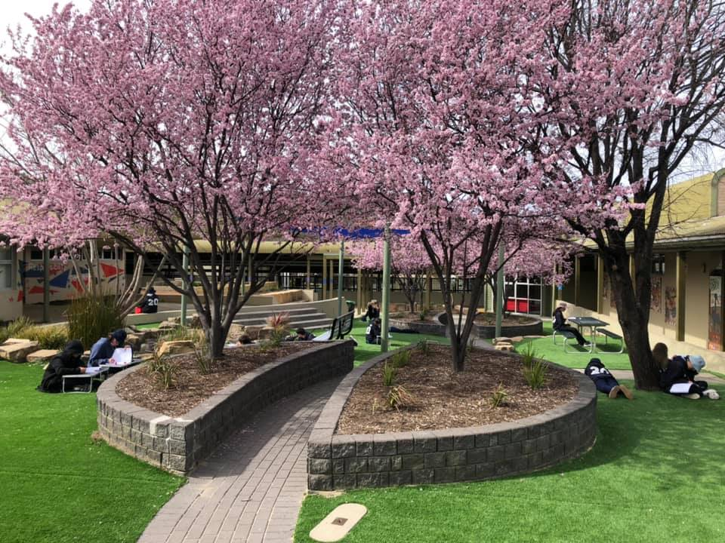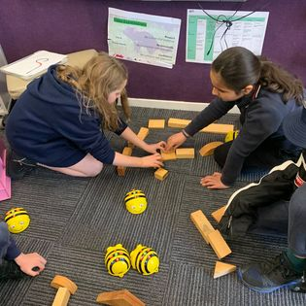

This page is intentionally left blank.

This report supports the work being done in the ACT Education Directorate, as outlined in Strategic Plan 2018-21: A Leading Learning Organisation.

Accessibility
The ACT Government is committed to making its information services, events and venues accessible to as many people as possible.
If you have difficulty reading a standard document and would like to receive this publication in an alternate format, such as large print and audio, please telephone (02) 6247 4580.
If English is not your first language and you require the translating and interpreting service, please telephone 13 14 50.
If you are deaf or hearing impaired and require the National Relay Service, please telephone 13 36 77.
© Australian Capital Territory, Canberra, 2021

Material in this publication may be reproduced provided due acknowledgement is made.

Contents
Reporting to the community 1
Summary of School Board activity 1
School Context 2
Student Information 2
Student enrolment 2
Student attendance Error! Bookmark not defined.
Supporting attendance and managing non-attendance 3
Staff Information 3
Teacher qualifications 3
Workforce composition 3
School Review and Development 4
School Satisfaction 4
Overall Satisfaction 4
Learning and Assessment 6
Performance in Literacy and Numeracy 6
Early years assessment 6
NAPLAN 6
Outcomes for College Students Error! Bookmark not defined.
Post School Destination Error! Bookmark not defined.
Financial Summary 7
Voluntary Contributions 8
Reserves 8
Endorsement Page 9
Members of the School Board 9

Reporting to the community
Schools report to communities in range of ways, including through:
- Annual School Board Reports
- a (5-year) School Improvement Plan (formerly School Strategic Plan)
- annual Impact Reports
- newsletters
- other sources such as My School.

Summary of School Board activity
It has been another busy year for the Fadden Primary School Board. This has been my fourth and final year as a parent member of the Fadden Primary School Board, so it has been rewarding to see the plans and ideas come to fruition. The close-knit school community at Fadden Primary School is amazing to be a part of. The students, families and staff all have a say in the decisions made for the school. It has been reassuring for the school community to have Mrs Jo Jefferson as permanent Principal of Fadden Primary School, settling many years of leadership changes for the school. The Fadden Primary School Board wish to thank Mrs Jefferson for her continued leadership and support of the School Board, and for bringing together our school community once again.
With the complications of COVID 19, there have been less opportunities throughout the year for parents to be engaged in their child’s learning. A successful open classrooms was held early in the year, with the feedback from the community being overly positive about getting to meet the classroom teacher and see the learning environment of their child. A number of conversations have been undertaken by the School Board in relation to school assemblies. These changes will be implemented on return to ‘normal’ parent involvement in the school. The unprecedent pandemic, COVID 19, has had a massive impact on how the school has been able to operate. I strongly believe that everyone involved with the Fadden Primary School community, are equally as proud as they are grateful of the work done by the teachers and staff at Fadden, to make remote learning, and the return to face to face learning as easy as possible. The complications of COVID 19, continue to impact the day to day running of the school, in particular how thoroughly and regularly all surfaces must be sanitised. As COVID 19 restrictions ease, the focus will return to the strategic priorities of the school.
There has continued to be a significant effort put into student wellbeing at Fadden Primary School through Positive Behaviours For Learning (PBL) which is a whole school approach to appropriate and safe behaviours at school. Discussions at Board level have indicated that PBL is having a positive effect on behaviour management across the school.
The goal for Fadden Primary School has remained the same throughout; improving in student outcomes by engaging in effective, quality pedagogy. The School Board, along with the leadership team, have been able to support the Strategic Plan to ensure that each student at Fadden Primary School has access to an engaging, differentiated, high quality education. Moving into 2021, the school will go through the review process and a new Strategic Plan will be developed.
The School Board have been involved in a number of changes for Fadden Primary School, including, but not limited to; implementing a uniform for the Preschool, the finalisation of the homework and anaphylaxis policies, the development of a gifted and talented policy and changes made to how the school communicates regularly with families through the weekly emails from Mrs Jefferson. It was a privilege to be a part of the in-depth discussions about changes to the school vision statement and changes made to the school motto. The students, families, staff and school community as a whole had an input into the changes that were made, and the Fadden Primary School community should be extremely proud of the changes that have been made, taking the school into the future.
It has been an absolute pleasure to work with all the members of the Fadden Primary School Board for 2020. The Fadden Primary School community should be extremely proud of the hard work and resilience shown by all members of Fadden Primary School, the school leadership team, teachers, administration staff, students and parents.
Jen Glover, School Board Chair

School Context
Fadden Primary School is located in the southern Canberra suburb of Fadden in the district of Tuggeranong. The school opened in 1985 and was named after Sir Arthur Fadden, a former Prime Minister of Australia.
In 2020 the school revised its motto to Growing Leaders for Tomorrow, which reflects the new mission of the school, to empower learners to be tomorrow’s active citizens. The core values of Fadden Primary School are: Respect: respect for people opinions and property; Confidence: displaying confidence and doing ones best and Responsibility: being responsible and organised.
Fadden Primary School aims to deliver a rigorous and engaging curriculum which provides opportunities for students to develop critical thinking skills, personal and social capabilities, and confidence to take responsibility for their own future. The school has specialist teachers delivering programs in Japanese language and culture, information technology and physical education.
Fadden Primary School provides an inclusive environment for students with diverse social and emotional needs. The school runs a small group program for students with autism which caters for the unique learning needs of students on an individualised basis.

Student Information

Student enrolment
In this reporting period there were a total of 294 students enrolled at this school.
Table: Student enrolment*
Student type | Number of students
Gender - Male | 147
Gender - Female | 147
Gender - Non-binary or other | 0
Aboriginal and Torres Strait Islander | 8
LBOTE** | 59
Source: ACT Education Directorate, Analytics and Evaluation Branch
* To protect personally identifiable information any figures less than six are not reported.
** Language Background Other Than English

Student attendance
Due to the effects of the COVID-19 pandemic, 2020 attendance data has not been published in the Annual School Board Report.

Supporting attendance and managing non-attendance
ACT public schools support parents and careers to meet their legal responsibilities in relation to the compulsory education requirements of the Education Act 2004. The Education Directorate’s Education Participation (Enrolment and Attendance) Policy describes its position with regard to supporting attendance and managing non-attendance. A suite of procedures supports the implementation of the policy. Please refer to https://www.education.act.gov.au/ for further details.

Staff Information

Teacher qualifications
All teachers at this school meet the professional requirements for teaching in an ACT public school. The ACT Teacher Quality Institute (TQI) specifies two main types of provision for teachers at different stages of their career, these are detailed below.
- Full registration is for teachers with experience working in a registered school in Australia or New Zealand who have been assessed as meeting the Proficient level of the Australian Professional Standards for Teachers.
- Provisional registration is for newly qualified teachers or teachers who do not have recent experience teaching in a school in Australia and New Zealand. Many teachers moving to Australia from another country apply for Provisional registration.

Workforce composition
Workforce composition for the current reporting period is provided in the following table. The data is taken from the school’s verified August staffing report. For reporting purposes, it incorporates all school staff including preschools, staff absent for a period of less than four consecutive weeks and staff replacing staff absent for more than four consecutive weeks. It does not include casuals and staff absent for a period of four consecutive weeks or longer.
The Education Directorate is required to report Aboriginal and Torres Strait Islander staff figures. As of June of the reporting period, 135 Aboriginal and Torres Strait Islander staff members were employed across the Directorate.
Table: Workforce composition numbers
Staff employment category | TOTAL
Teaching Staff: Full Time Equivalent Permanent | 15.86
Teaching Staff: Full Time Equivalent Temporary | 7.70
Non Teaching Staff: Full Time Equivalent | 9.98
Source: ACT Education Directorate, People and Performance Branch

School Review and Development
The ACT Education Directorate’s Strategic Plan 2018-2021 provides the framework and strategic direction for School Improvement Plans (formerly School Strategic Plans). This is supported by the school performance and accountability framework ‘People, Practice and Performance: School Improvement in Canberra Public Schools, A Framework for Performance and Accountability’. Annually, system and school level data are used alongside the National School Improvement Tool to support targeted school improvement, high standards in student learning, innovation and best practice in ACT public schools.
Our school will be reviewed in 2021.

School Satisfaction
Schools use a range evidence to gain an understanding of the satisfaction levels of their parents and carers, staff and students. Annually in August/ September ACT schools undertake a survey to gain an understanding of school satisfaction at that time. This information is collected from staff, parents and from 2020 students from year 4 and above (previously year 5 and above) through an online survey.

Overall Satisfaction
In this period of reporting, 71% of parents and carers, 100% of staff, and 68% of students at this school indicated they were satisfied with the education provided by the school.
Included in the survey were 16 staff, 14 parent, and 12 student items which are described as the national opinion items. These items were approved by the then Standing Council on School Education and Early Childhood (SCSEEC) for use from 2015. The following tables show the percentage of parents and carers, students and staff who agreed with each of the national opinion items at this school.
Note: The overall response rate for parents and carers in ACT public schools was negatively impacted by COVID-19, dropping from 31% in 2019 to 23% in 2020.
A total of 20 staff responded to the survey. Please note that not all responders answered every question.
Table: Proportion of staff* in agreement with each national opinion item
National opinion item | Proportion of staff
Parents at this school can talk to teachers about their concerns. | 100
Staff are well supported at this school. | 85
Staff get quality feedback on their performance. | 55
Student behaviour is well managed at this school. | 85
Students at this school can talk to their teachers about their concerns. | 95
Students feel safe at this school. | 90
Students like being at this school. | 100
Students’ learning needs are being met at this school. | 95
Teachers at this school expect students to do their best. | 95
Teachers at this school motivate students to learn. | 85
Teachers at this school treat students fairly. | 100
Teachers give useful feedback. | 90
This school is well maintained. | 95
This school looks for ways to improve. | 95
This school takes staff opinions seriously. | 85
This school works with parents to support students' learning. | 100
Source: ACT Education Directorate, Analytics and Evaluation Branch
*Proportion of those who responded to each individual survey question

A total of 89 parents responded to the survey. Please note that not all responders answered every question.
Table: Proportion of parents and carers* in agreement with each national opinion item
National opinion item | Proportion of parents and carers
I can talk to my child’s teachers about my concerns. | 89
My child feels safe at this school. | 81
My child is making good progress at this school. | 72
My child likes being at this school. | 77
My child's learning needs are being met at this school. | 68
Student behaviour is well managed at this school. | 58
Teachers at this school expect my child to do his or her best. | 86
Teachers at this school give useful feedback. | 73
Teachers at this school motivate my child to learn. | 73
Teachers at this school treat students fairly. | 71
This school is well maintained. | 87
This school looks for ways to improve. | 73
This school takes parents’ opinions seriously. | 70
This school works with me to support my child's learning. | 71
Source: ACT Education Directorate, Analytics and Evaluation Branch
*Proportion of those who responded to each individual survey question

A total of 119 students responded to the survey. Please note that not all responders answered every question.
Table: Proportion of students* in agreement with each national opinion item
National opinion item | Proportion of students
I can talk to my teachers about my concerns. | 42
I feel safe at this school. | 55
I like being at my school. | 61
My school gives me opportunities to do interesting things. | 74
My school is well maintained. | 65
My school looks for ways to improve. | 71
My teachers expect me to do my best. | 91
My teachers motivate me to learn. | 82
Staff take students’ concerns seriously. | 53
Student behaviour is well managed at my school. | 41
Teachers at my school treat students fairly. | 60
Teachers give useful feedback. | 63
Source: ACT Education Directorate, Analytics and Evaluation Branch
*Proportion of those who responded to each individual survey question

Learning and Assessment

Performance in Literacy and Numeracy

Early years assessment
Students in kindergarten undertake an on-entry and on-exit assessment of their early reading and numeracy skills using the BASE program. Student results are reported against five performance bands at the end of semester 1 and 2. Below are the results for this school for the current reporting period.
Due to the impact of COVID-19, analysis of BASE data for 2020 has been delayed. Analysis will be provided to schools in 2021. Please speak with the school should you require further information.

NAPLAN
Students in years 3, 5, 7 and 9 in all ACT schools participate in the National Assessment Program-Literacy and Numeracy (NAPLAN). This program assesses skills in reading, writing, spelling, grammar and punctuation, and numeracy.
*Note: There are no NAPLAN results for 2020, with the assessments not being conducted due to the impacts of COVID-19.

Financial Summary
The school has provided the Directorate with an end of year financial statement that was approved by the school board. Further details concerning the statement can be obtained by contacting the school. The following summary covers use of funds for operating costs and does not include expenditure in areas such as permanent salaries, buildings and major maintenance.
Table: Financial Summary
INCOME | January-June | July-December | January-December
Self-management funds | 120867.24 | 112342.57 | 233209.81
Voluntary contributions | 8300.00 | 4719.00 | 13019.00
Contributions & donations | 9471.00 | 3434.80 | 12905.80
Subject contributions | 268.00 | 3066.00 | 3334.00
External income (including community use) | 14502.95 | 6153.88 | 20656.83
Proceeds from sale of assets | 0.00 | 0.00 | 0.00
Bank Interest | 2454.84 | 1900.09 | 4354.93
TOTAL INCOME | 155864.03 | 131616.34 | 287480.37
EXPENDITURE
Utilities and general overheads | 40026.89 | 60602.44 | 100629.33
Cleaning | 0.00 | 0.00 | 0.00
Security | -1033.88 | 0.00 | -1033.88
Maintenance | 60069.98 | 20310.47 | 80380.45
Administration | 3083.38 | 3845.09 | 6928.47
Staffing | 0.00 | 0.00 | 0.00
Communication | 1527.72 | 2233.37 | 3761.09
Assets | 24001.25 | 675.37 | 24676.62
Leases | 0.00 | 0.00 | 0.00
General office expenditure | 12500.26 | 12929.51 | 25429.77
Educational | 17696.79 | 22391.79 | 40088.58
Subject consumables | 5900.00 | 262.72 | 6162.72
TOTAL EXPENDITURE | 163772.39 | 123250.76 | 287023.15
OPERATING RESULT | -7908.36 | 8365.58 | 457.22
Actual Accumulated Funds | 114400.66 | 111528.52 | 111528.52
Outstanding commitments (minus) | -18822.83 | 0.00 | -18822.83
BALANCE | 87669.47 | 119894.10 | 93162.91

Voluntary Contributions
The funds listed were used to support the general operations of the school. The spending of voluntary contributions is in line with the approved budget for this reporting period.

Reserves
Name and Purpose | Amount | Expected Completion
Staffing  Planning for possible staffing debt  To achieve high level student wellbeing | $100 000 | 2022
Digital Sign  Procure and install a new digital sign to improve communication with families and community | $30 000 | 2022
Flooring  Replace damaged/old flooring in classrooms | $30 000 | 2022
Playground equipment  Purchase new playground equipment to enhance student growth and wellbeing. | $20 000 | 2022

Endorsement Page

Members of the School Board
Parent Representative(s): | Jennifer Glover, | Libby Werner-Gibbings, | Leah Marshall.
Teacher Representative(s): | Sarah Sams, | Dave Matthews.
Board Chair: | Jennifer Glover
Principal: | Jo Jefferson
I approve the report, prepared in accordance with the provision of the ACT Education Act 2004, section 52.

2020 Board Chair Signature: | Jennifer Glover | Date: | 24/ 06/ 2021

I certify that to the best of my knowledge and belief the evidence and information reported in this Annual School Board Report represents an accurate record of the Board’s operations during this reporting period.

Principal Signature: | Jo Jefferson | Date: | 24 / 06 / 2021

